CRANFIELD UNIVERSITY

__________________________________________________________ BIRGITTA BEDFORD

LEGIONELLA CONTROL IN WATER SYSTEMS USING COPPER

AND SILVER ION GENERATION SYSTEMS

INSTITUTE OF BIOSCIENCE AND TECHNOLOGY

PhD. THESIS

___________________________________________________________

CRANFIELD UNIVERSITY

INSTITUTE OF BIOSCIENCE AND TECHNOLOGY

BIRGITTA BEDFORD

LEGIONELLA CONTROL IN WATER SYSTEMS USING COPPER

AND SILVER ION GENERATION SYSTEMS

PhD THESIS

2012

SUPERVISORS:

Dr. D. Aldred

Prof. N. Magan

31st January 2012

This thesis is submitted in partial fulfilment of the requirements for the Degree of

Doctor of Philosophy

© Cranfield University, 2012. All rights reserved. No part of this publication may be reproduced

without the written permission of the copyright holder.

ABSTRACT

Legionella can cause human disease which can be fatal. Routine monitoring for Legionella in water systems is not recommended by UK authorities. Evidence of the efficacy of control modalities against Legionella in these water systems is, therefore, not available.

Although studies have been conducted with copper and silver ionization on its efficacy against Legionella and on its value in reducing hospital-acquired legionellosis, little evidence of its efficacy is available from routine monitoring data.

This study demonstrates the efficacy of copper and silver ionization against Legionella in water systems of 10 hospitals from data obtained from routine monitoring for Legionella, copper and silver. The inefficiencies of maintaining temperatures above 50ºC at hot outlets and below 20ºC at cold outlets, as recommended by UK authorities for controlling Legionella in water systems, is also demonstrated from the data obtained from routine monitoring for Legionella and temperatures. The futility of maintaining hot temperatures above 50ºC and then to reduce them to temperatures that do not present a risk of scalding is also demonstrated from the data obtained.

This efficacy of copper and silver ionization and inefficiency of maintaining temperatures at 50ºC against Legionella was demonstrated as well in novel model rigs, built to simulate a typical water system of a small hospital, by data obtained from Legionella, copper, and silver analysis, and temperature recordings.

The differences in biofilm formation and Legionella growth on the surfaces of copper, polyethylene, and synthetic rubber, which are commonly used plumbing materials, were also examined in the model rigs as well as with a Robbins device. These studies indicated that copper is not as biocidal as previously reported in other studies, and gave similar results to polyethylene, which previously been shown to promote biofilm development. Synthetic rubber, however, showed to promote biofilm production and should not be used as a plumbing material.

ACKNOWLEDGEMENTS

I would like to thank the following people without whom this thesis would not have been possible.

Dave Aldred and Naresh Magan, of Cranfield University, for their encouragement, ideas, supervision and patience.

Melany and Alwyn Jones, for their support whilst working on this thesis in Wales.

My children Jamie and Byron, for their support throughout my studies even though they were both busy developing careers.

My husband, Nick, for his support, for his belief in me, and for simply being a great husband and father.

CONTENTS
Abstract
List of Contents
List of Figures
List of Plates
List of Tables
List of Graphs
Notation
Glossary
1. INTRODUCTION AND LITERATURE REVIEW | 1
1.1 General introduction | 1
1.2 Microbiology and Taxonomy | 2
1.3 Transmission | 3
1.4 Legionellosis | 4
1.5 Reported cases and outbreaks of Legionnaires’ disease | 7
1.5.1 Community acquired Legionnaires’ disease | 8
1.5.2 Hospital acquired Legionnaires’ disease | 9
1.5.3 Travel associated Legionnaires’ disease | 10
1.5.4 Legionnaires’ disease in long-term care residents | 10
1.6 Legionella sources | 11
1.7 Factors that influence Legionella growth | 12
1.7.1 Physio-chemical factors | 12
1.7.2 Microbial factors | 12
1.8 Biofilms | 15
1.8.1 Factors supporting biofilm formation | 15
1.9 Detecting Legionella in water systems | 20
1.10 Models built to examine biofilm formation and Legionella growth on
plumbing materials | 21
1.11 Controlling Legionella in hot and cold water distribution systems | 25

1.12 UK guidance for controlling Legionella | 26
1.12.1 Temperature control | 26

1.12.2 Chlorine Dioxide |  | 27
1.12.3 Copper and silver ionization |  | 28
1.12.4 Ozone (O₃) and Ultraviolet Light (UV) |  | 34
1.12.5 Intermittent disinfection |  | 35
1.12.6 Point-of-use filtration |  | 36
2. AIMS AND OBJECTIVES |  | 38
3. MATERIALS AND METHODS |  | 40
3.1 Evaluation studies in UK hospitals |  | 40
3.1.1 | The Orca copper and silver ionization system | 41
3.1.2 | Sampling and system maintenance procedures | 42
3.1.3 | Study hospital 1 | 44
3.1.4 | Study hospital 2 | 46
3.1.5 | Study hospital 3 | 48
3.1.6 | Study hospital 4 | 50
3.1.7 | Study hospital 5 | 52
3.1.8 | Study hospital 6 | 54
3.1.9 | Study hospital 7 | 57
3.1.10 Study hospital 8 |  | 60
3.1.11 Study hospital 9 |  | 62
3.1.12 Study hospital 10 |  | 65
3.2 The copper and polyethylene rigs |  | 68
3.2.1 Initial experimental procedures – Rigs A |  | 72
3.2.2 | Additional experimental procedures – Rigs B and C | 78
3.3 Analytical methods |  | 83
3.3.1 | Water analysis | 83
3.3.2 | Statistical analysis | 86

 | 3.4 The Robbins device | 87
4. RESULTS |  | 89
4.1 | Study hospital 1 | 89
4.2 | Study hospital 2. | 96

4.3 | Study hospital 3 | 103
4.4 | Study hospital 4 | 109
4.5 | Study hospital 5 | 113
4.6 | Study hospital 6 | 121
4.7 | Study hospital 7 | 128
4.8 | Study hospital 8 | 134
4.9 | Study hospital 9 | 141
4.10 Study hospital 10 |  | 149
4.11 Summary of results of study hospitals |  | 156
4.12 Initial experiment – Rigs |  | 159
 | 4.12.1 Rigs A | 159
 | 4.12.2 Rigs B and C | 166
4.13 Comparison experiment – Rigs |  | 169
 | 4.13.1 Rigs A | 169
 | 4.13.2 Rigs B | 172
 | 4.13.3 Rigs C | 175
4.14 The Robbins device |  | 178
5. DISCUSSION |  | 181
5.1 | Evaluation of 10 hospitals | 181
5.2 Initial experiment with rigs |  | 195
5.3 | Comparison experiment with rigs | 202
5.4 | Experiment with the Robbins device | 205
REFERENCES |  | 207
GLOSSARY |  | 223

LIST OF FIGURES
Fig. 1.1 | Diagram of model hot water system (Schofield and Locci, 1985) | 21
Fig. 1.2 | Continuous culture biofilm model (Keevil et a., 1993, Rogers et al., 1994) | 22
Fig. 1.3 | Schematic of the BSRIA test facility (BSRIA TN6/96) | 23
Fig. 1.4 | Diagram of model warm water system (van der Kooij et al., 2005) | 24
Fig. 3.1 | Study hospital 2 – drawing of copper and silver ionization installation | 47
Fig. 3.2 | Study hospital 3 – drawing of copper and silver ionization installation | 48
Fig. 3.3 | Study hospital 4 – drawing of copper and silver ionization installation | 50
Fig. 3.4 | Study hospital 5 – drawing of copper and silver ionization installation | 53
Fig. 3.5 | Study hospital 6 – drawing of copper and silver ionization installation - 1 | 55
Fig. 3.6 | Study hospital 6 – drawing of copper and silver ionization installation – 2 | 55
Fig. 3.7 | Study hospital 6 – drawing of copper and silver ionization installation – 3 | 56
Fig. 3.8 | Study hospital 7 – drawing of copper and silver ionization installation – 1 | 58
Fig. 3.9 | Study hospital 7 – drawing of copper and silver ionization installation – 2 | 58
Fig. 3.10 | Study hospital 8 – drawing of copper and silver ionization installation | 61
Fig. 3.11 | Study hospital 9 – drawing of copper and silver ionization installation | 63
Fig. 3.12 | Study hospital 10 – drawing of copper and silver ionization installation - 1 | 66
Fig. 3.13 | Study hospital 10 – drawing of copper and silver ionization installation – 2 | 66
Fig. 3.14 | Drawing of rig plus 24 sections | 71
Fig. 3.15 | Drawing of ‘Speedfit’ connector | 71
Fig. 3.16 | Drawing of polyethylene rig A – sections left and removed | 79
Fig. 3.17 | Drawing of polyethylene rig B – sections replaced with polyethylene rig A sections | 79
Fig. 3.18 | Drawing of polyethylene rig C – sections replaced with polyethylene rig A sections | 80
Fig. 3.19 | Drawing of copper rig A – sections left and removed | 80
Fig. 3.20 | Drawing of copper rig B – sections replaced with copper rig A sections | 81
Fig. 3.21 | Drawing of copper rig C – sections replaced with copper rig A sections | 81
Fig. 4.1 | Drawing of copper rig A, including Legionella results of sections 1 to 16 | 162

LIST OF PLATES
Plate 1.1 Legionella bacteria (www.bbc.co.uk) |  | 2
Plate 1.2 Hartmannella vermiformis amoeba filled with L. pneumophila (Robert Koch Institute) |  | 13
Plate 1.3 Biofilm formation (Center for Biofilm Engineering Montana State University |  | 15
Plate 1.4 Inner surfaces of an eroded galvanized pipe |  | 18
Plate 1.5 Outlet with point of use filter attached (Sheffer et al., 2005) |  | 37
Plate 3.1 The Orca copper and silver ionization system |  | 41
Plate 3.2 Study hospital 1 – photo of copper and silver ionization installation |  | 45
Plate 3.3 Study Hospital 9 – photo of construction work |  | 64
Plate 3.4 | Photo of copper rig | 69
Plate 3.5 | Photo of polyethylene rig | 70
Plate 3.6 | Photo of two Legionella pneumophila colonies on BCYE+ | 84
Plate 3.7 | The Robbins device including drawing of press-fit plug | 87

 | LIST OF TABLES
Table 1.1 | Number of reported cases of Legionnaires’ disease 1993-2006 (EWGLI data) | 8
Table 3.1 | Study hospitals – size, number of sample outlets and sampling frequencies | 40
Table 3.2 | Initial experiment with rigs – inoculation | 73
Table 3.3 | Initial experiment with rigs – frequency of TVC analysis | 74
Table 3.4 | Initial experiment with rigs – frequency of Legionella analysis | 75
Table 3.5 | Initial experiment with rigs – pattern and procedures of biofilm harvesting | 76
Table 3.6 | Initial experiment with rigs – pattern of sampling for Legionella analysis of biofilm | 77
Table 3.7 | Treatment of rigs A, B, and C | 78
Table 4.1 | Study hospital 1 – results before commissioning copper and silver ionization | 90
Table 4.2 | Study hospital 1 – results 1 month after commissioning copper and silver ionization | 92
Table 4.3 | Study hospital 2 – results before commissioning copper and silver ionization | 96
Table 4.4 | Study hospital 2 – results 1 month after commissioning copper and silver ionization | 97
Table 4.5 | Study hospital 2 –56.030.1 hot outlet - results from 04/02/08 to 27/07/11 | 101
Table 4.6 | Study hospital 3 – results before commissioning copper and silver ionization | 103
Table 4.7 | Study hospital 3 – results 1 month after commissioning copper and silver ionization | 104
Table 4.8 | Study hospital 3 – APN49 mixer tap – results from 04/02/08 to 19/07/11 | 107
Table 4.9 | Study hospital 4 – results before commissioning copper and silver ionization | 109
Table 4.10 | Study hospital 4 – results 1 month after commissioning copper and silver ionization | 110
Table 4.11 | Study hospital 5 – results before commissioning copper and silver ionization | 114
Table 4.12 | Study hospital 5 – results 1 month after commissioning copper and silver ionization | 116
Table 4.13 | Study hospital 5–results single pure hot and pure cold taps 2 months after | 117
 | commissioning
Table 4.14 | Study hospital 6 – results before commissioning copper and silver ionization | 122
Table 4.15 | Study hospital 6 – results 1½ months after commissioning copper and silver ionization | 124
Table 4.16 | Study hospital 7 – results before commissioning copper and silver ionization | 128
Table 4.17 | Study hospital 7 – results 1 month after commissioning copper and silver ionization | 130
Table 4.18 | Study hospital 8 – results before commissioning copper and silver ionization | 135
Table 4.19 | Study hospital 8 – results 1 month after commissioning copper and silver ionization | 137
Table 4.20 | Study hospital 9 – results before commissioning copper and silver ionization | 141
Table 4.21 | Study hospital 9 – results 1 month after commissioning copper and silver ionization | 143
Table 4.22 | Study hospital 9 – results before construction work was started | 144
Table 4.23 | Study hospital 9 – results 1 month after construction work started | 146

Table 4.24 Study hospital 9 – results 5 months after construction work started |  | 146
Table 4.25 Study hospital 9 – results 14 months after construction work started |  | 147
Table 4.26 Study hospital 10 – results before commissioning copper and silver ionization |  | 150
Table 4.27 Study hospital 10 – results 1 month after commissioning copper and silver ionization |  | 151
Table 4.28 | Study hospitals–number of Legionella contaminated taps before and after | 156
 | commissioning
Table 4.29 Study hospitals-average Legionella counts before and after commissioning |  | 157
Table 4.30 | Study hospitals –copper, silver, chloride, phosphorus, pH and temperature values | 158
Table 4.31 Initial experiment with rigs – biofilm analysis results – copper rig A |  | 161
Table 4.32 Initial experiment with rigs – biofilm analysis results – polyethylene rig A |  | 161
Table 4.33 Initial experiment – Legionella results rigs A |  | 162
Table 4.34 The Robbins device – rubber discs results |  | 178
Table 4.35 The Robbins device – copper discs results |  | 178
Table 4.36 | The Robbins device – polyethylene discs results | 179
Table 4.37 | The Robbins device – brushed rubber, copper, and polyethylene discs results | 179

 | LIST OF GRAPHS
Graph 4.1 | Study hospital 1 – average Legionella counts from 05/10/07 to 11/07/11 | 93
Graph 4.2 | Study hospital 1 – average copper levels from 05/10/07 to 11/07/11 | 94
Graph 4.3 | Study hospital 1 – average silver levels from 05/10/07 to 11/07/11 | 94
Graph 4.4 | Study hospital 2 – average Legionella counts from 04/02/08 to 27/07/11 | 98
Graph 4.5 | Study hospital 2 – average copper levels from 04/02/08 to 27/07/11 | 99
Graph 4.6 | Study hospital 2 – average silver levels from04/02/08 to 27/07/11 | 99
Graph 4.7 | Study hospital 3 – average Legionella counts from 06/03/08 to 19/07/11 | 105
Graph 4.8 | Study hospital 3 – average copper levels from 06/03/08 to 19/07/11 | 106
Graph 4.9 | Study hospital 3 – average silver levels from 06/03/08 to 19/07/11 | 106
Graph 4.10 | Study hospital 4 – average Legionella counts from 07/05/08 to 28/06/11 | 111
Graph 4.11 | Study hospital 4 – average copper levels from 07/05/08 to 28/06/11 | 111
Graph 4.12 | Study hospital 4 – average silver levels from 07/05/08 to 28/06/11 | 112
Graph 4.13 | Study hospital 5 – average Legionella counts from 18/08/08 to 04/07/11 | 118
Graph 4.14 | Study hospital 5 – average copper levels from 15/09/08 to 04/07/11 | 119
Graph 4.15 | Study hospital 5 – average silver levels from 15/09/08 to 04/07/11 | 119
Graph 4.16 | Study hospital 6 – average Legionella counts from 25/03/09 to 08/07/11 | 126
Graph 4.17 | Study hospital 6 – average copper levels from 25/03/09 to 08/07/11 | 126
Graph 4.18 | Study hospital 6 – average silver levels from 25/03/09 to 08/07/11 | 127
Graph 4.19 | Study hospital 7 – average Legionella counts from 04/02/09 to 26/07/11 | 131
Graph 4.20 | Study hospital 7 – average copper levels from 04/02/09 to 26/07/11 | 132
Graph 4.21 | Study hospital 7 – average silver levels from 04/02/09 to 26/07/11 | 132
Graph 4.22 | Study hospital 8 – average Legionella counts from 27/05/09 to 25/07/11 | 138
Graph 4.23 | Study hospital 8 – average copper levels from 27/05/09 to 25/07/11 | 139
Graph 4.24 | Study hospital 8 – average silver levels from 27/05/09 to 25/07/11 | 139
Graph 4.25 | Study hospital 9 – average Legionella counts from 02/09/09 to 15/07/11 | 145
Graph 4.26 | Study hospital 9 – average copper levels from 02/09/09 to 15/07/11 | 147
Graph 4.27 | Study hospital 9 – average silver levels from 02/09/09 to 15/07/11 | 148
Graph 4.28 | Study hospital 10 – average Legionella counts from 13/01/10 to 13/07/11 | 152
Graph 4.29 | Study hospital 10– average copper levels from 13/01/10 to 13/07/11 | 154
Graph 4.30 | Study hospital 10 - average silver levels from 13/01/10 to 13/07/11 | 154
Graph 4.31 | Initial experiment with rigs – Legionella results polyethylene rig A | 159

Graph 4.32 Initial experiment with rigs – Legionella results copper rig A |  | 160
Graph 4.33 Initial experiment with rigs – Legionella results rig A after inoculation of rigs B and C |  | 164
Graph 4.34 Initial experiment with rigs – Legionella results rigs B after inoculation |  | 166
Graph 4.35 Initial experiment with rigs – Legionella results polyethylene rig C after inoculation |  | 167
Graph 4.36 Initial experiment with rigs – Legionella results copper rig C after inoculation |  | 168
Graph 4.37 Treatment experiment with rigs – Legionella results polyethylene rig A |  | 169
Graph 4.38 Treatment experiment with rigs – Legionella results copper rig A |  | 170
Graph 4.39 | Treatment experiment with rigs – Legionella results polyethylene rig B | 172
Graph 4.40 | Treatment experiment with rigs – Legionella results copper rig B | 173
Graph 4.41 | Treatment experiment with rigs – Legionella results and temperatures polyethylene rig C | 175
Graph 4.42 | Treatment experiment with rigs - Legionella results and temperatures copper rig C | 176

NOTATION

~ = Around

- = Smaller than > = Greater than

± = Plus or minus ºC = Degrees Celsius
Лd = Circumference per diameter

µg/l = microgrammes per litre

µm = micro metre

µS/cm²= Micro Siemens per square centimetre µWs/cm² = Microwatt seconds per square centimetre ACoP = Approved Code of Practice Ag = Silver atom

Ag⁺ = Silver atom that has lost one electron or silver + ion BCYE = Buffered charcoal yeast extract

BYCE+ = Buffered charcoal yeast extract with cysteine

BSRIA = Building Services Research Information Association Limited CFU/l = Colony forming units per litre CFU/ml = Colony forming units per millilitre

Cu = Copper atom
⁺
Cu = (Cuprous) Copper atom that has lost one electron or copper + ion
²⁺
Cu = (Cupric) Copper atom that has lost two electrons or copper +2 ion

DNA = Deoxyribonucleic acid

EC = European Council

GVPV = Glycine Vancomycin Polymyxin and Cyclohexamide selective agent

HSE = Health and Safety Executive

HTM = Health Technical Memorandum

ICPMS = Inductively coupled plasma mass spectrometry

ICPOES = Inductively coupled plasma optical emission spectroscopy M² = Square metre

Mg/l = Milligrams per litre

Ml = Millilitre

Mm² = square millimetre

NOAEL = No observed adverse effect level

Nm = Nanometre

O₃ = Ozone

pH = Potential hydrogen

RNA = Ribonucleic acid

TMV = Thermostatically controlled mixing valve TVC = Total viable count of bacteria UK = United Kingdom

UKAS = United Kingdom accreditation service US = United States of America UV = Ultraviolet

WHO = World Health Organisation

GLOSSARY

Alveolar macrophage = A white blood cell that is specialized for the uptake of particulate material by phagocytosis which is found in the lung.

Amoeba = Free-living, single-celled eukaryote that crawls by changing its shape. A particular genus of protozoa that move in this way.

Analyte = A substance or chemical constituent that is determined in an analytical procedure.

Antibody = Protein produced in response to a foreign molecule or invading oragnsism. Often binds to the foreign molecule or cell extremely tightly, thereby inactivating it or marking it for destruction by phagocytosis or lysis. Antigen = Molecule that provokes an immune response.

Aspiration = The entry of secretions or foreign material into the trachea and lungs.

Atomization = separating something into fine particles.

ATP = Adenosine triphosphate = The principal carrier of chemical energy in cells. Bioaccumulation = Accumulation of substances, such as pesticides, or other organic chemicals in an organism.

Biodispersant = A liquid or gas used to disperse organic material in a medium. Biomagnification = Also known as bioamplification or biological magnification, is the increase in concentration of a substance that occurs in a food chain.

Carbon footprint = The amount of carbon dioxide emitted due to the consumption of fossil fuels.

Catabolism = The breakdown of complex molecules in living organisms to form simpler ones, together with the release of energy; destructive metabolism. Cell lysis = refers to the breaking down of a cell.

Cellulitis = Inflammation of subcutaneous connective tissue.

Cerebellar ataxia = Failure of muscular coordination; irregularity of muscular action caused by a region in the brain that has suffered damage.

Chemostat = A bioreactor to which fresh medium is continuously added, while culture

liquid is continuously removed to keep the culture volume constant

Cyanobacteria = A division of micro-organisms (class Cyanophyceae, kingdom

Eubacteria) that are related to the bacteria but are capable of photosynthesis. They are

prokaryotic and represent the earliest known form of life on the earth. Also called

blue-green algae.

Cysteine = A sulfur-containing amino acid, HSCH2CH(NH2)COOH, that occurs in proteins and is a constituent of many enzymes. Deadend = A capped off end of a pipe.

Deadleg = A length of pipe ending at a fitting through which water flows only when the fitting is opened.

Desolvation = The removal of solvent from a material in solution.

Diabetes mellitus = The commonest form of diabetes, caused by a deficiency of the pancreatic hormone insulin.

Dissolved Oxygen = The amount of oxygen dissolved in water. Important to aquatic ecology, often determines the number and types of organisms living in the water. DNA = Deoxyribonucleic acid. Polynucleotide formed from covalently linked deoxyribonucleotide units; serves as the carrier of genetic information.

DNA degradation = The random catabolism of DNA accompanying the irreversible damage to tissue which leads to the pathological death of one or more cells.

Endemic = A disease (or condition) regularly found among particular people or in a certain area.

Endocarditis = Inflamation of the the inner lining of the heart muscle, which also covers the heart valves.

Etiologic agent = A viable microorganism, or its toxin, which causes or may cause human disease.

Eukaryote = Living organism composed of one or more cells with a distinct nucleus and cytoplasm. Includes all forms of life except viruses and bacteria (procaryotes). Exopolymer = A biopolymer that is secreted by an organism into the environment (i.e. external to the organism). These exopolymers include the biofilms produced by bacteria to anchor them and protect them from environmental conditions.

Fatty acid = Compound used as a major source of energy during the metabolism of cells and as a starting point for the synthesis of phospholipids, which are molecules used to construct biological membranes.

Febrile illness = A nonspecific term for an illness of sudden onset accompanied by fever.

Flagella = tail-like projection that protrudes from the cell body of certain bacteria and plays the dual role of locomotion and sense organ, being sensitive to chemicals and temperatures outside the cell.

Genetically homologous = sharing a common ancestor.

Genus = A well deifined group of one or more species that is clearly separate from other genera.

Gram–negative bacteria = Bacteria that do not retain crystal violet dye in the Gram staining protocol.

Gram-staining = A differential staining procedure that divides bacteria into Gram-positive and Gram-negative groups based on their ability to retain crystal violet when decolorized with an organic solvent such as ethanol.

Hemoptysis = The expectoration of blood or of blood-streaked sputum from the larynx, trachea, bronchi, or lungs.

Heterotrophicorganism = An organism that cannot synthesize its own food and is dependent on complex organic substances for nutrition.

Heterotrophic plate count = The reference procedure for estimating the number of live, heterotrophic bacteria in water.

Hydrophillic = Having a tendency to mix with, dissolve in, or be wetted by water.

Hydrophobic = Tending to repel or fail to mix with water.

Inductively Coupled Plasma = (ICP) A type of plasma source in which the energy is supplied by electric currents which are produced by electromagnetic induction. Plasma temperatures are comparable to the surface of the sun. ICP discharges are of relatively high electron density. As a result, the discharges are used to measure the emmission spectrum of chemical elements or chemical compounds.

Inhalation = (also known as inspiration) The movement of air from the external environment, through the air ways, and into the lungs.

In-vitro = Taking place in a test tube, culture dish, or elsewhere outside a living

organism.

In-vivo = Taking place in real life.

Isotonic = Having the same concentration of solutes as the blood.

Lymphadenopathy = A disease affecting the lymph nodes.

Malaise = A general feeling of discomfort, illness, or uneasiness.

Macrophage = A white blood cell that is specialized for the uptake of particulate material by phagocytosis.

Membrane-bound enzyme = Enzyme/catalytic protein that is embeded in the membrane of the enclosed organelle of the cell it belongs to.

Metabolism = The sum total of the chemical processes that take place in living cells.

Morphology = The form and structure of an organism or one of its parts.

Mutagenic = Refers to a physical or chemical agent that changes the genetic material, usually DNA, of an organism and thus increases the frequency of mutations above the natural background level.

Myalgia = Pain in a muscle or group of muscles.

Myocarditis = Infection of the heart, with an inflammatory infiltrate, and damage to the heart muscle.

Nosocomial = Originating in a hospital.

Phagocytosis = Process by which particulate material is ‘eaten’ by a cell.

Pericarditis = An inflammation of the two layers of the thin, sac-like membrane that surrounds the heart.

Peritonitis = Inflammation of the membrane which lines the inside of the abdomen and all of the internal organs.

pH = Measure of the acidity of a solution. ‘p’ refers to power of 10, ‘H’ to hydrogen Phagosome = A vacuole formed around a particle absorbed by phagocytosis.

Pili = Short, filamentous projections on a bacterial cell, used not for motility but for adhering to other bacterial cell (especially for mating) or to animal cells.

Planktonic organisms = The collection of small or microscopic organisms float or drift.

Postcardiotomy syndrome = Illnes believed to be caused by an autoimmune response against damaged cardiac tissue.

Protozoa = Free-living, single-celled, motile eukaryotic organisms, especially those, such as Amoeba, that live by feeding on other organisms.

Purulent sputum = Mucus that is coughed up from the lower airways, which is off-white, yellow or green, and opaque. It indicates the presence of large numbers of white blood cells.

Organelle = A specialized subunit within a cell that has a specific function. Prokaryotic cells = Cells that lack a membrane-bound nucleus (from the Greek meaning before nuclei). These cells have few internal structures that are distinguishable under a microscope. Cells in the monera kingdom such as bacteria and cyanobacteria (also known as blue-green algae) are prokaryotes.

Pyelonephritis = Inflammation of the substance of the kidney as a result of bacterial infection.

Quorum sensing = a type of decision-making process used by decentralized groups to coordinate behavior. Many species of bacteria use quorum sensing to coordinate their gene expression according to the local density of their population.

Respiratory epithelial cell = Cells arranged in one or more layers, forming part of a covering or lining of a body surface that take up O₂ and make CO₂.

Respiratory chain = couples electron transfer between an electron donor (such as NADH) and an electron acceptor (such as O₂) with the transfer of H⁺ ions (protons) across a membrane.

Respiratory metabolism = Generating energy by enzyme-mediated electron transport from an electron donor to an external electron acceptor

Ribosome = Particle composed of ribosomal RNAs and ribosomal proteins that associated with messenger RNA and catalyzes the synthesis of protein.

Ringers solution = An aqueous solution of the chlorides of sodium, potassium, and calcium that is isotonic to animal tissue.

RNA = Ribonucleic acid. Polymer formed from covalently linked ribonucleotide monomers.

Septicaemia = Blood poisoning: Invasion of the bloodstream by virulent microorganisms from a focus of infection.

Serogroup = refers to distinct variations within a subspecies of bacteria, classified together based on their cell surface antigens.

Sessile organisms = Organisms that are fixed in one place.

Silastic = Polymeric silicone substances that have the properties of rubber but are biologically inert; used in surgical prostheses. Sinusitis = Inflammation of a nasal sinus.

Species = Bacterial species are collections of strains that have many stable properties in common and differ significantly from other groups of strains. Stupor = State of near-unconsciousness or insensibility.

Taxonomy = The practice and science of classification or the result of it.

Teratogenicity = Relating to, or causing malformations of an embryo or foetus.

Thiol group = (sulfhydryl) = Chemical group containing sulphur and hydrogen found in the amino acid cysteine and other molecules.

Total Viable Count = (TVC) gives a quantitative idea about the presence of microorganisms such as bacteria, yeast and mold in a sample. To be specific, the

count actually represents the number of colony forming units (cfu) per ml of the sample.

- INTRODUCTION AND LITERATURE REVIEW

1.1 General introduction

Legionnaires’ disease was first described in the 1970s. Aerobic Gram-negative bacteria, isolated from infected post mortem lung tissue of victims of the unexplained pneumonia outbreak at the 1976 American Legion Convention in Philadelphia were identified as the causative agent. 221 of those attending the Convention became ill with pneumonia. 34 of those affected died (Brenner, 1987). The bacterium was named Legionella pneumophila, receiving the name Legionella to honour the stricken American legionnaires and pneumophila from the Greek word meaning ‘lung loving’. The pneumonia contracted was named Legionnaires’ disease (Fang et al., 1989).

Since this outbreak, Legionella pneumophila have been identified as the causative agents of more outbreaks and cases of disease in humans. Some of these cases have been fatal, especially, in immuno-compromised people, such as patients in hospitals. Most national laws enforce preventing contamination by Legionella of anthropogenic water systems (UK Health and Safety at Work Act, UK Control of Substances Hazardous to Health Regulations). Infestation by Legionella of water systems in hospitals is, however, common due to complex system layout, poor water use and application of ineffective control methods. Controlling Legionella can be difficult because the bacteria survive extreme ranges of conditions and grow and are protected in biofilms and in protozoan cells.

Results of in-vitro and in-vivo studies demonstrated that Legionella was inactivated and that cases of Legionnaires’ disease were reduced by the implementation of copper and silver ionization systems (Landeen et al., 1989, Liu et al., 1994, Lin et al., 1996, BSRIA TN6/96, Miuetzner et al., 1997, Liu et al., 1998, Stout et al., 1998, Biurrun et al., 1999, Kusnetsov et al., 2001, Stout and Yu, 2003, Chen et al., 2008). These studies were mainly conducted in hospitals in the US. Little data is, however, available on its efficacy in hospitals in the UK, and little is known on its influence on biofilms and on the inactivation of Legionella multiplying in biofilms.

This study, therefore, examines the effectiveness of copper and silver ionization against Legionella in the water systems of hospitals in the UK. The efficacy of

1

controlling Legionella by applying elevated temperatures, which is generally employed in the UK, compared to copper and silver ionization is also assessed, and the growth of biofilms on plumbing materials, commonly found in UK water distribution systems, is also looked at.

2

1.2 Microbiology and Taxonomy
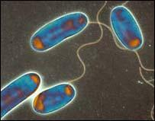

Plate 1.1 Legionella bacteria

(www.bbc.co.uk)

Legionella appear as small rods, faintly staining Gram-negative. They are unencapsulated and non-spore forming with an average size of 0.5-1.0 µm wide and 1.0-3.0 µm long (Barbaree, 1991). Most species exhibit motility through one or more polar or lateral flagella. Legionella cell walls are unique from other Gram-negative bacteria in that they contain significant amounts of branched-chain cellular fatty acids. Legionella require low levels of oxygen for growth (Brenner et al., 1985).

Following the initial identification of L. pneumophila after the 1976 outbreak, numerous species have been discovered within the Legionella genus. Currently, the genus consists of at least 50 species, nine of which can be further divided into serogroups that are genetically homologous but can be differentiated by specific reactivity to antibodies. Currently, 70 serogroups are recognised in the genus, including 16 among L. pneumophila (World Health Organisation, 2007).

3

1.3 Transmission

Legionella exist naturally in water and moist soil. Transmission to humans normally occurs via inhalation or aspiration of droplets of water containing Legionella (aerosols). Person-to person transmission does not occur (Dennis and Lee, 1988, Fitzgeorge et al., 1993, Fields, 1996, Stout and Yu 1997, Belyi, 1999). Wound infection may be caused by direct entry of Legionella into damaged skin, and has been observed after immersion of a wound in contaminated water (Brabender et al., 1983, Lowry et al., 1991).

Transmission hazards have been associated with water distribution systems, cooling towers, humidifiers, whirlpool spas, car wash systems, vegetable water sprayers, and windscreen wiper water. As reviewed by Rathore and Alvarez, (2009), transmission hazards have also been associated with respiratory therapy equipment, nasogastro tubes, dental unit water lines and potting compost (Breiman et al., 1990, Kool et al., 1998, Seenivasan et al., 2005, Kumar et al., 2010, Pravinkumar et al., 2010, www.hcinfo.com, www.nhs.uk).

Disease is mainly caused by the transmitted Legionella residing within phagosomes of alveolar macrophages, where they multiply intracellularly until the cell ruptures. Liberated Legionella then infect other macrophages (Microbiology Third Edition, 1996). Immuno-compromised people are at increased risk of contracting disease from Legionella because their cell-mediated immunity against Legionella is impaired (Greenberg et al., 2006).

4

1.4 Legionellosis

The disease caused by Legionella is called legionellosis. The severity of legionellosis ranges from typical Legionnaires’ disease, an acute form of fulminating pneumonia with low attack rate and relatively high fatality rate (a low attack rate means that a small proportion, less than 5%, of those exposed to the bacteria develop the disease), to Pontiac fever, a mild infection with a high attack rate (a high proportion, usually over 80%, of those exposed to the bacteria develop the disease) (Newsome, 2001).

The majority of legionelloses (70-90%) have been caused by L. pneumophila. Virulence varies between strains of L. pneumophila, for instance some strains could adhere to the respiratory epithelial cells via pili, whereas strains with a mutated gene that encodes for the pili showed reduced adherence in-vitro (Stone and Kwaik, 1998).

Legionella pneumophila serogroups 1 (predominant), 6 and 13 are currently considered to be the main causative agent of legionellosis. (Lo Presti et al., 1997, Fields et al., 2002, Yu et al., 2002, Faris et al., 2005).

A minority of legionelloses are due to other Legionella species, most commonly L. bozemanii, L. cincinnatiensis, L. dumoffii, L. longbaechae and L. micadadei (Stout and Yu, 1997, Spieker et al., 1998, Diederen et al., 2005). L. micadadei and L. dumoffii are the second and third most common species to cause Legionnaires’ disease in children, respectively (Greenberg et al., 2006).

Recognized risk factors for contracting legionellosis include, cigarette smoking, lung disease, immuno-suppression, end-stage renal disease, diabetes mellitus, and advanced and very young age (Rathore and Alvarez, 2009).

Pneumonia is the predominant clinical manifestation of Legionnaires’ disease. After an incubation period of 2 to 10 days, patients typically develop fever, weakness, fatigue, malaise, myalgia, chills. Respiratory symptoms may not be present initially but develop as the disease progresses. Almost all patients develop a cough, which is initially dry and non-productive, but may become productive, with purulent sputum and, in rare cases, haemoptysis. Patients may experience chest pain. Neurologic complaints may include headache, lethargy, confusion, cerebellar ataxia, agitation, stupor. Other symptoms include diarrhoea, nausea, vomiting, and abdominal pain

5

Legionnaires’ disease can manifest as septicaemia which is often diagnosed at autopsy. Extra pulmonary legionellosis is rare. The most common site of extra pulmonary infection in adults is the heart. Manifestations of extra pulmonary legionellosis may also include sinusitis, cellulitis, peritonitis, pyelonephritis, pancreatitis, wound infection, lymphadenopathy, prosthetic valve endocarditis, myocarditis, pericarditis, postcardiotomy syndrome (Sopena et al., 1998, and Rathore and Alvarez, 2009).

Middle-aged and older adults have a higher risk of developing Legionnaires’ disease than do young adults and children. Among children, more than one third of reported cases have occurred in infants younger than 1 year (Rathore and Alvarez, 2009).

The mortality rate in patients with Legionnaires’ disease is 5-80%, depending on certain risk factors. These factors associated with high mortality rates include age (especially those younger than 1 year and elderly patients), predisposing underlying conditions such as chronic lung disease, immunodeficiency, malignancies, end-stage renal disease, diabetes mellitus, nosocomial acquisition, and delayed initiation of specific antimicrobial therapy.

Previous to the Legionnaires’ disease outbreak in 1976, in July 1968 an explosive epidemic of acute febrile illness occurred at a county health department facility in Pontiac, Michigan. Illness characterized principally by fever, headache, myalgia, and malaise affected at least 144 persons, including 95 of 100 persons employed in the health department building. The mean incubation period was 36 hours. Illness was self-limited, generally lasting from two to five days. Secondary cases did not occur in family contacts. A defective air-conditioning system was implicated as the source and mechanism of spread of the causative factor. However, extensive laboratory and environmental investigations failed to identify the etiologic agent. Since these investigations a bacterium identical to the bacterium responsible for Legionnaires’ disease was isolated from guinea pigs exposed to the Pontiac health department building in 1968 as well as from guinea pigs exposed to water from the evaporative condenser (Glick et al., 1977). The illness, named after the town ‘Pontiac’, is an influenza-like illness, typically with an abrupt onset. The incubation period is 24 to 48 hours. Prominent symptoms include fever, malaise, myalgia, cough, and headache. Pontiac fever tends to occur in outbreaks and the infection rate is greater than 90%.

6

The disease is self-limiting, persisting for approximately 1 week (Rathore and Alvarez, 2009).

Legionellosis is a growing problem not only because Legionella are ubiquitous and are present in natural and anthropogenic water systems (Borella et al., 2004), but also because the number of reported infections is on the increase (Montagne et al., 2006).

7

1.5 Reported cases and outbreaks of Legionnaires’ disease

Legionnaires’ disease requires to be reported to most national health protection authorities.

Clinical presentation of Legionnaires’ disease is however non-specific and many Legionnaires’ disease cases are not diagnosed. Many are also not reported. The frequency of Legionnaires’ disease is, therefore, underestimated. For instance, although approximately 1000 cases are reported annually to the Center for Disease Control and Prevention (CDC), Atlanta, USA, it has been estimated that over 25000 cases of the illness actually occur (Stout et al., 1982, Marston et al., 1994, World Health Organization 2007, Newsome, 2001).

Between 1995 and 2005 over 32,000 cases of Legionnaires' disease and more than 600 outbreaks were reported to the European Working Group for Legionella Infections (EWGLI). 35 Countries participating in EWGLI reported in the period of 2005 to 2006 a total of 11980 cases, showing a continued increase in reported cases compared with earlier years, see Table 1.5 below. 377 cases of these 11980 reported cases were fatal, giving a case fatality of 6.6%. (EWGLI data – Legionnaires’ disease in Europe).

8

Year | Cases | No. of countries | Population | Incidence rate per
 |  | contributing data | (millions) | million population
1993 | 1242 | 19 | 300 | 4.1
1994 | 1161 | 20 | 346 | 3.4
1995 | 1255 | 24 | 339 | 3.7
1996 | 1563 | 24 | 350 | 4.5
1997 | 1360 | 24 | 351 | 3.9
1998 | 1442 | 28 | 333 | 4.3
1999 | 2136 | 28 | 398 | 5.4
2000 | 2156 | 28 | 400 | 5.4
2001 | 3470 | 29 | 455 | 7.6
2002 | 4696 | 32 | 467 | 10.1
2003 | 4578 | 34 | 468 | 9.8
2004 | 4588 | 35 | 550 | 8.3
2005 | 5700 | 35 | 551 | 10.3
2006 | 6280 | 35 | 563 | 11.2

Table 1.1 - Total number of reported cases of Legionnaires’ disease and incidence rate per million population 1993 -2006 (EWGLI data – Legionnaires’ disease in Europe).

The total confirmed cases of Legionnaires’ disease in England and Wales reported to the UK Health Protection Agency (HPA) from 1980 to 2009 was 6750 of which 837 were fatal, giving a fatality rate of 12.4% (www.hpa.org.uk).

Reported Legionnaires’ disease cases are categorized as either acquired from sources in the community or from sources in healthcare facilities, hospital-acquired, or cases that are associated with travel.

1.5.1 Community acquired Legionnaires’ disease

The largest outbreak of community acquired Legionnaires’ disease in the world reported to date was in 2001 in Murcia, Spain. More than 800 suspected cases were reported; 449 of these cases were confirmed. Fatality of the reported cases was 1%. (Garcia-Fulgueiras et al., 2003).

9

An outbreak of legionellosis among visitors and participants at a flower show in the Netherlands in 1999 caused 31 deaths and more than 200 cases of the disease (Den Boer et al., 2002).

The total confirmed community acquired cases of Legionnaires’ disease in England and Wales reported to the HPA from 1980 to 2009 was 3418 (www.hpa.org.uk).

Britain’s worst outbreak of community acquired Legionnaires’ disease was in July 2002 when 131 cases were confirmed in Barrow-in-Furness, Cumbria, 4 of these patients died. A further 330 people received hospital treatment for Legionnaires’ disease-like symptoms (www.hcinfo.com).

1.5.2 Hospital-acquired Legionnaires’ disease

It is envisaged that hospital-acquired Legionnaires’ disease cases account for a substantial proportion of cases. Mortality of hospital cases is also higher than that of community acquired Legionnaires’ disease cases due to increased mortality risk factors in hospitals (Marston et al., 1994).

The death rate for patients who develop Legionnaires’ disease while in the hospital is close to 50%, especially when antibiotics are started late (U.S. National Institute of Health and National Library of Medicine Services).

In hospitals with Legionella colonization of the water systems, hospital-acquired legionellosis is frequently endemic, accounting for 10% to 40% of hospital-acquired pneumonias (Muder et al., 1983, Marrie et al., 1991).

The total reported hospital-acquired cases of Legionnaires’ disease in England and Wales from 1980 to 2009 was however only 239, with 99 cases of these as suspected cases of Legionnaires’ disease (www.hpa.org.uk). This suggests that many of the hospital-acquired cases are either not diagnosed or not reported.

In Britain the first reported outbreak of Legionnaires’ disease was hospital-acquired at the Stafford District General Hospital in 1984 and 1985. A total of 68 confirmed cases were treated in hospital and 22 of these patients died. A further 35 patients, 14 of

10

whom were treated at home, were suspected cases of Legionnaires’ disease (O’Mahony et al., 1990).

1.5.3 Travel associated Legionnaires’ disease

In 2008, the European Surveillance Scheme for Travel Associated Legionnaires’ disease (EWGLINET) received reports of 866 cases of travel-associated Legionnaires’ disease, which was slightly below the number of cases reported in 2007. 42 of these cases were fatal. Prior to 2007 there had been a steady increase in the number of cases reported to the scheme since its inception in 1987. This was due in part to improved national surveillance and to an increasing number of countries joining the scheme. There is, however, significant under-ascertainment of Legionnaires’ disease within Europe. Especially among the newer Member States of the European Union which include countries where surveillance for Legionnaires’ disease is less well developed. Therefore, there is potential for case numbers to increase (Ricketts et al., 2010).

The total reported travel-associated cases of Legionnaires’ disease in England and Wales from 1980 to 2009 was 3343. 2880 of these cases were associated with travel outside the UK and 463 cases were associated with travel within the UK (www.hpa.org.uk).

1.5.4 Legionnaires’ disease in long-term care residents

Pneumonia is the leading cause of death and an important cause of transfer to acute care facilities in long-term care residents (Muder, 1998).

There are a number of epidemiological factors that suggest that long-term care residents might be at particular risk for legionellosis should it be present in the environment. Long-term care residents often have swallowing difficulties, and many receive nasogastric tube feedings, predisposing factors to aspiration which is the primary mode of transmission (Seenivasan et al., 2005).

11

1.6 Legionella sources

Ubiquitously found in nature, Legionella exist primarily in environmental waters, although some have been isolated from potting soils and moist soil samples (Fields 1996).

Subsequent to the 1976 outbreak, Legionella species were discovered and isolated in lakes, rivers, and naturally warm water such as hot springs in North America (Tison et al., 1983, Campbell et al., 1984) and in Europe (Bornstein et al., 1989). It was noted that significantly more were isolated from waters whose temperatures lay between 36°C and 70°C. In Europe, they have also been isolated from both surface and ground waters (Newsome, 2001).

Legionella are present in all phases of sewage treatment, and population numbers do not decline significantly through the treatment process (Palmer et al., 1993). States et al., 1989 showed the potential for Legionella growth within municipal systems, which supports the hypothesis that public water supplies may contaminate the plumbing systems of hospitals and other large buildings (States et al., 1989).

Legionella species have been found in these water systems as well as in drinking water at temperatures below 15ºC (Wullings and van der Kooij, 2006). Rusin et al., (1997) suggested that drinking water could be a significant source of infection with Legionella (Rusin et al., 1997). Restrictive values for Legionella in drinking water supplies are however not set as Legionella are considered pathogenic only when inhaled and not when consumed (UK Water Supply (Water Quality) Regulations 2000).

12

1.7 Factors that influence Legionella growth

Various factors that influence and promote Legionella growth have been identified since its initial identification back in 1976.

1.7.1 Physio-chemical factors

Legionella can survive extreme ranges of environmental conditions. It can survive temperatures of 0ºC to 63ºC and has been found in waters at temperatures between 5ºC and 63ºC but significantly more Legionella has been isolated from warm waters at temperatures of 30ºC and above. Legionella can also survive a wide pH range of 5.0-8.5 and a dissolved oxygen concentration in water of 0.2 to 15 mg/l. L. pneumophila grows best at a pH of 5.5 to 6.2 with an oxygen concentration of 6.0 to 6.2 mg/l. However, Legionella species were found in an extremely acidic, predominantly eukaryotic algal biofilm community in Yellowstone National Park, US, at a pH as low as 2.7. Small concentrations of salt (NaCl 0.1 to 0.5%) may also enhance the survival of Legionella and it has been found in cooling systems using seawater (Fliermans et al., 1981, Nguyen et al.,. 1991, Lee and West, 1991, Newsome, 2001, Sheenan et al., 2005).

Metal plumbing components and associated corrosion products are also important factors as these can provide iron and other metals that support the survival and growth of Legionella in plumbing systems (States et al., 1985).

1.7.2 Microbial factors

The growth and survival of Legionella is affected by the presence of other organisms. Studies have demonstrated that Legionella were incapable of growing in sterile water because it required nutrients supplied by other micro-organisms, including bacteria (Wadowsky and Yee, 1983), protozoa (Rowbottom, 1980), and cyanobacteria (Tison et al., 1980).

Protozoa play an important role in the increase and spread of Legionella in anthropogenic water systems and therefore in the occurrence of Legionnaires’ disease (DeClerck et al., 2009). Legionella can infect and grow, similar as with macrophages,

13

inside protozoa to such an extent that the protozoan bursts releasing live Legionella into water systems (Wadowsky et al., 1991, Nahapetian et al., 1991, Cirillo et al., 1994, Kuiper et al., 2004, Berk et al., 2005).
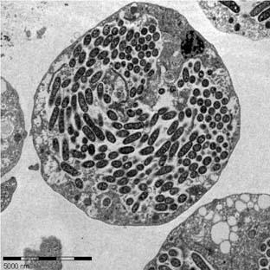

Plate 1.2 Hartmannella vermiformis amoeba filled with L.

pneumophila. (Holland/Özel, Robert Koch Institut)

Kuiper et al., (2004) demonstrated the intracellular growth of L. pneumophila in amoebae, with 25.9% (± 10.5%) of the amoeba, Hartmannella vermiformis, containing L. pneumophila on day 10 and more than 90% containing L. pneumophila on day 14.

Hartmannella vermiformis containing Legionella were also isolated from hospital hot water systems. The amoeba entered these systems through the mains water distribution, open tanks and during maintenance (Rowbottom, 1986, Kilvington and Price, 1990, Barker et al., 1992, Abu Kwaik et al., 1997, Rohr et al., 1998). The protozoan Tetrahymena pyriformis containing L. pneumophila was found in tap water at 35ºC (Fields et al., 1984), and Legionella were also observed multiplying within Acanthamoeba species isolated from drinking water (Michel et al, 1998). Tetrahymena pyriformis was also found to be a habitat for L. longbeachae found in potting soil mixes (Steele and McLennan, 1996).

Protozoa provide not only nutrients for Legionella to grow but also protect Legionella against adverse extracellular or environmental conditions such as high temperatures, drying, chlorine and other biocides. With 1mg/l of chlorine, various bacteria including Legionella, when contained within Tetrahymena and Acanthamoeba, required 60 to 200 times more contact time to kill 99% of the bacterial cells than if they were freely suspended in water (Newsome, 2001), and L. pneumophila was recovered from Acanthamoeba after exposure to 50mg/l of free chlorine for 19 hours (Kilvington and Price, 1990).

14

Cirillo et al., (1994) showed that growth in protozoa also enhanced the ability of L.

pneumophila to enter human cells, and Brieland et al., (1997) found that parasitic L.

pneumophila were more pathogenic than free living L. pneumophila.

Micro-organisms, including Legionella, become attached to surfaces submerged in water and form layers of microbial cells, called biofilms. Biofilms play an important role in the spread of Legionella as they also provide nutrients for their growth and a protective environment enabling them to survive water treatment processes (Kuchta et al., 1993, Lin et al., 1998, Barbeau et al., 1998, Atlas, 1999, Kuiper et al., 2004, Newsome, 2001).

A study carried out in 1994 showed that Legionella were more easily detected from swab samples of biofilm than from flowing water, which suggested that the majority of Legionella were essentially biofilm associated (Rogers et al., 1994).

Legionella cells persisting in biofilms (sessile Legionella) are also much more resistant to disinfectants than the planktonic, free-living, cells (Cargill et al., 1992, Stewart and Costerton, 2001, Tachikawa et al., 2005).

15

1.8 Biofilms

Biofilms are widespread in nature and can be found on the surfaces of pipes in any anthropogenic water system. As well as through attachment to surfaces, biofilms may also form suspended in water, also referred to as ‘floating biofilms’ (Declerck et al., 2007a).

Biofilm formation occurs as a result of the following events:
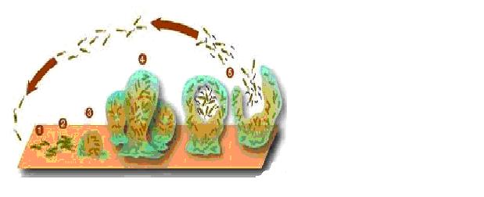

Plate1.3 Biofilm formation. Graphic by Peg Dirckx

and David Davies. 2003 Center for Biofilm
Engineering Montana State University.

- Microbial surface attachment.

- Irreversible attachment

- Maturation stage I

- Maturation stage II

- Dispersion

Microbial attachment is the first step in the colonization of surfaces (1) and precedes the process of consolidation, during which the initially weak adhesive forces are strengthened by exopolymer formation (2). When irreversibly attached, the micro-organisms continue to multiply forming micro-colonies or stacks (3 and 4). Portions of these stacks can shear off and colonize other parts of the system (5) (Denyer et al., 1993).

1.8.1 Factors supporting biofilm formation

Water flowing around biofilms carries nutrients, supporting growth and re-growth, and aiding colonization downstream (Le Chevalier et al., 1988, Morton et al., 1998, Newsome, 2001, Murga et al., 2001).

16

Biofilms are more likely to form where there are areas of low water flow and where water is allowed to stagnate. Biofilms are, therefore, found in anthropogenic water systems in dead-end pipes, which are closed at one end through which no water passes, and dead-leg pipes, through which water only passes when there is draw-off from the fitting (Donlan, 2002).

Liu et al., (2006), found, however, the lowest biofilm-associated Legionella counts with a stagnant flow and the highest counts with a turbulent flow. This could be explained by the fact that turbulent flow results in a higher overall mass transfer rate compared with laminar flow. Mass transfer can be described as the efficiency of suspended solids (nutrient) delivery from the bulk phase (flowing water) to the attached phase (biofilm). A higher mass transfer rate would result in greater particle deposition onto the pipe surface. It could be possible that turbulent flow increases oxygen and nutrient availability at the attachment surface, which in turn may lead to an increase in Legionella under turbulent conditions. The lowest concentration of Legionella recovered from stagnant flow pipes could be explained by the limited availability of oxygen and nutrients under these conditions (Lui et al., 2006).

Temperature also is an important factor in the formation of biofilms. Villanueva et al., (2010) found that although biofilms developed at temperatures as low as 11ºC, formation was faster when the temperatures were higher (Villanueva et al., 2010).

A study by Else et al., (2003) found that when the temperature was held at 30°C there was an increase in values of heterotrophic plate counts per coupon of the materials tested, which were stainless steel, nickel and titanium, but that when the temperature was held at 60°C and 70°C, the counts decreased for all three coupon types to undetectable levels (Else et al., 2003).

Materials such as synthetic rubber (ethylene-propylene rubber), polyethylene and copper are commonly used in water distribution systems. These materials can encourage or resist biofilm formation.

Studies have demonstrated that synthetic rubber encourages biofilm formation (Schofield and Locci, 1985, Keevil et al., 1993, Rogers et al., 1994, BSRIA Technical Note TN 9/96). The persistence of L. pneumophila in water systems was also attributed to their survival within biofilms on rubber materials in taps and showers

17

(Colburne et al., 1984b, Schofield and Locci 1985, Memish et al., 1992). Rubber grommets within a cooling tower probably provided a nidus of infection which caused Legionnaires’ disease in 16 patients of the Glasgow Royal Infirmary. (Timbury et al., 1986). Shock absorbers, installed within water lines to absorb pipe vibration, usually consist of an inflatable balloon that is made of synthetic rubber and that is in constant contact with water (Timbury et al., 1986). Memish et al., (1992) found that these absorbers were a reservoir for Legionella in one hospital, due to Legionella sloughing off from biofims that had formed on the rubber surfaces of the absorbers (Memish et al., 1992).

Biofilms have been found on the surfaces of synthetic rubber lined flexible hoses, which are often used in water systems to connect pipes to taps. Investigations into the occurrence of Legionella in hospitals have shown that some rubber lined flexible hoses were heavily infected with biofilm which included Legionella (Water Regulations Advisory Scheme, January 2006, EPDM (Ethylene Propylene Diene Monomer (M-class) Rubber Flexible Hoses). A 2010 alert by the UK Department of Health highlighted the removal of rubber lined flexible hoses due to the risk of colonization that they present (Estates and Facilities Alert Department of Health Ref. DH (2010) 03. 05/05/10).

Polyethylene also seems to encourage biofilm formation. Biofilm formation was found to be higher on polyethylene pipes than on copper pipes by Van der Kooij, et al., (2005).

Copper seems to resist biofilm formation because copper is naturally biocidal (Schofield and Locci, 1985, Keevil et al., 1993, Rogers et al., 1994, BSRIA Technical Note TN 9/96).

Iron pipes coated with a protective coating of zinc, called galvanized pipes, are also used in water distribution systems. The corrosion rate of the protective zinc layer increases at temperatures in the range of 55ºC to 95ºC, exposing the underlying iron. Iron pipes facilitate the development of tubercles due to the iron hydroxide or loose porous rust slowly transforming into a crystallized form. If other ions like calcium or carbonate are present they make a variety of precipitates that mix in with the iron hydroxide producing a crusty twisted coating which can grow into convoluted shapes (tubercles), see plate 1.4 below. These tubercles can affect the flow of water and

18

because they also absorb organic material they can provide nutrients and a habitat for micro-organisms including Legionella (Haas et al.,1983, BSRIA Application Guide Ag 2/93, Camper, 1996, Geldreich and Le Chevalier, 1999, www.corrosion-doctors.org).
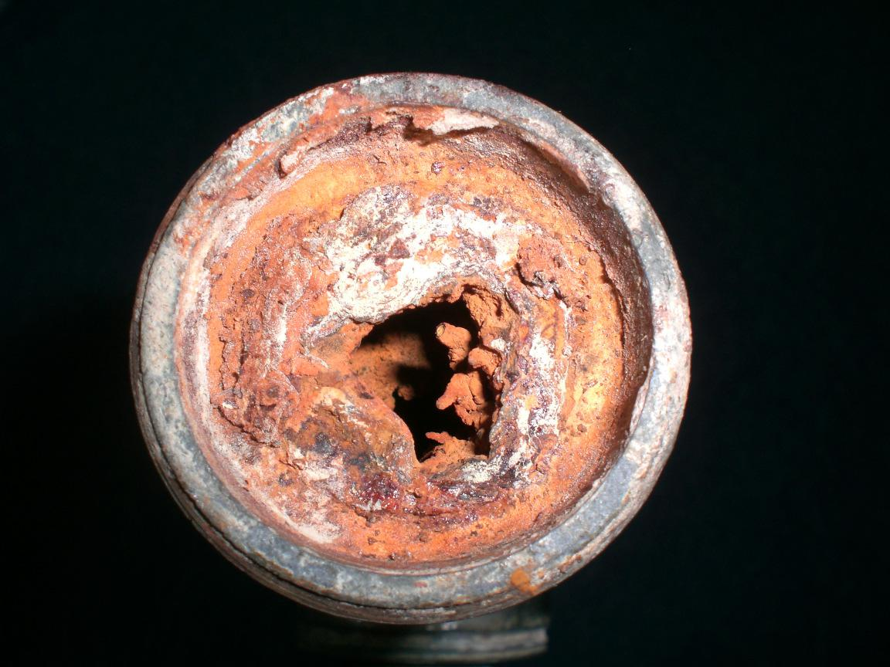

Plate 1.4. Inner surfaces of an eroded galvanized pipe. (ProEconomy Ltd, 2006)

Biofilm formation can be higher on rough surfaces because the ‘valleys’ present can allow microbes to reside in a protected area with reduced shear forces and the surface roughness can provide a surface with increased surface area for bacterial attachment (Donlan, 2002).

Micro-organisms have also been found to attach more rapidly to hydrophobic than hydrophilic surfaces (Donlan, 2002, Flemming and Wingender, 2001a), and corrosion of pipes and scale formation on pipes attracts nutrients which also aids bacterial attachment and biofilm formation (Research meeting, University of Plymouth, 2009).

Biofilm formation can vary depending upon the characteristics of the micro-organisms forming the biofilms, and is influenced by an interbacterial communication mechanism, called quorum sensing (Sauer et al., 2002).

Bacteria can oppose or promote Legionella attachment. For instance, Schofield and Locci, (1985), found that Flavobacteria aided the attachment of Legionella, and Mampel et al., (2006), observed attachment of L. pneumophila to biofilms formed by Empedobacter breve, Microbacterium sp. and Acinetobacter baumanii but not to Pseudomonas species, Corynebacterium glutamicum or Klebsiella pneumoniae biofilms.

19

Biofilm formation is also aided by protozoa grazing the surfaces of biofilms which causes the loss or ‘sloughing’ of parts of biofilms which then colonize other parts of the system (Keevil et al., 1993, Abu Kwaik et al., 1997).

Jass et al., (1995) used a chemostat coupled modified Robbins device to monitor the colonization of soil isolates, P. fluorescens and P. putida, on silastic rubber surfaces. The authors found that P. fluorescens formed confluent dense biofilms in less than 24 hours, whereas P. putida adhered as single cells or microcolonies after the same period (Jass et al., 1995).

20

1.9 Detecting Legionella in water systems

The association of Legionella with protozoa and its occurrence within biofilms, in which they hide, complicates its detection.

The current standard and validated technique for detecting Legionella in water is based on culturing for Legionella (ISO 11731:1998). This technique is however lengthy and complex, and detects only planktonic, free-living, and extracellular Legionella.

Rapid molecular tests for the detection of Legionella Deoxyribonucleic Acid (DNA) have been developed (Mahbubani et al., 1990). Although these tests detect planktonic, sessile, extracellular and intracellular Legionella, nonviable Legionella cells are also detected. Since it is likely that water samples contains nonviable Legionella cells, which were killed by disinfection measures, false-positive readings of Legionella samples are possible which could lead to unnecessary and expensive emergency decontamination procedures (Shih and Lin, 2006).

21

1.10 Models built to examine biofilm formation and Legionella growth on plumbing materials

Schofield and Loci (1985), built a model hot water system to examine the survival of L. pneumophila and the formation of biofilms on different materials, see Figure 1.1. The model consisted of a 1 litre conical flask, which acted as a reservoir and was connected via a flow meter and peristaltic pump to three glass chambers; one chamber contained twisted strips of copper; one contained twisted strips of stainless steel and; one contained glass beads interspersed with aluminium discs. The outflow silicone tubes from the top of the chambers were connected and returned, via a sample port, to the conical flask. The temperature of the reservoir was controlled by placing it in a water bath. When fluid was actively circulating the temperature was kept at 45ºC. During static phases the temperature was allowed to drop to ambient. The water was circulated. Ten weeks after the start of the experiment the apparatus was dismantled and samples were taken for examination. The materials sampled included the rubber plugs on top and bottom of each chamber, the connecting silicone tubing, the glass beads and the copper and stainless steel twisted strips.
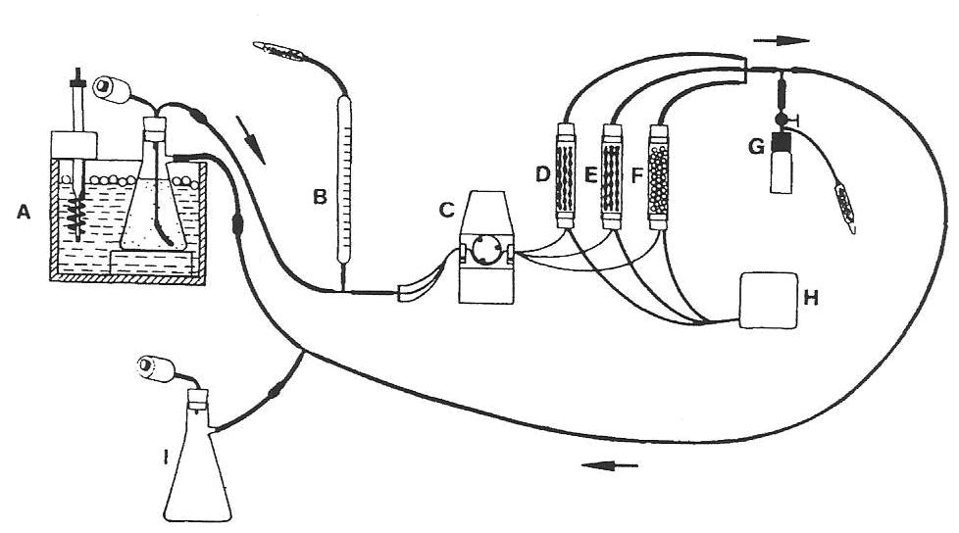

Figure 1.1 Diagram of the model hot water system. A, water bath; B, flow meter; C, peristaltic pump; D, rubber-stoppered glass tube containing copper turnings; E, rubber stoppered glass tube containing stainless steel turnings; F, rubber-stoppered glass tube containing glass beads and aluminium discs; G, sample port; H, air pump; I, return flask. All tubing was a silicone (Schofield and Loci 1985).

The authors observed that mats of cells and slime-like debris were heaviest on natural

rubber and least on copper materials. Abundant growth of L. pneumophila on rubber

22

was also observed. L. pneumophila also appeared to be able to colonize silicone tubing and adhere to stainless steel (Schofield and Loci, 1985).

Keevil et al. (1993) and Rogers et al. (1994) used a model water distribution system, which consisted of two glass vessels linked in series to analyse biofilm formation on plumbing materials, see Figure 1.2. The first (seed) vessel simulated a storage tank, and the second (biofilm) vessel (which was constantly fed by the seed vessel) modelled the distribution system. Biofilms were generated in the second vessel by inserting 1cm² coupons of sterile plumbing materials, commonly used in the construction of water systems, into the culture suspended on titanium wire. The model system was run continuously for the duration of the work. Each experiment had plumbing materials of only one type. The coupons were removed and tested after 1, 4, 7, 14, 21 and 28 days from the onset of each experiment.
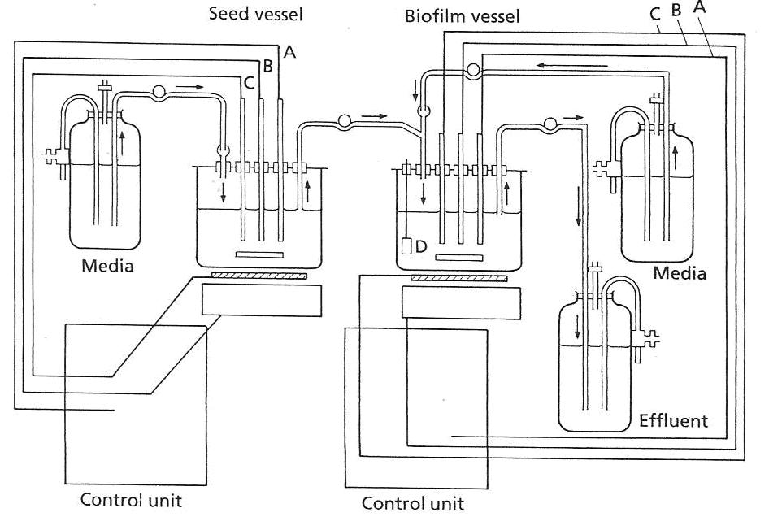

Figure 1.2 Continuous-culture biofilm model. A, pH monitoring; B, oxygen/stirrer control; C, temperature control; D, plumbing material coupon (Keevil et al., 1993, Rogers et al., 1994).

The pH was monitored but not controlled. The temperatures of the vessels were maintained between 20ºC and 60ºC. The temperature was corrected with an external heater pad beneath the fermenters. Dissolved oxygen tension was maintained at 20% of air saturation via feedback control of the stirrer speed.

23

Keevil et al., (1993) found that copper supported sparse microbial growth and Legionella comprised a very low proportion of the population. The low colonization of copper surfaces was presumed to be due to the inhibitory effect of copper ions, either by selectively inhibiting Legionella or by inhibiting the organisms that support their growth. The most prolific biofilms were those that developed on the surface of elastomeric materials. The biofilm covered the entire elastomer surfaces after only 24 hours and contained more than 8.9x10⁶cfu/cm² on latex and 2.7x10⁶cfu/cm² on ethylene propylene rubber. The highest populations of L. pneumophila were found on latex as well (Keevil et al., 1993).

Rogers et al., (1994) found that the lowest concentration of flora was on the stainless steel surface and that the latex and ethylene-propylene rubber were most heavily colonised. Of the plastic materials used, polyethylene appeared to be most heavily colonised (Rogers et al., 1994).

Three full size hot and cold water services rigs were constructed by the Building Services Research and Information Association (BSRIA) in 1996 to evaluate the efficacy of temperature and copper and silver ionization techniques to control Legionella, see Figure 1.3. Each rig replicated the water system of a small home for the elderly. Two of the rigs were fitted with ionization water treatment from silver/copper alloy electrodes and were operating at reduced hot water temperatures; one was filled with hard water and one with soft water. The third rig relied solely upon temperature as disinfection and was filled only with hard water. The cold water system in each rig consisted of a glass reinforced plastic cistern, which served a cold water copper pipework circuit of 30m in length, which included two cold taps and one shower. The hot water system consisted of a vertical hot water storage calorifier of copper construction, which served a hot water copper pipework circuit of 40m length, which included two hot taps and one shower. Copper and glass reinforced plastic coupons were inserted at various locations in each rig. These coupons were regularly removed for biofilm and Legionella analysis.

24

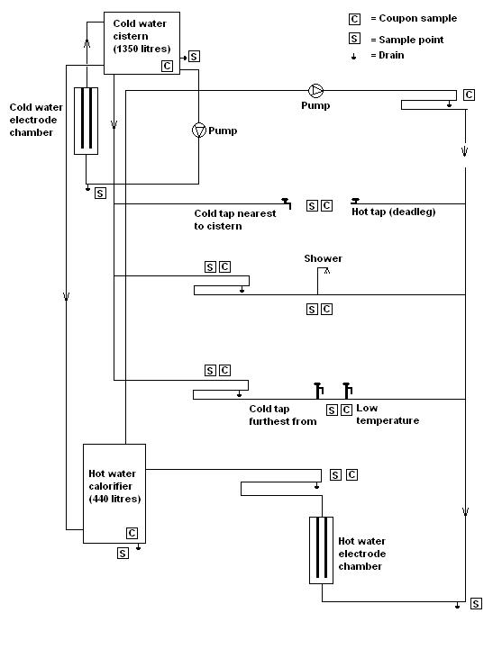

Figure 1.3 Schematic of the BSRIA test facility (BSRIA Technical Note TN6/96).

Legionella and heterotrophic bacteria were recovered from the biofilms that had formed on the copper and glass reinforced plastic coupons before copper and silver ionisation was applied but numbers were only significant on the glass reinforced plastic coupons and not on the copper pipework because this appeared to be naturally biocidal (BSRIA Technical Note TN 9/96).

The effects of stainless steel, polyethylene and copper pipe materials on the promotion of biofilm formation and growth of Legionella were investigated using a model system that simulated domestic consumption of hot tap water at a water temperature of around 37ºC by Van der Kooij et al. (2005), see Figure 1.4. The system included 3 separate identical electric water heaters fed with cold tap water. The water was not

25

stored and the heated water was re-circulated. Each heater fed either two duplicate stainless steel, or copper or polyethylene pipes. These pipes were 5.9m long and included four pipe segments, each with a length of 15cm, for biofilm analysis. The pipe segments were frequently removed for biofilm and Legionella analysis (Van der Kooij et al., 2005).
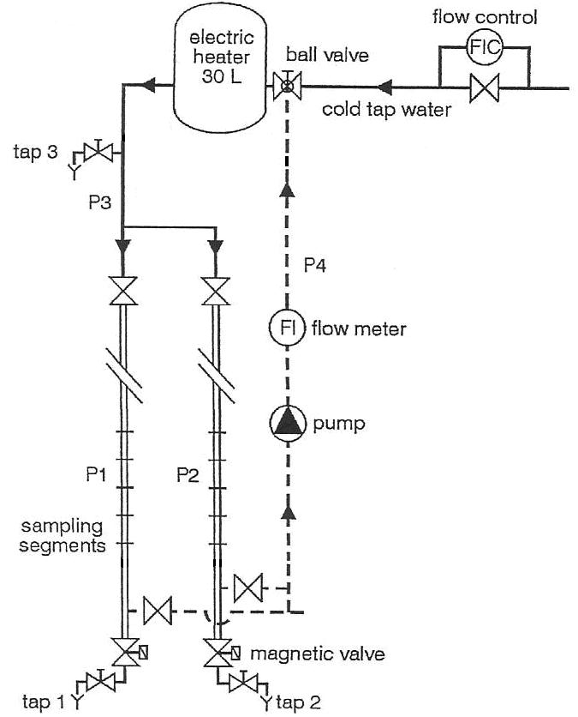

Figure 1.4 Diagram of the model warm water system. P1 and P2, pipes of the test material. P3, PVC-C pipe for the supply of warm water. P4, PVC-C pipe for recirculation. Tap 1 and Tap 2, sampling for collecting water from the pipes, Tap 3, heater outlet and sampling point for collecting water from the heater (van der Kooij et al., 2005).

The results suggested that biofilm formation on the polyethylene surfaces was higher than that on the copper and stainless steel surfaces and that Legionella concentrations in water from the polyethylene pipes were more than 10 times higher than those from the copper pipes. After about 2 years of operating the system the Legionella concentrations from the copper pipes and surfaces were similar to those observed with the stainless steel pipes (Van der Kooij et al., 2005).

26

1.11 Controlling Legionella in hot and cold water distribution systems

The risk from exposure to Legionella can be controlled by not allowing Legionella to proliferate in water systems. However, Legionella contaminate anthropogenic water supplies from the environment, and when these systems are contaminated, preventing proliferation and gaining control of Legionella is difficult because Legionella survive extreme ranges of conditions and grow and are protected in biofilms and in protozoan cells.

Evidence suggested that, once, colonized, anthropogenic water systems, particularly those in large complex buildings and hospitals, retain a relatively constant population of Legionella for many years (Rangel-Frausto et al., 1999, Garcia et al., 2003, Perola et al., 2005).

National legislation in most countries, however, enforces preventing or controlling the risk of legionellosis. The Health and Safety at Work Act (HSWA) and the Control of Substances Hazardous to Health Regulation (COSHH) make this obligatory in the UK.

To comply with the UK legal duties, employers and those with responsibilities for the control of Legionella in water systems of premises should identify and assess sources of risk, prepare a scheme for preventing or controlling the risk, implement, manage and monitor precautions, keep records of the precautions, and appoint a person to be managerially responsible.

27

1.12 UK guidance for controlling Legionella

Practical advice on how to prevent or control Legionella in water systems is given in the Health and Safety Executive’s Approved Code of Practice (L8) (ACoP, (L8), 2000). Specific guidance for National Health Trusts is given in the Department of Health’s Technical Memorandum 04-01 (HTM 04-01, 2006).

Both documents recommend that hot and cold water distribution systems should be designed to aid safe operation by preventing or controlling conditions which permit the growth of Legionella and to allow easy cleaning and disinfection. Water supply quality should always be of equivalent quality as mains water and the materials used should avoid biofilm formation and Legionella growth. Water should flow consistently and stagnation should be avoided.

The documents also recommend that prevention or control of the risk from exposure to Legionella should include the use of water treatment techniques. The techniques recommended for continuous control are:

1.12.1 Temperature control

Temperature control involves storing hot water at 60ºC and distributing it so that it reaches a temperature of above 50ºC within one minute at outlets. Cold water temperatures should be below 20ºC after running outlets for up to two minutes.

Whilst Dennis et al., (1984) reported that L. pneumophila serogroup 1 had a decimal reduction time at 50ºC in-vitro, there is a lack of in-vivo controlled evaluation tests on the efficacy of controlling Legionella at these temperatures.

Controlling Legionella by temperature may also not always be possible or practical. The ACoP (L8), therefore, advises that alternative techniques instead of temperature control can be used as long as proliferation of Legionella is prevented. The HTM 04-01 document also recommends the use of alternative techniques but only together with and not instead of temperature control.

28

The alternative techniques for continuous control described in the ACoP (L8) and

HTM 04-01 documents are:

1.12.2 Chlorine Dioxide

According to the ACoP (L8) levels of 0.5mg/l of chlorine dioxide can, if properly managed, be effective against Legionella in hot water systems.

Chlorine dioxide is an oxidizing biocide with an extremely high oxidation potential, which probably accounts for its potent bactericidal powers through inactivation of critical cell enzyme systems or disruption of cell protein synthesis (Metcalf and Eddy, 1991).

It is a gas in solution that is typically generated on site at the facility. Methods for producing chlorine dioxide include controlled mixing of chemical precursors or electrochemical generation. Although only a limited number of controlled evaluations have been published, chlorine dioxide has been used for water treatment in Europe since the 1940s, and numerous systems have been installed in the US for Legionella disinfection (Lin et al., 2011).

Compared to chlorine, chlorine dioxide has superior penetration into biofilms, it does not produce carcinogenic by-products, and it is less corrosive, (Lin et al., 2011).

Studies have demonstrated that a chlorine dioxide residual at outlets of 0.3mg/l to 0.5mg/l controlled Legionella (Hamilton et al., 1996, Pavey and Roper, 1998, Hill et al., 2000, Hood et al., 2000). It is, however, difficult to maintain such levels, especially, in hot water systems. Sidari et al., (2004) reported that chlorine dioxide residuals decreased with increasing distance from the application point and with raised temperature (Sidari et al., 2004). Higher doses may, therefore, be necessary (Walker et al., 1995, Makin, 1998, Harris and Rendell, 1999) although the Drinking Water Inspectorate only allows a maximum of 0.5mg/l in drinking water (www.dwi.defra.gov.uk). A prolonged time may also be necessary to demonstrate significant reductions in the Legionella positivity rate (Lin et al., 2011).

29

1.12.3 Copper and silver ionization

Copper and silver ionization involves the continuous release of copper and silver ions in water. The ions can be generated either by passing a low electrical current between two pure copper and two pure silver electrodes or by passing a current between copper and silver alloys, usually consisting of 70% copper and 30% silver.

The biocidal efficacy of copper and silver is well documented. The copper ion is thought to be responsible for the cascading effect of copper toxicity in bacterial cells. Suggested mechanisms involve an initial cell membrane compromise, followed by rapid accumulation of copper ions in the bacterial cells, and subsequent protein damage resulting in cell death and DNA degradation (Grass et al., 2011). It was suggested that the silver ion primarily affected the function of membrane-bound enzymes, such as those in the respiratory chain, through binding to thiol groups (Bragg and Rainnie, 1974, McDonnell and Russell, 1999, Uchida et al., 2003). Yamanaka et al., (2005) found, however, that the silver ion also readily infiltrated in the interior of Escherichia coli, rather than residing in the cell membrane area, and that one of the major bactericidal actions of the silver ion was caused by its interaction with the ribosome and subsequent suppression in the expression of enzymes and proteins essential to ATP production (Yamanaka et al., 2005).

Studies carried out in-vitro demonstrated that copper and silver ionization inactivated L. pneumophila with 0.4mg/l copper and 0.04mg/l silver (Landeen et al., 1989, Lin et al., 1996, BSRIA TN6/96). In-vitro studies also demonstrated that biofilm formation was controlled with copper and silver ionization when levels of 0.4mg/l copper and 0.04mg/l silver were maintained (BSRIA TN6/96, Walker et al, 1997, Shih and Lin, 2010).

Evaluation tests of copper and silver ionization installed treating hot and cold water distribution systems of hospitals mainly in the US showed that L. pneumophila was controlled (Liu et al., 1994, Miuetzner et al, 1997, Liu et al, 1998, Stout et al., 1998, Biurrun et al., 1999, Kusnetsov et al, 2001, Stout and Yu, 2003, Chen et al., 2008). A residual effect of copper and silver throughout the treated systems was also observed. (Lui et al., 1994, Lui et al., 1998).

30

The ACoP (L8) and HTM 04-01 documents recommend concentrations for Legionella control of 0.4mg/l copper and 0.04mg/l silver in hot water systems, and 0.4mg/l copper and 0.02mg/l silver in soft water systems. Both documents advise, however, that it can be difficult to maintain silver ion concentrations in hard water systems due to build–up of scale on the electrodes and that the ionization process is pH sensitive, which may need extra water treatments. The documents also suggest that it is difficult to maintain silver ion concentrations above a pH of 7.6.

Although Lin et al., (2002), showed that there was no impact by hardness ions, calcium and magnesium, on the biocidal efficacy of copper and silver ions, calcium and magnesium ions can convert in water with a high pH into insoluble particles, which can precipitate and cause rapid scale formation on the copper-silver electrodes, potentially obstructing copper and silver ions release and reducing the presence of copper and silver ions in the water (Lin et al., 2002).

Lin et al., (2002) demonstrated that a high pH had little effect on the Legionella inactivation action of the silver ions and that at a pH as high as 9 only the copper ions, at 0.4mg/l, failed to kill L. pneumophila, achieving only a 10-fold reduction in 72 hours. There is, however, a lack of studies on the influence of a pH above 7.6 on the efficacy of copper and silver ionization in controlling Legionella in hot and cold water distribution systems (Lin et al., 2002).

Copper and silver ions are positively charged ions (cations) and are attracted to negatively charged ions (anions) in water, which can result in the formation of insoluble chemical compounds, potentially resulting in less biocidal efficacy. A chloride ion is an anion that enters water distribution systems via treatment processes in which chlorine or chloride is used. It also enters water systems from run-off containing road de-icing salts, the use of inorganic fertilizers, landfill leachates, septic tank effluents, animal feeds, industrial effluents, irrigation drainage, and seawater intrusion in coastal areas (www.who.int).

Lin et al., (2002) also demonstrated that as the chloride concentration in solution increases, silver complexation reduces the available silver cations by 56% at 15mg/l

31

chloride to 26% at 50mg/l chloride. The authors suggested that it was possible that chloride concentrations in water may decrease the availability of silver cations and reduce its biocidal potential (Lin et al., 2002). Studies evaluating the affect of chloride on the efficacy of copper and silver ionization in controlling Legionella in hot and cold water distribution systems are, however, lacking.

One French hospital reported failure of copper and silver ionization (Blanc et al., 2005). According to Lin et al., (2005) this could have been due to a phosphate compound that was added to the water system to control corrosion, which may have interfered with the efficacy of ionization (Lin et al., 2005). Although a reduction of the biocidal effect of copper and silver has been reported when copper and silver were complexed by phosphates in-vitro (Wuhrmann and Zobrist, 1958, Zevenhuizen et al., 1979, Landeen et al., 1989), there is a lack of studies on the influence of phosphates on the efficacy of copper and silver ionization in controlling Legionella in hot and cold water distribution systems.

In two German hospitals copper and silver ionization systems were unable to control Legionella. Possible resistance of Legionella against the metal ions was suggested as the reason for the lack of control (Rohr et al., 1999, Mathys et al., 1999). According to Lin et al., (2011), the lack of control in the hospitals was more likely due to the concentration of the silver ions being below the recommended levels at 0.01mg/l (Lin et al., 2011).

Long term treatment with copper and silver ions could, however, theoretically result in the development of resistance to these ions, although Chopra, (2007), suggested that copper and silver resistance is metabolically expensive for bacteria (Chopra, 2007), which could make resistance less likely. Although studies have demonstrated development of resistance in Salmonella, Pseudomonas, Enterococcus, Klebsiella, and E. coli (McHugh et al., 1975, Bridges et al., 1979, Haefeli et al., 1984, Kaur and Vadehra 1986, Solioz and Odermatt 1995, Silver, 1996, Gaillard and Webb, 1997, Gupta et al., 1999, Gupta, et al., 2001), resistance has not yet been demonstrated in Legionella. Studies on Legionella resistance affecting the efficacy of copper and silver ionization in controlling Legionella in hot and cold water distribution systems are, however, lacking.

32

Kuchta et al., (1995) showed that copper and silver ions inhibit the amoeba H. vermiformis. Rohr et al., (2000) reported that the amoebas T. pyriformis and H. vermiformis were inactivated by 0.1mg/l of silver and 1mg/l of copper. Cassells et al., (1995), reported a T₉₉ value of 3.9 minutes (exposure time required to achieve a 99% reduction) of the amoeba Naegleria fowleri by 0.8mg/l copper and 0.08mg/l silver with 1mg/l of free chlorine (Cassells et al., 1995).

At present, each country in Europe specifies individual maximum permitted copper and silver levels for water intended for human consumption. These levels apply until maximum concentration values for copper and silver are given in the European Council Biocidal Products Directive (98/8/EC).

The UK Water Supply (Water Quality) Regulations 2000 and the European Council Directive 98/83/EC, which currently govern the maximum permitted levels of a range of substances in water intended for human consumption in the UK, revealed a surprising situation in the case of silver as the regulations and the directive do not specify a maximum concentration value for silver. Theoretically, this state of affair allows any level of silver to be used. It could also mean, however, that previous permitted levels should be applied, which would be, if silver is used in a water treatment process, 0.08mg/l (The UK Water Supply (Water Quality) Regulations 1989). Levels for copper are much more clearly defined, with a maximum permitted level of 2mg/l being specified in the UK Water Supply (Water Quality) Regulations 2000.

The US Environmental Protection Agency (EPA) has set maximum concentration levels for drinking water of 1.3mg/l for copper and 0.1mg/l for silver (Lin et al., 2011).

The World Health Organisation (WHO) gives a guideline value for copper in drinking water of 2mg/l. No specific guideline value for silver is given because there are no adequate data with which to derive a health-based guideline value in drinking water. The guidelines advise, however, that silver, up to 0.1mg/l, in drinking water gives a total dose over 70 years of half the human no observable adverse effect level

33

(NOAEL) of 10g, and, therefore, could be tolerated without risk to health (WHO Guidelines for Drinking Water Quality, 2011).

Being biocidal, copper and silver fall within the scope of the European Council Biocidal Products Directive (98/8/EC) and evidence has to be presented to the Council that they do not pose significant risk to humans, animals or the environment.

Task Forces were created to share the costs for the preparation and evaluation of technical dossiers specifying copper and silver toxicity and assessing the risk of exposure to copper and silver. Dossiers were submitted to the relevant authorities for evaluation. These authorities are currently assessing the dossiers so that an acceptable copper and silver value can be determined, which will be then be published in the European Council Biocidal Products Directive (98/8/EC).

However, due to its extensive use in the photographic industry, considerable research has already been carried out upon the effects of silver in the environment. Although laboratory investigations have indicated that it is potentially very toxic with acute toxicity values of 0.023mg/l to 0.357mg/l for saltwater invertebrates, it seems to have little actual impact upon organisms in an ecosystem. This could be due to its readiness to form complexes with a wide variety of substances, so reducing its availability for absorption, which reduces toxicity and the biocidal effectiveness of silver in an ecosystem. Bioaccumulation data also suggest that it is not concentrated in species to any great extent. Copper shows a higher level of bioaccumulation, although again it does not seem to be regarded as presenting any significant risk to the environment. There is also no indication of substantive biomagnification occurring in the case of either metal.

When assessing the level of toxicity of copper and silver to humans, instances of fatalities caused by acute copper poisoning have been recorded, although doses required were considerable. Instances of acute silver poisoning, however, are unknown. Cases of chronic copper poisoning are rare, whilst for silver the only known long term effect of ingesting quantities of the element is argyria, a condition in which skin and hair are heavily discoloured by silver in the tissues. Silver in particular seems to be readily excreted from the body, only a small percentage of silver is absorbed, retention rates in humans and laboratory animals range between 0% and 10%. The

34

evidence available indicates that neither copper nor silver is carcinogenic or mutagenic, despite extensive exposure via water pipes in the former and therapeutic and industrial use of the latter. With regard to teratogenicity, the few studies done for silver suggest that it is not toxic in this respect. More studies have been done on copper but results are conflicting (Bedford, 2003).

35

1.12.4 Ozone (O₃) and Ultraviolet Light (UV)

According to the ACoP (L8) and HTM 04-01 documents Ozone (O₃) and UV light are not intended to be dispersive and are designed to have their effect only at or very close to the point of application.

Ozone (O₃) is a powerful oxidizing agent, far more powerful then oxygen (O₂). It is generally believed that bacterial kill through ozonation occurs directly because of cell wall disintegration (cell lysis). Ozone is generated either from air or pure oxygen when a high voltage is applied across the gap of narrowly spaced electrodes. It is, however, chemically unstable and decomposes rapidly to oxygen after generation and must be generated on-site. (Metcalf and Eddy, 1991).

The effect of ozonation of supply water for one wing of an unoccupied hospital building which had positive cultures for L. pneumophila from multiple potable water fixtures was studied by Edelstein et al., (1982). Although mean ozone residual concentrations of 0.79 mg/l eradicated L. pneumophila from the fixtures, the authors suggested that whether or not ozone could be considered to be an effective biocide to use for the eradication and continuous suppression of L. pneumophila in a potable water system was not answered because L. pneumophila was also eradicated from by non-ozonated water in the control wing fixtures (Edelstein et al., 1982).

In-vitro studies developed on a 38 litres plumbing system using ozone, among other biocides, was evaluated by Muraca et al., (1986). The studies showed effectively control of L. pneumophila by a residual concentration of 1 to 2 mg/l of ozone and the data suggested that ozone could potentially remove L. pneumophila in a large water distribution system. However, the authors also suggested that because of the rapid decomposition of the ozone residual in water, its main utility may be limited as a supplemental disinfectant (Muraca et al., 1986).

Several authors have also noted that corrosion could also be a potential problem with the application of ozone (Bird, 1987, Keenahan, 1990, Ford, 1991), and Newsome, (2001) suggested that the major problem with ozone was poor penetration to all parts of the water system (Newsome, 2001).

36

UV light of wavelength 254nm can destroy bacteria. Legionella pneumophila has been reported to be sensitive to UV dosages of 2500-7000µW-s/cm² at 254nm (Antopol and Ellner, 1979).

Muraca et al., (1986) showed that UV irradiation at 30000µW-s/cm² at 254 nm produced a 5 log decrease in the concentration of L. pneumophila within 20 minutes. (Muraca et al., 1986). Makin and Hart, (1992) found that during an 8-month period of 254 nm UV lamps being lit, no Legionella or amoebae were found in the water tested at one shower (Makin and Hart, 1992).

Franzin et al., 2002 demonstrated that UV irradiation was useful to protect a water system but only in a small area. UV irradiation was found to be effective only at the point immediately after the UV light lamps but Legionella persisted especially at the furthest point from the UV light. Because of the lack of residual activity, the authors recommended combining UV irradiation with other methods of disinfection (Franzin et al., 2002).

1.12.5 Intermittent disinfection of hot and cold water distribution systems

The ACoP (L8) and HTM 04-01 documents recommend that hot and cold water distribution systems are cleaned and disinfected thermally or chemically when inspections consider it to be necessary, if the system or part of it has been substantially altered or entered for maintenance purposes in a manner which may lead to contamination, and during or following an outbreak or suspected outbreak of legionellosis.

Thermal disinfection is recommended to be carried out by ensuring that the temperature at a calorifier is high enough so that the temperatures at the outlets do not fall below 60°C. Each outlet should also be run sequentially for at least five minutes at above 60ºC. The risk of scalding should be considered and particular care should be taken to ensure that water services are not used, other than by authorised personnel, until water temperatures have dropped to their normal operating levels.

As well as disinfecting water systems thermally, the ACoP (L8) and HTM 04-01 documents recommend that disinfection may also be carried out using oxidizing

37

chemicals such as chlorine dioxide, chlorine, and bromine. It is recommended that all parts of the system are disinfected and not just those which are readily accessible.

When chlorine is used the free residual level in the cold water storage tank should be between 20 and 50mg/l, which should be allowed to flow to all parts of the system by successively opening the outlets in the system until there is a smell of chlorine. The outlets should then be closed for an appropriate period, which depends on the chlorine concentration – from at least one hour at 50mg/l to at least two hours at 20mg/l. The chlorine concentration needs to be monitored throughout the disinfection process and after disinfection the system should be thoroughly flushed.

The ACoP (L8) and HTM 04-01 documents point out that because chemical disinfection is hazardous it may only be carried out by trained personnel and should be closely supervised. All building occupants should also be warned.

The ACoP (L8) also advises that biodispersants may be needed to remove organic fouling from pipework and that chemical descaling may also be necessary.

The HTM 04-01 document recommends that after disinfection, when water is run to waste into a natural watercourse, or a drain leading to it, it should be de-chlorinated using either sulphite or bisulphite or meta-bisulphite to avoid contamination.

1.12.6 Point-of-use filtration

The HTM 04-01 document briefly discusses using point-of-use filters in the operational considerations part of the document.

The risk of exposure to Legionella in water systems can be controlled by attaching 0.2µm filters to outlets (Salvatorelli et al., 2005).

38

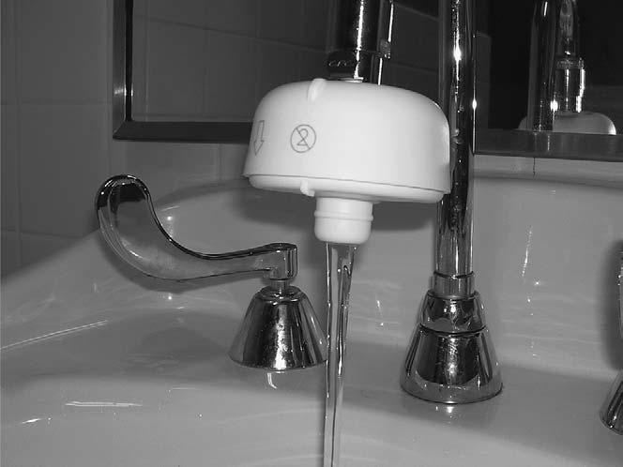

Plate 1.5 Outlet with point-of-use water filter attached (Sheffer et al., 2005)

Results of a study conducted on a water system of a hospital building in the US, colonized with L. pneumophila, suggested that point of use filters can prevent exposure of high risk patients to waterborne bacteria (Sheffer et al., 2005).

The HTM 04-01 document highlights that it is feasible for bacteria to colonize the filter material. It is, therefore, recommended to replace the filters at appropriate intervals in accordance with the manufacturer’s recommendations, typically at least once a month.

39

- AIMS AND OBJECTIVES

Hospital-acquired Legionnaires’ disease is linked to the presence of Legionella in hospital water systems.

Results of studies suggest that cases of hospital-acquired Legionnaires’ disease are reduced by the implementation of copper and silver ionization systems.

Measures to control Legionella in hospital water systems in the UK are recommended in the HTM 04-01 documents. Little data is however available on the efficacy of these measures.

Although the HTM 04-01 document recommend using copper and silver ionization as an alternative measure, it is recommended to only be used together with and not instead of temperature control. Temperature control is, therefore, seen by UK National Health Trusts as the main control method.

The overall aim of this project is, therefore, to investigate the efficacy of controlling Legionella by applying copper and silver ionization in UK hospital water systems and to examine efficacy by applying the HTM 04-01 recommended temperatures, taking into consideration the formation of biofilms on plumbing materials that are commonly used.

The objectives of this project are:

- To study the efficacy of copper and silver ionization systems in controlling Legionella in water systems of 10 hospitals in the UK.

- To study the efficacy of maintaining hot water temperatures above 50ºC after running hot outlets for 1 minute in controlling Legionella in water systems in the UK.

- To study the efficacy of maintaining cold water temperatures below 20ºC after running cold outlets for 2 minutes in controlling Legionella in water systems in the UK.

- To design and build small scale rigs to simulate circulating water flow systems in copper and polyethylene piping to compare:

  - The growth of Legionella.

40

  - The efficacy of controlling Legionella with elevated temperatures.

  - The efficacy of controlling Legionella with copper and silver ionization.

- To evaluate the impact of chloride and phosphate on the efficacy of copper and silver ionization in controlling Legionella in 10 hospital water systems in the UK.

- To assess the growth of biofilms on plumbing materials commonly found in hospital water systems in the UK using a Robbins device.

41

- MATERIALS AND METHODS

3.1 Evaluation studies in UK hospitals

Studies on the efficacy of copper and silver ionization in controlling Legionella in water distribution systems of hospitals in the UK were carried out. These studies were conducted by contractual arrangement with these hospitals for control of Legionella.

Results of Legionella analyses that may have been carried out outside the contractual arrangement with these hospitals before the copper and silver ionization systems were activated were not available.

One set of samples was taken before activation of the systems from each hospital, which were analysed for Legionella. Temperatures at the outlets were recorded whenever samples were taken. The outlets selected were outlets that were identified as being at risk of Legionella contamination and outlets that were known to be contaminated. At least double the number of outlets was tested before activation of the copper and silver ionization systems than after activation.

The probability of contamination at outlets at which Legionella were found before the copper and silver ionization systems were activated would be higher than at outlets at which no Legionella were found. Also due to financial limitations in the number of samples to be analysed, the Legionella contamination at outlets at which Legionella were found before activation was, therefore, primarily monitored after activation.

The water system near to outlets at which Legionella persisted after activation was also investigated by taking samples for Legionella analysis from outlets close to the Legionella contaminated outlets.

Table 3.1 below shows the approximate number of beds that accommodated these hospitals, the date the copper and silver ionization systems were activated, the number

42

of outlets that were sampled before the systems were activated, and the number of outlets that were sampled on a monthly basis after these systems were activated.

Study | Approximate | Date system | Number of outlets | Number of outlets | Frequency of
 | number of |  | sampled before | sampled after
hospital |  | commissioned |  |  | sampling
 | beds |  | commissioning | commissioning
1 | 800 | 11/09/2007 | 46 | 21 | Monthly (21 outlets)
2 | 350 | 10/01/2008 | 30 | 15 | Monthly (15 outlets)
3 | 70 | 04/02/2008 | 20 | 10 | Monthly (10 outlets)
4 | 100 | 08/04/2008 | 12 | 6 | Monthly (6 outlets)
5 | 550 | 25/07/2008 | 51 | 25 | Monthly (20 outlets)
6 | 550 | 06/10/2008 | 60 | 25 | Monthly (13 outlets)
7 | 150 | 25/11/2008 | 26 | 20 | Monthly (13 outlets)
8 | 200 | 27/04/2009 | 45 | 22 | Monthly (21 outlets)
9 | 100 | 03/08/2009 | 30 | 15 | Monthly (15 outlets)*
10 | 850 | 21/12/2009 | 60 | 30 | Monthly (30 outlets)

*- From September 2010 onwards samples were taken once every two months from 15 outlets and once a month from 6 outlets.

Table 3.1 – Study hospitals - Size, number of sample outlets and sampling frequencies.

The copper and silver ionization systems installed in these hospitals were designed and manufactured by ProEconomy Limited, Bedfordshire, UK.

43

3.1.1 The Orca copper and silver ionization system

With the Orca copper and silver ionization system, see Plate 3.1, water flows through the turbine of a flow sensor, which sends a signal to a control unit. The control unit then passes a low direct current between two 99.9% copper and two 99.9% silver electrodes, housed in electrode chambers, called ‘Orca pods’. This causes the release of copper and silver ions into the flowing water. To ensure that the necessary levels of copper and silver are released by the system, the system has been designed to deliver automatic adjustment taking into account variable flow rates and water qualities. Copper and silver levels, electric current settings, and flow rates can be interrogated remotely. The system is commonly installed on the mains water pipe.
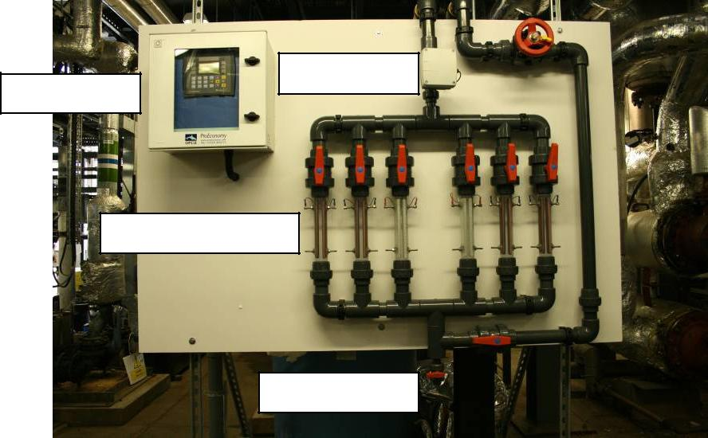

Flow sensor
Control unit

Electrode chambers

Draw off point

Plate 3.1 The Orca copper and silver ionization system (ProEconomy Ltd)

Potential formation of scale on the electrodes, which can obstruct the release of copper and silver ions in hard water, is prevented with the Orca system by using pure copper and pure silver electrodes instead of copper/silver alloys. This provides controlled release of the copper and silver ions by being able to separately increase or reduce the electrical current output, which is not possible when copper/silver alloys are used. Also, the polarity of the electrodes is automatically switched from anode to cathode and visa versa, which results in cations, such as calcium and magnesium ions, that may have become stuck on the on the surface of the cathode, desorbing from its surface when the polarity switches to anode.

44

3.1.2 Sampling and system maintenance procedures

Samples were taken before the copper and silver ionization systems were activated and once a month after activation of the systems from pre-selected outlets of the water distributions systems of the hospitals studied. These samples were analyzed by a UKAS accredited laboratory for Legionella, copper and silver.

The outlets from which the samples were taken were either identified, through risk assessments conducted by the hospitals, as being at risk of Legionella contamination or were known to be contaminated with Legionella, therefore, potentially presenting a risk of legionellosis in patients. Outlets identified through risk assessment as being at risk of Legionella contamination were mostly outlets that were not or infrequently used, cold outlets at which temperatures were not maintained below 20ºC, and hot outlets at which temperatures were not maintained above 50ºC.

When samples were taken, the type of outlet that was sampled from was recorded, showing if it was a single hot or cold, a mixer, a shower, or an assisted bath outlet. When rubber lined flexible hoses and mixing valves were attached to the outlets, this was also recorded.

The sample for Legionella analysis was taken after running the outlets for 1 to 2 minutes in a sterilized one litre plastic bottle which also contained 1ml of sodium thiosulfate to de-chlorinate the sample. After the sample for Legionella analysis was taken, the sample for copper and silver analysis was collected in a 125ml plastic bottle containing 1ml of nitric acid to ensure that the metal content stayed in solution, free from particulate matter. After the sample for copper and silver analysis was taken, the temperature was recorded using a non-contact TN1 infrared thermometer, positioned as close to the running water as possible.

The creation of aerosols was avoided when known Legionella contaminated outlets were sampled by attaching a clean hose between the outlet and its drain, and, where this was not possible, by running the outlet slowly, avoiding splashing. Samples from showers that were known to be contaminated with Legionella were taken either by dismantling the showerhead and attaching a clean hose between the outlet and its drain, or, when this was not possible, by cutting a corner of a food grade plastic bag,

45

inserting the shower head into the plastic bag, securing the bag closed around the shower head with an elastic band, and then running the water slowly into the sample bottle, avoiding splashing.

The Legionella, copper and silver samples were placed in a carton box, away from UV light. All samples were then transported to a UKAS accredited laboratory for analysis.

When Legionella were found, the hospitals were advised to flush the contaminated outlet, avoiding the creation of aerosols, to encourage the copper and silver levels and to avoid water stagnation. Re-samples were also taken for copper, silver and Legionella analysis immediately after opening the contaminated outlet and also after running it for ten minutes. This was in-line with the recommendations given in the ACoP (L8) and the HTM 04-01 documents, and the British standard 7592:1992.

The copper and silver ionization systems were checked monthly. Where necessary, the electrodes were cleaned and re-gapped, worn electrodes were replaced with new ones, and the control unit settings were adjusted.

Samples to determine the pH, chloride, and phosphorus levels in the water supply of the hospitals were taken. These samples were taken where the water entered the hospitals, and were also analyzed by a UKAS accredited laboratory.

The pH samples were taken in a clean and empty plastic 150ml bottle. The samples for chloride analysis were taken in a clean and empty plastic 1 litre bottle and the samples for phosphorus analysis were taken in a plastic 125ml bottle containing 1ml of nitric acid to ensure that the phosphorus content stayed in solution, free from particulate matter.

46

3.1.3 Study hospital 1

Study hospital 1 was a large site consisting of many buildings, built in the 1960s and modernized over the years. The hospital accommodated approximately 800 beds.

The hospital’s water distribution system was complex and extensive. The temperature regime, as recommended in the ACoP(L8) and HTM 04-01 documents, was applied as the sole Legionella control measure but it proved to be difficult to maintain hot water temperatures above 50ºC and cold water temperatures below 20ºC in some parts of the hospital due to cross heating and poor insulation.

Approximately 1000 mixing valves had to be fitted to hot outlets to reduce the hot water temperatures to non-scalding temperatures, below 45ºC. Water below 45ºC and the debris that built up in the mixing valves was, however, considered ideal for Legionella proliferation. Rubber lined flexible hoses and rubber fittings were also attached to several outlets and water stagnation was possible due to poor use of outlets and ward closures, which was also considered ideal for Legionella proliferation.

The water was supplied to the site via a mains pipe and was passed to two large concrete tanks from which water was provided to the whole site. The storage capacity of these tanks was approximately 600000 litres. The water was not softened.

One copper and silver ionization system with nine copper electrode chambers and nine silver electrode chambers was installed treating the incoming mains supply water, see Plate 3.2.

The system was installed on the incoming mains pipe before the two storage tanks.

The systems were commissioned on the 11th September 2007.

47

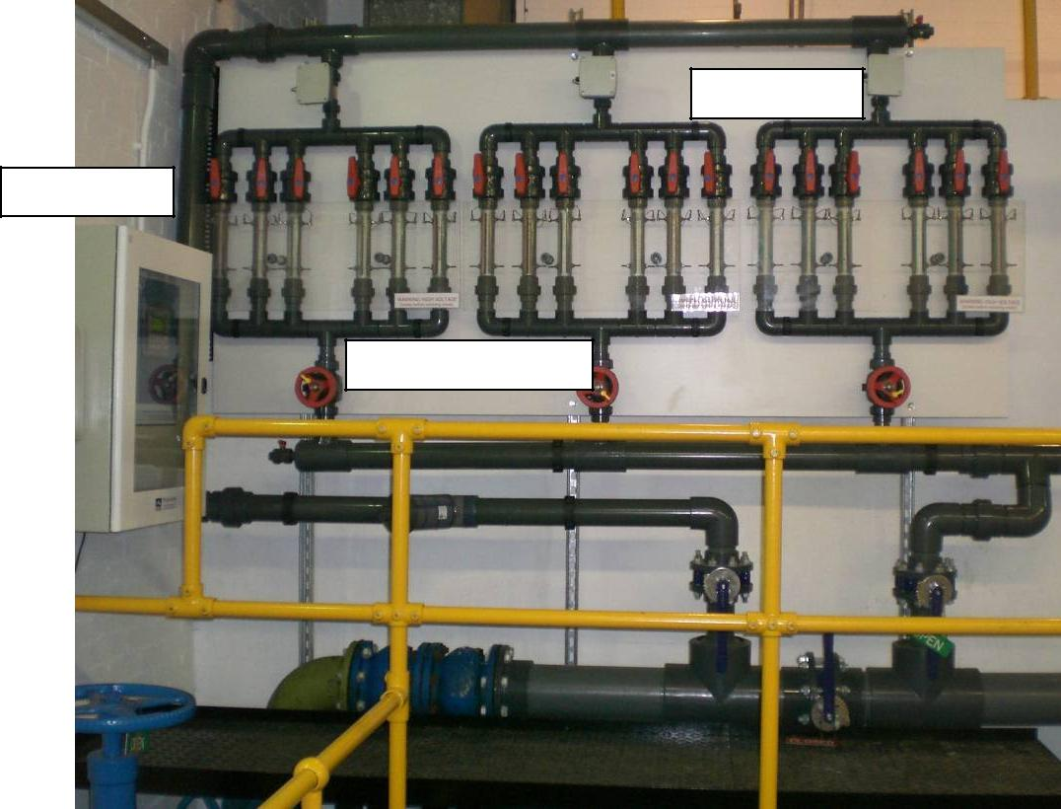

Flow sensors

Control unit

Electrode chambers

Plate 3.2. Photograph of the copper and silver ionization system installed in study hospital 1

The copper and silver ionization system installed was a digital system. The system was activated when the storage tanks were filling up with water. The system, therefore, released copper and silver ions into the storage tanks. The electrical currents adjusted automatically to the different flow rates and could also be manually adjusted to either increase or reduce the silver and copper ions output. The polarity of the electrodes reversed automatically, from anode to cathode, every fifty seconds to prevent scale build-up on the surfaces of the electrodes.

On the 05th September 2007, before the system was activated, samples were taken from 46 outlets.

On the 05th October 2007, after the system was commissioned, samples were taken from 21 outlets at which Legionella were found in the samples taken before the system was commissioned.

Samples were taken monthly from the 05th October 2007 onwards from 21 outlets.

48

3.1.4 Study hospital 2

Study hospital 2 was a smaller site with newer buildings than study hospital 1. The hospital accommodated approximately 350 beds.

As well as with study hospital 1, the temperature regime was applied as the sole Legionella control measure, which also proved to be difficult to maintain. Mixing valves had to be fitted and rubber lined flexible hoses and rubber fittings were attached to several outlets. Water stagnation was also possible due to poor use of outlets and ward closures. This was considered ideal for Legionella proliferation.

The water was supplied to the site via a mains pipe and was passed to two small break tanks, which prevented contamination of the mains water supply by incorporating an air gap which stopped water from flowing backwards into the mains. From these break tanks the water was passed to four underground concrete tanks, which supplied approximately 26 roof tanks scattered around the site. The water was again not softened.

One copper and silver ionization system, with eight copper electrode chambers and four silver electrode chambers, was installed to treat the incoming mains supply. The system was installed on the incoming mains pipe before the ‘break’ tanks, see Figure 3.1. The system was also digital, similar to the system installed in study hospitals 1, and consisted of two control units controlling two flow sensors. The system was commissioned on the 10th January 2008.

49

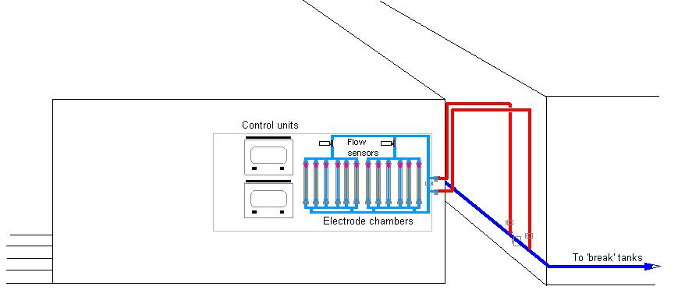

Figure 3.1 Schematic drawing of the copper and silver ionization installation in study hospital 2

Before the system was activated samples were taken from 30 outlets.

On the 04th February 2008, 3 weeks after the system was commissioned, samples were taken from 15 outlets. Six of these outlets were outlets at which Legionella were found in the samples taken before the system was commissioned.

Samples were taken monthly from the 04th February 2008 onwards from 15 outlets.

50

3.1.5 Study hospital 3

Study hospital 3 was a new hospital commissioned in 2007. The hospital accommodated 70 beds over two floors. The temperature regime was the sole method used to control Legionella in the water system.

The water system was less complex compared to study hospitals 1 and 2 but it was again difficult to maintain temperatures, particularly, in the cold water system and mixing valves had to be fitted to reduce hot water temperatures to non-scalding temperatures. Rubber lined flexible hoses and rubber fittings were again attached to several outlets. This was considered ideal for Legionella proliferation.

As with study hospital 1, the water was supplied to the site via a mains pipe and was passed to two tanks from which water was provided to the whole site. The capacity of these tanks was 20000 litres each. The water was again not softened.

One copper and silver ionization system, with two copper electrode chambers and two silver electrode chambers, was installed to treat the incoming mains supply. The system was installed on the incoming mains pipe before the two tanks, see Figure 3.2. The system was digital, similar to the systems installed in study hospitals 1 and 2. The system was commissioned on the 04th February 2008.
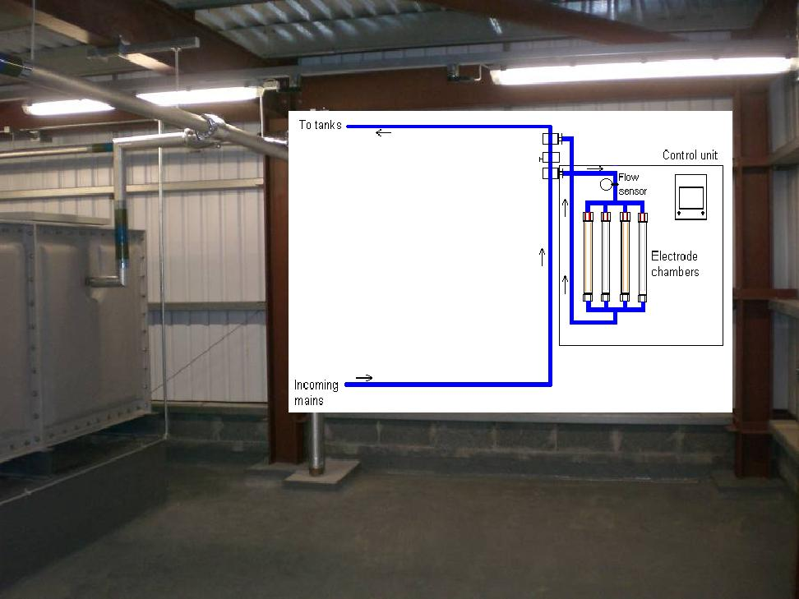

Figure 3.2 Schematic drawing of the copper and silver ionization installation in study hospital 3.

51

On the 04th February 2008, before the system was activated, samples were taken from 20 outlets.

On the 06th March 2008, after the system was commissioned, samples were taken from 10 outlets. Three of these outlets were outlets at which Legionella were found in the samples taken before the system was commissioned.

Samples were taken monthly from the 06th March 2008 onwards from 10 outlets. The outlet points were rotated from June 2010.

52

3.1.6 Study hospital 4

Study hospital 4 was built in the 1980s and accommodated approximately 100 beds. The temperature regime was again the sole method used to control Legionella and the advocated temperatures were being maintained. Mixing valves had to be, however, fitted to reduce hot water temperatures to non-scalding temperatures and rubber lined flexible hoses and rubber fittings were attached to several outlets, which were considered ideal for Legionella proliferation.

The water was supplied to the site via a mains pipe and was passed to two tanks from which water was provided to the whole site. The capacity of each tank was approximately 20000 litres. The hot water was de-scaled by electronic de-scaling devices.

One copper and silver ionization system, with three copper electrode chambers and one silver electrode chamber, was installed to treat the incoming mains supply. The system was installed on the incoming mains pipe before the two tanks, see Figure 3.3. The system was digital, similar to the systems installed in study hospitals 1, 2, and 3. The system was commissioned on the 08th April 2008.
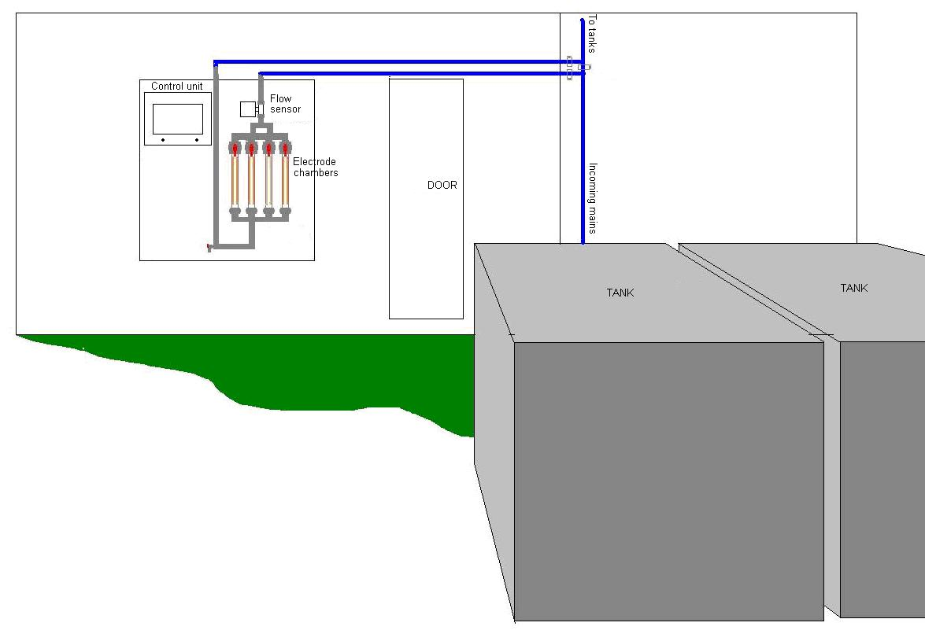

Figure 3.3 Schematic drawing of the copper and silver ionization installation in study hospital 4.

On the 08th April 2008, before the system was activated, samples were taken from 12 outlets.

53

On the 24th April and the 07th May 2008 re-samples were taken from the outlets at which Legionella were found in the samples taken on the 08th April.

Samples were taken monthly from the 07th May 2008 onwards from 6 outlets.

54

3.1.7 Study hospital 5

Study hospital 5 was a three storey building, built in the 1970s, which accommodated approximately 550 beds.

The temperature regime was applied as the sole Legionella control measure but it proved to be difficult to maintain cold water temperatures below 20ºC in some parts of the hospital due to cross heating and poor insulation. Approximately 600 mixing valves had to also be fitted to hot outlets to reduce the hot water temperatures to non-scalding temperatures, rubber lined flexible hoses and rubber fittings were also attached to several outlets, and water stagnation was possible due to poor use of outlets and ward closures. This was considered ideal for Legionella proliferation.

The water was supplied to the site by a mains pipe, which was divided in two, one side delivering water via two softening systems to a softened water storage tank, and the other side delivering water to a raw water storage tank.

One copper and silver ionization system with four copper electrode chambers and two silver electrode chambers was installed to treat the softened water and one copper and silver ionization system with eight copper electrode chambers and four silver electrode chambers was installed to treat the raw water. These systems were installed on the incoming mains pipe before the storage tanks, see Figure 3.4. Because water softening with salt reduces the concentration of positively charged ions (cations) in the water, such as calcium and magnesium, it also reduces the concentrations of copper and silver, which is why the system that treated the softened water was installed after the softening systems.

55

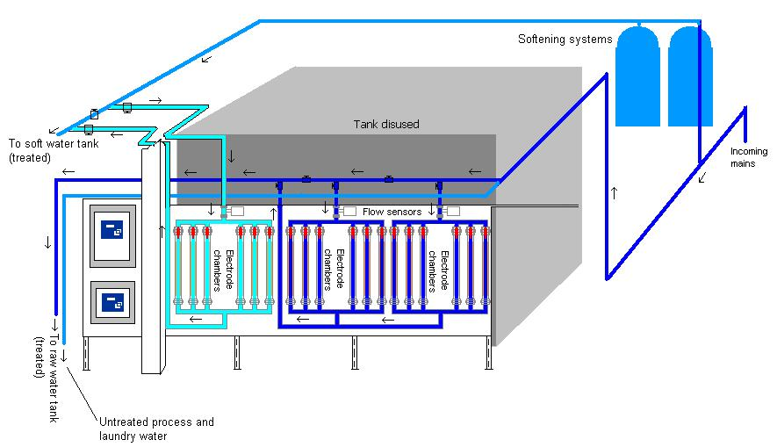

Figure 3.4 Schematic drawing of the copper and silver ionization installation in study hospital 5

The copper and silver ionization systems installed were digital systems, similar to the systems installed in the other study hospitals. The systems were commissioned on the 25th July 2008.

Before the systems were activated samples were taken from 51 outlets. Samples were taken from pure cold and pure hot outlets but in order to obtain a wider view of the potential contamination of the cold and hot water system, samples were also taken by filling the sample bottles half with hot water and half with cold water from 17 outlets. Less than one month after the systems were commissioned, samples were taken, on the 18th August 2008, from 25 outlets at which Legionella were found in the samples taken before the systems were commissioned.

From the 18th August 2008 onwards, samples were taken once every month from 20 outlets.

56

3.1.8 Study hospital 6

Study hospital 6 consisted of a combination of old and new buildings, dating from the 1950’s to 2005, spread over a large site. The hospital accommodated approximately 550 beds.

The temperature regime was applied as the sole Legionella control measure but it proved to be difficult to maintain cold water temperatures below 20ºC in some parts of the hospital due to cross heating and poor insulation. Approximately 600 mixing valves had to also be fitted to hot outlets to reduce the hot water temperatures to non-scalding temperatures, rubber lined flexible hoses and rubber fittings were also attached to several outlets, and water stagnation was possible due to poor use of outlets and ward closures. This was considered ideal for Legionella proliferation.

The water was supplied to the site via two mains pipes and also from a borehole. The borehole water was used for the hot water supply. The water from the two mains was used for drinking and the cold water supply. The water was passed to numerous tanks around the site, all with varied capacities. The borehole water was softened. The water from the two mains was not softened.

One copper and silver ionization system, with four copper electrode chambers and four silver electrode chambers, was installed to treat the borehole water. As with study hospital 5, because water softening with salt reduces the concentrations of copper and silver, this system was installed after the softening systems and before the storage tanks, see Figure 3.5.

One copper and silver ionization system, with four copper electrode chambers and two silver electrode chambers, treated one of the two mains supplies, and one copper and silver ionization system, also with four copper electrode chambers and two silver electrode chambers, treated the other mains supply. These systems were installed before the storage tanks, see Figures 3.6 and 3.7.

The systems were digital, similar to the systems installed in the other study hospitals.

The systems were commissioned on the 06th October 2008.

57

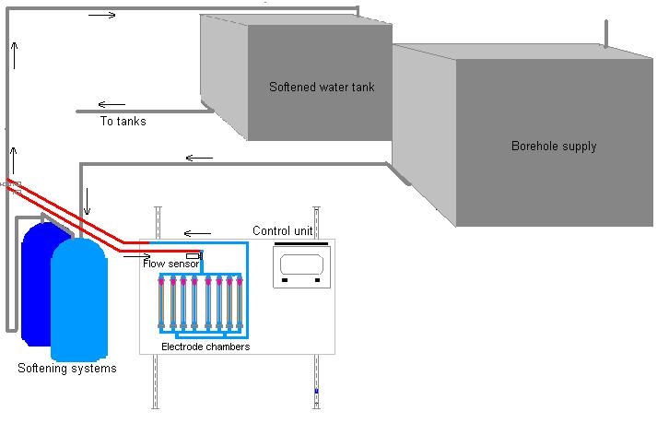

Figure 3.5 Schematic drawing of the copper and silver ionization installation in study hospital 6 – Borehole
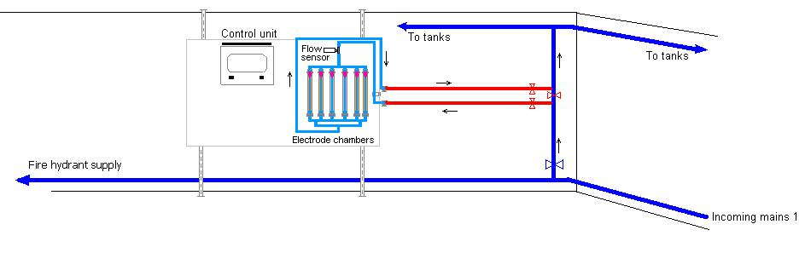

Figure 3.6 Schematic drawing of the copper and silver ionization installation in study hospital 6 – Incoming mains 1.

58

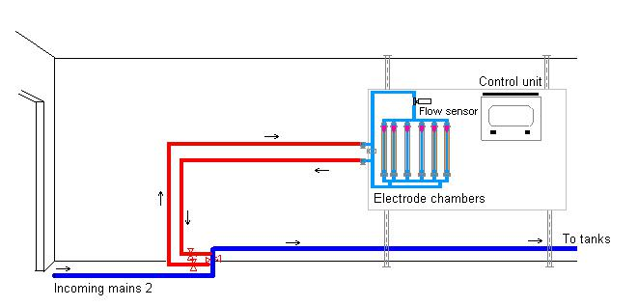

Figure 3.7 Schematic drawing of the copper and silver ionization installation in study hospital 6 – Incoming mains 2

On the 02nd October 2008, before the systems were activated, samples were taken from 60 outlets.

On the 27th November 2008, after the systems were activated, samples were taken from 25 outlets. Eleven of these outlets were outlets at which Legionella were found in the samples taken before the systems were commissioned.

Samples were taken monthly from the 27th November onwards from 25 outlets.

59

3.1.9 Study hospital 7

Study hospital 7 was a combination of old and new buildings, dating back to the 1930s, that spread over a large site. These buildings accommodated approximately 150 beds in total.

The temperature regime was applied as the sole Legionella control measure but it proved to be difficult to maintain cold water temperatures below 20ºC in some parts of the hospital due to cross heating and poor insulation. Mixing valves had to also be fitted to hot outlets to reduce the hot water temperatures to non-scalding temperatures, and rubber lined flexible hoses and rubber fittings were also attached to several outlets. This was considered ideal for Legionella proliferation.

The water was supplied to the site via two mains pipes and was passed to many tanks with various capacities. The water was not softened.

One copper and silver ionization system, with two copper electrode chambers and two silver electrode chambers, was installed to treat one of the incoming mains supplies, and one system, with one copper electrode chamber and one silver electrode chamber, was installed to treat the other incoming mains supply. Both systems were installed on the incoming mains pipes before the storage tanks, see Figures 3.8 and 3.9.

The systems were digital, similar to the systems installed in the other study hospitals.

The systems were commissioned on the 25th November 2008.

60

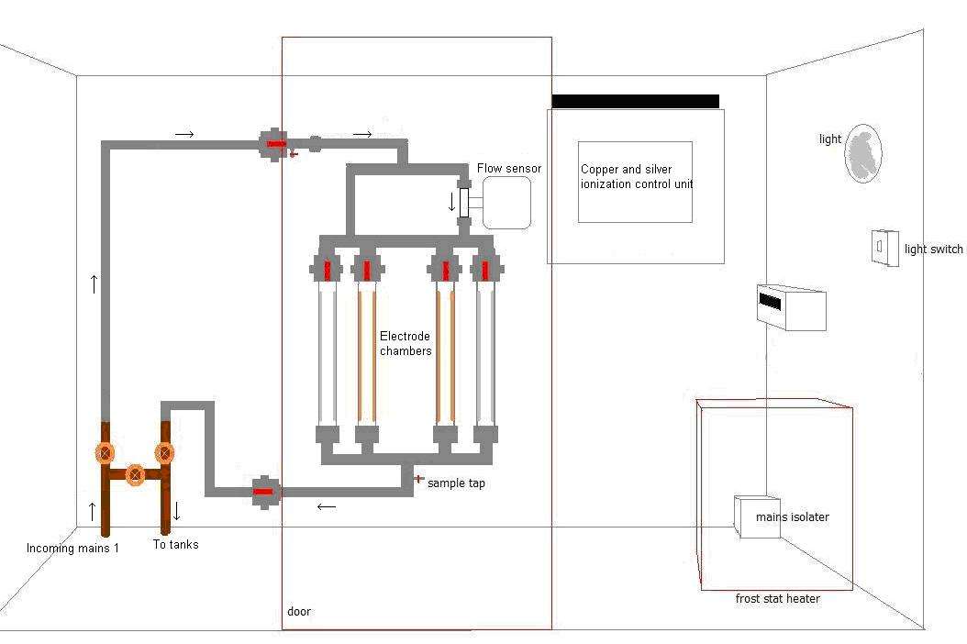

Figure 3.8 Schematic drawing of the copper and silver ionization installation in study hospital 7 – incoming mains 1.
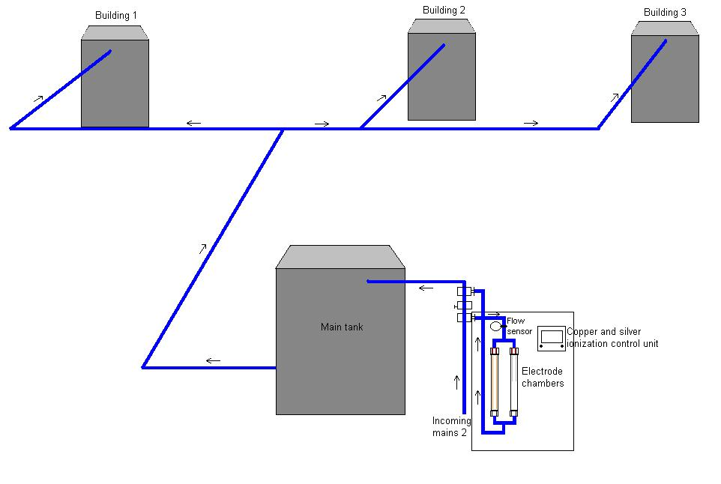

Figure 3.9 Schematic drawing of the copper and silver ionization installation in study hospital 7 – incoming mains 2

61

Before the systems were activated samples were taken from 26 outlets.

Six weeks after the systems were commissioned samples were taken, on the 05th January 2009, from 20 outlets at which Legionella were found in the samples taken before the systems were commissioned. Samples were again taken on the 04th February 2009 from 11 outlets at which Legionella were found in the samples taken on the 05th January 2009.

Samples were taken monthly from the 04th February 2009 onwards from 13 outlets.

62

3.1.10 Study hospital 8

Study hospital 8 consisted of buildings going back to the Victorian times. The hospital was, however, re-piped in 2000. The hospital accommodated approximately 200 beds.

The temperature regime was applied as the sole Legionella control measure but it proved to be difficult to maintain the advocated temperatures in some parts of the hospital. More than 600 mixing valves had to also be fitted to hot outlets to reduce the hot water temperatures to non-scalding temperatures, and rubber lined flexible hoses and rubber fittings were also attached to several outlets. This was considered ideal for Legionella proliferation.

The water was supplied to the site via a mains pipe and was passed to two tanks both with a storage capacity of 44000 litres, which supplied water to smaller tanks throughout the buildings. The water was not softened.

One copper and silver ionization system, with eight copper electrode chambers and four silver electrode chambers, was installed to treat the incoming mains supply. The system was installed on the incoming mains pipe before the two large tanks, see Figure 3.10. The system was digital, similar to the systems installed in the other study hospitals. The system was commissioned on the 27th April 2009.

63

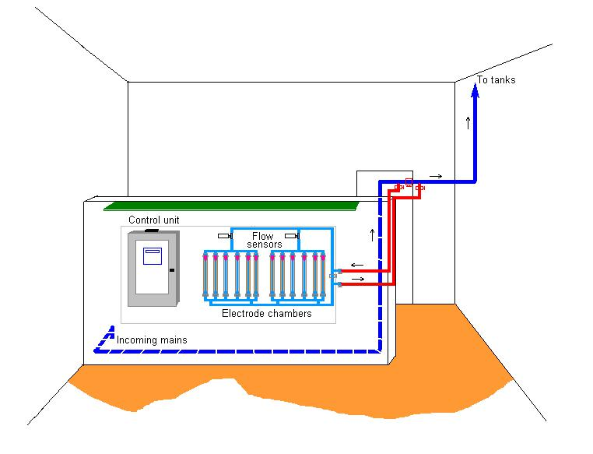

Figure 3.10 Schematic drawing of the copper and silver ionization installation in study hospital 8.

On the 27th April 2009, before the system was activated, samples were taken from 45 outlets.

One month later, on the 27th May 2009, samples were taken from 22 outlets. Eight of these outlets were outlets at which Legionella were found in the samples taken before the system was commissioned.

Samples were taken monthly from the 27th May onwards from 21 outlets.

64

3.1.11 Study hospital 9

Study hospital 9 was an orthopaedic hospital and consisted of a combination of new and old buildings dating from the 1940s to 2003. The hospital accommodated approximately 100 beds.

The temperature regime was applied as the sole Legionella control measure but it proved to be difficult to maintain cold water temperatures below 20ºC in some parts of the hospital due to cross heating and poor insulation. More than 100 mixing valves had to also be fitted to hot outlets to reduce the hot water temperatures to non-scalding temperatures, and rubber lined flexible hoses and rubber fittings were also attached to several outlets. This was considered ideal for Legionella proliferation.

The water was passed around the site directly from the incoming mains. No storage tanks were on site. However, from 2010 onwards extensive modifications to the water distribution system included the installation of two storage tanks. The water was not softened.

One copper and silver ionization system, with four copper electrode chambers and two silver electrode chambers, was installed in an enclosure outside the hospital. The system treated initially the mains water only. After the two tanks were installed the system also treated the water before it entered the two tanks. The system was installed on the incoming mains pipe, see Figure 3.11. The system was digital, similar to the systems installed in the other study hospitals, and was commissioned on the 03rd August 2009.

65

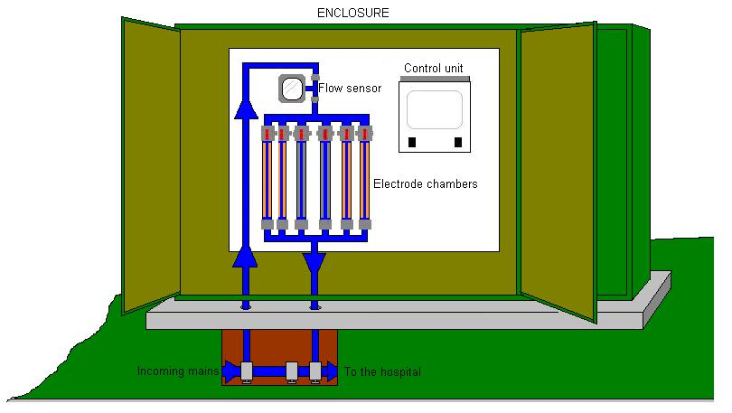

Figure 3.11 Schematic drawing of the copper and silver ionization installation in study hospital 9.

On the 29th July 2009, before the system was activated, samples were taken from 30 outlets.

On the 02nd September 2009, after the system was commissioned, samples were taken from 15 outlets, which included 13 outlets at which Legionella were found in the samples taken before the system was commissioned.

Samples were taken monthly from the 02nd September 2009 onwards from 15 outlets. From September 2010 onwards samples were taken once every two months from 15 outlets and once a month from 6 outlets.

Extensive construction work, including major modifications to the water system, see Plate 3.3 below, were started in May 2010. This work was not completed at the time of writing.

66

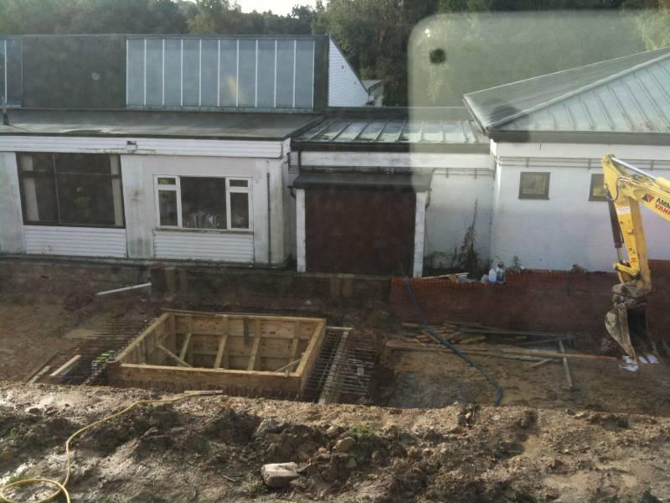

Plate 3.3 Study hospital 9 – photograph of construction work started in May 2010.

67

3.1.12 Study Hospital 10

Study hospital 10 is a nine-storey building, originally constructed in the 1960s and added to since then. The hospital accommodated approximately 850 beds.

The temperature regime was applied as a Legionella control measure but it proved to be difficult to maintain the advocated temperatures. The water system was, therefore, also treated with chlorine dioxide. Legionella was, however, not controlled by both measures and 3 patients contracted Legionnaires’ disease from Legionella that was present in the water system.

The water was supplied to the site via one mains pipe and was passed to two large tanks. The hot water was softened. The softened water was stored in one of the tanks, holding 320m³, and the raw water was stored in the other tank, holding 800m³.

One copper and silver ionization system with four copper electrode chambers and four silver electrode chambers was installed to treat the softened water and water softening with salt reduces the concentrations of copper and silver, this system was installed after the softening systems and before the storage tank, see Figure 3.12.

One copper and silver ionization system with eight copper electrode chambers and four silver electrode chambers was installed to treat the raw water. This system was installed on the incoming mains pipe before the storage tank, see Figure 3.13. Both systems were digital, similar to the systems installed in the other study hospitals. The systems were commissioned on the 21st December 2009.

68

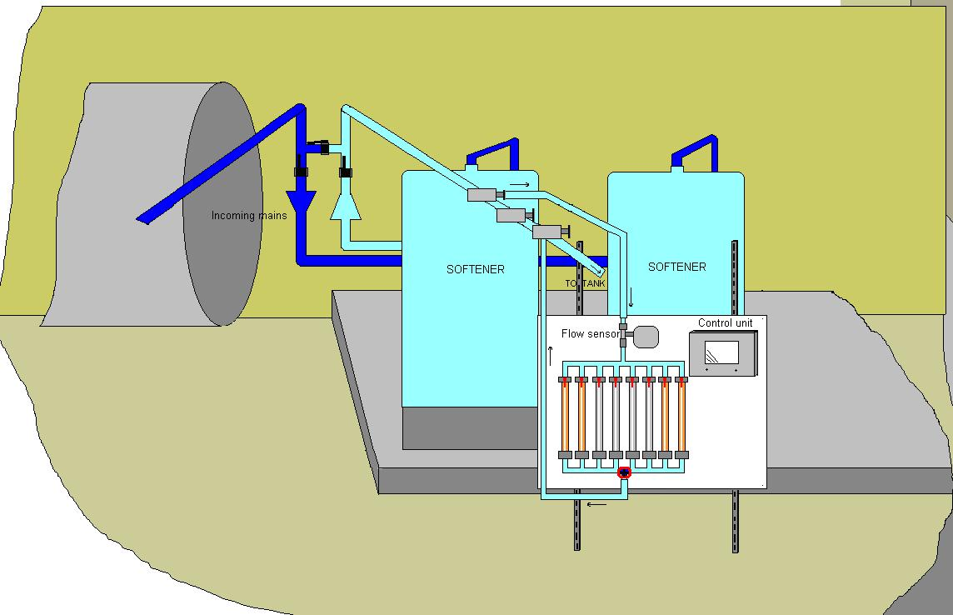

Figure 3.12 Schematic drawing of the copper and silver ionization installation in study hospital 10 – Soft water.
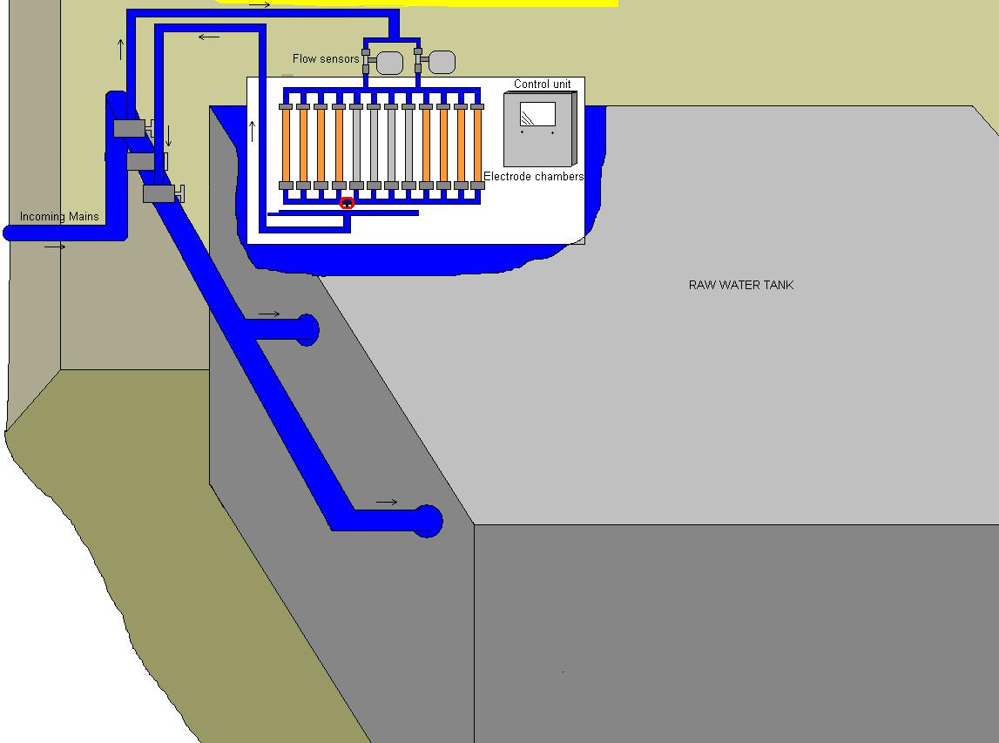

Figure 3.13 Schematic drawing of the copper and silver ionization installation in study hospital 10 – Raw water.

69

On the 15th December 2009, before the systems were activated, samples were taken from 60 outlets.

One month later, on the 13th January 2010, samples were taken from 30 outlets, which included 15 outlets at which Legionella were found in the samples taken before the systems were commissioned.

Samples were taken monthly from the 13th January 2010 onwards from 30 outlets. From April 2011 onwards samples were taken monthly immediately after opening 30 outlets and also after running them for 2 minutes.

70

3.2 The copper and polyethylene rigs

Pneumonia is the leading cause of death in care residents and the risk of contracting Legionnaires’ disease is, particularly, higher in the elderly. Legionella also tends to proliferate more in blended water systems than in pure hot and pure cold water systems.

Managing risk factors, such as a water temperature between 30ºC and 45ºC and the presence of biofilms, can limit the growth of Legionella in these systems but these factors can be difficult to manage, especially, in systems in which water is blended to avoid scalding and in systems in which materials are used that can promote biofilm formation.

Copper and polyethylene are plumbing materials that are commonly used in UK water systems and experiments with model systems have indicated that polyethylene can promote growth more than copper (Keevil et al., 1993, van der Kooij et al., 2005). Although the model systems constructed for these experiments endeavoured to replicate small hot water systems, they did not simulate a copper and a polyethylene piped hot water system of a typical small hospital in the UK, in which water is stored, blended and circulated. Biofilm formation and Legionella growth were also only examined in these model systems and Legionella control measures were not tested.

For this project, copper and polyethylene piped rigs were, therefore, constructed to not only examine the differences in biofilm and Legionella growth in copper and polyethylene piped water systems that simulate a typical blended water system of a small UK hospital but also to examine the effect of hot water temperatures of 50ºC and the effect of copper and silver ionization at temperatures below 45ºC in controlling Legionella in the rigs.

Initially two small scale rigs, simulating circulating hot water flow systems in copper and polyethylene piping, were designed and built. Four more identical rigs were built later on.

71

Each of these rigs consisted of 15mm diameter ‘push fitted’ pipe. For one rig copper material was used, and for the other rig polyethylene pipe (PE-X) BS 7291 material was used.
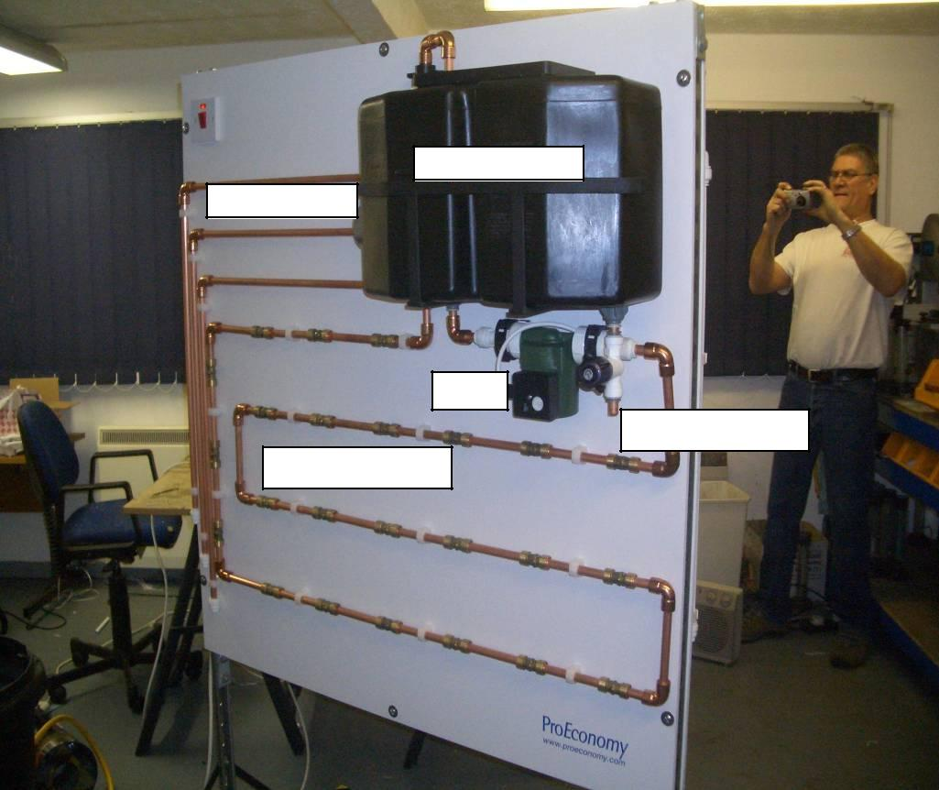

4 gallon PVC tank

Immersion heater

Pump

Sample/Draw off tap

Speedfit connector

Plate 3.4 Rig with copper push fitted piping.

72

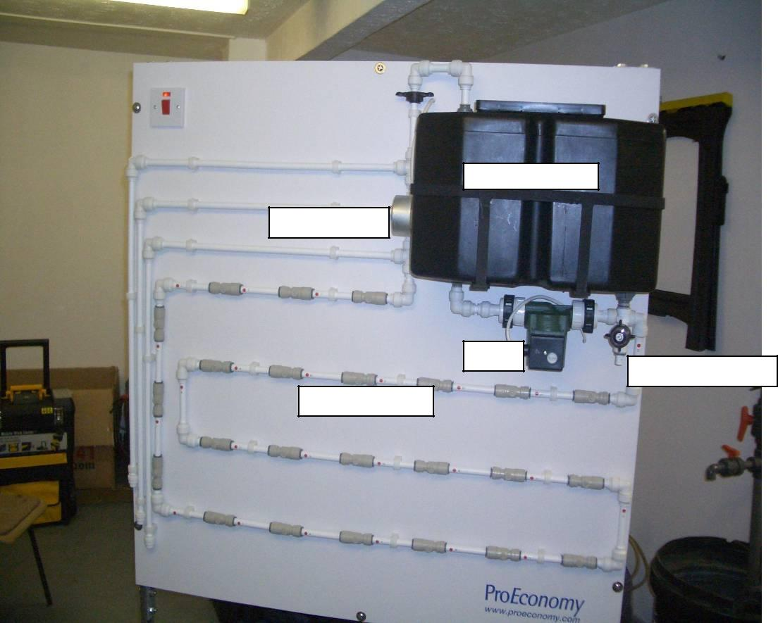

4 gallon PVC tank

Immersion heater

Pump
Sample/Draw off tap

Speedfit connector

Plate 3.5 Rig with polyethylene push fitted piping.

In order to be able to collect samples to determine biofilm formation, the presence of total viable counts and Legionella in biofilm, 24 removable sections were introduced in each rig.

73

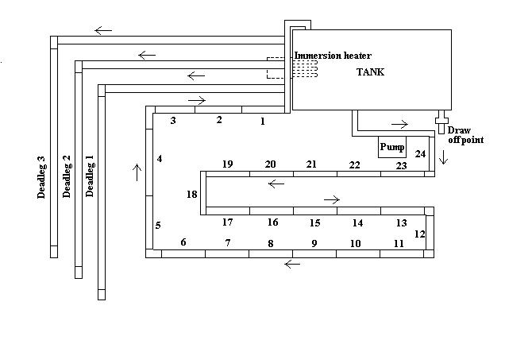

Figure 3.14 Rig plus 24 sections

These sections were connected by 15mm diameter ‘Speedfit’ pipe connectors on each end, which were commonly used in water systems to connect pipes. A ‘Speedfit’ connector contained a collet which had stainless steel teeth that gripped the pipe. It also contained two rubber ‘O’ rings, which provided a leak-proof seal, and a valve to enable isolation.
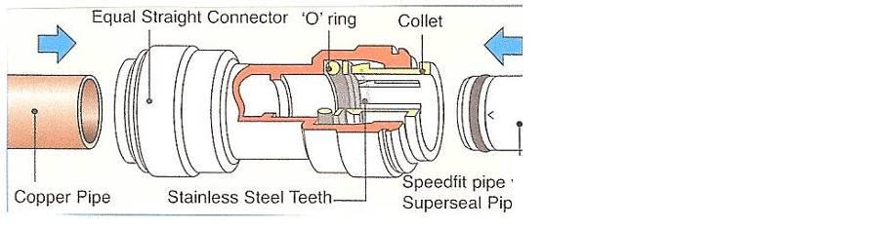

Figure 3..15 Speedfit connector (www.speedfit.co.uk)

The pipe sections were each 15mm diameter, 15.24cm long, and were made of either copper or polyethylene. The sections could be easily removed using a special tool and when removed were replaced with new sections.

The height of each rig was 1.22m, the width was 1.22m. All rigs were mounted, back to back, on a movable board. The total length of the pipes of each rig was 538cm each.

The PVC tank of each rig held approximately 15 litres of water. The water was circulated through each rig using a brass circulating pump. The water was heated

74

using an 11 inch long stainless steel immersion heater (immersed in each tank). The flow-rate of the water going through each rig was approximately 2 litres per minute. The flow could be reduced, if necessary, by changing the settings of the valve nearest to the tank input.

3.2.1 Initial experimental procedures – Rigs A

The experiment with the first built rigs (Rigs A) was designed to develop and monitor a microbial population for comparison between the copper piped rig and the polyethylene piped rig.

Both rigs were run at a temperature of ~ 42ºC.

Mains water was introduced into the rigs and, to simulate hot water use whilst not loosing the introduced micro-organisms, three litres of water were manually drawn from the rigs every day. The rigs were also manually re-filled with three litres of mains water every day. This represented storage of ~5 days. In reality, it is, however, advised not to store water for longer than 24 hours.

To introduce bacteria into the rigs and to encourage biofilm formation, both rigs were deliberately filled with one litre of water with pre-established counts of viable bacteria (Total Viable Counts or TVCs) as shown in Table 3.2 below.

75

TVC @ 37º | TVC @ 22º | Legionella | L. pneumophila | Day introduced | Day introduced
2 days | 3 days | Species | Serogroup 1 |  | to Polyethylene
 |  |  |  | to Copper rig
CFU/ml | CFU/ml | CFU/l | CFU/l |  | rig
770 | 330 | Not found | Not found | None | 102
3470 | 2260 | Not found | Not found | 102 | None
330 | 440 | Not found | Not found | None | 123
605 | 550 | Not found | Not found | 123 | None
5450 | 7430 | Not found | Not found | None | 179
3960 | 9410 | Not found | Not found | 179 | None
14 | 2 | Not found | 1800 | 260 | 260
3 | 16 | 900 | Not found | 285 | 285

Table 3.2 Initial experiment - Total viable bacteria and Legionella bacteria added to rigs A

Analysis for viable bacteria present in the rigs was carried out following the standard culture method (BS EN ISO 6222:1999). Table 3.3 below shows the pattern of water sampling for this analysis.

76

Day | Day
0 | 417
7 | 424
14 | 431
19 | 438
27 | 445
33 | 453
70 | 459
80 | 466
90 | 473
97 | 478
110 | 480
119 | 487
128 | 494
137 | 501
155 | 508
162 | 515
193 | 522
211 | 529
239 | 536
246 | 543
268 | 550
284 | 557
302 | 564
324 | 569
333 | 570
344 | 571
355 | 572
372 | 575
383 | 576
387 | 577
395 | 578
404 | 579
409 | 582
410
Table 3.3 Initial experiment Rigs – Frequency of TVC analysis.

Sixty seven samples were taken from each rig. The last samples were taken on day 582.

On day 260 the rigs were seeded with one litres of water that contained 1800CFU/l of L. pneumophila serogroup 1, and on day 285 the rigs were seeded with one litre of water that contained 900CFU/l of Legionella non-pneumophila as shown in Table 3.2. One litre samples were, therefore, taken from both rigs for Legionella analysis from day 324 onwards as shown in Table 3.4 below.

77

Day | Day
324 | 473
333 | 480
344 | 487
355 | 494
372 | 501
383 | 508
387 | 515
395 | 522
404 | 529
409 | 536
410 | 543
417 | 550
424 | 557
431 | 564
438 | 571
445 | 578
453 | 585
459
466
Table 3.4 Initial experiment Rigs - Frequency of Legionella analysis.

Thirty seven samples were taken from each rig. The last samples were taken on day 585.

The pattern of biofilm development was followed by periodic removal of sections. Pipe sections of each rig were isolated by closing the valves of the ‘Speedfit’ connectors. The pipe sections were then removed by using a special tool to separate the connectors from the pipe. The pipe sections were then aseptically released in a sterilized, plastic bottle containing 500ml of distilled water.

In order to investigate the best way to remove and to quantify any biofilm from the inner surfaces of the pipe sections a number of different techniques were attempted as shown in Table 3.5 below.

78

Section | Time in rigs | Procedure
 | Days
1 | 19 | Shaken/biomass/TVC
2 | 27 | Shaken/biomass/TVC
3 | 70 | Shaken/biomass/TVC
4 | 80 | Shaken/biomass/TVC
5 | 89 | Shaken/biomass/TVC
6 | 128 | Shaken/biomass/TVC
7 | 128 | Sonicated/biomass/TVC
8 | 211 | Control section
9 | 211 | Sonicated/biomass/TVC
10 | 211 | Shaken/biomass/TVC
11 | 211 | Brushed/biomass/TVC
12 | 284 | Brushed/biomass/TVC
13 and 14 | 387 | Brushed/biomass/TVC
15 | 409 | Brushed/biomass/TVC
16 | 478 | Brushed/biomass/TVC

Table 3.5 Initial experiment Rigs - Pattern and procedures of biofilm harvesting and time of sections in rigs A.

The first method involved placing removed sections together with 500ml distilled water in a sonification bath for 1 hour after which the suspended solids were collected and weighed. This was done by recording the weight of a filter, placing it on a filtration manifold, filtering the sample through the filter, placing the filter in an oven at 40ºC, drying it, then weighing the filter again, and deducting the initial weight result from that of the dried filter. An analytical balance was used for the weighing. The second method involved shaking removed sections in 500ml distilled water on a rotary shaker for one hour after which the suspended solids obtained were dried and weighed. In the third method, removed sections were brushed through 5 times with a sterilized 50cm long bottle brush holding the section half way into the bottle filled with 500ml of distilled water, after which the sample was also dried and weighed. The third method was introduced as it was felt that strongly adherent biofilms could withstand the first 2 treatments and not be fully removed by them.

79

The highest weight was found in the brushed samples. All sections were from then on, therefore, brushed through to remove biofilm.

Initially, viable biological material within the brushed samples was also analyzed by the standard culture method (BS EN ISO 6222:1999), shown also in Tables 3.6 and 3.7. The result, expressed in colony forming units per ml, was then multiplied by 500, because the sample was 500ml, which was then divided by 7000mm², approximately the inner surface area of the pipe section (surface area = circumference (πd = 3.14 x 15mm = 47.1mm) x length (15.24cm or 152.4mm) ≈ 7000mm²), which gave the approximate colony forming units per mm². A result of >1000/mm² was considered a substantial biolayer.

The presence of Legionella in biofilms on the inner surfaces of pipe sections of the rigs was monitored by analyzing brushed through pipe section samples by the culture method (ISO 11731:1998). Table 3.6 below shows the pattern of the sampling for Legionella analysis of biofilm in the sections.

Section | Time in rigs
 | Days
1 | 19
13 and 14 | 387
15 | 409
16 | 478
1, 2, 3, 4, 5, 6, 7, 8, | 547, 539, 496, 486, 477, 436,
9, 10, 11, 12, 13, | 436, 353, 353, 353, 353, 220,
14, 15, and 16 | 177, 177, 155, 86

Table 3.6 Initial experiment Rigs - Pattern of sampling for Legionella analysis of biofilm of rigs A.

Legionella sampling of the biofilm in the pipe sections commenced after a population of Legionella organisms was detected in the rigs’ water. Sections representing residence times of between 86 and 547 days were all analyzed at one time point, on day 564, to investigate whether a pattern of biolayer development could be shown.

80

3.2.2 Additional experimental procedures – Rigs B and C

Two more copper and two more polyethylene rigs (Rigs B and C), identical to rigs A, were built to compare the efficacy of controlling Legionella by elevated temperatures with copper piping and polyethylene piping, and to compare the efficacy of controlling Legionella by copper and silver ionization with copper piping and polyethylene piping, see Table 3.7 below.

Rigs | Treatment | Temp. ºC
A | Copper and silver ionization | < 45
B | None | < 45
C | Temperature | ~ 50
Table 3.7 Treatment of rigs A, B and C.

To obtain a similar microbial load as in rigs A, water from rigs A was introduced into rigs B and C. The copper rigs B and C were each filled with one third of the water from the copper rig A and the polyethylene rigs B and C were each filled with also one third of the water from the polyethylene rig A.

To obtain similar biofilm layers and to encourage biofilm formation in rigs B and C, sections of rigs A were placed in rigs B and C.

Figures 3.16, 3.17, and 3.18 below show the sections removed from and left in the polyethylene rig A and the sections replaced in the polyethylene rigs B and C.

Sections 18, 17, 16, 15, 14, 13, 12, and 11 of the polyethylene rig B were replaced with sections 18, 17, 16, 15, 14, 13, 12, and 11 of the polyethylene rig A. Sections 11, 10, 9, 8, 7, 6, 5, and 4 of the polyethylene rig C were replaced with sections 10, 9, 8, 7, 6, 5, 4, and 3 of the polyethylene rig A.

Figures 3.19, 3.20, and 3.21 below show the sections removed from and left in the copper rig A and the sections replaced in the copper rigs B and C.

Sections 23, 22, 21, 20, 19, 18, 17, and 16 of the copper rig B were replaced with sections 23, 22, 21, 20, 19, 18, 17, and 16 of the copper rig A. Sections 23, 22, 21, 20,

81

19, 18, 17, and 16 of the copper rig C were replaced with sections 15, 14, 13, 12, 11,

10, 9, and 8 of the copper rig A.
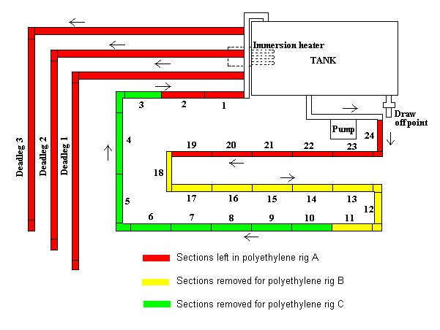

Figure 3.16 Polyethylene rig A sections left and removed.
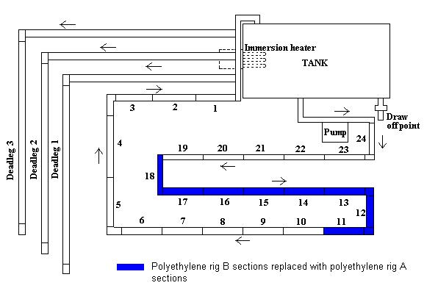

Figure 3.17 Polyethylene rig B sections replaced with polyethylene rig A sections.

82

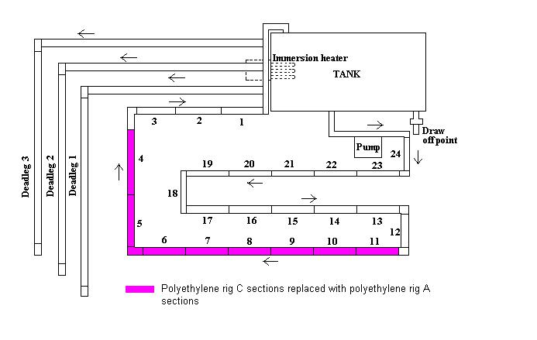

Figure 3.18 Polyethylene rig C sections replaced with polyethylene rig A sections.
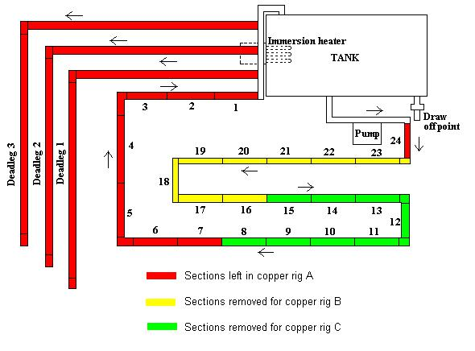

Figure 3.19 Copper rig A sections left and removed.

83

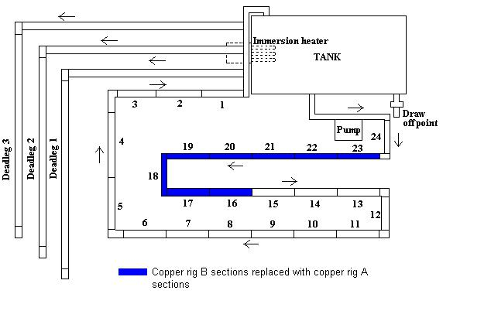

Figure 3.20 Copper rig B sections replaced with copper rig A sections.
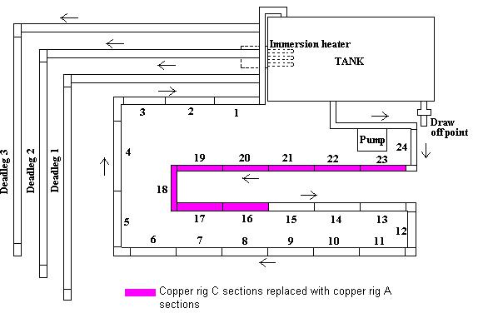

Figure 3.21 Copper rig C sections replaced with copper rig A sections

Three litres of water were manually drawn from all six rigs every day to simulate hot water use. Rigs B and C were automatically re-filled with three litres of mains water by a ball valve mechanism inserted in each tank and rigs A were re-filled manually every day.

84

Once Legionella populations were found in all rigs, treatment was started. Three litres of water from rigs A were manually replenished every day with water containing copper and silver ions. The temperatures in rigs A were kept below 45ºC.

The Orca copper and silver ionization system produced the copper and silver ions that were introduced into rigs A. This system was not attached directly to the rigs, as it was unsuitable for the small size of the experimental rigs. The system produced approximately 0.1mg/l of silver and 3.6mg/l of copper and three litres of this water were introduced into the rigs daily in a separate operation.

No treatment was added to the B rigs. The temperatures in these rigs were maintained below 45ºC, simulating a typical hot water circulating system in which mixing valves are used to blend water to a temperature below 45ºC to avoid scalding.

The temperatures in rigs C were maintained above 50ºC, simulating a pure hot water circulating system to which the temperature control regime as recommended in the ACoP (L8) and the HTM 04-01 documents is applied.

The temperatures in the six rigs tanks were recorded in ºC using an infrared non-contact thermometer. Recordings were done daily when the water was being drawn from the rigs.

125ml samples for analysis for copper and silver by Inductively Coupled Plasma Optical Emission Spectroscopy (ICPOES) and Inductively Coupled Plasma Mass Spectrometry (ICPMS) were collected from the draw off points of all six rigs, also daily.

One litre of sample for Legionella analysis was collected once a week from the draw off points of all six rigs. The analysis for Legionella was carried out by the culture method (ISO 11731:1998).

The presence of Legionella in biofilms was monitored once a month by analyzing samples of pipe sections, brushed through in 500ml distilled water, by the culture method (ISO 11731:1998).

85

3.3 Analytical methods

3.3.1 Water analysis

Water analysis was carried out by a UKAS accredited laboratory.

(a) Total Viable Count (TVC) (BS EN ISO 6222:1999)

The standard culture method for analysis for total viable bacteria was applied. 1ml of the sample was plated, within 12 hours, onto prepared Petri dishes. The sample was incubated at 37ºC for 48 hours and at 22ºC for 72 hours, after which the number of colony forming units that had formed in the medium were calculated using a standard plate counter. The results were expressed in colony forming units per 1ml (CFU/ml). A colony forming unit represents a number of bacterial cells that has the ability to form a colony on the media.

(b) Legionella (ISO 11731:1998)

The standard culture method for analysis for Legionella bacteria was applied. The sample was filtered through a 0.2µm membrane filter. The filter was placed in a stomaching bag containing 10ml of ‘Ringer’s solution’ and rubbed between thumb and finger to ‘wash’ the bacteria from the filter into the solution.

10ml of the solution produced was then split into 3 portions, one was tested without further treatment, one was heat treated at 50ºC (± 1ºC) for 30 minutes (± 2 minutes), and one was treated with acid (pH 2.2) left for 5 minutes (± 30 seconds). Legionella are resistant to these treatments whereas other bacteria may be killed, therefore, reducing the total amount of bacteria in the test solutions without (ideally) losing any Legionella.

0.1ml of each of the 3 solutions was then spread onto agar containing the selective agents: Glycine, vancomycin, polymyxin and cyclohexamide (GVPC) and incubated at 36ºC for 10 days. The plates were inspected 4 times during the 10 day incubation, on days 3, 5, 7 and 10. If colonies grew on any of the 3 plates during the 10 day period with the correct morphology, these were scored as ‘presumptive’ Legionella

86

positive. The number of ‘presumptive’ colony forming units present on the medium was then calculated. The ‘presumptive’ colonies from these plates were then sub-cultured onto two further plates. One with and one without supplements to determine the presence of Legionella species, which grow only on the plate with supplements: Buffered charcoal yeast extract agar with cysteine (BCYE+), and fail to grow on the plate without supplements, BCYE- (without cysteine).

To identify L. pneumophila serogroup 1 and serogroup 2-14 coloured latex beads coated in antibodies were used. These antibodies agglutinate if those species are present. The results were expressed in colony forming units per litre (CFU/l).
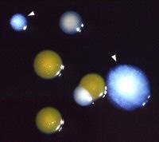

Plate 3.6 Two Legionella pneumophila colonies on BCYE+

- Phosphorus, copper and silver (Inductively Coupled Plasma Optical Emission Spectroscopy/Mass Spectrometry - ICPOES/ICPMS)

The sample was released into inductively coupled plasma, which was created from highly ionized argon gas. The sample was released into it as an aerosol suspended in argon gas formed by a nebulizer. When the sample aerosol stream passed through the plasma, desolvation and atomization occurred, this resulted in the constituent elements achieving an excited state.

In the case of optical emission spectroscopy (ICPOES), after excitation, the phosphorus and metal ions in the sample emitted light of characteristic wavelengths,

87

which were converted to an electrical current which was proportional to the concentration of the specific ions in the sample.

In the case of mass spectrometry (ICPMS), after excitation, the specific mass to charge ratio of the ions was measured and an electrical current was generated, which was proportional to the concentration of the specific ions in the sample. ICPOES was used to obtain phosphorus and copper concentrations, whereby, ICPMS was used to obtain the lower silver concentrations.

(d) Chloride (AQUA-800 Analyzer)

Analysis for chloride was carried out by the AQUA-800 Analyzer. The sample was placed on a sample wheel. Aliquots of the sample and reagents were dispensed into reaction vials and the reaction and colour development were allowed to proceed. After an appropriate delay the reaction mixture passed through a read head, which measured the intensity of the colour formed. By comparison to the readings obtained from previously analyzed standards of known strength the concentration of each analyte was determined.

(e) pH

Analysis for pH was carried out by measuring the electromotive force (EMF) of a cell comprising of an indicator electrode (which was responsive to hydrogen ions, such as a glass electrode) and a reference electrode, both immersed in a test solution. The EMF of this cell was measured with a pH meter, which was a high-impedance electrometer calibrated in terms of pH.

88

3.3.2 Statistical analysis

The results of all analyses and the temperature recordings were entered and interpreted using Microsoft Excel software.

The variability of the values was measured by taking the root mean square deviation of the values from their mean.
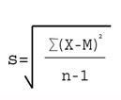

Where:
- = Sum of

X = Individual score

M = Mean of all scores

N = Sample size (Number of scores)

89

3.4 Experiments using the Robbins device

The Tyler Research Corporation (Edmonton, Alberta, US) manufactures a range of devices for the analysis of biofilms on surfaces, which includes the modified Robbins device.

Synthetic rubber, as well as copper and polyethylene, is also commonly used in UK water systems and it was suggested that synthetic rubber encouraged biofilm growth (Schofield and Locci, 1985, Keevil et al., 1993, Rogers et al., 1994, BSRIA Technical Note TN 9/96).

The Robbins device was, therefore, used to compare biofilm formation on rubber, copper and polyethylene discs. The device used consisted of 12 sampling ports in a linear array, see Plate 3.7 below. These ports accepted press-fit plugs that held 1 sample disc each with a surface area of 50mm². These discs were made of rubber, copper, and polyethylene. The design of the press-fit plugs was such that the surfaces of the rubber, copper and polyethylene sample discs became part of the channel wall. The sample discs were, therefore, exposed to the water that was circulated through the channel of the device.
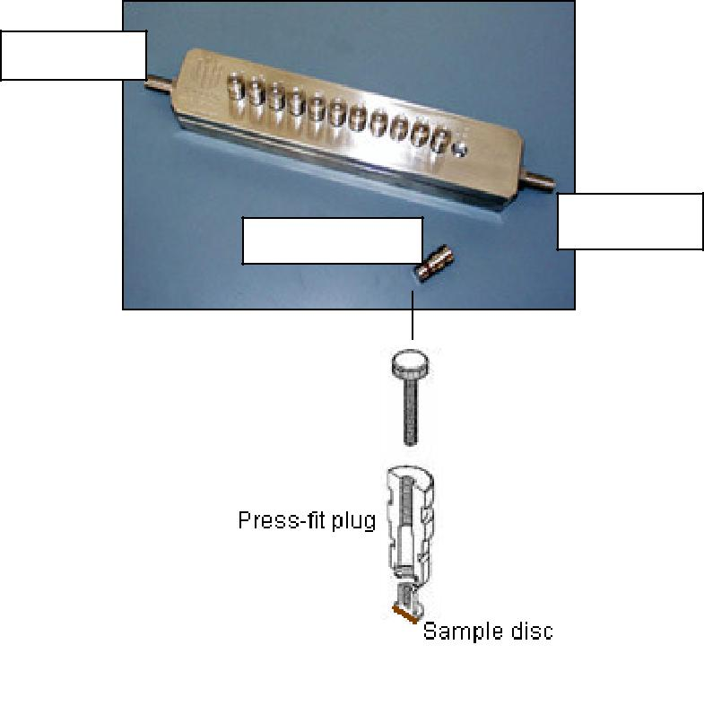

Water out

Water in
Press-fit plug

Plate 3.7 The Robbins device including drawing of

press-fit plug (www.tylerresearch.com).

90

Before the experiments, the Robbins device was disinfected by pumping 20ml of methanol through the device, using a peristaltic pump (Watson Marlow Limited, Falmouth, Cornwall) set at 12 reps per minute, followed by 50ml of distilled water.

Six copper discs were first placed on the surface of six press-fit plugs. These plugs were fitted in the first six ports of the Robbins device.

The water that was circulated through the channel of the device as an inoculum source was inoculated by leaving unbrushed sections 20 and 21 from the polyethylene rig A in 500ml distilled water for 1 week. 500ml of this water was circulated through the device for 24 hours, using the peristaltic pump again set at 12 reps per minute. The temperature of the water was ~ 20ºC.

The sample discs were aseptically removed from the plugs after 24 hours. The discs were released in 10ml distilled water, and shaken for 30 seconds. 1ml of this sample was serial diluted from neat to 10⁻¹, 10⁻², and 10⁻³. 0.1ml of the 10⁻² and 10⁻³ dilutions were then spread onto trypto soya agar plates. The 10⁻¹ dilutions were too overgrown and were therefore not used. Two plates were not spread and were used as controls. The plates were then incubated at 20ºC (± 2ºC), and checked after twenty-four hours.

In total three individual tests, as described above, were conducted with the copper discs, three individual tests with the polyethylene discs, and three individual test were done with the rubber discs (Tests 1, 2, and 3).

It was felt that strongly adherent biofilms would not be totally removed by shaking the discs in 10ml distilled water for 30 seconds. The surfaces of 4 copper, 4 polyethylene and 4 rubber discs that were exposed to the inoculated water for 48 hours, were, therefore, brushed using interdental brushes (Tests 4).

91

- RESULTS

4.1 Study hospital 1

The results of samples taken on the 05th September 2007, before the copper and silver ionization system was activated, are shown in Table 4.1 below.

92

 | Sample Point | Temp. | Silver | Copper | Legionella
 |  | ºC | Mg/l | Mg/l | CFU/l
 | 71 142 HT | 25 | 0.0003 | 0.116 | 2100 s1
 | 71 142 CT | 24 | 0.0003 | 0.142 | 200 s1
 | 0.2.0016 HT | 43 | 0.0003 | 0.049 | 100 s1
 | 0.2.0016 CT | 20 | 0.0003 | 0.029 | 100 s1
 | 58-00-87 HT | 40 | 0.0003 | 0.031 | 1700 s1
 | 58-00-87 CT | 21 | 0.0003 | 0.014 | <LOD
 | 58-03-112 HT | 39 | 0.0003 | 0.043 | 100 s1
 | 58-03-112 CT | 22 | 0.0003 | 0.027 | 100 s1
 | 67-0-008 HT | 57 | 0.0003 | 0.041 | <LOD
 | 67-0-008 CT | 28 | 0.0003 | 0.068 | <LOD
 | 68-01-045 HT | 43 | 0.0003 | 0.043 | <LOD
 | 68-01-045 CT | 21 | 0.0003 | 0.023 | <LOD
 | 68-01-05 HT | 42 | 0.0003 | 0.037 | 9800 s1
 | 68-01-05 CT | 21 | 0.0003 | 0.019 | <LOD
 | 69-010-70 HT | 38 | 0.0003 | 1.050 | 7500 s1
 | 38-0-029 HT | 34 | 0.0003 | 0.057 | 1600 s1
 | 38-0-029 CT | 27 | 0.0003 | 0.026 | 1200 s1
 | 14-01-023 HT | 47 | 0.0003 | 0.059 | 200 s2-14
 | 14-01-023 CT | 20 | 0.0003 | 0.021 | <LOD
 | 35-0-028 HT | 28 | 0.0003 | 0.043 | 4200 s1 + 100 np
 | 35-0-028 CT | 20 | 0.0003 | 0.019 | 200 s1
 | 62-02-067 shower | 26 | 0.0003 | 0.068 | <LOD
 | 62-02-067 CT | 19 | 0.0003 | 0.014 | 200 s1
 | 39-01-86 HT | 51 | 0.0003 | 0.081 | <LOD
 | 39-91-86 CT | 20 | 0.0003 | 0.183 | <LOD
 | 39-00-65 HT | 57 | 0.0003 | 0.053 | <LOD
 | 39-00-65 CT | 22 | 0.0003 | 0.02 | 3500 s1
 | 25-00-31 shower | 26 | 0.0003 | 0.273 | <LOD
 | 25-00-31 HT | 39 | 0.0003 | 0.067 | 200 s1 + 1200 np
 | 25-00-31 CT | 19 | 0.0003 | 0.04 | <LOD
 | 22-086 shower | 40 | 0.0003 | 0.037 | <LOD
 | 22-086 HT | 37 | 0.0003 | 0.029 | <LOD
 | 22-086 CT | 20 | 0.0003 | 0.013 | <LOD
 | 21-1-137 shower | 40 | 0.0003 | 0.118 | <LOD
 | 21-1-137 HT | 42 | 0.0003 | 0.038 | <LOD
 | 21-1-137 CT | 19 | 0.0003 | 0.013 | <LOD
 | 23-01-78 shower | 43 | 0.0003 | 0.132 | 1100 np
 | 23-01-78 HT | 40 | 0.0003 | 0.083 | 1100 np
 | 23-01-78 CT | 19 | 0.0003 | 0.03 | <LOD
 | 29-00-07 HT | 56 | 0.0003 | 0.062 | <LOD
 | 29-00-07 CT | 34 | 0.0003 | 0.035 | 8200 s1
 | 41-0-072 shower | 40 | 0.0003 | 0.064 | 500 s1
 | 41-0-052 HT | 43 | 0.0003 | 0.073 | <LOD
 | 41-0-052 CT | 19 | 0.0003 | 0.067 | <LOD
 | 681-08-22 HT | 43 | 0.0003 | 0.065 | <LOD
 | 71-01-30 HT | 39 | NA | NA | <LOD
CT = Cold Tap, HT = |  | Hot Tap, np | = Legionella | non-pneumophila, s1 = Legionella

pneumophila serogroup 1, s2-14 = Legionella pneumophila serogroup 2 to 14, <LOD =

Below Limit of Detection (100CFU/L).

Table 4.1 Study hospital 1 - Results from samples taken on the 05th September 2007, before

commissioning of copper and silver ionization system.

93

Legionella were found at 21 out of the 46 outlets tested, around 46% of the outlets tested were, therefore, contaminated.

The Legionella colony forming unit counts found ranged from 100CFU/l to 9800CFU/l. The average Legionella count of the 46 outlets sampled was 983CFU/l (± 331CFU/l). Hot and cold outlets were contaminated.

The highest Legionella counts were found in samples taken from hot outlets at which low hot water temperatures, below 50ºC, were recorded and in cold outlets at which elevated temperatures, above 20ºC, were recorded. Although not visible, thermostatically controlled mixing valves (TMVs) may have been blending the water at the hot outlets at which low hot water temperatures were recorded.

The copper found in the samples was due to copper leaching from copper pipes. The average was 0.08mg/l (± 0.023mg/l), which included the highest level of 1.050mg/l. Excluding the highest copper level the average copper found was 0.058mg/l (± 0.007mg/l).

The copper and silver ionization system was activated on the 11th September 2007.

Table 4.2 below shows the results of samples taken on the 05th October 2007 from the 21 outlets that were contaminated before the system was activated.

94

Sample Point | Temp. | Silver | Copper | Legionella
 | ºC | Mg/l | Mg/l | CFU/l
71 142 HT | 24 | 0.011 | 0.217 | <LOD
71 142 CT | 23 | 0.006 | 0.245 | 2000 s1
02.0016 HT | 41 | 0.027 | 0.132 | <LOD
02.0016 CT | 18 | 0.041 | 0.186 | <LOD
58-00-87 HT | 40 | 0.031 | 0.131 | 700 s1
58-03-112 HT | 39 | 0.026 | 0.104 | <LOD
58-03-112 CT | 18 | 0.047 | 0.181 | <LOD
68-01-05 HT | 41 | 0.021 | 0.116 | <LOD
69-010-70 HT | 55 | 0.014 | 0.111 | <LOD
38-0-029 HT | 33 | 0.038 | 0.173 | 400 s1
38-0-029 CT | 25 | 0.048 | 0.17 | <LOD
14-01-023 HT | 50 | 0.009 | 0.065 | <LOD
35-0-028 HT | 27 | 0.04 | 0.183 | 100 s1
35-0-028 CT | 17 | 0.048 | 0.179 | <LOD
62-02-067 CT | 19 | 0.059 | 0.176 | <LOD
39-00-65 CT | 21 | 0.004 | 0.157 | <LOD
25-00-31 HT | 39 | 0.027 | 0.147 | <LOD
23-01-78 shower | 41 | 0.029 | 0.579 | <LOD
23-01-78 HT | 39 | 0.03 | 0.173 | 200 np
29-00-07 CT | 30 | 0.021 | 0.126 | <LOD
41-0-072 shower | 37 | 0.013 | 0.193 | <LOD

CT = Cold Tap, HT = Hot Tap, np = Legionella non-pneumophila, s1 = Legionella pneumophila serogroup 1, <LOD = Below Limit of Detection (100CFU/l).
Table 4.2 Study hospital 1 - Results from samples taken on the 05th October 2007, one month after commissioning of copper and silver ionization system.

No Legionella were found in samples taken from 16 outlets that were previously contaminated. The Legionella colony forming unit counts also reduced. The average Legionella count was 161CFU/l (± 99CFU/l). The highest Legionella count was 2000CFU/l, found in a sample taken from a cold outlet. The temperature recorded at this outlet was 23ºC.

The cold temperatures remained above 20ºC at 4 out of the 8 cold water outlets tested and the hot water temperatures were again predominantly below 50ºC. A TMV was blending the water at the 38-0-029 hot outlet at which a L. pneumophila serogroup 1 count of 400CFU/l was found. TMVs were, however, not visible at the other hot outlets tested at which also L. pneumophila serogroup 1 organisms were found. The average hot water temperature was 39ºC (± 2ºC).

95

The silver found in the 21 outlets tested ranged from 0.004mg/l to 0.059mg/l. The average silver level was 0.028mg/l (± 0.003mg/l). The copper ranged from 0.104mg/l to 0.579mg/l. The average copper level was 0.178mg/l (± 0.022mg/l).

From the 05th October 2007 onwards, the Legionella contamination continued to decline in the blended and cold water system, see Graph 4.1 below. This graph shows the average Legionella counts in samples taken monthly from 21 outlets from the 05th October 2007 up to the 11th July 2011.
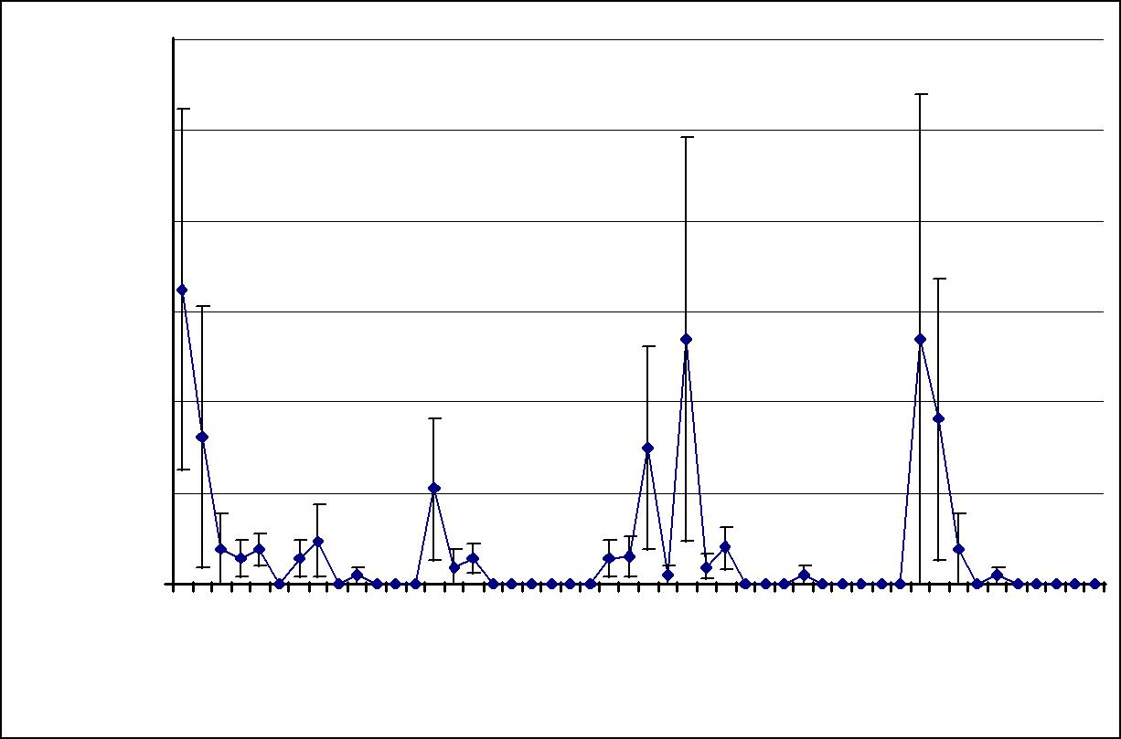

 |  | 300
 |  | 250
CFU/l |  | 200
Legionella |  | 150
 |  | 100
 |  |  | 50
 |  |  |  | 0
 |  |  |  | . |  | 008 |  | 008 |  |  |  | 8 |  |  |  | 9 |  | 009 |  | 010 |  | 010 |  |  |  | 0 |  |  |  |  | 1
 |  |  |  | 7 |  |  |  |  |  |  | 0 |  |  |  | 0 |  |  |  |  |  |  |  |  |  | 1 |  |  |  |  | 1
 |  |  | 00 |  | /2 |  | /2 |  |  |  |  |  | /2 |  |  |  | /2 |  | /2 |  | /2 |  |  |  |  |  |  | /2
 |  | 2 |  |  |  |  |  |  |  | /20 |  |  |  | /06/20 |  |  |  |  |  |  |  |  |  | /20 |  |  |  |  | /05/20
 | 0/ |  |  |  |  |  |  |  |  | 6 |  |  | 0 |  |  |  |  |  |  |  |  |  |  | 5 |  |  | 8
 | /1 |  |  |  |  |  |  |  | /0 |  |  |  | /1 |  |  |  |  |  |  |  |  |  | /0 |  |  |  | /0
05 |  |  |  | 09/01 |  | 01/04 |  | 0 |  |  | 06 |  |  | 08/01/200926/03/2009 | 26/10 |  |  | 18/01 |  | 06/04 |  | 5 |  |  | 16 |  |  |  | 6
 |  |  |  |  |  |  | 3 |  |  |  |  |  |  |  |  |  |  |  |  |  | 2 |  |  |  |  |  |  |  | 15/11/201025/02/2011
Graph 4.1 Study hospital 1 – Average Legionella results from the 05th October 2007 to the 11th July 2011.

Graphs 4.2 and 4.3 below show the average copper and silver levels found in samples taken monthly from the 21 outlets tested from the 05th October 2007 to the 11th July 2011.

96

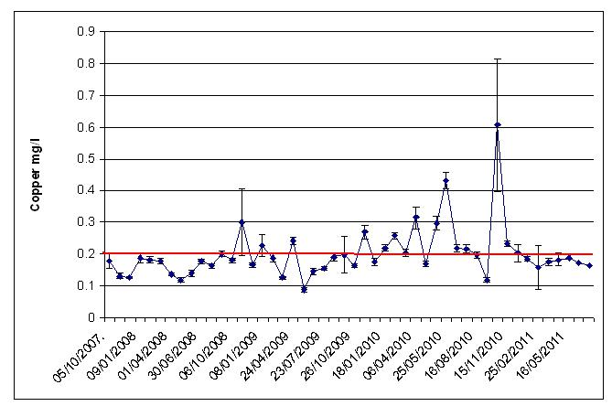

Graph 4.2 Study hospital 1 – Average copper levels from the 05th October 2007 to the 11th July 2011 (the red line is the target level for copper of 0.2mg/l).

The average copper level from the 05th October 2007 to the 11th July 2011 was 0.201mg/l (± 0.012mg/l).
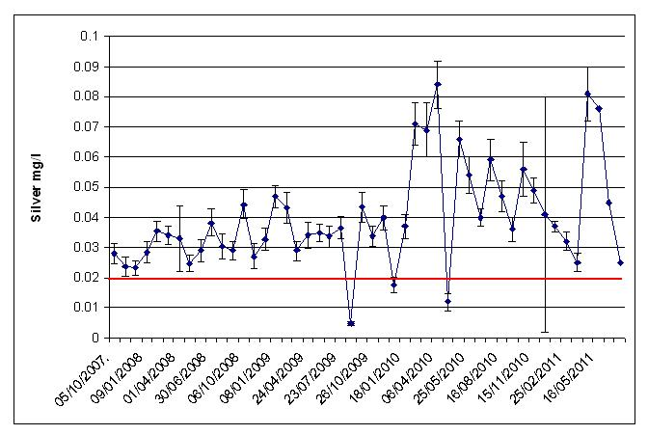

Graph 4.3 Study hospital 1 – Average silver levels from the 05th October 2007 to the 11th July 2011 (the red line is the target level for silver of 0.02mg/l).

97

The average silver level from the 05th October 2007 to the 11th July 2011 was 0.04mg/l (± 0.002mg/l).

Legionella persisted, albeit at reduced counts, in samples taken from outlets at which either less than the copper target level or less than the silver target level was found, and at outlets at which less than both the copper and the silver target levels were found. No Legionella were found in samples taken from cold water outlets at which water temperatures above 20ºC were recorded when the copper and silver target levels were being maintained. No Legionella were also found in samples taken from hot water outlets at which water temperatures below 50ºC were recorded when the copper and silver target levels were being maintained.

The average cold water temperature recorded monthly at the outlets samples were taken from, from the 05th October 2007 to the 11th July 2011, was 17ºC (± 0.3ºC). The average hot water temperature recorded was 41ºC (± 0.4ºC).

The chloride level found in a sample taken on the 05th April 2011 from the incoming mains was 15.1mg/l, the phosphorus was 455µg/l, and the pH was 8.5.

98

4.2 Study hospital 2

The results of samples taken on the 10th January 2008, before the copper and silver ionization system was activated, are shown in Table 4.3 below.

Sample Point | Temp. | Silver | Copper | Legionella
 | ºC | Mg/l | Mg/l | CFU/l
43.32.1 MT hot | 28 | 0.0003 | 0.088 | <LOD
49-023-1 HT | 57 | 0.0003 | 0.070 | <LOD
49-023-1 CT | 13 | 0.0003 | 0.018 | 100 np
56-030-1 MT hot | 14 | 0.0003 | 0.156 | 2200 np
19-069-01 MT hot | 45 | 0.0003 | 0.039 | 100 np
17-029-01 HT | 55 | 0.0003 | 0.064 | <LOD
17-029-01 HT | 15 | 0.0003 | 0.063 | <LOD
23-024-01 MT hot | 18 | 0.0003 | 0.036 | 100 s1
18-054-01 HT | 41 | 0.0003 | 0.059 | <LOD
18-054-01 CT | 13 | 0.0003 | 0.026 | <LOD
16-027-01 HT | 57 | 0.0003 | 0.053 | <LOD
16-027-01 CT | 12 | 0.0003 | 0.013 | <LOD
13-027-01 HT | 53 | 0.0003 | 0.044 | <LOD
13-027-01 CT | 11 | 0.0003 | 0.026 | <LOD
14-040.2 HT | 54 | 0.0003 | 0.039 | <LOD
14-040.2 CT | 12 | 0.0003 | 0.018 | <LOD
12-049-01 MT hot | 39 | 0.0003 | 0.035 | <LOD
10-0-014 MT hot | 36 | 0.0003 | 0.071 | <LOD
10-131-1 MT hot | 44 | 0.0003 | 0.047 | <LOD
12-107-1 HT | 56 | 0.0003 | 0.043 | <LOD
12-107-1 CT | 14 | 0.0003 | 0.014 | <LOD
14-137.1 MT hot | 38 | 0.0003 | 0.030 | <LOD
13-128-1 HT | 55 | 0.0003 | 0.042 | <LOD
13-128-01 CT | 12 | 0.0003 | 0.015 | <LOD
16-128-1 MT hot | 32 | 0.0003 | 0.057 | 5900 np
17-103-1 MT hot | 41 | 0.0003 | 0.042 | 100 np
19-156 1 HT | 59 | 0.0003 | 0.034 | <LOD
19-156-1 CT | 12 | 0.0003 | 0.009 | 200 np
20-136-1 HT | 57 | 0.0003 | 0.387 | <LOD
20-136-1 CT | 11 | 0.0003 | 0.047 | <LOD
MT = Mixer Tap, CT = Cold Tap, HT = Hot Tap, np = Legionella non-pneumophila, s1 =

Legionella pneumophila serogroup 1, <LOD = Below Limit of Detection (100CFU/l).

Table 4.3 Study hospital 2 - Results from samples taken on the 10th January 2008, before

commissioning of copper and silver ionization system.

Legionella were found at 7 out of the 30 outlets tested, around 23% of the outlets tested were, therefore, contaminated.

99

The Legionella colony forming unit counts found ranged from 100CFU/l to 5900CFU/l. The average Legionella count of the 30 outlets sampled was 290CFU/l (± 207CFU/l). Cold and blended outlets were contaminated.

The average temperature recorded at the cold water outlets was 12ºC (± 0.3ºC). The temperatures recorded at the two contaminated cold water outlets were 12ºC and 13ºC. The average temperature at the hot water outlets was 43ºC (± 3ºC).

The temperatures recorded at the 5 contaminated hot outlets were all below 50ºC mainly because the hot water was blended. The highest Legionella count, of 5900CFU/l, was found in a sample taken from a blended outlet (a shower). The temperature recorded here was 32ºC.

The average copper level found due to copper leaching from copper pipes was 0.056mg/l (± 0.013mg/l).

The copper and silver ionization system was activated on the 10th January 2008.

Table 4.4 below shows the results of samples taken on the 04th February 2008 from the 7 outlets that were contaminated before the system was activated and from 8 outlets that were identified as being at risk of Legionella contamination.

100

Sample Point |  | Temp. | Silver | Copper | Legionella
 |  | ºC | Mg/l | Mg/l | CFU/l
49-023-1 CT |  | 12 | 0.052 | 0.341 | <LOD
56-030-1 MT hot |  | 42 | 0.009 | 0.179 | 200 np
19-069-01 MT hot |  | 45 | 0.031 | 0.224 | <LOD
23-024-01 MT hot |  | 18 | 0.05 | 0.364 | <LOD
16-128-1 MT hot |  | 34 | 0.028 | 0.225 | <LOD
17-103-1 MT hot |  | 42 | 0.029 | 0.193 | <LOD
19-156-1 CT |  | 45 | 0.031 | 0.224 | <LOD
10.0-014 | MT hot | 33 | 0.033 | 0.231 | <LOD
14.0-0391 HT |  | 51 | 0.033 | 0.209 | <LOD
14.0-0391 CT |  | 12 | 0.052 | 0.347 | <LOD
13.128-1 | HT | 54 | 0.019 | 0.109 | <LOD
13.128-1 | CT | 11 | 0.054 | 0.346 | <LOD
20.136-1 | CT | 11 | 0.055 | 0.345 | <LOD
20-136-1 HT |  | 56 | 0.02 | 0.167 | <LOD
43.32-1 CT |  | 11 | 0.049 | 0.338 | <LOD
MT = Mixer Tap, CT = Cold Tap, HT = Hot Tap, np = Legionella non-pneumophila, <LOD =

Below Limit of Detection (100CFU/l).

Table 4.4 Study hospital 2 - Results from samples taken on the 04th February 2008, one month

after commissioning of copper and silver ionization system.

No Legionella were found in samples taken from 6 of the 7 outlets that were previously contaminated. Legionella persisted at one outlet but the Legionella colony forming unit count had dropped from 2200CFU/l to 200CFU/l. The temperature recorded at the contaminated outlet was 42ºC because the hot water was blended with the cold water.

The silver found in the 15 outlets tested ranged from 0.009mg/l to 0.057mg/l. The average silver level was 0.038mg/l (± 0.004mg/l). The silver found in the sample taken from the outlet in which Legionella were found was 0.009mg/l, which was below the target level of 0.02mg/l.

The copper found in the 15 outlets tested ranged from 0.109mg/l to 0.364mg/l. The average copper level was 0.263mg/l (± 0.022mg/l). The copper found in the sample taken from the outlet in which Legionella were found was 0.179mg/l, which was below the target level of 0.2mg/l.

From the 04th February 2008 onwards, the Legionella contamination around the site continued to decline except for in samples taken from one blended outlet, the 56.030.1

101

hot tap. Graph 4.4 below shows the average Legionella counts in samples taken monthly from 15 outlets from the 04th February 2008 up to the 27th July 2011.
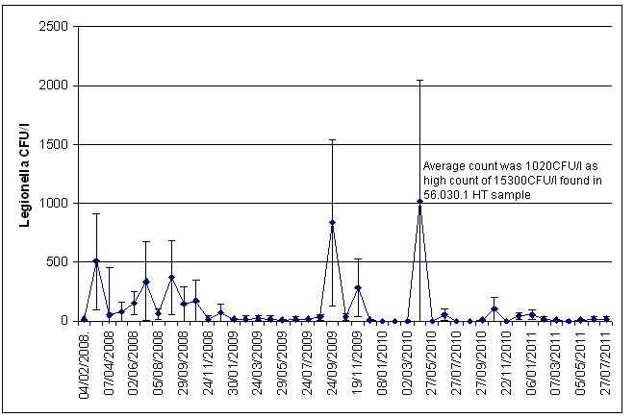

Graph 4.4 Study hospital 2 – Average Legionella results from the 04th February 2008 to the 27th July 2011.

Graphs 4.5 and 4.6 below show the average copper and silver levels found in samples taken monthly from the 15 outlets from the 04th February 2008 to the 27th July 2011.
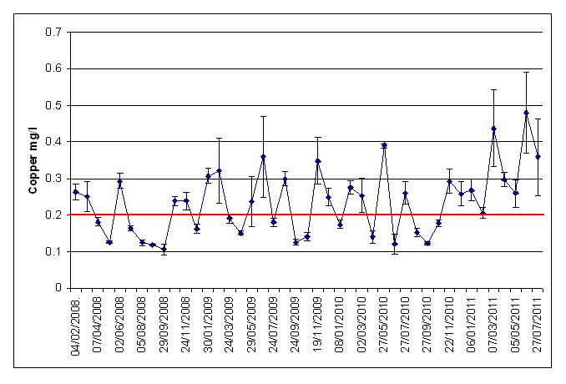

Graph 4.5 Study hospital 2 – Average copper levels from the 04th February 2008 to the 27th July 2011 (the red line is the target level for copper - 0.2mg/l).

102

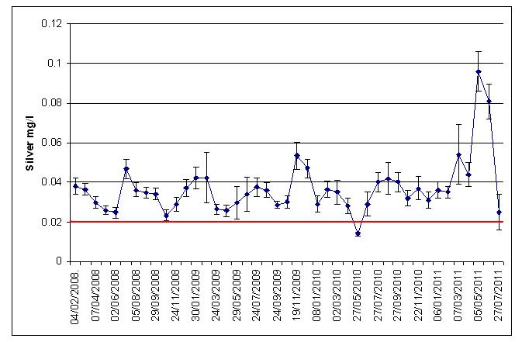

Graph 4.6 Study hospital 2. Average silver levels from the 04th February 2008 to the 27th July 2011 (the red line is the target level for silver - 0.02mg/l).

The average copper level from the 04th February 2008 to the 27th July 2011 was 0.235mg/l (±0.014mg/l).The average silver level was 0.037mg/l (± 0.002mg/l).

Table 4.5 below shows that the copper and silver target levels at the blended outlet at which Legionella persisted were not consistently maintained. Forty nine samples were taken from this outlet from the 04th February 2008 to the 27th July 2011. Legionella were found in 29 of these. The average silver level found in the contaminated samples was below the target level of more than 0.02mg/l at 0.013mg/l (± 0.002mg/l), the average copper level found was just above the target of 0.2mg/l at 0.213mg/l (± 0.012mg/l).

No Legionella were found in 20 of the 49 samples taken from the outlet. The average silver level in these samples was above the target level of more than 0.02mg/l at 0.021mg/l (± 0.005mg/l). More copper was also found than in the contaminated samples at an average level of 0.228mg/l (± 0.016mg/l).

These results suggested that both the copper and silver target levels needed to be consistently maintained at the outlet to control the Legionella, and that, especially, more silver was needed.

103

Date | Copper | Silver | Legionella
 | mg/l | mg/l | CFU/l
04/02/2008 | 0.179 | 0.009 | 200 np
04/03/2008 | 0.175 | 0.018 | 1500 np
07/04/2008 | 0.164 | 0.01 | 600 np
06/05/2008 | 0.129 | 0.006 | 1200 np
02/06/2008 | 0.255 | 0.008 | 1000 np
01/07/2008 | 0.156 | 0.008 | 5000 np
05/08/2008 | 0.129 | 0.033 | 700 np
02/09/2008 | 0.139 | 0.006 | 5600 np
02/09/2008 | 0.121 | 0.033 | 800 np
29/09/2008 | 0.291 | 0.03 | 2200 np
27/10/2008 | 0.294 | 0.003 | 2600 np
24/11/2008 | 0.293 | 0.003 | 300 np
06/01/2009 | 0.195 | 0.009 | 1100 np
30/01/2009 | 0.331 | 0.008 | 200 np
02/03/2009 | 0.26 | 0.002 | <LOD
24/03/2009 | 0.203 | 0.008 | 200 np
28/04/2009 | 0.188 | 0.015 | 300 np
29/05/2009 | 0.264 | 0.002 | <LOD
24/06/2009 | 0.356 | 0.002 | 200 np
24/07/2009 | 0.231 | 0.004 | 200 np
17/08/2009 | 0.281 | 0.002 | 200 np
24/09/2009 | 0.143 | 0.037 | <LOD
23/10/2009 | 0.158 | 0.009 | 400 np
19/11/2009 | 0.145 | 0.013 | 4200 np
19/11/2009 | 0.225 | 0.036 | 300 np
11/12/2009 | 0.21 | 0.014 | 100 np
08/01/2010 | 0.217 | 0.014 | <LOD
08/01/2010 | 0.215 | 0.015 | <LOD
02/02/2010 | 0.294 | 0.028 | <LOD
02/03/2010 | 0.326 | 0.017 | <LOD
01/04/2010 | 0.142 | 0.017 | 15300 np
27/05/2010 | 0.405 | 0.018 | <LOD
25/06/2010 | 0.252 | 0.005 | 100 np
26/07/2010 | 0.179 | 0.003 | <LOD
26/07/2010 | 0.216 | 0.034 | <LOD
25/08/2010 | 0.119 | 0.022 | <LOD
27/09/2010 | 0.121 | 0.002 | <LOD
26/10/2010 | 0.209 | 0.002 | <LOD
21/11/2010 | 0.186 | 0.019 | <LOD
09/12/2010 | 0.294 | 0.018 | 300 np
06/01/2011 | 0.216 | 0.02 | 100 np
10/02/2011 | 0.199 | 0.024 | 200 np
07/03/2011 | 0.216 | 0.001 | 100 np
07/03/2011 | 0.265 | 0.011 | <LOD
04/04/2011 | 0.279 | 0.033 | <LOD
05/05/2011 | 0.238 | 0.086 | <LOD
01/06/2011 | 0.28 | 0.062 | <LOD
27/06/2011 | 0.216 | 0.006 | <LOD
27/07/2011 | 0.131 | 0.009 | <LOD
np = Legionella non-pneumophila, <LOD = Below Limit of Detection (100CFU/l).

Table 4.5 Copper, silver and Legionella results from the 04th February 2008 to the 27th July

2011 of samples taken from the 56.030.1 hot tap (highlighted in bold are copper and silver

levels that were below the target levels).

104

The average copper found in the samples taken from the 56.030.1 hot tap from the 04th February 2008 to the 27th July 2011 was 0.219mg/l (± 0.01mg/l). The average silver level found was 0.016mg/l (± 0.002mg/l).

The average cold water temperature recorded at the cold outlets sampled from the 10th January to the 27th July 2011 was 15ºC (± 0.2ºC). The average hot water temperature recorded at the hot and blended outlets samples was 44ºC (± 0.5ºC).

The chloride level found in a sample taken from the incoming mains on the 06th October 2009 was 17mg/l, the phosphorus was 390µg/l, and the pH was 8.45.

105

4.3 Study hospital 3

The results of samples taken on the 04th February 2008, before the copper and silver ionization system was activated, are shown in Table 4.6 below.

Sample Point | Temp. | Silver | Copper | Legionella
 | ºC | Mg/l | Mg/l | Cfu/l
APN 58 MT | 35 | 0.004 | 0.034 | <LOD
APN 49 CT | 16 | <0.003 | 0.043 | 100 np
APN 49 MT | 39 | <0.003 | 0.056 | 1100 np
NE 12 CT | 17 | <0.003 | 0.035 | <LOD
NE 46 MT | 34 | <0.003 | 0.047 | <LOD
PE 30 CT | 16 | <0.003 | 0.069 | <LOD
DS 82 Shower Hot | 34 | <0.003 | 0.042 | <LOD
DS 99 HT | 57 | <0.003 | 0.063 | <LOD
DS 55 CT | 20 | <0.003 | 0.029 | <LOD
DS 50 MT | 39 | <0.003 | 0.044 | <LOD
ANC 18 CT | 15 | <0.003 | 0.037 | <LOD
ANC 18 MT | 41 | <0.003 | 0.054 | <LOD
ANC 28 MT | Not Taken | Not Taken | Not Taken | 1200 s1
ANC 28 CT | 14 | <0.003 | 0.109 | <LOD
Toilet Near 9 CT | 12 | 0.014 | 0.033 | <LOD
GW 1 MT | 38 | <0.003 | 0.057 | <LOD
GW 25 Shower Hot | 41 | <0.003 | 0.059 | <LOD
GW 50 MT | 38 | <0.003 | 0.058 | 500 np
GW 85 MT | 38 | 0.021 | 0.051 | <LOD
SO 37 Shower Cold | 13 | 0.015 | 0.034 | <LOD
SO 37 Shower Hot | 42 | 0.006 | 0.073 | <LOD
MT = Mixer Tap, CT = Cold Tap, HT = Hot Tap, np = Legionella non-pneumophila, s1 =

Legionella pneumophila serogroup 1, <LOD = Below Limit of Detection (100CFU/l).

Table 4.6 Study hospital 3 - Results from samples taken on the 04th February 2008, before

commissioning of copper and silver ionization system.

Legionella were found at one cold outlet, at 100 cfu/l, and at three blended outlets, at 1200 cfu/l, 1100 cfu/l, and 500 cfu/l. Twenty one outlets were tested, around 20% were, therefore, contaminated.

The Legionella colony forming unit counts found ranged from 100CFU/l to 1200CFU/l. The average Legionella count of the 21 outlets sampled was 138CFU/l (± 77CFU/l).

The average temperature recorded at the cold water outlets was 16ºC (± 1ºC). The temperature recorded at the contaminated cold water outlet was 16ºC. The average temperature at the hot water outlets was 38ºC (± 2.5ºC). The temperatures recorded at

106

the 3 contaminated hot outlets were all below 50ºC mainly because the hot water was blended.

The average copper level found due to copper leaching from copper pipes was 0.051mg/l (± 0.004mg/l).

The copper and silver ionization system was activated on the 04th February 2008.

Table 4.7 below shows the results of samples taken on the 06th March 2008. Samples were taken from the 4 outlets that were contaminated before the system was activated and from 6 outlets that were identified as being at risk of Legionella contamination.

Sample Point | Temp. | Silver | Copper | Legionella
 | ºC | Mg/l | Mg/l | CFU/l
APN 49 CT | 10 | 0.092 | 0.199 | <LOD
APN 49 MT | 40 | 0.045 | 0.162 | <LOD
ANC 28 MT | 40 | 0.049 | 0.188 | <LOD
GW 50 MT | 41 | 0.041 | 0.158 | <LOD
DS 82 Shower Hot | 41 | 0.039 | 0.155 | <LOD
DS 50 MT | 42 | 0.043 | 0.156 | <LOD
DS 50 CT | 10 | 0.083 | 0.183 | <LOD
S0 37 Shower Cold | 11 | 0.115 | 0.287 | <LOD
SO 37 Shower Hot | 42 | 0.044 | 0.150 | <LOD
GW 25 Shower Hot | 41 | 0.046 | 0.157 | <LOD
MT = Mixer Tap, CT = Cold Tap, <LOD = Below Limit of Detection (100CFU/l).

Table 4.7 Study hospital 3 - Results from samples taken on the 06th March 2008, one month after commissioning of copper and silver ionization system..

No Legionella were found in these samples with silver levels of between 0.039mg/l and 0.115mg/l, the average silver level was 0.060mg/l (± 0.008mg/l), and copper levels of between 0.150mg/l and 0.287mg/l, the average copper level was 0.180mg/l (± 0.013mg/l).

The hot water temperatures recorded were all below 50ºC because it was blended water. The average hot water temperature recorded was 41ºC (± 0.3ºC). The average cold water temperature recorded was 10ºC (± 0.3ºC).

Legionella persisted at 1 blended outlet, APN 49 mixer tap (set on hot), until June 2009, after which no Legionella were detected in samples taken to May 2011, see

107

Graph 4.7 below. This graph shows the average Legionella count of all 10 outlets sampled monthly from the 06th March 2008 to the 19th July 2011.
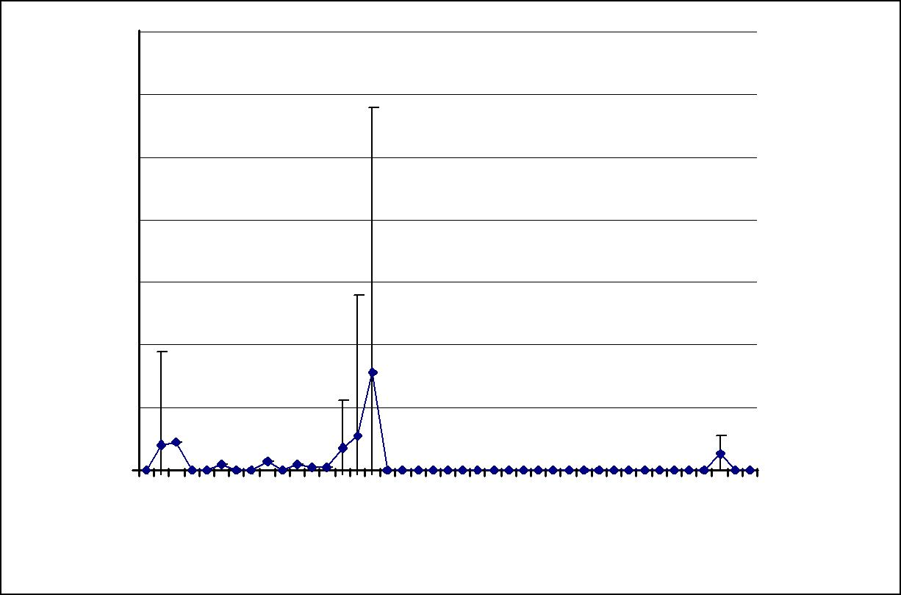

Legionella CFU/l

1400

1200

1000

800

600

400

200

0

 |  | 00 |  | . |  |  | 8 |  |  | 8 |  |  | 8 |  | 9 | 9 |  |  |  |  | 0 |  | 0 |  | 0 |  |  | 1 |  | 011
06 |  |  |  |  |  | 04 |  |  | 00 |  |  | 2 |  | 08/06/200927 |  | 00 | 26 |  |  |  | 01 | 01 |  |  | 24/11/20101 |  | 22/06 |  | /2
 | 2 |  | 0 |  |  |  |  | 0 |  |  |  |  |  |  |  | 26/11 |  |  |  | 28 |  | 2
 | /0 |  | 8 |  |  | 0 |  |  |  |  |  | 0 |  |  | 08 |  |  | /0 |  |  | /05 |  | /0 |  |  |  | 1
 |  |  |  | /0 |  |  | /0 |  |  |  | /12/20 |  | /0 |  |  |  |  |  |  |  |  |  |  |  |  | /03/20
 | 3/ |  | 4 |  | 6 |  | 9 |  | 4 |  |  |  | 3 |  |  |  |  | 2 |  |  |  |  | 8 |  |  | 9
 |  |  |  |  |  |  |  |  |  |  |  | 0 |  |  |  |  |  |  |  |  |  | 6

Graph 4.7 Study hospital 3 – Average Legionella results from the 06th March 2008 to the 19th July 2011.

Graph 4.8 shows the average copper levels found in samples taken monthly from 10 outlets from the 06th March 2008 to the 19th July 2011.

The treated water started to discolour in 2009, which may have been due to high phosphate levels in the mains water supply potentially forming precipitates with the higher levels of copper, and the copper side of the ionization system was turned off from the 08th June 2009 onwards.

The average copper levels in samples taken on the 08th June, the 09th July and the 04th August 2009 remained, however, above 0.2mg/l, at 0.26mg/l, 0.241mg/l and 0.35mg/l respectively, which was most likely residual copper from the ionization treatment as well as copper leaching from the copper pipes in the water system, but the levels reduced from the 27th August 2009 onwards. The average copper level from the 27th August to the 19th July 2011 was 0.093mg/l (± 0.025mg/l), which was solely the copper that had leached from the copper pipes.

108

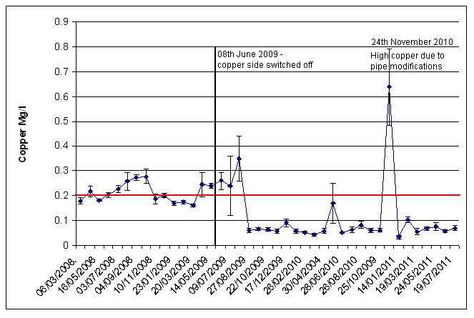

Graph 4.8 Study hospital 3 – Average copper levels from the 06th March 2008 to the 19th July 2011 (the red line is the target level for copper - 0.2mg/l).

Graph 4.9 shows the average silver level found in samples taken monthly from 10 outlets from the 06th March 2008 to the 19th July 2011.
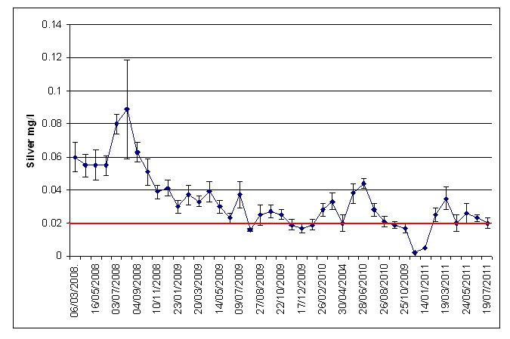

Graph 4.9 Study hospital 3 – Average silver levels from the 06th March 2008 to the 19th July 2011 (the red line is the target level for silver - 0.02mg/l).

The average silver level from the 06th March 2008 to the 19th July 2011 was 0.033mg/l (± 0.003mg/l).

109

The copper target level at the blended outlet at which Legionella persisted, the APN 49 mixer tap (set on hot), was not maintained. The silver target level was also often not maintained, see Table 4.8 below.

Date | Copper | Silver | Legionella
 | mg/l | mg/l | CFU/l
04/02/08 | 0.043 | <0.0003 | 1100 np
06/03/08 | 0.162 | 0.045 | <LOD
03/04/08 | 0.199 | 0.074 | 700 np
16/05/08 | 0.172 | 0.038 | <LOD
03/07/08 | 0.243 | 0.079 | <LOD
01/08/08 | 0.202 | 0.051 | 200 np
04/09/08 | 0.246 | 0.048 | <LOD
10/10/08 | 0.201 | 0.034 | <LOD
10/11/08 | 0.171 | 0.033 | <LOD
04/12/08 | 0.181 | 0.036 | <LOD
23/01/09 | 0.145 | 0.022 | 100 np
26/02/09 | 0.155 | 0.033 | 100 np
20/03/09 | 0.152 | 0.017 | 100 np
15/04/09 | 0.183 | 0.044 | 200 np
14/05/09 | 0.221 | 0.017 | 1000 np
08/06/09 | 0.2 | 0.016 | 2400 np
22/06/09 | 0.115 | 0.008 | <LOD
09/07/09 | 0.148 | 0.029 | <LOD
04/08/09 | 0.580 | 0.0012 | <LOD
27/08/09 | 0.086 | 0.017 | <LOD
05/10/09 | 0.074 | 0.02 | <LOD
22/10/09 | 0.075 | 0.017 | <LOD
26/11/09 | 0.071 | 0.001 | <LOD
17/12/09 | 0.098 | 0.009 | <LOD
28/01/10 | 0.056 | 0.0161 | <LOD
26/02/10 | 0.062 | 0.019 | <LOD
26/03/10 | 0.056 | 0.02 | <LOD
30/04/10 | 0.08 | 0.003 | <LOD
28/05/10 | 0.888 | 0.027 | <LOD
26/08/10 | 0.103 | 0.036 | <LOD
23/09/10 | 0.064 | 0.011 | <LOD
25/10/10 | 0.081 | 0.005 | <LOD
24/11/10 | 1.18 | 0.004 | <LOD
14/01/11 | 0.05 | 0.005 | <LOD
09/03/11 | 0.056 | 0.019 | <LOD
05/04/11 | 0.092 | 0.005 | <LOD
24/05/11 | 0.074 | 0.012 | 600 np
07/06/11 | 0.146 | 0.003 | 400 np
19/07/11 | 0.100 | 0.009 | <LOD
np = Legionella non-pneumophila, <LOD = Below Limit of Detection (100CFU/l).

Table 4.8 Copper, silver and Legionella results from the 04th February 2008 to the 19th July

2011 of samples taken from the APN 49 mixer tap (set on hot) (highlighted in bold are copper

and silver levels that were below the target levels).

No Legionella were found from June 2009 to May 2011 at this outlet, after the rubber lined flexible hoses were replaced with copper pipes in June 2009, although the

110

copper and silver target levels were not consistently met. Legionella were found in a sample taken from the outlet on the 24th May 2011 but no Legionella were found in the samples taken from the outlet on the 22nd June and the 19th July 2011, after the mixing valve attached to the outlet was cleaned.

The average copper found in the samples taken from the outlet was 0.185mg/l (± 0.04mg/l). The average silver level found was 0.023mg/l (± 0.003mg/l).

The average cold water temperature recorded at the cold outlets sampled from the 04th February 2008 to the 19th July 2011 was 17ºC (± 0.3ºC). The average hot water temperature recorded at the hot and blended outlets sampled was 41ºC (± 0.3ºC).

The chloride level found in the sample taken from the incoming mains on the 05th October 2009 was 24.5mg/l, the phosphorus was 1000µg/l, and the pH was 7.9.

111

4.4 Study hospital 4

The results of samples taken on the 08th April 2008, before the copper and silver ionization system was activated, are shown in Table 4.9 below.

Sample Point | Temp. | Silver | Copper | Legionella
 | ºC | Mg/l | Mg/l | Cfu/l
S. Ward Male Bed HT | 36 | <0.003 | 0.135 | <LOD
S11 shower hot | 34 | <0.003 | 0.169 | <LOD
S. Ward Kitchen CT | 13 | <0.003 | 0.088 | <LOD
B19 HT | 36 | <0.003 | 0.146 | <LOD
B30 bath shower cold | 13 | <0.003 | 0.085 | <LOD
B5 shower hot | 41 | <0.003 | 0.147 | 100 np
O30 CT | 15 | <0.003 | 0.094 | <LOD
O15 shower hot | 38 | <0.003 | 0.177 | <LOD
O32 CT | 13 | <0.003 | 0.074 | <LOD
L13 CT | 14 | <0.003 | 0.109 | <LOD
L37 MT hot | 40 | <0.003 | 0.227 | 4100 np
L29 CT | 19 | <0.003 | 0.291 | <LOD

HT = hot tap, CT = cold tap, MT = Mixer tap, np = Legionella non-pneumophila, <LOD = Below Limit of Detection (100CFU/l).

Table 4.9 Study hospital 4 - Results from samples taken on the 08th April 2008, before commissioning of copper and silver ionization system.

Legionella were found in samples taken from 1 shower, at 100 CFU/L, and at 1 mixer tap (set on hot), at 4100CFU/l. Twelve outlets were tested, around 17% were, therefore, contaminated.

The average temperature at the hot water outlets was 37.5ºC (± 1ºC). Mixing valves were blending the hot water with cold water at both contaminated outlets. The temperatures recorded at the outlets were, therefore, 41ºC and 40ºC. The average temperature recorded at the cold water outlets samples were taken from was 14.5ºC (± 0.9ºC).

The average copper level found due to copper leaching from copper pipes, was 0.145mg/l (± 0.019mg/l).

The copper and silver ionization system was activated on the 08th April 2008.

112

Table 4.10 below shows the results of samples taken on the 07th May 2008. Samples were taken from the 2 outlets that were contaminated before the system was activated and from 3 more blended outlets that were identified as being at risk of Legionella contamination.

Sample Point | Temp. | Silver | Copper | Legionella
 | ºC | Mg/l | Mg/l | Cfu/l
L37 MT hot | 43 | 0.034 | 0.327 | 2300 np
B5 shower hot t | 32 | 0.081 | 0.392 | <LOD
S11 shower hot | 32 | 0.096 | 0.398 | <LOD
O15 shower hot | 34 | 0.092 | 0.417 | <LOD
B32 HT | 42 | 0.091 | 0.383 | <LOD
MT = Mixer tap, HT = Hot tap, np = Legionella non-pneumophila, <LOD = Below Limit of

Detection (100CFU/l).

Table 4.10 Study hospital 4 - Results from samples taken on the 07th May 2008.

No Legionella were found in the samples taken from 4 of the 5 outlets tested. Legionella were found in 1 outlet that was previously contaminated but the Legionella colony forming unit count had dropped from 4100CFU/l to 2300CFU/l. The temperature recorded at the contaminated outlet was 43ºC, and the copper and silver levels found were 0.327mg/l copper and 0.034mg/l silver.

The average copper level of the 5 outlets tested was 0.383mg/l (± 0.015mg/l), and the average silver level was 0.079mg/l (± 0.011mg/l). The average hot water temperature recorded was 37ºC (± 2ºC) because hot water was blended with cold water.

No Legionella were found in samples taken monthly from 6 outlets from the 30th May 2008 to the 28th June 2011, see Graph 4.10 below. Except for a high count of Legionella non-pneumophila, of 22400CFU/l, which was found in a sample taken from a blended outlet (a shower, set on hot) on the 24th November 2008. No Legionella were found at this outlet, however, since rubber lined flexible hoses were replaced with copper pipes in December 2008. The average copper level found in samples taken from the outlet from January 2009 to July 2010 was 0.451mg/l (± 0.012mg/l) and the average silver level was 0.04mg/l (± 0.003mg/l).

113

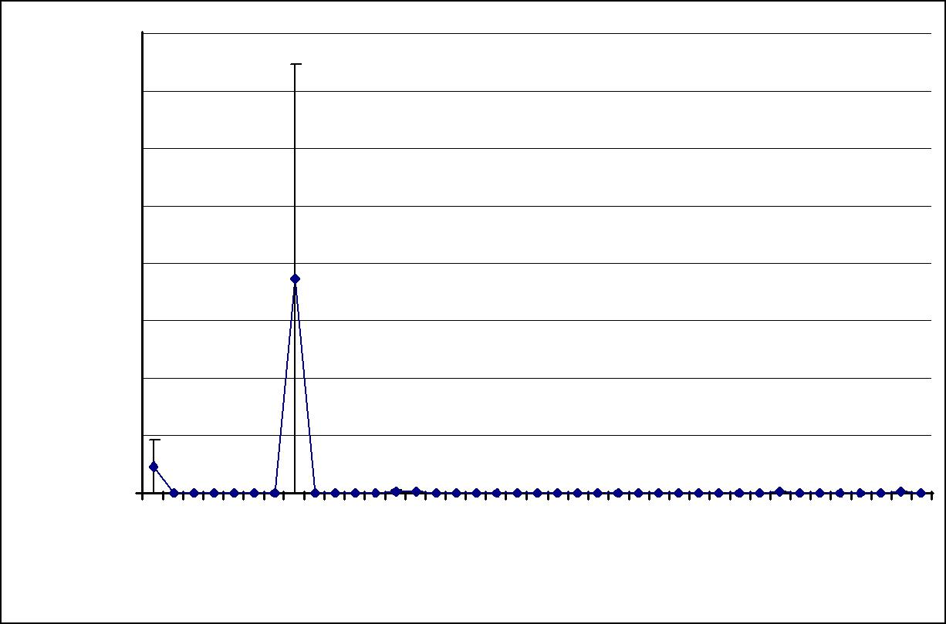
 |  | 8000
 |  | 7000
 |  | 6000
CUF/l |  | 5000
Legionella |  | 4000
 |  | 3000
 |  | 2000
 |  | 1000
 |  |  | 0
 |  |  |  |  | . |  |  | 8 | /2008 |  |  | 8 |  |  | 9 |  | 9 | /2009 |  |  | 9 |  |  |  |  | 0 |  | 0 |  | 010 |  | 0 |  |  |  | 0 |  |  | 1 |  | 1 | /2011
 |  |  |  | 8 |  |  | 0 |  |  |  |  |  |  | 00 |  | 0 |  |  |  |  | 0 |  |  |  | 01 |  | 1 |  |  |  |  | 1 |  |  |  |  |  | 01 |  | 1
 |  |  | 00 |  |  | /20 |  |  |  |  | /2 |  | /2 |  |  |  |  |  |  |  |  |  | /2 |  |  |  |  |  | /2 |  |  |  |  | /2 |  |  | /2
 |  | 2 |  |  |  |  |  |  |  |  |  |  |  |  | /05/20 |  |  |  |  |  |  |  |  |  |  | /03/20 |  |  |  |  | 7 |  |  |  |  |  |  |  | /05/20
 |  | 5/ |  |  | 7 |  |  |  |  | 0 |  | /02 |  |  |  |  |  |  |  | 9 |  | 1 |  |  |  |  |  |  |  |  |  |  | 1 |  |  | 03
 |  |  |  | /0 |  |  |  |  |  | /1 |  |  |  |  |  |  |  |  |  | /0 |  | /0 |  |  |  |  |  |  |  |  | /0 |  | /1
 | 07 | /0 | 1 |  |  |  | 03/09 27 |  |  |  |  | 05/01/200927 | 1 |  |  | 06/07 |  |  | 0 |  | 05/11/200914 |  |  | 2 |  |  | 14/05 |  | 6 |  |  | 10/09/2010 |  |  | 12/01/201103 |  | 3 |  |  | 28/06
 |  |  | 0 |  |  |  |  |  |  |  |  |  | 0 |  |  |  |  |  | 1 |  |  |  |  | 1 |  |  |  |  | 0 |  |  |  |  |  |  |  | 0
Graph 4.10 Study hospital 4 - Average Legionella results of all 6 outlets sampled monthly from the 07th May 2008 to the 28th June 2011.

Graphs 4.11 and 4.12 show the averages of the copper and silver levels found in samples taken monthly from 6 outlets from the 07th May 2008 to the 28th June 2011. The average copper level was 0.419mg/l (± 0.008mg/l). The average silver level was 0.043mg/l (± 0.003mg/l).
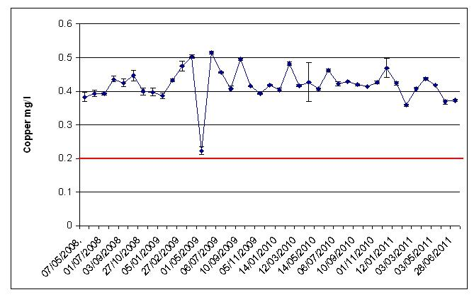

Graph 4.11 Study hospital 4 – Average copper levels from the 07th May 2008 to the 28th June 2011 (the red line is the target level for copper - 0.2mg/l).

114

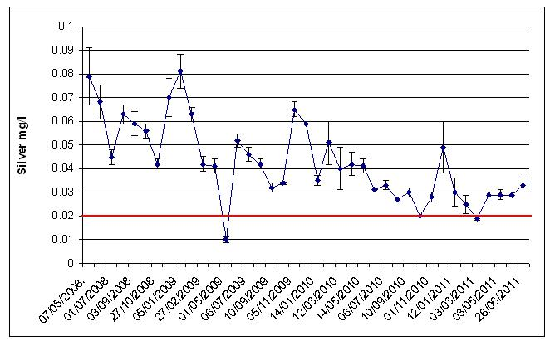

Graph 4.12. Study hospital 4 – Average silver levels from the 07th May 2008 to the 28th June 2011 (the red line is the target level for silver - 0.02mg/l).

The average hot water temperature recorded at the blended outlets sampled from the 07th May 2008 to the 28th June 2011 was 38ºC (± 0.3ºC).

The chloride level found in the sample taken from the incoming mains on the 08th October 2009 was 30.2mg/l, the phosphorus was 577µg/l, and the pH was 7.47.

115

4.5 Study hospital 5

The results of samples taken on the 25th July 2008, before the copper and silver ionization systems were activated, are shown in Table 4.11 below.

The samples were taken from pure cold and pure hot outlets but in order to obtain a wider view of the potential contamination of the cold and hot water system and to reduce analysis costs, samples were also taken by filling sample bottles half with hot water and half with cold water from 17 mixer taps, these outlets are abbreviated as H&C on Table 4.11 below.

116

Sample Point |  | Temp. | Silver | Copper | Legionella
 |  | ºC | Mg/l | Mg/l | CFU/l
3.2.118 | HT | 60 | <0.0003 | 0.214 | <LOD
3.2.118 | CT | 17 | <0.0003 | 0.067 | <LOD
S1 nurse station HT |  | 42 | <0.0003 | 0.160 | <LOD
S1.nurse station CT |  | 17 | <0.0003 | 0.085 | <LOD
3.2.036 | HT | 43 | <0.0003 | 0.176 | 100 np
3.2.036 | CT | 17 | <0.0003 | 0.176 | 400 np
S2 nurse station CT |  | 17 | <0.0003 | 0.097 | 100 np
S2 nurse station HT |  | 42 | <0.0003 | 0.174 | 100 np
3.2.068 | HT | 40 | <0.0003 | 0.314 | 100 np
3.2.068 | CT | 20 | <0.0003 | 0.212 | 200 np
S3 nurse station HT |  | 59 | <0.0003 | 0.210 | <LOD
S3 nurse station CT |  | 20 | <0.0003 | 0.272 | <LOD
3.2.089.3 HT |  | 58 | <0.0003 | 0.209 | <LOD
3.2.089.3 CT |  | 21 | <0.0003 | 0.251 | 100 np
S4 nurse station HT |  | 58 | <0.0003 | 0.200 | <LOD
S4 nurse station CT |  | 21 | <0.0003 | 0.087 | <LOD
S4 sluice H&C |  | 39 | <0.0003 | 0.155 | <LOD
3.3.118 | HT | 60 | <0.0003 | 0.205 | <LOD
3.3.118 | CT | 18 | <0.0003 | 0.074 | 200 np
H4 nurse station HT |  | 60 | <0.0003 | 0.202 | <LOD
H4 nurse station CT |  | 28 | <0.0003 | 0.640 | 600 np
3.3.106 | H&C | 33 | <0.0003 | 0.159 | <LOD
H3 nurse station HT |  | 42 | <0.0003 | 0.232 | 300 s1
H3 nurse station CT |  | 20 | <0.0003 | 0.190 | 100 np
H3 cleaners H&C |  | 34 | <0.0003 | 0.182 | 300 np
H2 nurse station HT |  | 54 | <0.0003 | 0.213 | <LOD
H2 nurse station CT |  | 23 | <0.0003 | 0.433 | 200 np
Room 68 H&C |  | 37 | <0.0003 | 0.450 | 400 np
3.3.032/2 H&C |  | 30 | <0.0003 | 0.151 | 100 np
3.3.019 | H&C | 28 | <0.0003 | 0.202 | 500 np
M kitchen HT |  | 59 | <0.0003 | 0.050 | <LOD
M kitchen CT |  | 17 | <0.0003 | 0.127 | <LOD
M shower H&C |  | 28 | <0.0003 | 0.147 | <LOD
M sluice HT |  | 55 | <0.0003 | 0.208 | <LOD
M sluice CT |  | 22 | <0.0003 | 0.202 | 2400 np
A kitchen CT |  | 25 | <0.0003 | 17.9 | <LOD
4.3.39 H&C |  | 27 | <0.0003 | 0.174 | 1100 np
F S1 H&C |  | 31 | <0.0003 | 4.92 | 100 np
C2094 H&C |  | 35 | <0.0003 | 0.187 | <LOD
C2027 CT |  | 20 | <0.0003 | 0.100 | 100 s1
Theatres H&C |  | 34 | <0.0003 | 0.127 | 100 s1
Endoscopy H&C |  | 31 | <0.0003 | 0.208 | 100 np
Maternity sluice H&C |  | 35 | <0.0003 | 0.204 | <LOD
D.1.12 H&C |  | 43 | <0.0003 | 0.178 | 300 np
6.2.142 | H&C | 36 | <0.0003 | 0.448 | 2600 s1
C3152 H&C |  | 35 | <0.0003 | 0.168 | 300 s1
C3100 shower HT |  | 37 | <0.0003 | 0.149 | <LOD
C3060 H&C |  | 33 | <0.0003 | 0.213 | <LOD
C3057 HT |  | 57 | <0.0003 | 0.207 | <LOD
C3057 CT |  | 19 | <0.0003 | 0.161 | <LOD
C3100 after filter HT |  | 33 | <0.0003 | 0.136 | <LOD

HT = Hot tap, CT = Cold tap, H&C = sample filled with half hot and half cold water, np = Legionella non-pneumophila, s1 = Legionella pneumophila serogroup 1, <LOD = Below Limit of Detection (100CFU/l).

Table 4.11 Study hospital 5 - Results from samples taken on the 25th July 2008, before commissioning of copper and silver ionization systems.

117

Legionella were found in samples taken from 25 outlets. Fifty one outlets were sampled, therefore, around 49% of the outlets were contaminated.

The Legionella colony forming unit counts found ranged from 100CFU/l to 2600CFU/l. The average Legionella count of the 51 outlets sampled was 214CFU/l (± 10CFU/l). Blended and cold outlets were contaminated and Legionella were found in 11 of the 17 H&C samples taken.

The water temperatures recorded at 6 of the 17 cold water outlets sampled were above 20ºC. The average at the 17 cold water outlets tested was 20ºC (± 0.8ºC).

The average hot water temperature at the 17 hot water outlets tested was 51ºC (± 2ºC). Although mixing valves were hidden and could not be seen, the hot water was, most likely, blended with cold water at 7 of the 17 hot water outlets tested because the temperatures recorded at these were ranging from 33ºC to 43ºC.

The average temperature recorded in the 17 H&C samples was 33ºC (± 1ºC).

The average copper level found at the 51 outlets, due to copper leaching from copper pipes, was 0.323mg/l (± 0.014mg/l).

The copper and silver ionization systems were activated on the 25th July 2008.

Table 4.12 below shows the results of samples taken on the 18th August 2008 from the 25 outlets that were contaminated before the systems were activated.

118

Sample Point |  | Temp. | Silver | Copper | Legionella
 |  | ºC | Mg/l | Mg/l | CFU/l
3.2.036 | HT | 22 | 0.074 | 0.434 | <LOD
3.2.036 | CT | 20 | 0.06 | 0.378 | <LOD
S2 nurse station CT |  | 43 | 0.080 | 0.428 | <LOD
S2 nurse station HT |  | 22 | 0.086 | 0.390 | <LOD
3.2.068 | HT | 43 | 0.066 | 0.473 | <LOD
3.2.068 | CT | 22 | 0.081 | 0.451 | <LOD
3.2.089.3 CT |  | 20 | 0.099 | 0.404 | <LOD
3.3.118 | CT | 18 | 0.1 | 0.380 | <LOD
H4 nurse station CT |  | 22 | 0.089 | 0.424 | <LOD
H3 nurse station HT |  | 45 | 0.074 | 0.462 | <LOD
H3 nurse station CT |  | 18 | 0.094 | 0.444 | <LOD
H3 cleaners H&C |  | 28 | 0.063 | 0.469 | <LOD
H2 nurse station CT |  | 19 | 0.056 | 0.749 | <LOD
Room 68 H&C |  | 35 | 0.039 | 0.612 | 200 np
3.3.032/2 H&C |  | 29 | 0.091 | 0.427 | 400 np
3.3.019 | H&C | 27 | 0.086 | 0.428 | 800 np
M sluice CT |  | 18 | 0.089 | 0.472 | <LOD
4.3.39 H&C |  | 32 | 0.084 | 0.540 | <LOD
F S1 H&C |  | 34 | 0.076 | 0.565 | <LOD
Theatres H&C |  | 32 | 0.094 | 0.428 | <LOD
Endoscopy H&C |  | 29 | 0.1 | 0.410 | <LOD
D.1.12 H&C |  | 34 | 0.083 | 0.434 | <LOD
6.2.142 | H&C | 32 | 0.019 | 0.746 | 100 s1 + 200 np
C2027 CT |  | 22 | 0.09 | 0.421 | <LOD
C3152 H&C |  | 30 | 0.097 | 0.438 | <LOD

HT = Hot tap, CT = Cold tap, H&C = sample filled with half hot and half cold water, np = Legionella non-pneumophila, s1 = Legionella pneumophila serogroup 1, <LOD = Below Limit of Detection (100CFU/l).
Table 4.12 Study hospital 5 - Results from samples taken on the 18th August 2008.

No Legionella were found in samples taken from 21 outlets that were previously contaminated. Only H&C samples were contaminated. The highest Legionella count was 800CFU/l. The temperature recorded in this sample was 27ºC.

The cold temperatures remained above 20ºC at 4 out of the 10 cold water outlets tested. The hot water temperatures were predominantly below 50ºC because it was, most likely, blended water. The hot water temperature was particularly low at 22ºC at the 3.2.036 hot tap.

119

The silver found in the 25 outlets tested ranged from 0.019mg/l to 0.1mg/l. The average silver level was 0.079mg/l (± 0.004mg/l). The copper ranged from 0.378mg/l to 0.749mg/l. The average copper level was 0.472mg/l (± 0.02mg/l).

Because the Legionella contaminated H&C samples that were taken on the 18th August 2008 were half filled with hot water and topped up with cold water, samples were taken on the 15th September 2008 from the hot and the cold sides of the 4 mixer taps. The results are shown in Table 4.13 below.

 | Temp. | Silver | Copper | Legionella
Sample Point |  |  |  | CFU/l
 | ºC | Mg/l | Mg/l
Room 68 HT | 42 | 0.038 | 0.553 | 2500 np
Room 68 CT | 18 | 0.05 | 0.601 | 500 np
3.3.032/2 HT | 39 | 0.06 | 0.513 | <LOD
3.3.032/2 CT | 14 | 0.066 | 0.582 | <LOD
3.3.019 HT | 40 | 0.067 | 0.503 | <LOD
3.3.019 CT | 14 | 0.055 | 0.580 | 100 np
6.2.142 HT | 38 | 0.02 | 0.498 | 100 np
6.2.142 CT | 20 | 0.021 | 0.869 | 100 np
HT = Hot tap, CT = Cold tap, np = Legionella non-pneumophila, <LOD = Below Limit of Detection (100CFU/l).

Table 4.13 - Study hospital 5 - Results from samples taken on the 15th September 2008 from single hot and cold taps of the previously Legionella contaminated outlets.

Both the hot and cold water was contaminated at 2 of the 4 outlets tested. The cold water only was contaminated at 1 of the 4 outlets tested. The highest Legionella count, of 2500CFU/l, was found at a hot outlet that was, most likely, blended because the temperature recorded was 42ºC.

From the 15th September 2008, the Legionella contamination declined in the blended and cold water system, except for at 1 hot outlet at which a Legionella count of 2800CFU/l was found, and at 1 cold outlet at which a count of 3700CFU/l was found in samples taken on the 13th November 2008. The samples were taken from the hot and cold outlets of the same sink. The cold water was, most likely, contaminating the hot water because the water was, probably, blended as the temperature recorded was 35ºC. Although a higher count, of 1300CFU/l, was found in a sample taken on the 14th January 2009 after running the cold outlet for 10 minutes, after the rubber lined flexible hoses were replaced in November 2008, the Legionella counts declined. No

120

Legionella were found at both outlets from February 2009 onwards. The average silver level found in the samples taken from the hot outlet from the 15th September 2008 to March 2010 was 0.026mg/l (± 0.003mg/l), and the average copper level was 0.463mg/l (± 0.02mg/l). The average silver level found in the samples taken from the cold outlet was 0.020mg/l (± 0.005mg/l), and the average copper level was 0.464mg/l (± 0.03mg/l). The average hot temperature was 39ºC (± 1ºC). The average cold temperature was 22ºC (± 1ºC).

Legionella counts were found in samples taken on the 18th November 2010 from a cold outlet, at 3100CFU/l, from the hot outlet of the same sink, at 5800CFU/l, and from another cold outlet, at 1500CFU/l. The temperatures recorded at the 2 cold outlets were both 16ºC. The temperature recorded at the hot outlet was 40ºC, most likely, because it was blended water. The copper and silver targets were met in these samples but the copper and silver had been below the targets previously. The outlets were flushed regularly after the Legionella were found, and the copper and silver levels were kept above 0.3mg/l copper and 0.08mg/l silver in samples taken in January, February and March 2011. In samples taken on the 04th May 2011 the copper and silver levels dropped to 0.189mg/l copper and to 0.052mg/l silver in 1 of the cold outlet samples and to 0.233mg/l copper and to 0.043mg/l silver in the hot outlet sample, and Legionella returned, albeit at lower counts of 100CFU/l in the cold outlet sample and 200CFU/l in the hot outlet sample. The average of the temperatures recorded from January 2011 to the 04th May 2011 was 43ºC (± 2ºC) at the hot outlet and 15ºC (± 0.5ºC), 14ºC (± 0.4ºC) at the cold outlets.

Graph 4.13 below shows the average Legionella counts in samples taken monthly from 20 outlets from the 18th August 2008 to the 04th July 2011.

121

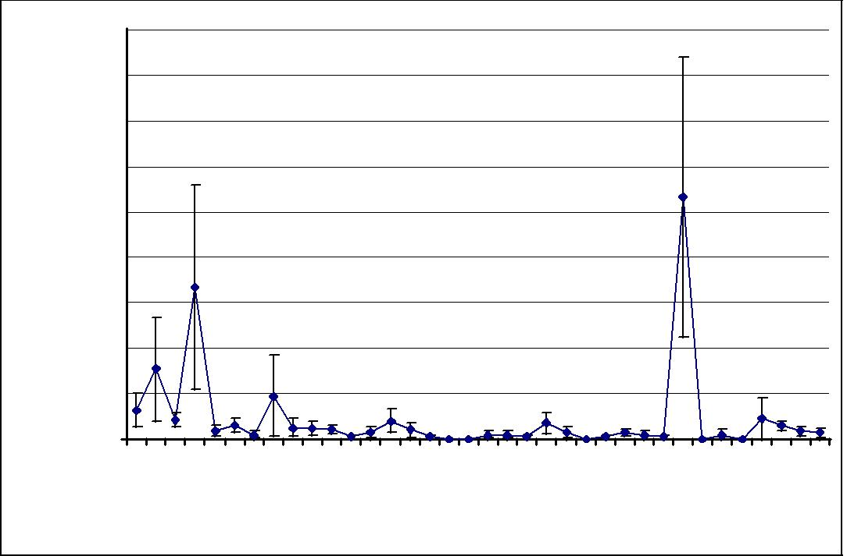
 | 900
 | 800
 | 700
CFU/l | 600
 | 500
Legionella
 | 400
 | 300
 | 200
 | 100
 |  | 0
 |  |  | . |  |  | 8 | 08 |  |  | 9 |  |  |  |  |  |  | 9 |  |  | 09 |  |  | 0 |  |  |  |  | 0 |  |  | 10 |  |  | 011 | 1 |  | 11
 |  | 08 |  |  | 0 |  |  |  | 0 |  | 20 |  |  |  |  | 0 |  |  |  |  |  |  | 1 | 20 |  |  |  | 1 |  |  |  |  |  |  | 1
 | 0 |  |  | 0/20 |  |  |  | 4/20 |  |  |  |  |  |  | 0/20 |  |  | 20 |  |  |  |  |  |  |  |  |  |  | /20 |  |  |  | 2 |  |  |  | /20
/08/2 |  |  |  |  |  | 12/ |  |  |  | 06/ |  |  |  |  |  |  | 11/ |  |  |  | /01/2010 |  | 05/ |  |  | /07/2010 |  |  | 1 |  |  | /02/ |  |  |  | 6
 |  |  | 1 |  |  |  |  | 0 |  |  |  |  |  | 1 |  |  |  |  |  |  |  |  |  |  |  |  |  | 1 |  |  |  |  |  |  | 0
 |  |  |  |  | 1/ |  | 11/02/200906/ |  | 0/ |  |  |  | /08/2009 |  |  | 0/ |  |  |  |  |  |  | 0/
18 |  | 16/ |  |  |  |  |  |  |  |  |  | 5 |  | 05/ |  |  |  |  | 5 |  |  |  |  |  | 0 |  | 20/09/2018/ |  |  | 1 |  |  |  | 28/03/2006/
 |  |  |  |  | 1 |  |  |  | 1 |  |  | 0 |  |  |  | 3 |  |  | 2 |  |  | 22/03/201 |  |  | 2 |  |  |  |  | 0
Graph 4.13 Average Legionella counts in samples taken monthly from 20 outlets from the 18th August 2008 to the 04th July 2011.

Graphs 4.14 and 4.15 show the averages of the copper and silver levels found in samples taken monthly from 20 outlets from the 15th September 2008 to the 04th July 2011. The average copper level was 0.366mg/l (± 0.02mg/l). The average silver level was 0.043mg/l (± 0.003mg/l).
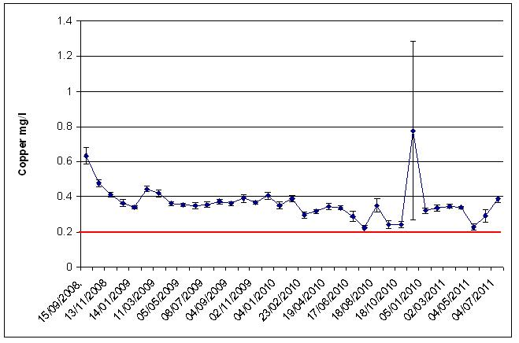

Graph 4.14. Study hospital 5 – Average copper levels from 15th September 2008 to the 04th July 2011 (the red line is the target level for copper - 0.2mg/l).

122

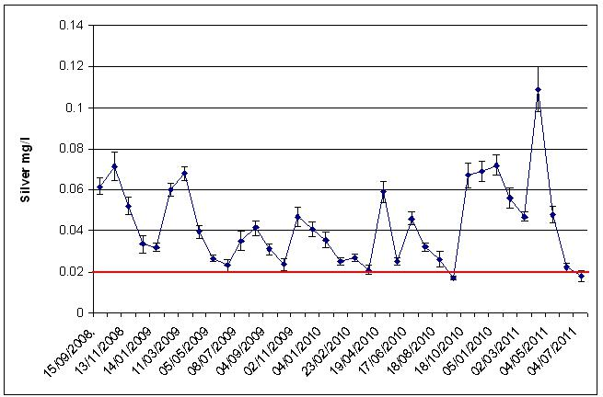

Graph 4.15. Study hospital 5 – Average silver levels from the 15th September 2008 to the 04th July 2011 (the red line is the target level for silver - 0.02mg/l).

The average hot water temperature recorded from the 15th September 2008 to the 04th July 2011 was 46ºC (± 0.5ºC). The average cold water temperature was 16ºC (± 0.2ºC).

The chloride level found in the sample taken from the incoming mains on the 30th November 2010 was 60.7mg/l, the phosphorus was 701µg/l, and the pH was 7.24.

123

4.6 Study hospital 6

The results of samples taken on the 02nd October 2008, before the copper and silver ionization systems were activated, are shown in Table 4.14 below.

124

Sample Point | Temp. | Silver | Copper | Legionella
 | ºC | Mg/l | Mg/l | CFU/l
92-1-010 CT | 16 | <0.0003 | 0.058 | <LOD
31-01-019 CT | 17 | <0.0003 | 0.060 | <LOD
32-01-027 CT | 21 | <0.0003 | 0.473 | <LOD
32-01-007 HT | 14 | <0.0003 | 0.645 | <LOD
39-01-004 CT | 16 | <0.0003 | 0.043 | <LOD
39-01-004 HT | 59 | <0.0003 | 0.312 | <LOD
10-06-051 HT | 36 | <0.0003 | 0.428 | <LOD
10-01-040 HT | 42 | <0.0003 | 0.228 | <LOD
10-01-059 CT | 23 | <0.0003 | 0.185 | <LOD
047-2-002 CT | 19 | <0.0003 | 0.020 | 400 np
047-2-002 HT | 61 | <0.0003 | 0.156 | <LOD
003-1-018 HT | 55 | <0.0003 | 0.285 | <LOD
003-1-018 CT | 20 | <0.0003 | 0.091 | 100 np
075-2-006 HT | 39 | <0.0003 | 0.245 | <LOD
075-2-006 CT | 17 | <0.0003 | 0.093 | <LOD
074-06-041 CT | 22 | <0.0003 | 0.182 | 100 np
074-06-057 HT | 37 | <0.0003 | 0.408 | <LOD
074-G-074 CT | 21 | <0.0003 | 0.203 | <LOD
011-G-075 CT | 16 | <0.0003 | 0.045 | 100 np
011-06-042 HT | 52 | <0.0003 | 0.301 | <LOD
011-06-042 CT | 20 | <0.0003 | 0.096 | 100 np
030-G-022 HT | 31 | <0.0003 | 0.568 | 600 np
030-G-022 CT | 18 | <0.0003 | 0.139 | 300 np
072-1-006 CT | 17 | <0.0003 | 0.057 | <LOD
072-1-006 HT | 52 | <0.0003 | 0.370 | <LOD
071-1-006 CT | 17 | <0.0003 | 0.047 | <LOD
071-1-006 HT | 52 | <0.0003 | 0.389 | <LOD
005-G-058 HT | 37 | <0.0003 | 0.399 | <LOD
007-1-025 CT | 24 | <0.0003 | 0.340 | 4000 s1
067-G-001 CT | 21 | <0.0003 | 0.122 | <LOD
067-G-001 HT | 36 | <0.0003 | 0.412 | 100 s1
004-G-037 CT | 21 | <0.0003 | 0.122 | <LOD
004-2-012 HT | 54 | <0.0003 | 0.213 | <LOD
004-2-012 CT | 26 | <0.0003 | 0.225 | <LOD
009-G-042 HT | 41 | <0.0003 | 0.422 | <LOD
009-G-042 CT | 22 | <0.0003 | 0.374 | <LOD
001-G-062 HT | 42 | <0.0003 | 0.522 | <LOD
001-G-062 CT | 21 | <0.0003 | 0.116 | 800 np
095-G-B027 CT | 18 | <0.0003 | 0.086 | <LOD
095-G-B021 CT | 25 | <0.0003 | 1.28 | <LOD
095-G-B021 HT | 40 | <0.0003 | 1.14 | <LOD
095-1-H038 HT | 39 | <0.0003 | 0.784 | <LOD
095-1-H038 CT | 21 | <0.0003 | 0.658 | <LOD
095-G F21 CT | 17 | <0.0003 | 0.213 | <LOD
095-G-F21 HT | 39 | <0.0003 | 0.347 | <LOD
030-G-079 HT | 40 | <0.0003 | 0.414 | <LOD
030-G-079 CT | 18 | <0.0003 | 0.102 | <LOD
021-1-037 CT | 20 | <0.0003 | 0.159 | 200 np
021-G-032 CT | 21 | <0.0003 | 0.241 | <LOD
021-B-014 CT | 20 | <0.0003 | 0.285 | <LOD

HT = Hot tap, CT = Cold tap, np = Legionella non-pneumophila, s1 = Legionella pneumophila serogroup 1, <LOD = Below Limit of Detection (100CFU/l).
Table 4.14 Study hospital 6 - Results from samples taken on the 02nd October 2008, before commissioning of copper and silver ionization systems.

125

Legionella were found in samples taken from 11 outlets. Fifty outlets were sampled, therefore, 22% of the outlets were contaminated.

The Legionella colony forming unit counts found ranged from 100CFU/l to 4000CFU/l. The average Legionella count of the 50 outlets sampled was 136CFU/l (± 82CFU/l). Hot and cold outlets were contaminated.

The average hot water temperature at the 21 hot water outlets tested was 43ºC (± 2ºC). Although mixing valves were hidden and could not be seen, the hot water could have been blended with cold water at 13 of the 21 hot water outlets tested because the temperatures recorded at these were ranging from 36ºC to 42ºC.

The water temperatures recorded at 13 of the 29 cold water outlets sampled were above 20ºC. The average at the 29 cold water outlets tested was 20ºC (± 0.5ºC).

The average copper level found at the 50 outlets, due to copper leaching from copper pipes, was 0.302mg/l (± 0.037mg/l).

The copper and silver ionization systems were activated on the 02nd October 2008.

Table 4.15 below shows the results of samples taken on the 27th November 2008 from the 11 outlets that were contaminated before the systems were activated and from 14 outlets that were identified as being at risk of Legionella contamination.

126

Sample Point | Temp. | Silver | Copper | Legionella
 | ºC | Mg/l | Mg/l | CFU/l
10-06-051 HT | 40 | 0.0218 | 0.325 | <LOD
10-01-059 HT | 40 | 0.0146 | 0.435 | <LOD
047-2-002 CT | 10 | < 0.0003 | 0.011 | <LOD
003-1-018 CT | 13 | 0.0396 | 0.207 | <LOD
075-2-006 HT | 41 | 0.0027 | 0.293 | <LOD
075-2-006 CT | 10 | 0.0007 | 0.413 | <LOD
074-06-041 CT | 15 | 0.0312 | 0.252 | <LOD
074-06-057 HT | 40 | 0.0058 | 0.404 | <LOD
011-G-075 CT | 10 | 0.0139 | 0.138 | <LOD
011-06-042 CT | 14 | 0.0283 | 0.197 | <LOD
030-G-022 HT | 46 | 0.0103 | 0.519 | <LOD
030-G-022 CT | 14 | 0.0238 | 0.162 | <LOD
072-1-006 CT | 13 | 0.0124 | 0.124 | <LOD
071-1-006 CT | 11 | 0.0125 | 0.138 | <LOD
005-G-058 HT | 32 | 0.0130 | 0.428 | <LOD
007-1-025 CT | 18 | 0.0116 | 0.207 | 700 s1
007-1-025 HT | 47 | 0.0100 | 0.506 | <LOD
067-G-001 HT | 40 | 0.0115 | 0.444 | <LOD
004-G-037 CT | 13 | 0.0058 | 0.145 | <LOD
009-G-042 HT | 44 | 0.0130 | 0.391 | <LOD
001-G-062 HT | 41 | 0.0086 | 0.532 | <LOD
001-G-062 CT | 14 | 0.0157 | 0.198 | <LOD
095-G-B021 HT | 39 | 0.0047 | 1.48 | <LOD
095-1-H038 HT | 40 | 0.0048 | 0.964 | <LOD
021-1-037 CT | 16 | 0.0357 | 0.273 | <LOD
HT = Hot tap, CT = Cold tap, s1 = Legionella pneumophila serogroup 1, <LOD = Below

Limit of Detection (100CFU/l).

Table 4.15 Study hospital 6 - Results from samples taken on the27th November 2008.

No Legionella were found in samples taken from 10 outlets that were previously contaminated. The Legionella persisted only at 1 cold outlet, the 007-1-025 CT, but the count had dropped from 4000CFU/l to 700CFU/L. The silver target, of 0.02mg/l, was not met in the contaminated sample, only 0.012mg/l was found. The temperature recorded at the contaminated outlet was 18ºC.

The cold temperatures recorded at the 13 cold outlets tested were below 20ºC. The hot water temperatures at the 12 hot outlets tested were below 50ºC because it was, most likely, blended water.

The silver found in the 25 outlets tested ranged from <0.0003mg/l to 0.036mg/l. The average silver level was 0.014mg/l (± 0.002mg/l). The silver target level, of 0.02mg/l,

127

was not met at 19 of the 25 outlets tested. The copper ranged from 0.011mg/l to 1.480mg/l. The average copper level was 0.367mg/l (± 0.061mg/l. The copper target, of 0.2mg/l, was not met at 8 of the 25 outlets tested.

Re-samples for Legionella, copper and silver analysis were taken from the 007-1-025 cold outlet on the 19th December 2008. 2700CFU/l were found in the sample taken immediately after opening the outlet but the count dropped, to 300CFU/l, in the sample that was taken after running the outlet for 10 minutes. The silver target was not met in both samples and the copper target was also not met in the sample that was taken after running the outlet for 10 minutes.

It was difficult to maintain the copper and silver target levels at outlets because they were not regularly used, and although the Legionella declined from the 07th January 2009 onwards, it persisted at outlets at which very low copper and silver levels were found.

A Legionella count of 4500CFU/l was found in the brushed through rubber lined hose that was removed on the 25th March 2009 from the 007-1-025 outlet. After the hose was removed, the contamination dropped.

The copper and silver target levels were not consistently maintained at some outlets, and the contamination worsened. Legionella were found, albeit at low counts, in samples taken from 8 outlets on the 22nd July 2009, from 10 outlets on the 02nd March 2010, from 5 outlets on the 11th January 2011 and from 5 outlets on the 31st May 2011. However, after the copper and silver levels increased and the targets were consistently met at the outlets, no Legionella were detected.

Graph 4.16 below shows the average Legionella counts in samples taken monthly from 25 outlets from the 25th March 2009 to the 08th July 2011.

128

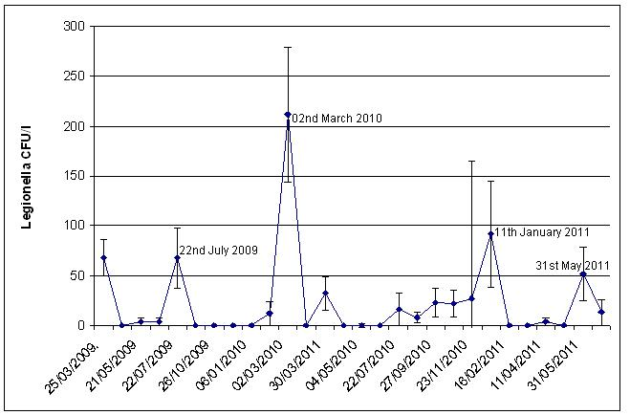

Graph 4.16 Study hospital 6 - Average Legionella counts in samples taken monthly from 25 outlets from the 25th March 2009 to the 08th July 2011.

Graphs 4.17 and 4.18 show the averages of the copper and silver levels found in samples taken monthly from the 25 outlets from the 25th March 2009 to the 08th July 2011. The average copper level was 0.328mg/l (± 0.013mg/l). The average silver level was 0.021mg/l (± 0.001mg/l).
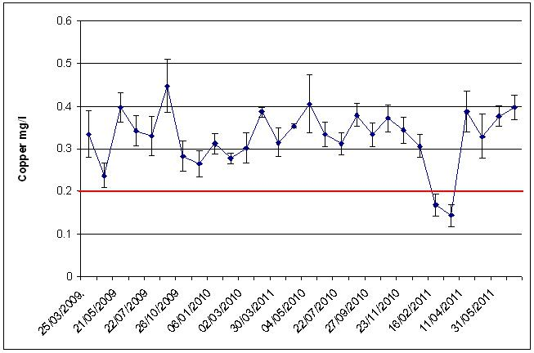

Graph 4.17 Study hospital 6 – Average copper levels from 25th March 2009 to the 08th July 2011 (the red line is the target level for copper - 0.2mg/l).

129

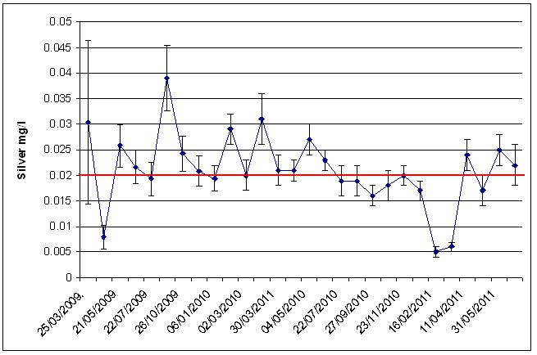

Graph 4.18 Study hospital 6 – Average silver levels from the 25th March 2009 to the 08th July 2011 (the red line is the target level for silver - 0.02mg/l).

The average hot water temperature recorded from the 02nd October 2008 to the 08th July 2011 was 44ºC (± 0.4ºC). The average cold water temperature was 15ºC (± 0.1ºC).

The chloride level found in the sample taken from the incoming mains on the 26th October 2009 was 46.7mg/l, the phosphorus was 1500µg/l, and the pH was 7.2.

The chloride level found in the sample taken from the borehole water on the 26th October 2009 was 32.9mg/l, the phosphorus was 2100µg/l, and the pH was 6.9.

130

4.7 Study hospital 7

The results of samples taken on the 25th November 2008, before the copper and silver ionization systems were activated, are shown in Table 4.16 below.

Sample Point | Temp. | Silver | Copper | Legionella
 | ºC | Mg/l | Mg/l | CFU/l
FB21 HT | 35 | < 0.0003 | 0.135 | 300 np
FA91 HT | 37 | < 0.0003 | 0.387 | 1300 s1
FA73 CT | 15 | < 0.0003 | 0.106 | <LOD
GM24 HT | 23 | < 0.0003 | 0.602 | 44800 s1
GG16 HT | 51 | < 0.0003 | 0.265 | 300 s1 | + | 200 np
FA116 CT | 17 | < 0.0003 | 0.123 | 1400 np
DE03 MT | 34 | < 0.0003 | 0.313 | 12100 np
DE39 HT | 36 | < 0.0003 | 0.333 | 200 np
DA43 MT | 31 | < 0.0003 | 0.346 | 7200 s1 | + | 6600 np
CE101 CT | 14 | < 0.0003 | 0.101 | <LOD
CE83 HT | 42 | < 0.0003 | 0.265 | 3600 s1 | + | 1200 np
CE66 HT | 61 | < 0.0003 | 0.391 | <LOD
FA2 CT | 19 | 0.0020 | 11.8 | 10600 s1 | + | 76800 np
AJ12 HT | 28 | < 0.0003 | 0.745 | 300 s1 | + | 100 np
AE05 CT | 14 | < 0.0003 | 0.087 | 100 s1 + 3200 np
AK 16 HT | 39 | 0.0007 | 1.41 | 100 s2-14
AX40 shower hot | 33 | < 0.0003 | 0.425 | 500 np
AX12 CT | 18 | < 0.0003 | 0.201 | 3200 np
AN04 HT | 37 | < 0.0003 | 0.527 | 100 np
AN44 CT | 23 | < 0.0003 | 0.339 | 11000 np
CY16 CT | 13 | < 0.0003 | 0.127 | 1100 np
AWT Kitchen HT | 64 | < 0.0003 | 0.387 | <LOD
CE118 CT | 15 | < 0.0003 | 0.299 | 200 s1
D Nurse Station HT | 60 | < 0.0003 | 0.600 | <LOD
BG11 MT | 13 | < 0.0003 | 0.160 | 100 s1 | + | 300 np
BG23 HT | 50 | < 0.0003 | 0.488 | <LOD

HT = Hot tap, CT = Cold tap, MT = Mixer tap, np = Legionella non-pneumophila, s1 = Legionella pneumophila serogroup 1, s2-14 = Legionella pneumophila serogroup 2 to 14, <LOD = Below Limit of Detection (100CFU/l).

Table 4.16 Study hospital 7. Results from samples taken on the 25th November 2008, before commissioning of copper and silver ionization systems.

Legionella were found in samples taken from 20 outlets. Twenty six outlets were sampled, therefore, around 77% of the outlets were contaminated.

The Legionella colony forming unit counts found ranged from 100CFU/l to 87400CFU/l. The average Legionella count of the 26 outlets sampled was 7188CFU/l (± 3681CFU/l). Hot, blended and cold outlets were contaminated. The highest

131

Legionella count, of 87400CFU/l, was found in a sample taken from a cold outlet. The temperature recorded at this outlet was 19ºC.

The average hot water temperature at the 16 hot water outlets tested was 41ºC (± 3ºC). Although mixing valves were hidden and could not be seen, the hot water could have been blended with cold water at 11 of the 16 hot water outlets tested because the temperatures recorded at these were ranging from 23ºC to 42ºC.

The water temperatures recorded at 9 cold water outlets were below 20ºC. The cold water temperature was high at 1 outlet at 23ºC. The average at the 10 cold water outlets tested was 16ºC (± 1ºC).

The average copper level found at the 26 outlets, due to copper leaching from copper pipes, was 0.398mg/l (± 0.062mg/l). Copper levels exceeded 1mg/l in samples taken from 2 outlets.

The copper and silver ionization systems were activated on the 25th November 2008.

Table 4.17 below shows the results of samples taken on the 05th January 2009 from the 20 outlets that were contaminated before the systems were activated.

132

Sample Point | Temp. | Silver | Copper | Legionella
 | ºC | Mg/l | Mg/l | CFU/l
FB21 HT | 33 | 0.0168 | 0.323 | <LOD
FA91 HT | 33 | 0.0434 | 0.644 | 100 np
GM24 HT | 17 | 0.0173 | 3.23 | 33600 s1 + 11600 np
GG16 HT | 58 | 0.0184 | 0.308 | <LOD
FA116 CT | 19 | 0.146 | 0.360 | <LOD
DE03 MT | 34 | 0.0983 | 0.509 | 700 np
DE39 HT | 33 | 0.0963 | 0.515 | <LOD
DA43 MT | 32 | 0.0635 | 0.609 | 600 s1
CE83 HT | 33 | 0.0771 | 0.343 | 1500 s1+ 1600 np
FA2 CT | 17 | 0.0467 | 0.395 | 100 s1 + 10800 np
AJ12 HT | 17 | 0.0236 | 2.16 | 100 s1 + 400 np
AE05 CT | 11 | 0.115 | 0.250 | <LOD
AK 16 HT | 37 | 0.0243 | 1.13 | 100 s1
AX40 shower hot | 31 | 0.0903 | 0.625 | <LOD
AX12 CT | 16 | 0.126 | 0.481 | <LOD
AN04 HT | 34 | 0.0350 | 0.581 | 300 np
AN44 CT | 23 | 0.0861 | 0.439 | 400 np
CY16 CT | 17 | 0.123 | 0.427 | <LOD
CE118 CT | 15 | 0.141 | 0.397 | 100 np
BG11 MT | 11 | 0.113 | 0.402 | <LOD
HT = Hot tap, CT = Cold tap, MT = Mixer tap, np = Legionella non-pneumophila, s1 =

Legionella pneumophila serogroup 1, <LOD = Below Limit of Detection (100CFU/l).

Table 4.17 Study hospital 7. Results from samples taken on the 05th January 2009.

No Legionella were found in samples taken from 9 outlets that were previously contaminated. The Legionella persisted at 11 outlets.

The Legionella colony forming unit counts had dropped in places. The average Legionella count of the 20 outlets sampled was 3085CFU/l (± 2284CFU/l). Hot, blended and cold outlets were again contaminated. The silver target level was not met in the sample taken from a hot outlet in which 45200CFU/l was found, only 0.017mg/l silver was found. The temperature recorded at this outlet was very low at 17ºC.

The cold temperatures recorded at the 8 cold outlets tested were below 20ºC, except for at 1 cold outlet at which the temperature was 23ºC. The copper found in this sample was 0.439mg/l, the silver was 0.086mg/l, and the Legionella count had dropped from 11000CFU/l to 400CFU/l.

133

The hot water temperatures at the 12 hot outlets tested were below 50ºC, except for at 1 hot outlet at which the temperature was 58ºC.

The silver found at the 20 outlets tested ranged from 0.017mg/l to 0.146 mg/l. The

average silver level was 0.075mg/l (± 0.01mg/l). The silver target level, of 0.02mg/l,

was not met at 3 of the 20 outlets tested. The copper ranged from 0.25mg/l to

3.23mg/l. The average copper level was 0.706mg/l (± 0.16mg/l). The copper target, of

0.2mg/l, was met at all outlets tested.

From the 05th January 2009 the Legionella contamination declined. Legionella counts of 100CFU/l and 200 CFU/l only persisted at some outlets tested.

Graph 4.19 below shows the average Legionella counts in samples taken monthly from 13 outlets from the 04th February 2009 to the 26th July 2011.
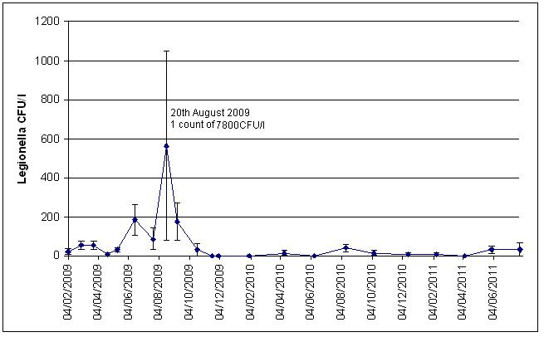

Graph 4.19. Study hospital 7 - Average Legionella counts in samples taken monthly from 13 outlets from the 04th February 2009 to the 26th July 2011.

A Legionella count of 7800CFU/l was found in a sample taken from a hot outlet on the 20th August 2009, which increased the average level. The copper found in this sample was above the target at 0.654mg/l, however, the silver target was not met as only 0.008mg/l silver was found. The temperature recorded was 35ºC, indicating that the hot water may have been blended with cold water.

134

Graphs 4.20 and 4.21 show the averages of the copper and silver levels found in samples taken monthly from the 13 outlets from the 04th February 2009 to the 26th July 2011. The average copper level was 0.539mg/l (± 0.02mg/l). The average silver level was 0.031mg/l (± 0.003mg/l).
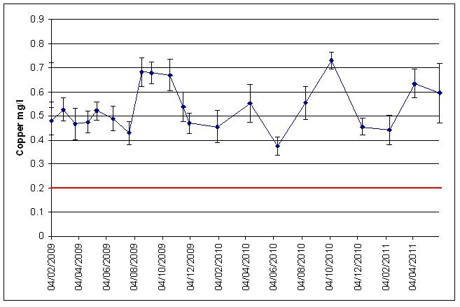

Graph 4.20 Study hospital 7 – Average copper levels from the 04th February 2009 to the 26th July 2011 (the red line is the target level for copper - 0.2mg/l).
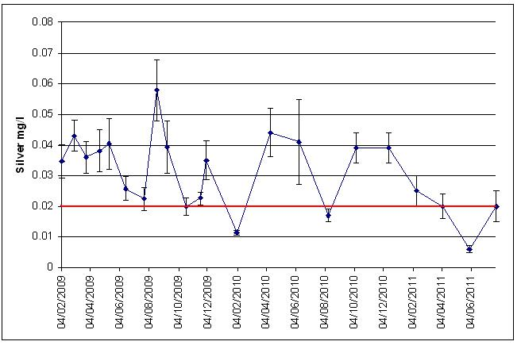

Graph 4.21 Study hospital 7 – Average silver levels from the 04th February 2009 to the 26th July 2011 (the red line is the target level for silver - 0.02mg/l).

135

The average hot water temperature recorded from the 25th November 2008 to the 26th July 2011 was 40ºC (± 0.5ºC). The average cold water temperature was 18ºC (± 0.4ºC).

The chloride level found in the sample taken from the incoming mains on the 20th October 2009 was 58.5mg/l, the phosphorus was 237µg/l, and the pH was 7.6.

136

4.8 Study hospital 8

The results of samples taken on the 27th April 2009, before the copper and silver ionization system was activated, are shown in Table 4.18 below.

137

Sample Point | Temp. | Silver | Copper | Legionella
 | ºC | Mg/l | Mg/l | CFU/l
RO PR2 CT | 13.0 | < 0.0003 | 0.005 | <LOD
RO 002 HT | 59.0 | < 0.0003 | 0.067 | <LOD
R1 018 CT | 12.0 | < 0.0003 | 0.019 | 500 np
R1 149 HT | 43.0 | < 0.0003 | 0.060 | 100 s1 + 400 np
R2 204 CT | 12.0 | < 0.0003 | 0.015 | <LOD
R2 017 HT | 54.0 | < 0.0003 | 0.049 | 300 s1
R3 122 CT | 12.0 | < 0.0003 | 0.010 | 100 np
R3 022 MT | 31.0 | < 0.0003 | 0.061 | 100 np
P3 012 HT | 61.0 | < 0.0003 | 0.066 | <LOD
G3 021 MT | 32.0 | < 0.0003 | 0.033 | <LOD
N3 015 CT | 16.0 | < 0.0003 | 0.014 | <LOD
M3.023 HT | 58.0 | < 0.0003 | 0.063 | <LOD
L3.001CT | 15.0 | < 0.0003 | 0.033 | <LOD
D3.012 HT | 59.0 | < 0.0003 | 0.067 | <LOD
E3 019 MT | 27.0 | < 0.0003 | 0.025 | <LOD
F3 010 HT | 58.0 | < 0.0003 | 0.041 | <LOD
N5 010 CT | 16.0 | < 0.0003 | 0.026 | <LOD
F5.006 MT | 25.0 | < 0.0003 | 0.025 | <LOD
G4.023 HT | 63.0 | < 0.0003 | 0.061 | <LOD
P4.012 CT | 14.0 | < 0.0003 | 0.019 | <LOD
N4.010 MT | 42.0 | < 0.0003 | 0.070 | <LOD
M4.017 CT | 13.0 | < 0.0003 | 0.015 | <LOD
N2.002 HT | 45.0 | < 0.0003 | 0.046 | <LOD
N1.012 CT | 12.0 | < 0.0003 | 0.007 | <LOD
E4.022 HT | 61.0 | < 0.0003 | 0.045 | <LOD
D4.034 CT | 12.0 | < 0.0003 | 0.043 | <LOD
L4.011 HT | 57.0 | < 0.0003 | 0.091 | <LOD
K2.001 CT | 12.0 | < 0.0003 | 0.011 | <LOD
D221 MT | 42.0 | < 0.0003 | 0.095 | <LOD
E2.023 HT | 61.0 | < 0.0003 | 0.055 | <LOD
M2.013 CT | 14.0 | < 0.0003 | 0.022 | <LOD
F2.050 HT | 45.0 | < 0.0003 | 0.033 | <LOD
G2.001 CT | 12.0 | < 0.0003 | 0.024 | <LOD
P1.031 HT | 49.0 | < 0.0003 | 0.043 | <LOD
P2.056 HT | 58.0 | < 0.0003 | 0.135 | <LOD
F1.034 CT | 12.0 | < 0.0003 | 0.010 | <LOD
F1.019 HT | 60.0 | < 0.0003 | 0.098 | <LOD
G1.017 CT | 12.0 | < 0.0003 | 0.004 | <LOD
GX HT | 42.0 | < 0.0003 | 0.149 | <LOD
X1.005 CT | 12.0 | < 0.0003 | 0.014 | <LOD
J3.006 CT | 12.0 | < 0.0003 | 0.010 | <LOD
AX002 HT | 59.0 | < 0.0003 | 0.042 | <LOD
A2.024 HT | 42.0 | < 0.0003 | 0.073 | 300 s1
A2.005 CT | 15.0 | < 0.0003 | 0.138 | 100 s1 + 200 np
A2.011 MT | 44.0 | < 0.0003 | 0.391 | 100 s1 + 500 np
HT = Hot tap, CT = Cold tap, MT = Mixer tap, np = Legionella non-pneumophila, s1 =

Legionella pneumophila serogroup 1, <LOD = Below Limit of Detection (100CFU/l).

Table 4.18 Study hospital 8. Results from samples taken on the 27th April 2009, before

commissioning of copper and silver ionization system.

138

Legionella were found in samples taken from 8 outlets. Forty five outlets were sampled, therefore, around 18% of the outlets were contaminated.

The Legionella colony forming unit counts found ranged from 100CFU/l to 600CFU/l. The average Legionella count of the 45 outlets sampled was 60CFU/l (± 23CFU/l). Hot, blended and cold outlets were contaminated. The highest Legionella count, of 600CFU/l, was found in a sample taken from a blended outlet. The temperature recorded at this outlet was 44ºC.

The average hot water temperature at the 26 hot water outlets tested was 49ºC (± 2ºC). Although mixing valves were hidden and could not be seen, the hot water could have been blended with cold water at 12 of the 26 hot water outlets tested because the temperatures recorded at these were ranging from 25ºC to 45ºC.

The water temperatures recorded at the 19 cold water outlets were below 20ºC. The average temperature at the 19 cold water outlets tested was 13ºC (± 0.3ºC). Three of the 8 outlets that were contaminated with Legionella were cold outlets.

The average copper level found at the 45 outlets, due to copper leaching from copper pipes, was 0.054mg/l (± 0.009mg/l).

The copper and silver ionization system was activated on the 27th April 2009.

Table 4.19 below shows the results of samples taken on the 27th May 2009 from the 8 outlets that were contaminated before the system was activated and from 14 outlets that had been identified as being at risk of Legionella contamination.

139

Sample Point | Temp. | Silver | Copper | Legionella
 | ºC | Mg/l | Mg/l | CFU/l
R1 018 CT | 14.0 | 0.0306 | 0.191 | 100 np
R1 149 HT | 43.0 | 0.0194 | 0.152 | <LOD
R2 017 HT | 58.0 | 0.0115 | 0.094 | <LOD
R3 122 CT | 15.0 | 0.0325 | 0.209 | 100 np
R3 022 MT | 19.0 | 0.0299 | 0.342 | 2000 np
G3 021 MT | 32.0 | 0.0229 | 0.184 | <LOD
N4.010 MT | 37.0 | 0.0211 | 0.187 | <LOD
A2.024 HT | 40.0 | 0.0110 | 0.141 | <LOD
A2.005 CT | 15.0 | 0.0323 | 0.387 | 100 s1 + 200 np
A2.011 MT | 32.0 | 0.0190 | 0.176 | <LOD
N5 010 CT | 16.0 | 0.0314 | 0.233 | <LOD
M4.017 CT | 14.0 | 0.0156 | 0.230 | <LOD
E4.022 HT | 59.0 | 0.0096 | 0.104 | <LOD
K2.001 CT | 14.0 | 0.0187 | 0.187 | <LOD
P4.012 CT | 15.0 | 0.0317 | 0.230 | <LOD
D3.012 HT | 58.0 | 0.0052 | 0.098 | <LOD
M3.023 HT | 57.0 | 0.0095 | 0.125 | <LOD
RO.002 HT | 55.0 | 0.0155 | 0.143 | <LOD
X1.005 CT | 14.0 | 0.0297 | 0.193 | <LOD
P1.031 HT | 43.0 | 0.0182 | 0.142 | <LOD
G2.001 CT | 14.0 | 0.0318 | 0.910 | <LOD
D221 MT | 38.0 | 0.0114 | 0.153 | <LOD
HT = Hot tap, CT = Cold tap, MT = Mixer tap, np = Legionella non-pneumophila, s1 =

Legionella pneumophila serogroup 1, <LOD = Below Limit of Detection (CFU/l).

Table 4.19 Study hospital 8. Results from samples taken on the 27th May 2009.

No Legionella were found in samples taken from 4 outlets that were previously contaminated. The average Legionella count of the 22 outlets sampled was 114CFU/l (± 91CFU/l). Three cold outlets and 1 blended outlet were contaminated. The copper and silver targets were met in the contaminated samples.

The Legionella colony forming unit count had increased at 1 blended outlet from 100 CFU/l to 2000CFU/l. However, no Legionella were found in the sample taken from this outlet on the 21st July 2009, only 100CFU/l were found in the sample taken on the 17th September 2009, and from the 17th September 2009 onwards no Legionella were found.

The cold temperatures recorded at the 9 cold outlets tested were below 20ºC. The hot water temperatures at 8 of the 13 hot outlets tested were below 50ºC.

140

The silver found at the 22 outlets tested ranged from 0.005mg/l to 0.032mg/l. The average silver level was 0.021mg/l (± 0.002mg/l). The copper ranged from 0.094mg/l to 0.91mg/l. The average copper level was 0.219mg/l (± 0.036mg/l). The copper target, of 0.2mg/l, was not met at 15 outlets.

Graph 4.22 below shows the average Legionella counts in samples taken monthly from 22 outlets from the 27th May 2009 to the 25th July 2011.
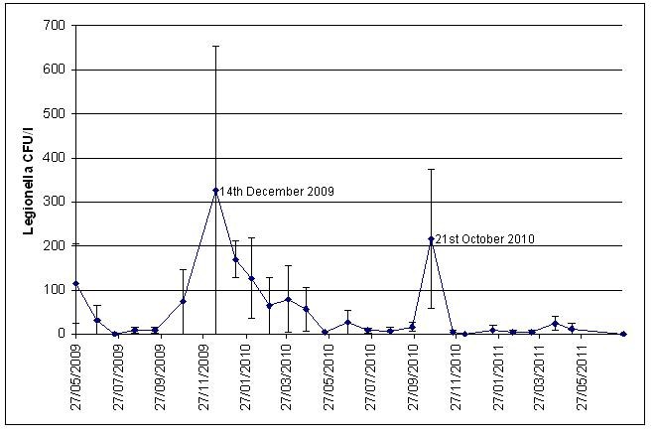

Graph 4.22 Study hospital 8 - Average Legionella counts in samples taken monthly from 22 outlets from the 27th May 2009 to the 25th July 2011.

The Legionella contamination declined from the 27th May 2009 onwards but it persisted at 1 cold outlet that was first tested on the 17th September 2009. The copper and silver targets were met in the sample taken on the 17th September 2009, which indicated that a potentially large source, too large for the available copper and silver to completely control, could be seeding the bacteria into the water. Hospital estates personnel were, therefore, advised to trace the pipework upstream the outlet with the view to isolate and remove any potential Legionella sources. This was not done and the Legionella contamination persisted even though the copper and silver targets were met. High Legionella colony forming unit counts were found in samples taken from the outlet on the 14th December 2009 – 7200CFU/l – and on the 21st October 2010 - 3500CFU/l in the sample taken immediately after opening outlet and 500CFU/l in the

141

sample taken after running outlet for 10 minutes. These counts increased the average Legionella levels.

Graphs 4.23 and 4.24 show the averages of the copper and silver levels found in samples taken monthly from the 22 outlets from the 27th May 2010 to the 25th July 2011. The average copper level was 0.187mg/l (± 0.01mg/l). The average silver level was 0.036mg/l (± 0.003mg/l).
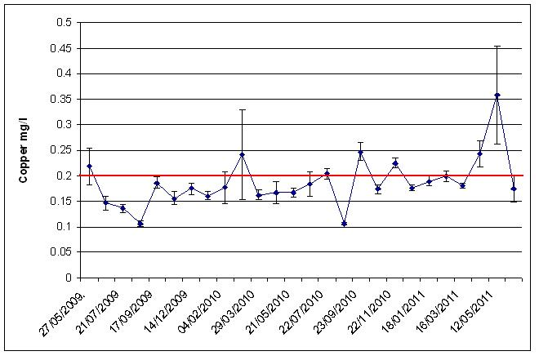

Graph 4.23 Study hospital 8 – Average copper levels from the 27th May 2009 to the 25th July 2011 (the red line is the target level for copper - 0.2mg/l).
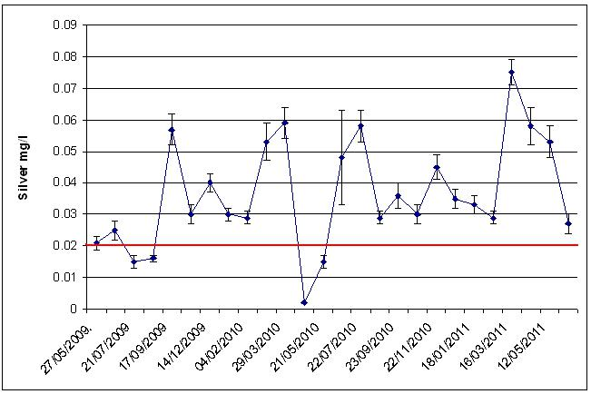

Graph 4.24 Study hospital 8 – Average silver levels from the 27th May 2009 to the 25th July 2011 (the red line is the target level for silver - 0.02mg/l).

142

The copper release by the copper and silver ionization system was too low, which resulted in less copper being available at the outlets. Legionella was, however, controlled, which suggested that the higher silver levels at the outlets compensated for the lower copper levels.

There was a substantial drop in silver found in the samples taken on the 24th April 2010. This was explained by the samples not being pre-treated properly by another UKAS accredited laboratory that had to be used to analyze the samples.

The average hot water temperature recorded from the 27th April 2009 to the 25th July 2011 was 45ºC (± 0.4ºC). The average cold water temperature was 15ºC (± 0.2ºC).

The chloride level found in the sample taken from the incoming mains on the 15th November 2010 was 8.4mg/l, the phosphorus was 452µg/l, and the pH was 8.5.

143

4.9 Study hospital 9

The results of samples taken on the 29th July 2009, before the copper and silver ionization system was activated, are shown in Table 4.20 below.

Sample Point | Temp. | Silver | Copper | Legionella
 | ºC | Mg/l | Mg/l | CFU/l
1F HT | 47 | < 0.0003 | 0.153 | 500 s1
1F CT | 18 | < 0.0003 | 0.022 | <LOD
1F WC MT | 39 | < 0.0003 | 0.129 | 1500 s2-14
D6 HT | 34 | < 0.0003 | 0.115 | <LOD
D3 shower set on hot | 39 | < 0.0003 | 0.122 | 300 s2-14
Staff WC HT | 46 | < 0.0003 | 0.2 | 6400 s2-14
Staff WC CT | 23 | < 0.0003 | 0.118 | <LOD
D10 shower set on hot | 37 | < 0.0003 | 0.124 | 600 s1
D11 CT | 20 | < 0.0003 | 0.053 | <LOD
B1 HT | 40 | < 0.0003 | 0.179 | 100 s1
Day room CT | 19 | < 0.0003 | 0.168 | <LOD
B5 HT | 49 | < 0.0003 | 0.205 | <LOD
Physio CT | 22 | < 0.0003 | 0.15 | <LOD
Physio HT | 53 | < 0.0003 | 1.3 | 200 s2-14
Red CT | 17 | < 0.0003 | 0.029 | <LOD
Treatment room CT | 18 | < 0.0003 | 0.053 | <LOD
Theatre shower set on hot | 40 | < 0.0003 | 0.173 | <LOD
TSSU CT | 18 | < 0.0003 | 0.053 | <LOD
Anaesthetic room 1 HT | 51 | < 0.0003 | 0.181 | <LOD
Recovery room CT | 22 | < 0.0003 | 0.159 | <LOD
T3 HT | 46 | 0.0003 | 0.357 | <LOD
T3 CT | 20 | < 0.0003 | 0.04 | <LOD
Joyce shower set on hot | 33 | < 0.0003 | 0.126 | 100 np
Cillia shower set on cold | 19 | < 0.0003 | 0.068 | <LOD
Surgical HT | 51 | < 0.0003 | 0.138 | 600 s2-14
C16 shower set on hot | 34 | < 0.0003 | 0.125 | 700 s2-14
X-Ray CT | 32 | < 0.0003 | 0.221 | 300 s2-14
OP HT | 49 | < 0.0003 | 0.16 | 700 s2-14
Disabled WC CT | 24 | < 0.0003 | 0.052 | 600 s2-14
Hydro WC HT | 47 | < 0.0003 | 0.144 | 1000 s2-14
HT = Hot tap, CT = Cold tap, MT = Mixer tap, np = Legionella non-pneumophila, s1 = Legionella pneumophila serogroup 1, s2-14 = Legionella pneumophila serogroup 2 to 14, <LOD = Below Limit of Detection (100CFU/l).

Table 4.20 Study hospital 9. Results from samples taken on the 29th July 2009, before commissioning of copper and silver ionization system.

Legionella were found in samples taken from 14 outlets. Thirty outlets were sampled, therefore, around 47% of the outlets were contaminated.

144

The Legionella colony forming unit counts found ranged from 100CFU/l to 6400CFU/l. The average Legionella count of the 30 outlets sampled was 453CFU/l (± 216CFU/l). Hot, blended and cold outlets were contaminated. The highest Legionella count, of 6400CFU/l, was found in a sample taken from a blended outlet. The temperature recorded at this outlet was 46ºC.

The average hot water temperature at the 17 hot water outlets tested was 43ºC (± 1.6ºC). Although mixing valves were hidden and could not be seen, the hot water could have been blended with cold water at 12 of the 17 hot water outlets tested because the temperatures recorded at these were ranging from 33ºC to 47ºC. Nine of these outlets were contaminated with Legionella. The temperatures recorded at 3 of the contaminated pure hot outlets were 53ºC, 51ºC, and 49ºC.

The average water temperature at the 13 cold water outlets tested was 21ºC (± 1.1ºC). The temperatures recorded at the 2 contaminated cold outlets were high at 32ºC and 24ºC.

The average copper level found at the 30 outlets, due to copper leaching from copper pipes, was 0.171mg/l (± 0.04mg/l). This figure included a high copper level of 1.3 mg/l found in a sample taken from a pure hot outlet. Excluding this level the average copper level found was 0.132mg/l (± 0.01mg/l).

The copper and silver ionization system was activated on the 03rd August 2009.

Table 4.21 below shows the results of samples taken on the 02nd and 04th September 2009 from the 14 outlets that were contaminated before the system was activated and from 2 outlets that had been identified as being at risk of Legionella contamination.

145

Sample Point | Temp. | Silver | Copper | Legionella
 | ºC | Mg/l | Mg/l | CFU/l
1F HT | 51 | 0.0382 | 0.318 | <LOD
1F WC MT | 37 | 0.0322 | 0.385 | 500 np
D3 shower set on hot | 39 | 0.0958 | 0.367 | 400 np
Staff WC HT | 49 | 0.0369 | 0.316 | <LOD
D10 shower set on hot | 37 | 0.0946 | 0.292 | 300 s1
B1 CT | 24 | 0.0060 | 0.380 | <LOD
B1 HT | 47 | 0.031 | 0.31 | <LOD
Physio HT | 52 | 0.0309 | 0.279 | <LOD
TSSU CT | 20 | 0.0363 | 0.142 | <LOD
Joyce shower set on hot | 39 | 0.0757 | 0.359 | 200 s1 + 100 np
Surgical HT | 53 | 0.0283 | 0.323 | <LOD
C16 shower set on hot | 38 | 0.0407 | 0.466 | <LOD
X-Ray CT | 28 | 0.0075 | 0.428 | <LOD
OP HT | 50 | 0.0269 | 0.323 | <LOD
Disabled WC CT | 24 | 0.0618 | 0.431 | 3300 np
Hydro WC HT | 54 | 0.0389 | 0.327 | <LOD
HT = Hot tap, CT = Cold tap, MT = Mixer tap, np = Legionella non-pneumophila, s1 =

Legionella pneumophila serogroup 1, <LOD = Below Limit of Detection (100CFU/l).

Table 4.21 Study hospital 9. Results from samples taken on the 02nd September 2009.

No Legionella were found in samples taken from 9 outlets that were previously contaminated. The water temperatures recorded at 4 hot outlets, at which 500CFU/l, 400CFU/l, 300CFU/l and 300CFU/l Legionella were found, were below 40ºC, which indicated that these outlets may have been blended.

The cold temperatures recorded at the 4 cold outlets tested were above 20ºC. The temperature of the cold outlet, the disabled WC cold tap, at which Legionella persisted, was 24ºC. The Legionella colony forming unit count increased at this outlet from 300CFU/l found in the sample taken on the 29th July to 3300CFU/l. The Legionella non-pneumophila species that were found instead of the Legionella pneumophila serogroup 2 to 14 found previously must be an evidence of a new contamination source.

The average Legionella count of the 16 outlets sampled was 300CFU/l (± 205CFU/l).

The silver found at the 16 outlets ranged from 0.006mg/l to 0.096mg/l. The average silver level was 0.043mg/l (± 0.007mg/l). The silver target, of 0.02mg/l, was met at 14 of the 16 outlets tested. The copper ranged from 0.142mg/l to 0.477mg/l. The average

146

copper level was 0.34mg/l (± 0.018mg/l). The copper target, of 0.2mg/l, was met at 15 of the 16 outlets tested.

No Legionella were found in the samples taken from 15 outlets, including the previously contaminated 5 outlets, on the 01st October 2009.

Legionella persisted at the cold outlet of the disabled WC, albeit at lower counts, from the 29th October 2009 onwards.

Legionella were found in samples and re-samples taken from 15 outlets on the 27th

November 2009, see Table 4.22 below. The copper and silver targets were met in

these samples.

Sample Point | Temp. | Silver | Copper | Legionella
 | ºC | Mg/l | Mg/l | CFU/l
1F HT | 57 | 0.0289 | 0.295 | <LOD
1F WC MT | 41 | 0.0475 | 0.29 | <LOD
D3 shower set on hot | 41 | 0.0398 | 0.312 | 2600 np
Staff WC HT | 42 | 0.0344 | 0.339 | 4500 np
D10 shower set on hot | 43 | 0.0574 | 0.28 | 200 s1
B1 HT | 43 | 0.0565 | 0.32 | <LOD
Therapy HT | 41 | 0.0551 | 0.297 | <LOD
TSSU CT | 14 | 0.0891 | 0.105 | <LOD
Joyce shower set on hot | 56 | 0.0059 | 0.256 | <LOD
Surgical HT | 50 | 0.0239 | 0.309 | 100 np
C16 shower set on hot | 42 | 0.0772 | 0.365 | <LOD
X-Ray CT | 19 | 0.0035 | 0.383 | <LOD
OP HT | 52 | 0.0309 | 0.552 | <LOD
Disabled WC CT – pre-flush | 15 | 0.0955 | 0.268 | 1800 np
Disabled WC CT – post-flush | 14 | 0.0917 | 0.265 | 1900 np
Hydro WC HT | 42 | 0.0417 | 0.301 | <LOD

HT = Hot tap, CT = Cold tap, MT = Mixer tap, np = Legionella non-pneumophila, s1 = Legionella pneumophila serogroup 1, <LOD = Below Limit of Detection (100CFU/l).

Table 4.22 Study hospital 9. Results from samples and re-samples taken on the 27th November 2009.

Graph 4.25 below shows the average Legionella counts in samples and re-samples taken monthly from the 02nd September 2009 to the 15th July 2011.

147

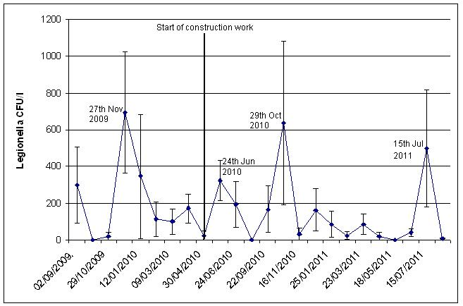

Graph 4.25 Study hospital 9 - Average Legionella counts in samples and re-samples taken monthly from the 02nd September 2009 to the 15th July 2011.

After the construction work was started, higher Legionella colony forming unit counts were found in re-samples taken on the 24th June 2010, in samples and re-samples taken on the 29th October 2010, and in re-samples taken on the 15th July 2011, see Tables 4.23, 4.24, and 4.25 below.

148

Sample Point | Temp. | Silver | Copper | Legionella
 | ºC | Mg/l | Mg/l | CFU/l
1F HT - pre-flush | 44 | 0.0145 | 0.309 | <LOD
1F HT – post-flush | 47 | 0.0171 | 0.295 | <LOD
1F WC MT – pre-flush | 40 | 0.0215 | 0.359 | 1100 np
1F WC MT – post-flush | 40 | 0.0286 | 0.301 | 100 np
Staff WC HT – pre-flush | 40 | 0.0094 | 0.41 | <LOD
Staff WC HT – post-flush | 40 | 0.0254 | 0.308 | <LOD
D3 shower set on hot – pre-flush | 20 | 0.0037 | 0.563 | <LOD
D3 shower set on hot – post-flush | 49 | 0.0185 | 0.302 | <LOD
B1 HT – pre-flush | 32 | 0.0131 | 0.278 | <LOD
B1 HT – post-flush | 42 | 0.0211 | 0.285 | <LOD
Disabled WC MT – pre-flush | 41 | 0.0061 | 0.266 | 2600 np
Disabled WC MT – post-flush | 41 | 0.0153 | 0.282 | 400 np
Consulting room 5 HT – pre-flush | 48 | 0.0094 | 0.373 | 100 s2-14
Consulting room 5 HT – post-flush | 53 | 0.0131 | 0.351 | <LOD
C16 shower set on hot | 41 | 0.0172 | 0.378 | <LOD
TSSU CT | 17 | 0.0257 | 0.228 | <LOD
Hydro WC HT | 56 | 0.0088 | 0.292 | <LOD
OP HT | 50 | 0.008 | 0.292 | <LOD
X-Ray CT | 19 | 0.02 | 0.337 | <LOD
Joyce shower set on hot | 45 | 0.0088 | 0.397 | <LOD
D8 shower set on hot | 40 | 0.0137 | 0.267 | <LOD
D10 shower set on hot | 50 | 0.0073 | 0.245 | <LOD
HT = Hot tap, CT = Cold tap, MT = Mixer tap, np = Legionella non-pneumophila, s2-14 =

Legionella pneumophila serogroup 2 to 14, <LOD = Below Limit of Detection (100CFU/l). Table 4.23 Study hospital 9. Results from re-samples taken on the 24th June 2010. The copper
target was met in all the samples taken from the contaminated outlets.

Sample Point | Temp. | Silver | Copper | Legionella
 | ºC | Mg/l | Mg/l | CFU/l
1F HT | 48 | 0.0176 | 0.378 | <LOD
1F WC MT | 35 | 0.0537 | 0.363 | 100 np
Disabled WC MT – pre-flush | 35 | 0.0581 | 0.367 | 5800 np
Disabled WC MT – post-flush | 38 | 0.0583 | 0.369 | 1000 np
Consulting room 5 MT | 50 | 0.0300 | 0.673 | 1300 s2-14
TSSU CT | 15 | 0.0462 | 0.187 | <LOD
OP HT | 39 | 0.0307 | 0.549 | <LOD
X-Ray CT | 22 | 0.0539 | 0.457 | <LOD
Joyce shower set on hot | 38 | 0.0527 | 0.510 | <LOD
D7 shower set on hot – pre-flush | 34 | 0.0314 | 0.340 | <LOD
D7 shower set on hot – post-flush | 39 | 0.0491 | 0.312 | <LOD
D10 shower set on hot – pre-flush | 30 | 0.0158 | 0.324 | 100 s1
D10 shower set on hot – post-flush | 52 | 0.0245 | 0.285 | <LOD
HT = Hot tap, CT = Cold tap, MT = Mixer tap, np = Legionella non-pneumophila, s1 =

Legionella pneumophila serogroup 1, s2-14 = Legionella pneumophila serogroup 2 to 14,

<LOD = Below Limit of Detection (100CFU/l).

Table 4.24 Study hospital 9. Results from samples and re-samples taken on the 29th October

2010.

149

Sample Point | Temp. | Silver | Copper | Legionella
 | ºC | Mg/l | Mg/l | CFU/l
1F WC MT – pre-flush | 36 | 0.037 | 0.399 | <LOD
1F WC MT – post-flush | 38 | 0.0492 | 0.3237 | <LOD
Cilla shower set on hot – pre-flush | 34 | 0.0158 | 0.3349 | 1600 s1
Cilla shower set on hot – post-flush | 36 | 0.0572 | 0.3101 | <LOD
Joyce shower set on hot – pre-flush | 41 | 0.0123 | 0.3293 | 1400 np
Joyce shower set on hot – pre-flush | 41 | 0.047 | 0.3096 | <LOD

MT = Mixer tap, np = Legionella non-pneumophila, s1 = Legionella pneumophila serogroup 1, <LOD = Below Limit of Detection (100CFU/l).

Table 4.25 Study hospital 9. Results from re-samples taken on the 15th July 2011.

The silver target was not met in samples taken from 2 contaminated outlets on the 24th June 2010, also not in a sample taken from 1 contaminated outlet on the 29th October 2010, and also not in the samples taken from the 2 contaminated outlets on the 15th July 2011.

Graphs 4.26 and 4.27 show the averages of the copper and silver levels found in samples and re-samples taken monthly from the 02nd September 2009 to the 15th July 2011. The average copper level was 0.398mg/l (± 0.026mg/l). The average silver level was 0.037mg/l (± 0.004mg/l).
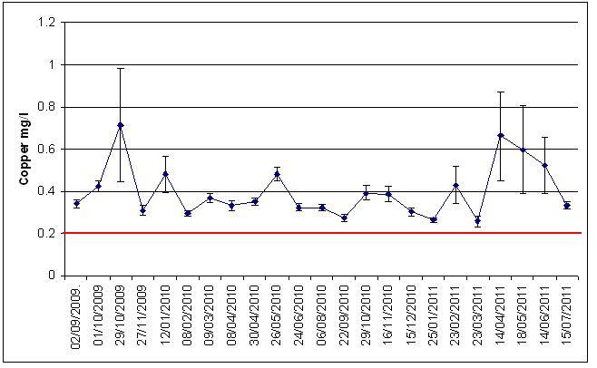

Graph 4.26 Study hospital 9 – Average copper levels from the 02nd September 2009 to the 15th July 2011 (the red line is the target level for copper - 0.2mg/l).

150

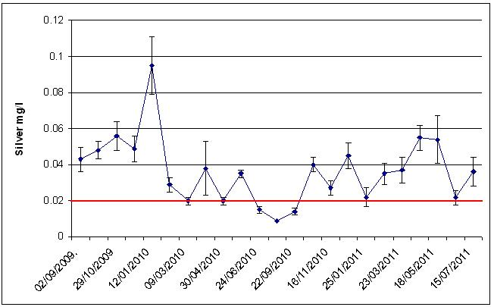

Graph 4.27 Study hospital 9 – Average silver levels from the 02nd September 2009 to the 15th July 2011 (the red line is the target level for silver - 0.02mg/l).

The results suggested that interruptions to the water system, due to the extensive construction work, had increased microbial growth and biofilm formation due to water pipes being exposed to the environment and wards being temporarily unoccupied, which may have resulted in an influx of organisms entering the water system from outside and water stagnation. Modifications to the pipework may also have dislodged biofilms and may have caused biofilms to disperse, colonizing other parts of the water system. Although the copper and silver target levels to control Legionella, of more than 0.2mg/l copper and more than 0.02mg/l silver, at outlets were mainly met, not enough was available at the Legionella contaminated outlets to completely control the microbial growth and Legionella contamination.

The average hot water temperature recorded from the 29th July 2009 to the 15th July 2011 was 43ºC (± 0.4ºC). The average cold water temperature was 17ºC (± 0.5ºC).

The chloride level found in the sample taken from the incoming mains on the 01st October 2009 was 54.9mg/l, the phosphorus was 191µg/l, and the pH was 7.5.

151

4.10 Study hospital 10

The results of samples taken on the 15th December 2009, before the copper and silver ionization systems were activated, are shown in Table 4.26 below.

Sample Point | Temp. | Silver | Copper | Legionella
 | ºC | Mg/l | Mg/l | CFU/l
10th FR305 CT | 15 | < 0.0003 | 0.064 | <LOD
10th DRB Shower | 39 | < 0.0003 | 0.08 | <LOD
10th DRB HT | 61 | < 0.0003 | 0.159 | <LOD
Ward 9A Kitchen HT | 42 | < 0.0003 | 0.144 | <LOD
Ward 9A Sluice CT | 13 | < 0.0003 | 0.013 | <LOD
Ward 9A Room 6 HT | 38 | < 0.0003 | 0.17 | 100 np
Ward 9B Sluice HT | 53 | < 0.0003 | 0.124 | <LOD
Ward 9B Nurse Station CT | 20 | < 0.0003 | 0.038 | <LOD
Ward 9B Male WC Shower | 40 | < 0.0003 | 0.099 | 2000 s2-14 + 200 np
Ward 8A Female Shower | 40 | < 0.0003 | 0.079 | <LOD
Ward 8A Sluice HT | 58 | < 0.0003 | 0.118 | <LOD
Ward 8A Kitchen CT | 15 | < 0.0003 | 0.035 | <LOD
Ward 8A Kitchen HT | 54 | < 0.0003 | 0.12 | <LOD
Ward 8A Sluice CT | 12 | < 0.0003 | 0.01 | <LOD
Ward 8A Bay A MT | 36 | < 0.0003 | 0.187 | 1700 s1
Ward 7 Kitchen HT | 56 | < 0.0003 | 0.117 | <LOD
Ward 7 Sluice CT | 12 | < 0.0003 | 0.01 | <LOD
Ward 7A Bay A MT | 34 | < 0.0003 | 0.123 | 1900 s1 + 100 np
Ward 7B Kitchen CT | 11 | < 0.0003 | 0.008 | <LOD
Ward 7B Female Shower | 39 | < 0.0003 | 0.08 | <LOD
Ward 7B Sluice HT | 54 | < 0.0003 | 0.115 | <LOD
Ward 6A Kitchen CT | 24 | < 0.0003 | 0.043 | <LOD
Ward 6A Sluice HT | 53 | < 0.0003 | 0.12 | <LOD
Ward 6A Shower Room MT | 38 | < 0.0003 | 0.089 | <LOD
Ward 6B Arjo MT | 40 | < 0.0003 | 0.215 | 2900 s2-14 + 1200 np
Ward 6B Sluice CT | 33 | < 0.0003 | 0.136 | 100 s1 + 1300 np
Ward 6B Bay A MT | 40 | < 0.0003 | 0.173 | 2100 s2-14 + 300 np
Ward 5A Arjo MT | 38 | < 0.0003 | 0.14 | <LOD
Ward 5A Sluice CT | 13 | < 0.0003 | 0.019 | <LOD
Ward 5A Bay A MT | 38 | < 0.0003 | 0.069 | 400 s1
Ward 5B Sluice HT | 57 | < 0.0003 | 0.119 | <LOD
Ward 5B Shower | 40 | < 0.0003 | 0.129 | 100 s1 + 400 np
Ward 5B Kitchen CT | 13 | < 0.0003 | 0.008 | <LOD
Ward 5B Corridor CT | 25 | < 0.0003 | 0.096 | <LOD
Ward 4A Sluice HT | 53 | < 0.0003 | 0.114 | <LOD
Ward 4A Kitchen CT | 15 | < 0.0003 | 0.023 | <LOD
Ward 4A Shower | 33 | < 0.0003 | 0.126 | <LOD
Ward 4B Sluice HT | 56 | < 0.0003 | 0.119 | <LOD
Ward 4A Bay A MT | 40 | < 0.0003 | 0.085 | 2500 s1
Ward 4B Kitchen CT | 14 | < 0.0003 | 0.025 | <LOD
Ward 3A Sluice HT | 56 | < 0.0003 | 0.116 | <LOD
Ward 3A Bay A MT | 40 | < 0.0003 | 0.091 | 400 s1 + 400 np
Ward 3A Kitchen CT | 19 | < 0.0003 | 0.052 | <LOD

152

Ward 3B Shower MT | 18 | < 0.0003 | 0.039 | <LOD
Ward 3B Sluice CT | 12 | 0.0133 | 0.021 | <LOD
Ward 3B Kitchen HT | 59 | < 0.0003 | 0.119 | <LOD
Ward 2A Bathroom HT | 36 | 0.0025 | 0.077 | <LOD
Ward 2A Kitchen CT | 11 | < 0.0003 | 0.011 | <LOD
Ward 2A Bay C HT | 40 | < 0.0003 | 0.089 | 1600 s2-14
Ward 2B Sluice HT | 55 | < 0.0003 | 0.147 | <LOD
Ward 2B Kitchen CT | 14 | 0.0093 | 0.028 | 100 s1 + 100 np
Ward 2B Shower MT | 41 | 0.0016 | 0.141 | 7200 s1
Ward 1 Waiting Room HT | 53 | < 0.0003 | 0.155 | <LOD
Ward 1 Pantry CT | 18 | < 0.0003 | 0.191 | <LOD
Ward 1 Dirty Utility HT | 59 | 0.0008 | 0.125 | <LOD
Ward 1 Clinical Area MT | 42 | 0.0007 | 0.054 | <LOD
Pathology WC 46 MT | 41 | 0.0006 | 0.081 | <LOD
Path Lab 124 HT | 51 | 0.0011 | 0.797 | <LOD
Pathology Pan Reception CT | 20 | < 0.0003 | 0.223 | 800 s2-14
Pathology Sluice HT | 44 | 0.0005 | 0.162 | <LOD

HT = Hot tap, CT = Cold tap, MT = Mixer tap, np = Legionella non-pneumophila, s1 = Legionella pneumophila serogroup 1, s2-14 = Legionella pneumophila serogroup 2 to 14, <LOD = Below Limit of Detection (100CFU/l).
Table 4.26 Study hospital 10. Results from samples taken on the 15th December 2009, before commissioning of copper and silver ionization systems.

Legionella were found in samples taken from 15 outlets. Sixty outlets were sampled, therefore, 25% of the outlets were contaminated.

The Legionella colony forming unit counts found ranged from 100CFU/l to 7200CFU/l. The average Legionella count of the 60 outlets sampled was 465CFU/l (± 156CFU/l). Blended and cold outlets were contaminated. The highest Legionella count, of 7200CFU/l, was found in a sample taken from a blended outlet. The temperature recorded at this outlet was 41ºC.

The average hot water temperature at the 40 hot water outlets tested was 45ºC (± 1.5ºC). Although mixing valves were hidden and could not be seen, the hot water could have been blended with cold water at 24 of the 40 hot water outlets tested because the temperatures recorded at these were ranging from 18ºC to 44ºC. Thirteen of these outlets were contaminated with Legionella.

The average water temperature at the 20 cold water outlets tested was 16ºC (± 1ºC).

The temperature recorded at 1 of the 3 contaminated cold outlets was high at 33ºC.

153

The average copper level found at the 60 outlets, due to copper leaching from copper pipes, was 0.108mg/l (± 0.01mg/l).

The copper and silver ionization systems were activated on the 21st December 2009.

Table 4.27 below shows the results of samples taken on the 13th January 2010 from

the 15 outlets that were contaminated before the systems were activated and from 15

outlets that had been identified as being at risk of Legionella contamination.

Sample Point | Temp. | Silver | Copper | Legionella
 | ºC | Mg/l | Mg/l | CFU/l
9A Room 6 HT | 37 | 0.0357 | 0.234 | <LOD
9B Shower | 39 | 0.0363 | 0.226 | <LOD
8A Bay A MT | 39 | 0.0416 | 0.236 | 200 s1
8B Bay B MT | 34 | 0.0284 | 0.243 | 12800 np
7A Bay A MT | 39 | 0.0384 | 0.233 | <LOD
7A Bay B MT | 39 | 0.0396 | 0.227 | <LOD
7B WC CT | 10 | 0.0677 | 0.237 | <LOD
7B Bay A MT | 43 | 0.036 | 0.229 | <LOD
6A Bay B MT | 39 | 0.0432 | 0.238 | 500 np
6B Arjo MT | 39 | 0.0442 | 0.288 | <LOD
6B Sluice CT | 9 | 0.0661 | 0.234 | <LOD
6B Bay A MT | 40 | 0.028 | 0.242 | <LOD
5A Bay A MT | 40 | 0.043 | 0.243 | <LOD
5A Bay B MT | 35 | 0.0524 | 0.511 | 200 s1
5B WC MT | 42 | 0.0356 | 0.232 | 12800 np
5B Shower | 39 | 0.033 | 0.233 | <LOD
4A Bay D MT | 39 | 0.0393 | 0.232 | <LOD
4A Bay A MT | 38 | 0.0413 | 0.23 | <LOD
4B Bay B MT | 40 | 0.0403 | 0.342 | <LOD
4B Bay A MT | 40 | 0.0454 | 0.446 | 500 np
3A Bay A MT | 40 | 0.039 | 0.233 | <LOD
3A Bay B MT | 44 | 0.0367 | 0.225 | <LOD
3B Shower | 35 | 0.0348 | 0.234 | <LOD
3B WC CT | 8 | 0.069 | 0.234 | <LOD
2A Bay B MT | 39 | 0.0393 | 0.228 | <LOD
2A Bay C HT | 38 | 0.0393 | 0.227 | 100 s2-14
2B Kitchen CT | 52 | 0.0328 | 0.226 | <LOD
2B Shower | 39 | 0.0376 | 0.229 | 4700 s1
Path Pan Reception CT | 19 | 0.0594 | 0.294 | <LOD
Path Pan Reception HT | 42 | 0.0337 | 0.247 | <LOD

HT = Hot tap, CT = Cold tap, MT = Mixer tap, np = Legionella non-pneumophila, s1 = Legionella pneumophila serogroup 1, s2-14 = Legionella pneumophila serogroup 2 to 14, <LOD = Below Limit of Detection (100CFU/l).
Table 4.27 Study hospital 10. Results from samples taken on the 13th January 2010.

154

No Legionella were found in samples taken from 11 outlets that were previously contaminated. The Legionella colony forming unit counts reduced in samples taken from the 4 outlets that were previously contaminated; from 1700CFU/l to 200CFU/l, from 2400CFU/l to 200CFU/l, from 1600CFU/l to 100CFU/l, and from 7200CFU/l to 4700CFU/l. Legionella were found at 4 outlets from which samples were not taken before the copper and silver ionization systems were activated.

The hot water temperatures of the 8 outlets at which Legionella were found were all below 50ºC, indicating that these were blended outlets.

The silver found at the 30 outlets ranged from 0.028mg/l to 0.069mg/l. The average silver level was 0.042mg/l (± 0.002mg/l). The silver target, of 0.02mg/l, was met at all the 30 outlets tested. The copper ranged from 0.225mg/l to 0.511mg/l. The average copper level was 0.257mg/l (± 0.012mg/l). The copper target, of 0.2mg/l, was met at all the 30 outlets tested.

Graph 4.28 below shows the average Legionella counts in samples taken monthly from 30 outlets from the 13th January 2010 to the 13th July 2011.
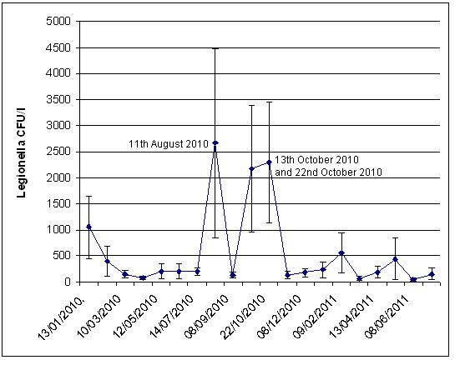

155

Graph 4.28 Study hospital 10 - Average Legionella counts in samples taken monthly from the 13th January 2010 to the 13th July 2011.

Legionella were found at high colony forming unit counts in samples taken on the 11th August 2010 from a blended outlet, 36200CFU/l, and from a cold outlet, 42000CFU/l, which increased the average Legionella count. The copper target was met in both contaminated samples but the silver found in the sample taken from the cold outlet was low at 0.0003mg/l.

Legionella were found at high counts in samples taken on the 13th October 2010. The copper had dropped substantially and its target was not met in samples taken from the 15 contaminated outlets. The average copper level found in the contaminated samples was 0.158mg/l (± 0.005mg/l).The silver had also dropped and its target was not met at 10 of the 15 contaminated outlets. The average silver level found at the contaminated outlets was 0.019mg/l (± 0.002mg/l).

Of the 15 contaminated outlets sampled on the 13th October, 7 were found to have no Legionella when sampled on the 22nd October. At these outlets the copper and silver levels had improved. At 3 outlets the copper and silver targets were not met and Legionella were still found. At 2 outlets the copper and silver levels had improved but Legionella were still found. A point of use filter was attached to 1 outlet and a mixing valve was attached to the other outlet. At 3 outlets the Legionella counts had increased in spite of improved copper and silver levels.

When the copper and silver targets were consistently maintained, the Legionella contamination declined and the Legionella colony forming unit counts reduced.

Graphs 4.29 and 4.30 show the averages of the copper and silver levels found in samples taken from 30 outlets from the 13th January 2010 to the 13th July 2011. The average copper level was 0.231mg/l (± 0.008mg/l). The average silver level was 0.031mg/l (± 0.001mg/l).

156

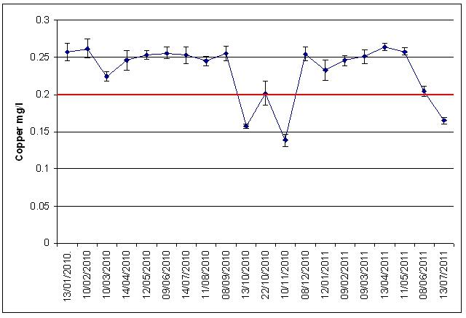

Graph 4.29 Study hospital 10 – Average copper levels from the 13th January 2010 to the 13th July 2011 (the red line is the target level for copper - 0.2mg/l).
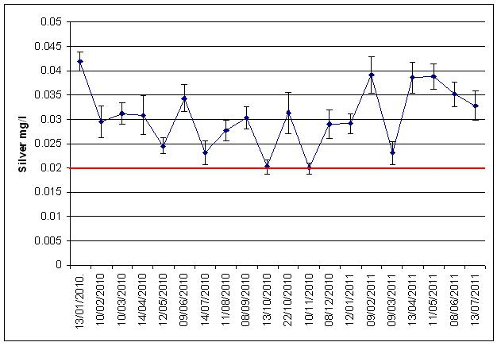

Graph 4.30 Study hospital 10 – Average silver levels from the 13th January 2010 to the 13th July 2011 (the red line is the target level for silver - 0.02mg/l).

157

The average hot water temperature recorded from the 15th December 2009 to the 13th July 2009 was 41ºC (± 0.3ºC). The average cold water temperature was 16ºC (± 0.4ºC).

The chloride level found in the sample taken from the incoming mains on the 05th July 2011 was 57.3mg/l, the phosphorus was 1030µg/l, and the pH was 7.5.

158

4.11 Summary of results of study hospitals

Table 4.28 below shows the number of outlets that were contaminated with Legionella before the copper and silver ionization systems were activated in the 10 hospitals as well as 3 months after activation of the systems and at the end of the studies.

 | Number of | Number of | Number of
Study hospital | contaminated outlets | contaminated outlets 3 | contaminated outlets at
 | before activation | months after activation | end of study
1 | 21 out of 46 | 1 out of 21 | 0 out of 21
2 | 7 out of 30 | 2 out of 15 | 0 out of 15
3 | 4 out of 21 | 1 out of 10 | 0 out of 10
4 | 2 out of 12 | 0 out of 6 | 0 out of 6
5 | 25 out of 51 | 6 out of 20 | 2 out of 20
6 | 11 out of 50 | 2 out of 25 | 1 out of 25
7 | 20 out of 26 | 4 out of 13 | 1 out of 13
8 | 8 out of 45 | 0 out of 21 | 0 out of 21
9 | 14 out of 30 | 1 out of 15 | 1 out of 14
10 | 15 out of 60 | 13 out of 29 | 6 out of 30

Table 4.28 Study hospitals - Number of Legionella contaminated outlets before activation of copper and silver ionization systems as well as 3 months after activation and at end of studies.

Table 4.29 below shows the average Legionella colony forming unit counts found before the copper and silver ionization systems were activated in the 10 hospitals as well as 3 months after activation of the systems and at the end of the studies.

159

 | Average Legionella |  | Average Legionella | Average Legionella
 | counts before |  | counts 3 months
Study hospital |  |  |  | counts at end of study
 | activation |  | after activation
 |  |  |  | CFU/l
 | CFU/l |  | CFU/l
1 | 983 | (± 331) | 19 (± 19) |  | 0
2 | 290 (± 20) |  | 53 (± 41) |  | 0
3 | 138 (± 77) |  | 90 (± 90) |  | 0
4 | 350 | (± 356) | 0 |  | 0
5 | 214 (± (10) |  | 42 (± 16) | 14 | (± 10)
6 | 136 (± 82) |  | 16 (± 11) | 13 | (± 13)
7 | 7188 | (± 3681) | 54 (± 24) | 33 | (± 33)
8 | 60 | (± 23) | 0 |  | 0
9 | 453 | (± 216) | 20 (± 20) | 7CFU/l (± 7CFU/l)
10 | 465 | (± 156) | 155 (± 66) | 157 | (± 112)

Table 4.29 Study hospitals - Average Legionella colony forming unit counts before activation of copper and silver ionization systems as well as 3 months after activation and at end of studies.

Table 4.30 below shows the averages of the copper and silver levels of the samples taken after the copper and silver ionization systems were activated in the 10 hospitals as well as the averages of the cold and hot water temperatures, and the chloride, phosphorus and pH values.

160

Study | Copper |  | Silver | Chloride |  | Phosphorus |  |  | Hot | Cold |  | Borehole
 |  |  |  |  |  |  | pH |  | temp. | temp. |  | Chloride P
Hospital | mg/l |  | mg/l | mg/l |  | µg/l
 |  |  |  |  |  |  |  |  | ºC | ºC |  | Mg/l
1 | 0.201 |  | 0.04 | 15.1 |  | 455 | 8.5 |  | 41 | 17
2 | 0.235 | 0.037 |  | 17 | 390 |  | 8.5 | 44 |  | 15
3 | 0.151 | 0.033 |  | 24.5 | 1000 |  | 7.9 | 41 |  | 17
4 | 0.419 | 0.043 |  | 30.2 | 577 |  | 7.5 | 38 |  | *
5 | 0.366 | 0.043 |  | 60.7 | 701 |  | 7.2 | 46 |  | 16
6 | 0.328 | 0.021 |  | 46.7 | 1500 |  | 7.2 | 44 |  | 15 | 32.9
7 | 0.539 | 0.031 |  | 58.5 | 237 |  | 7.6 | 40 |  | 18
8 | 0.187 | 0.036 |  | 8.4 | 452 |  | 8.5 | 45 |  | 15
9 | 0.398 | 0.037 |  | 54.9 | 191 |  | 7.5 | 43 |  | 17
10 | 0.231 | 0.031 |  | 57.3 | 1030 |  | 7.5 | 41 |  | 16

Table 4.30 Study hospitals - Average copper and silver results. Chloride, phosphorus and pH values. A

- The cold water temperatures were not recorded at study hospital 4.

4.12 Initial experiment - Rigs

4.12.1 Rigs A

The TVC results of the 67 samples taken from each rig were variable.

The TVC results of the samples taken from the polyethylene rig, incubated at 37ºC for 2 days, ranged from 0CFU/ml to 11900CFU/ml. The average of the 67 results was 1892CFU/ml (± 361CFU/ml).

The TVC results of samples incubated at 22ºC for 3 days ranged from 7CFU/ml to 7430CFU/ml. The average of the 67 results was 1001CFU/ml (± 194CFU/ml). The average temperature of the polyethylene’s rig tank water was 44ºC (± 0.3ºC).

The results of the samples taken from the copper rig, incubated at 37ºC for 2 days, ranged from 0CFU/ml to 9410CFU/ml. The average of the 67 results was 1810CFU/ml (± 264CFU/ml). The results of samples incubated at 22ºC for 3 days ranged from 0CFU/ml to 10400CFU/ml. The average of the 67 results was 1417CFU/ml (± 279CFU/ml). The average temperature of the copper rig’s tank water was 42ºC (± 0.3ºC).

Graph 4.31 below shows the planktonic Legionella results of samples taken from the polyethylene rig from first detection, at 324 days, to 585 days.
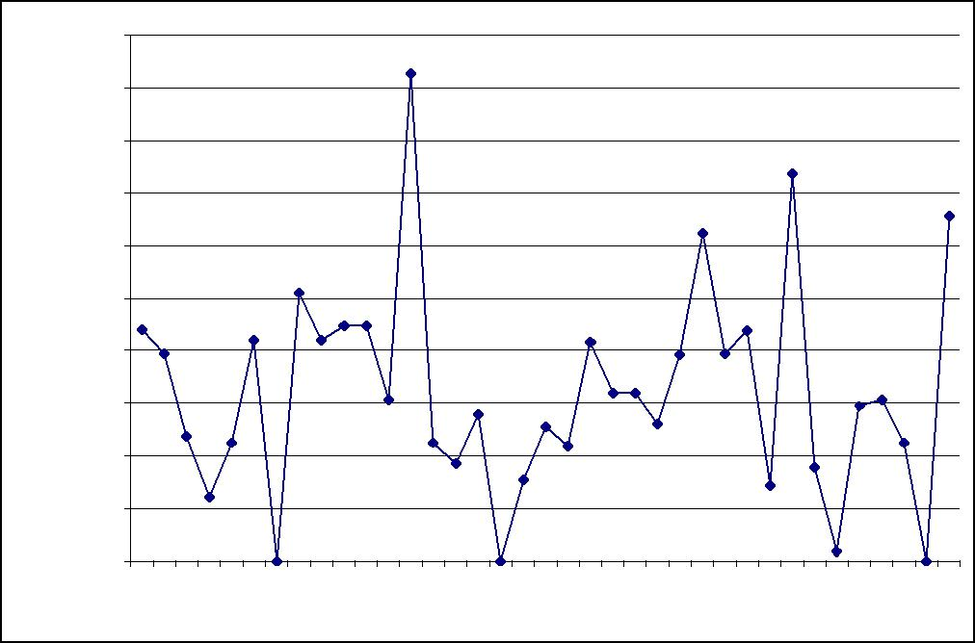

 | 50000
 | 45000
A | 40000
rig
Polyethylene | 35000
 | 30000
 | 25000
-
CFU/l | 20000
Legionella | 15000
 | 10000
 | 5000
 | 0
 | 324 |  | 4 | 372 | 387 | 404 | 410 | 424 | 438 |  | 3 | 466 | 480 | 487 | 501 | 515 | 529 | 43 | 557 | 571 | 585
 |  | 4 |  |  |  |  |  |  |  | 5
 |  | 3 |  |  |  |  |  |  |  | 4 |  |  |  |  |  |  |  | 5

Graph 4.31 Initial experiment - Legionella results polyethylene A

Page 162 of 229

The Legionella results were variable and ranged from 0CFU/l to 46400CFU/l. The average Legionella count found in the 37 samples was 16146CFU/l (± 1667CFU/l). The average temperature was 44ºC (± 0.4ºC).

Graph 4.32 below also shows the planktonic Legionella results of samples taken from the copper rig from first detection, at 324 days, to 585 days.
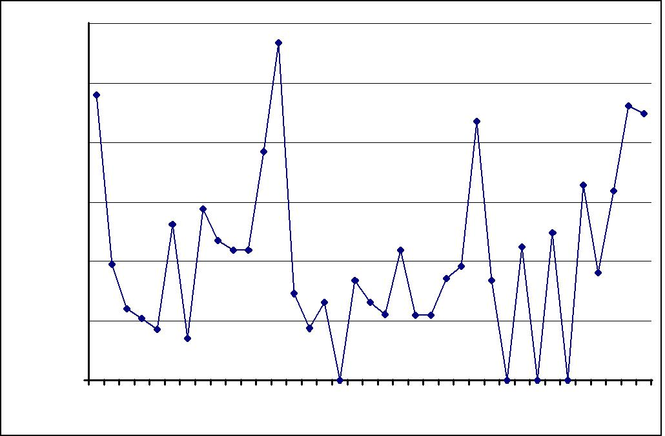

 | 60000
 | 50000
rig A
- Copper | 40000
CFU/l | 30000
Legionella | 20000
 | 10000
 | 0
 | 4 | 4 |  | 2 | 387 | 404 | 410 | 4 | 8 | 3 |  | 6 |  | 0 | 487 | 501 | 5 | 9 | 3 | 7 |  | 1 | 585
 | 32 | 34 | 7 |  |  |  |  | 42 | 43 | 45 | 6 |  | 8 |  |  |  | 51 | 52 | 54 | 55 | 7
 |  |  | 3 |  |  |  |  |  |  |  | 4 |  | 4 |  |  |  |  |  |  |  | 5

Graph 4.32 Initial experiment - Legionella results copper rig A.

The Legionella results were again variable and ranged from 0CFU/l to 56800CFU/l. The average Legionella count found in the 37 samples taken was 20611CFU/l (± 2352CFU/l). The average temperature was 42ºC (± 0.4ºC).

The Legionella species found in the rigs, L. pneumophila serogroup 2 to 14, were different from the species that were detectable in the original inoculum, L. pneumophila serogroup 1 and Legionella non-pneumophila. This may have been because the environment within the rigs supported the growth of Legionella pneumophila serogroup 2 to 14 and the original inoculum may have contained a mixture of species including serotypes that were not readily detectable.

Tables 4.31 and 4.32 below show the results of the methods applied to sections 1 to 16 of the rigs, as an initial experiment, to establish the best way to remove and quantify biofilms. The highest weight was found in the samples from the brushed through sections, although this was not necessarily reflected in some viable cell Page 163 of 229

results, for instance the TVC results obtained from section 11 of the copper rig at 211 days, where there appears to be a significant biolayer (in weight) but few viable cells. This could indicate that much of the biolayer consisted of non-viable material.

Tables 4.31 and 4.32 also show the results of the analysis for viable biological material within the sonified, shaken and brushed samples. The results were variable and did not indicate a steady build-up of biofilm with the length of time that sections were in place. The results also suggested that within 478 days a substantial biofilm did not form as the TVC density was calculated to be below 70/mm², which is generally considered to be insignificant.

 | Days in |  | TVC | TVC | Weight | Biolayer @ | Biolayer @
Section |  | Procedure | @37ºC | @22ºC |  | 37ºC per | 22ºC per
 | rig |  |  |  | grams
 |  |  | cfu/ml | cfu/ml |  | mm² | mm²
1 | 19 | Shaken | 0 | 0 | 0 | 0 | 0
2 | 27 | Shaken | 0 | 0 | 0 | 0 | 0
3 | 70 | Shaken | 10 | 6 | 0 | 0.7 | 0.4
4 | 80 | Shaken | 1 | 1 | 0.004 | 0.07 | 0.07
5 | 89 | Shaken | 0 | 1 | 0 | 0 | 0.07
6 | 128 | Shaken | 9 | 7 | 0 | 0.6 | 0.5
7 | 128 | Sonicated | 880 | 204 | 0 | 63 | 15
8 | 211 | Dried | 4 | 11 | 0.001 | 0.3 | 0.8
9 | 211 | Sonicated | 1 | 119 | 0.0008 | 0.07 | 9
10 | 211 | Shaken | 2 | 0 | 0.007 | 0.1 | 0
11 | 211 | Brushed | 2 | 1 | 0.02 | 0.1 | 0.07
12 | 284 | Brushed | 640 | 126 | 0.016 | 46 | 9
13 | 387 | Brushed | 50 | 1 | 0 | 4 | 0.07
14 | 387 | Brushed | 14 | 4 | 0 | 1 | 0.3
15 | 409 | Brushed | 60 | 3 | 0 | 4 | 0.2
16 | 478 | Brushed | 1 | 1 | 0 | 0.07 | 0.07
Table 4.31 Initial experiment - Biofilm results in weight and biolayer per mm² from TVC results at 37ºC and at 22ºC (TVC result x 500ml/7000mm²) - copper rig.

 | Days in |  | TVC | TVC | Weight | Biolayer @ | Biolayer @
Section |  | Procedure | @37ºC | @22ºC |  | 37ºC per | 22ºC per
 | rig |  |  |  | grams
 |  |  | cfu/ml | cfu/ml |  | mm² | mm²
1 | 19 | Shaken | 605 | 0 | 0 | 43 | 0
2 | 27 | Shaken | 0 | 4 | 0 | 0 | 0.3
3 | 70 | Shaken | 0 | 0 | 0 | 0 | 0
4 | 80 | Shaken | 0 | 1 | 0.004 | 0 | 0.07
5 | 89 | Shaken | 0 | 3 | 0.0004 | 0 | 0.2
6 | 128 | Shaken | 5 | 5 | 0 | 0.4 | 0.4
7 | 128 | Sonicated | 80 | 5 | 0 | 6 | 0.4
8 | 211 | Dried | 1 | 165 | 0.001 | 0.07 | 12
9 | 211 | Sonicated | 1 | 2 | 0.001 | 0.07 | 0.1
10 | 211 | Shaken | 0 | 1 | 0.0006 | 0 | 0.07
11 | 211 | Brushed | 3 | 91 | 0.006 | 0.2 | 7
12 | 284 | Brushed | 16 | 0 | 0.005 | 1 | 0.07
13 | 387 | Brushed | 29 | 1 | 0 | 2 | 0.07
14 | 387 | Brushed | 30 | 7 | 0 | 2 | 0.5

Page 164 of 229

15 | 409 | Brushed | 1 | 0 | 0 | 0.07 | 0
16 | 478 | Brushed | 330 | 4 | 0 | 24 | 0.3
 | Table 4.32 Initial experiment - Biofilm results in weight and biolayer per mm² from TVC

results at 37ºC and at 22ºC (TVC result x 500ml/7000mm²) – polyethylene rig.

Analysis for sessile Legionella was carried out on the brushed samples of sections 13, 14, 15 and 16 removed from the rigs on days 387, 409 and 478. The results are shown in Table 4.33 below. This table also shows the corresponding planktonic levels of Legionella.

 | Days | Legionella | Legionella | Planktonic | Planktonic
Section |  | Copper Rig | Polyethylene | Legionella | Legionella
 | in Rigs
 |  | Sections | Rig Sections | Copper Rig | Polyethylene Rig
13 | 387 | 4300 cfu/l | 0 | 7200 cfu/l | 0
14 | 387 | 15200 cfu/l | 0 | 7200 cfu/l | 0
15 | 409 | 21000 cfu/l | 4800 cfu/l | 21800 cfu/l | 22400 cfu/l
16 | 478 | 70000 cfu/l | 40800 cfu/l | 21800 cfu/l* | 20800 cfu/l*

* - Results from samples taken from rigs on day 480.

Table 4.33 Initial experiment - Sessile and planktonic Legionella results of copper and

polyethylene rigs.

More than 10000CFU/l were found in sections 14, 15 and 16 of the copper rig and in section 16 of the polyethylene rig. Legionella pneumophila serogroup 2 to 14 were only found.

Sections 13, 14, 15 and 16 were again simultaneously removed from each rig, as well as sections 1 to 13, on day 564 for Legionella analysis, representing residence times of between 86 and 547 days.

The results of the copper rig sections are shown in Figure 4.1 below.

Page 165 of 229

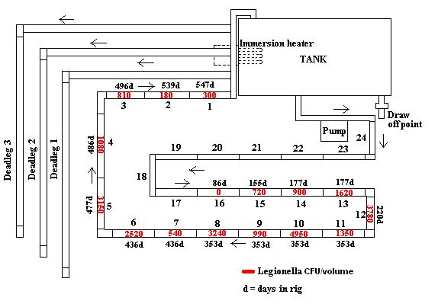

Figure 4.1 Legionella results of sections 1 to 16 of the copper rig – removed simultaneously on day 564.

Legionella were found in sections 1 to 15 of the copper rig. No Legionella were found in section 16, which had been in the copper rig for 86 days. The results indicated that Legionella multiplied in biofilm in pipe sections that were in the copper rig for more than 86 days and that multiplication peaked in pipe sections that had been in the rig for 353 days after which multiplication dropped to only 300CFU found in the pipe section that had been in the copper rig for 547 days.

Very surprisingly, no Legionella were found in the polyethylene rig sections 1 to 15 but a colony forming unit count of 1800CFU/500ml was found in section 16.

Legionella non-pneumophila and L. pneumophila serogroup 2 to 14 were found in the copper rig sections. Only L. pneumophila serogroup 2 to 14 were found in the polyethylene section samples.

Legionella results of samples taken from rigs A, after rigs B and C were inoculated with water and sections from rigs A (day 0), and before treatment was started (day 120), are shown in Graph 4.33 below.

Page 166 of 229

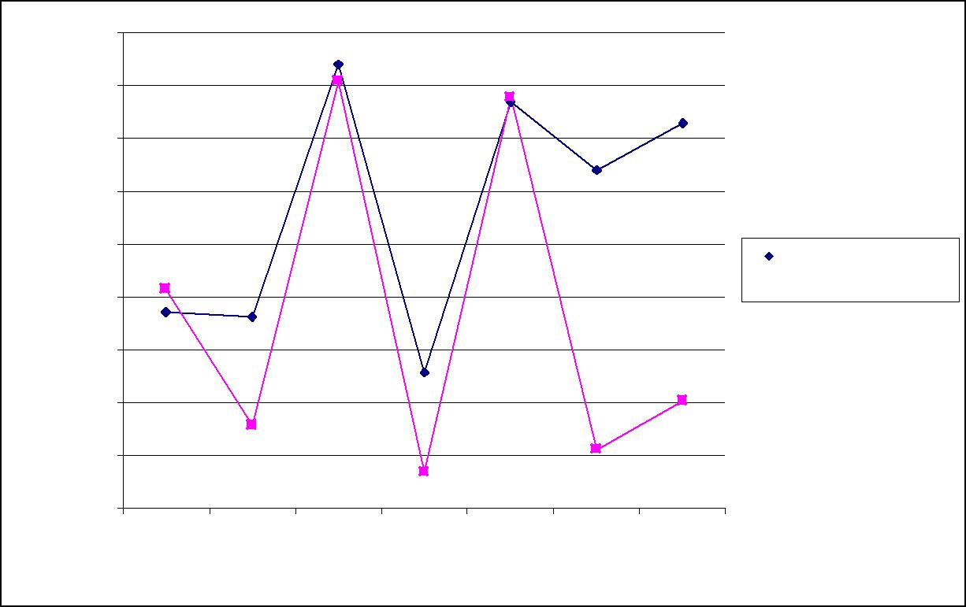
 | 45000
 | 40000
 | 35000
A
- rigs | 30000
CFU/l | 25000
Legionella | 20000
 | 15000
 | 10000
 | 5000
 | 0
 | 43 | 58 | 65 | 79 | 93 | 114 | 120

Days in rigs

Polyethylene rig A Copper rig A

Graph 4.33 Legionella results of samples taken from rigs A after inoculation of rigs B and C (day 0) and before treatment (day 120).

The Legionella results of the samples taken from the polyethylene rig were variable and ranged from 12800CFU/l to 42000CFU/l. The average Legionella count found in the 7 samples was 28329CFU/l (± 4384CFU/l).The temperature of the rigs was kept below 45ºC.

The Legionella results of the samples taken from the copper rig were also variable and ranged from 3500CFU/l to 40400CFU/l. The average Legionella count found in the 7 samples was 18129CFU/l (± 5920CFU/l).

The Legionella colony forming unit counts found in the samples of the polyethylene rig A brushed through sections, which were removed after inoculation of rigs B and C and before the comparison experiment, were:

Section 19, in place in rig since design stage, 5600CFU/l

Section 18, in place in rig for 79 days, 0CFU/l

Section 17, in place in rig for 114 days, 13600CFU/l.

The Legionella colony forming unit counts found in the samples of copper rig A brushed through sections, which were removed after inoculation of rigs B and C and before the comparison experiment, were:

Page 167 of 229

Section 19, in place in rig for 58 days, 6700CFU/l

Section 17, in place in rig for 79 days, 1500CFU/l

Section 16, in place in rig for 114 days, 800CFU/l.

Page 168 of 229

4.12.2 Rigs B and C

Graph 4.34 below shows the Legionella colony forming unit counts found in samples taken from rigs B after inoculation (day 0) and before treatment was started (day 120).
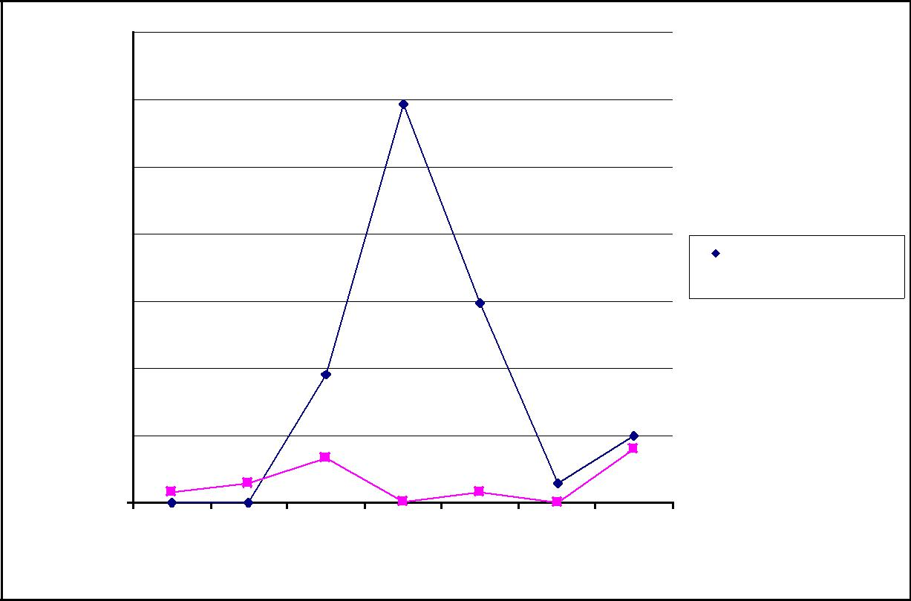

 | 350000
 | 300000
B | 250000
- rigs
CFU/L | 200000
Legionella | 150000
 | 100000
 | 50000
 | 0
 | 43 | 58 | 65 | 79 | 93 | 114 | 120

Days in rigs

Polyethylene rig B Copper rig B

Graph 4.34 Legionella results of samples taken from rigs B after inoculation and before treatment.

The Legionella results of the samples taken from the polyethylene rig were variable and ranged from 0CFU/l to 297000CFU/l. The average Legionella count found in the 7 samples was 86486CFU/l (± 40760CFU/l). The temperature of the rigs was kept below 45ºC.

The Legionella results of the samples taken from the copper rig were also variable and ranged from 0CFU/l to 40400CFU/l. The average Legionella count found in the 7 samples was 14986CFU/l (± 6006CFU/l).

The Legionella colony forming unit counts found in the samples of the polyethylene rig B brushed through sections were:

Section 19, in place in rig for 58 days, 0CFU/l

Section 18, from rig A, in place in rig for 79 days, 594000CFU/l Section 17, from rig A, in place in rig for 114 days, 89600CFU/l.

Page 169 of 229

The Legionella colony forming unit counts found in the samples of copper rig B brushed through sections, before the comparison experiment was started, were: Section 19, from rig A, in place in rig for 58 days, 4500CFU/l

Section 18, from rig A, in place in rig for 79 days, 300CFU/l Section 17, from rig A, in place in rig for 114 days, 21600CFU/l.

Graph 4.35 below shows the Legionella colony forming unit counts found in samples taken from the polyethylene rig C after inoculation (day 0) and before treatment (day 120).

 | 500000
 | 450000
C
rig | 400000
- Polyethylene | 350000
 | 300000
 | 250000
CFU/L | 200000
Legionella | 150000
 | 100000
 | 50000
 | 0
 | 43 | 58 | 65 | 79 | 93 | 120
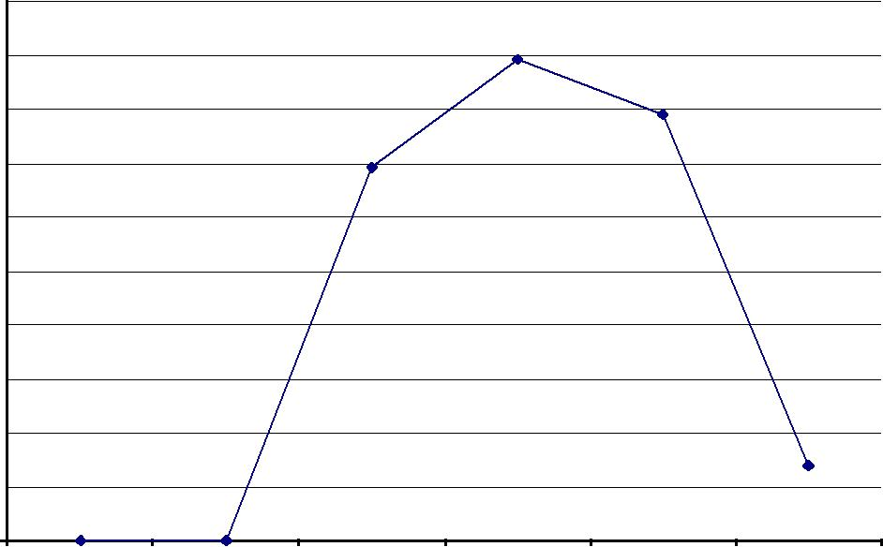

Days in rig

Graph 4.35 Legionella results of samples taken from the polyethylene rig C after inoculation and before treatment.

The Legionella results in the samples taken from the polyethylene rig C ranged from 0CFU/l to a very high count of 18150000CFU/l, which was not included in Graph 4.35. The average Legionella count found including the high count was 2772471CFU/l (± 2563928CFU/l). The average Legionella count excluding the high count was 209550CFU/l ((±78683CFU/l). The temperature of the rig was kept below 45ºC.

Page 170 of 229

Graph 4.36 below shows the Legionella colony forming unit counts found in samples taken from the copper rig C after inoculation (day 0) and before treatment (day 120).
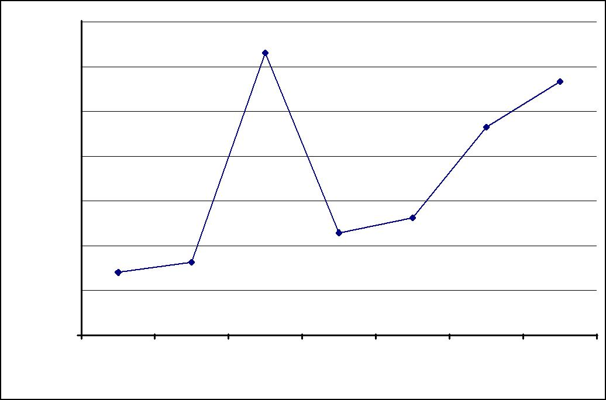

 | 70000
 | 60000
rig C | 50000
Copper
 | 40000
-
CFU/L | 30000
Legionella | 20000
 | 10000
 | 0
 | 43 | 58 | 65 | 79 | 93 | 114 | 120

Days in rig

Graph 4.36 Legionella results of samples taken from the copper rig C after inoculation and before treatment.

The Legionella results of the samples taken from the copper rig ranged from 14000CFU/l to 63200CFU/l. The average Legionella count found in the samples was 35071CFU/l (±7573CFU/l). The temperature of the rig was also kept below 45ºC.

The Legionella colony forming unit counts found in the samples of the polyethylene rig C brushed through sections were:

Section 19, in place in rig for 58 days, 0CFU/l

Section 18, in place in rig for 79 days, 0CFU/l

Section 6, from rig A, in place in rig for 114 days, 69600CFU/l.

The Legionella colony forming unit counts found in the samples of copper rig C brushed through sections, before the comparison experiment was started, were: Section 19, in place in rig for 58 days, 5100CFU/l Section 18, in place in rig for 79 days, 4300CFU/l

Section 8, from rig A, in place in rig for 114 days, 18800CFU/l.

Page 171 of 229

4.13 Comparison experiment - Rigs

4.13.1 Rigs A

Three litres of copper and silver ionized water produced by the copper and silver ionization system was added to rigs A daily for 83 days in a separate operation.

The average silver level found in samples taken daily from the copper and silver ionization system over the 83 days was 0.196mg/l. The average copper level was 3.31mg/l.

The average silver level found in samples taken daily from the draw off point of the polyethylene rig was 0.042mg/l (± 0.011mg/l). The average copper level was 0.866mg/l (± 0.127mg/l).

Graph 4.37 shows the Legionella results of samples taken once a week from the polyethylene rig draw off point from when treatment started to the end of treatment.
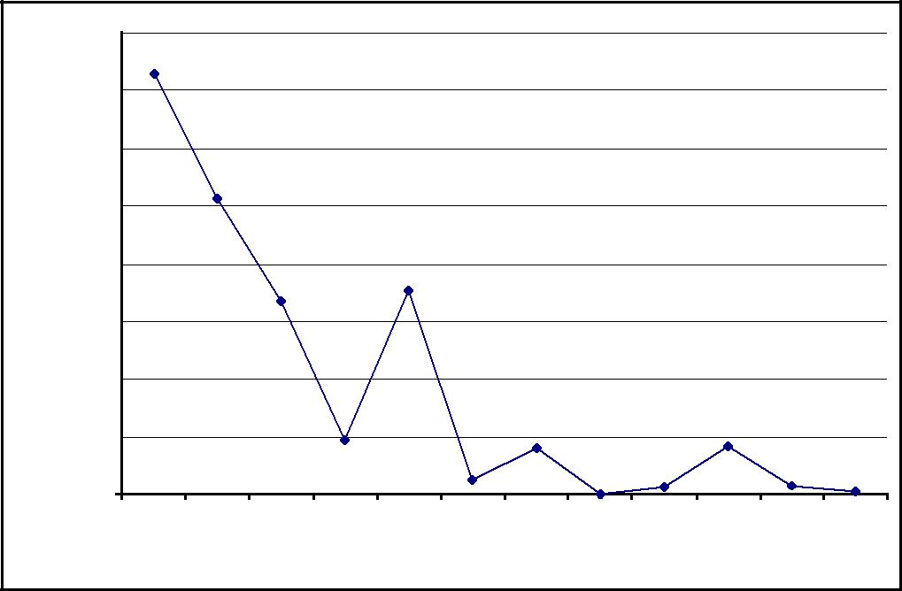

 | 40000
rig A | 35000
 | 30000
polyethylene
 | 25000
 | 20000
CFU/l -
 | 15000
Legionella | 10000
 | 5000
 | 0
 | 0 | 13 | 20 | 27 | 34 | 41 | 48 | 55 | 62 | 69 | 76 | 83

Days of treatment

Graph 4.37 Legionella results of polyethylene rig A.

At day 0, before copper and silver ionized water was added, a Legionella colony forming unit count of 36400CFU/l was found in the sample taken from the draw off point of the polyethylene rig. The Legionella contamination declined to a Legionella colony forming unit count of 200CFU/l found in the sample taken on day 83 (~ 99% Page 172 of 229

reduction). The average Legionella count of samples taken from day 13 to day 83 was 6900CFU/l (± 2668CFU/l).

The temperatures of the polyethylene rig tank recorded daily for 83 days ranged from 37ºC to 47ºC. The most common temperature recorded was 42ºC. The average temperature recorded in the polyethylene rig A tank during treatment was 44ºC (± 0.4ºC).

The Legionella colony forming unit counts found in the samples of the polyethylene rig brushed through sections during treatment were:

Section 16, in place in rig for 133 days, day 13 of trial, 2900CFU/l

Section 14, in place in rig for 175 days, day 55 of trial, 30400CFU/l

Section 13, in place in rig for 203 days, day 83 of trial, 0CFU/l.

All these sections had been in the rig for 120 days before treatment was started.

The average silver level found in samples taken daily from the draw off point of the copper rig was 0.031mg/l (± 0.007mg/l). The copper level found, due to copper leaching from the copper pipes, before copper and silver ionized water was added to the rig was 0.325mg/l. The average copper level for the duration of treatment was 0.874 mg/l (± 0.116 mg/l).

Graph 4.38 shows the Legionella results of samples taken ones a week from the copper rig draw off point from when treatment started to the end of treatment.
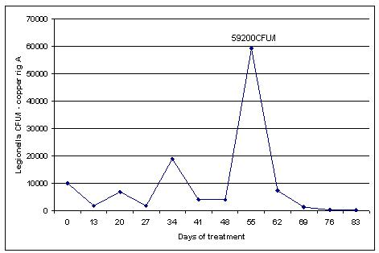

Graph 4.38 Legionella results of copper rig A.

Page 173 of 229

At day 0 a Legionella colony forming unit count of 10100CFU/l was found in the sample taken from the draw off point of the copper rig. A high Legionella colony forming unit count of 59200CFU/l was found in the sample taken from the copper rig on day 55. The silver found was 0.062mg/l and the copper was 0.664mg/l. The count reduced in a sample taken one week later, day 62, to 7400CFU/l, and the Legionella contamination declined from day 62 onwards to a count of 200CFU/l found in a sample taken on day 83 (~ 98% reduction). The average Legionella count of samples taken from day 13 to day 83 was 9636CFU/l (± 5207CFU/l).

The temperatures of the copper rig tank recorded daily for 83 days ranged from 33ºC to 50ºC. The most common temperature recorded was 44ºC. The average temperature recorded in the copper rig A tank during treatment was 42ºC (± 0.3ºC).

The Legionella colony forming unit counts found in the samples of the copper rig brushed through sections during treatment were:

Section 15, in place in rig for 133 days, day 13 of trial, 200CFU/l

Section 14, in place in rig for 175 days, day 55 of trial, 6600CFU/l

Section 13, in place in rig for 203 days, day 83 of trial, 900CFU/l.

All these sections had been in the rig for 120 days before treatment started.

Page 174 of 229

4.13.2 Rigs B

The temperatures in rigs B were maintained below 45ºC, simulating a typical hot water circulating system in which mixing valves are used to blend water to a temperature below 45ºC to avoid scalding. This was effectively the ‘control’ rig in this set of experiments.

The temperatures of the polyethylene rig tank recorded daily for 83 days ranged from 36ºC to 49ºC. The most common temperature recorded was 45ºC. The average temperature in the polyethylene rig tank recorded over the 83 days was 43ºC (± 0.4ºC).

Graph 4.39 shows the Legionella results of samples taken ones a week from the polyethylene rig draw off point.
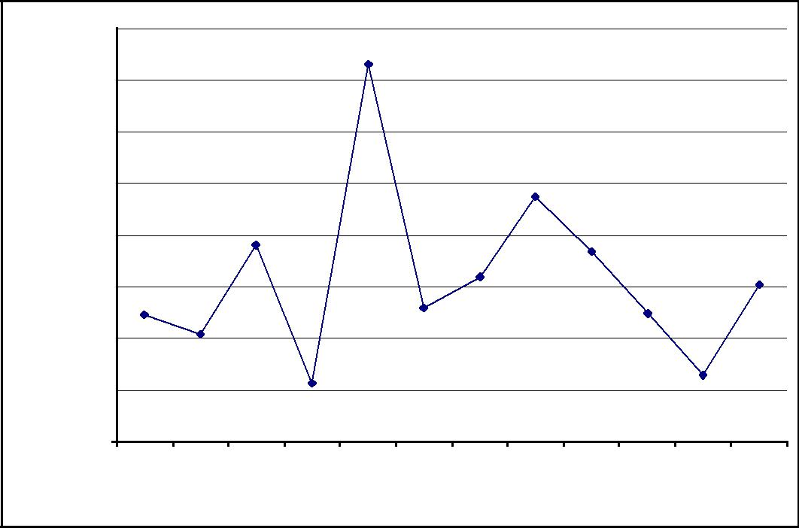

 | 160000
rig B | 140000
 | 120000
polyethylene
 | 100000
 | 80000
CFU/l -
 | 60000
Legionella | 40000
 | 20000
 | 0
 | 0 | 13 | 20 | 27 | 34 | 41 | 48 | 55 | 62 | 69 | 76 | 83

Days in rig

Graph 4.39 Legionella results of polyethylene rig B.

At day 0 a Legionella colony forming unit count of 49500CFU/l was found in the sample taken from the draw off point of the polyethylene rig. The Legionella contamination was variable but increased to a Legionella colony forming unit count of 60800CFU/l found in the sample taken on day 83 (~ 23% increase).The average Legionella count of samples taken from day 13 to day 83 was 64309CFU/l (± 10421CFU/l).

Page 175 of 229

The Legionella colony forming unit counts found in the samples of the polyethylene rig brushed through sections were:

Section 16, from rig A, in place in rig for 133 days, day 13 of trial, 8800CFU/l

Section 14, from rig A, in place in rig for 175 days, day 55 of trial, 96800CFU/l

Section 13, from rig A, in place in rig for 203 days, day 83 of trial, 32600CFU/l.

All these sections had been removed from the polyethylene rig A to inoculate rig B and had been in rig B for 120 days at day 0.

The temperatures of the copper rig tank recorded daily for 83 days ranged from 37ºC to 50ºC. The most common temperature recorded was 43ºC. The average temperature recorded in the copper rig tank was 44ºC (± 0.3ºC).

Graph 4.40 shows the Legionella results of samples taken ones a week from the copper rig draw off point.
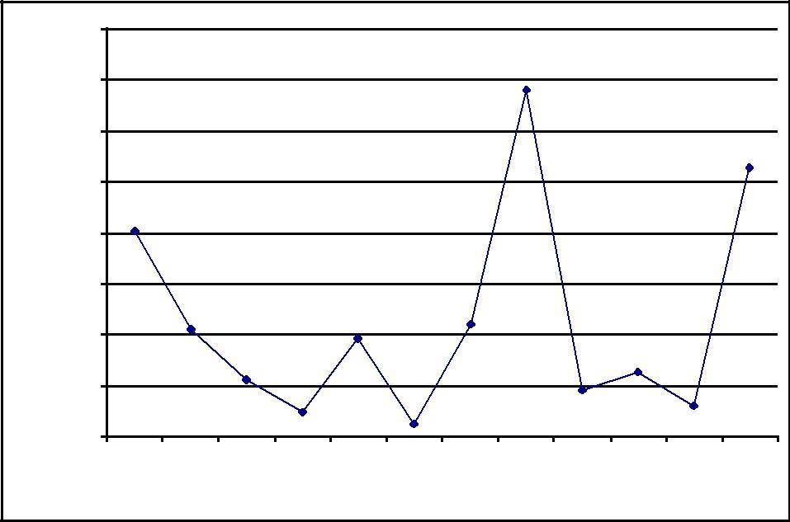

 | 80000
 | 70000
B
rig | 60000
- copper | 50000
CFU/l | 40000
Legionella | 30000
 | 20000
 | 10000
 | 0
 | 0 | 13 | 20 | 27 | 34 | 41 | 48 | 55 | 62 | 69 | 76 | 83

Days in rig

Graph 4.40 Legionella results of copper rig B.

At day 0 a Legionella colony forming unit count of 40400CFU/l was found in a sample taken from the draw off point of the copper rig. The Legionella contamination increased to a Legionella colony forming unit count of 52800CFU/l found in the sample taken on day 83 (~31% increase).The average Legionella count of samples taken from day 13 to day 83 was 20873CFU/l (± 6294CFU/l).

The Legionella colony forming unit counts found in the samples of the copper rig brushed through sections were:

Page 176 of 229

Section 15, in place in rig for 133 days, day 13 of trial, 200CFU/l

Section 14, in place in rig for 175 days, day 55 of trial, 25200CFU/l

Section 13, in place in rig for 203 days, day 83 of trial, 3400CFU/l.

All these sections had been in the rig for 120 days at day 0.

Page 177 of 229

4.13.3 Rigs C

The temperatures in rigs C were maintained ~50ºC, simulating a pure hot water circulating system to which the temperature control regime, as recommended in the ACoP (L8) and the HTM 04-01 documents, is applied.

The temperatures of the polyethylene rig tank recorded daily for 83 days ranged from 42ºC to 60ºC. The most common temperatures recorded were 45ºC, 46ºC, and 48ºC. The average temperature recorded was 49ºC (±0.6ºC).

Graph 4.41 shows the Legionella results of samples taken once a week from the polyethylene rig draw off point as well as the temperatures that were recorded on the day the Legionella samples were taken.

 |  | Temperature and Legionella Polyethylene Rig
 | 80000 | 60
 | 70000
 |  | 50
 | 60000
 |  | 40 | C
LegionellaCFU/L | 50000 |  | Temperaturedegrees
 | 40000 | 30
 | 30000
 |  | 20
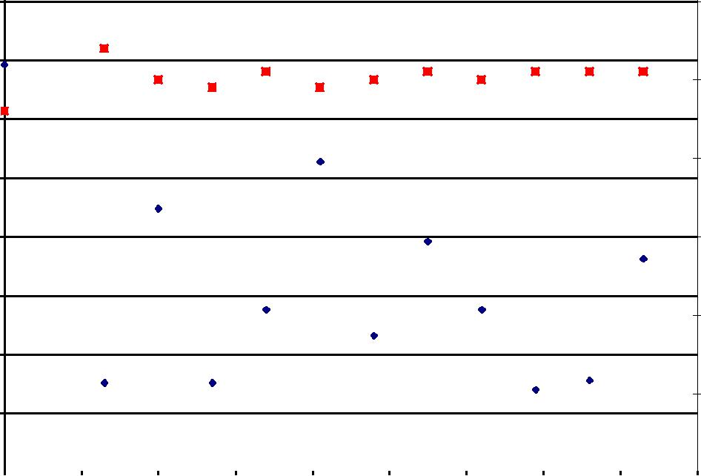

20000

10

10000

0 |  |  |  |  |  |  |  |  |  |  |  | 0
0 |  | 10 | 20 | 30 | 40 | 50 | 60 | 70 | 80 | 90

Days of treatment

Legionella CFU/L Temperature degrees C

Graph 4.41 Legionella results and temperature recordings of polyethylene rig C.

At day 0 a Legionella colony forming unit count of 69300CFU/l was found in the sample taken from the draw off point of the polyethylene rig. The Legionella contamination declined to a Legionella colony forming unit count of 36300CFU/l found in the sample taken on day 83 (~48% reduction).The average Legionella count of samples taken from day 13 to day 83 was 28318CFU/l (± 4035CFU/l).

Page 178 of 229

The Legionella colony forming unit counts found in the samples of the polyethylene rig brushed through sections were:

Section 7, from rig A, in place in rig for 133 days, day 13 of trial, 700CFU/l

Section 17, in place in rig for 175 days, day 55 of trial, 26400CFU/l

Section 16, in place in rig for 203 days, day 83 of trial, 500CFU/l.

Sections 17 and 16 had been in the rig for 120 days at day 0. Section 7 was removed from the polyethylene rig A to inoculate rig C and had been in rig C for 120 days at day 0

The temperatures of the copper rig tank recorded daily for 83 days ranged from 40ºC to 58ºC. The most common temperature recorded was 46ºC. .The average temperature recorded in the copper rig tank was 48ºC (± 0.5ºC).

Graph 4.42 shows the Legionella results of samples taken ones a week from the

copper rig draw off point as well as the temperatures that were recorded on the day

the Legionella samples were taken.

.
Temperature and Legionella Copper Rig

60000 |  |  |  |  |  |  |  |  | 60
50000 |  |  |  |  |  |  |  |  | 50
40000 |  |  |  |  |  |  |  |  | 40 | C
30000 |  |  |  |  |  |  |  |  | 30 | Temperature degrees
LegionellaCFU/L |  |  |  |  |  |  |  |  | 20
20000
10000 |  |  |  |  |  |  |  |  | 10
0 |  |  |  |  |  |  |  |  | 0
0 | 10 | 20 | 30 | 40 | 50 | 60 | 70 | 80 | 90
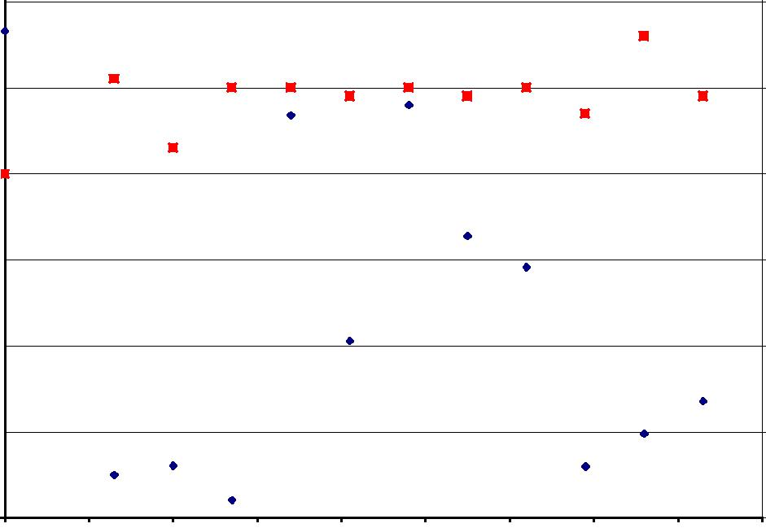

Days of Treatment

Graph 4.42 Legionella results and temperature recordings of copper rig C.

Legionella CFU/L Temperature degrees C

At day 0 a Legionella colony forming unit count of 56600CFU/l was found in the sample taken from the draw off point of the copper rig. The Legionella contamination declined to a Legionella colony forming unit count of 13600CFU/l found in the

Page 179 of 229

sample taken on day 83 (~76% reduction).The average Legionella count of samples taken from day 13 to day 83 was 20000CFU/l (± 5072CFU/l).

The Legionella count dropped to below 10000CFU/l in samples taken on day 13, the temperature was 51ºC, on day 20, the temperature was 43ºC, on day 27, the temperature was 50ºC, on day 69, the temperature was 47ºC, and on day 76, the temperature was 56ºC.

The Legionella colony forming unit counts found in the samples of the copper rig brushed through sections were:

Section 9, in place in rig for 133 days, day 13 of trial, 0CFU/l

Section 16, from rig A, in place in rig for 175 days, day 55 of trial, 0CFU/l Section 13, in place in rig for 203 days, day 83 of trial, 200CFU/l.

Sections 9 and 13 had been in the rig for 120 days at day 0. Section 16 was removed from the copper rig A to inoculate rig C.

Page 180 of 229

4.14 The Robbins device

Tables 4.34, 4.35, and 4.36 below show the results of the 3 tests carried out with the Robbins device by releasing the rubber, copper, and polyethylene discs in 10ml distilled water and shaking the sample for 30 seconds.
Test | Disc | ₁₀-2 | ₁₀-2
 |  | CFU/ml | CFU/ml
Test 1 | A | 350000 | 340000
Test 1 | B | 2800000 | 2400000
Test 1 | C | 2200000 | 3600000
Test 1 | D | 1500000 | 1200000
Test 1 | E | 1800000 | 1300000
Test 1 | F | 380000 | 460000
Test 2 | A | 1400000 | 550000
Test 2 | B | 1200000 | 720000
Test 2 | C | 1400000 | 870000
Test 2 | D | 560000 | 750000
Test 2 | E | 1500000 | 1100000
Test 2 | F | 720000 | 540000
Test 3 | A | 750000 | 840000
Test 3 | B | 610000 | 560000
Test 3 | C | 560000 | 600000
Test 3 | D | 1330000 | 1430000
Test 3 | E | 920000 | 800000
Test 3 | F | 710000 | 700000
Table 4.34 The Robbins device - rubber discs results.

Test | Disc | ₁₀-2 | ₁₀-2
 |  | CFU/ml | CFU/ml
Test 1 | A | 210000 | 170000
Test 1 | B | 130000 | 200000
Test 1 | C | 1300000 | 1000000
Test 1 | D | 880000 | 1160000
Test 1 | E | 1640000 | 1240000
Test 1 | F | 1410000 | 740000
Test 2 | A | 1900000 | 1500000
Test 2 | B | 1900000 | 2100000
Test 2 | C | 900000 | 920000
Test 2 | D | 570000 | 580000
Test 2 | E | 810000 | 920000
Test 2 | F | 1200000 | 1100000
Test 3 | A | 140000 | 180000
Test 3 | B | 280000 | 270000
Test 3 | C | 70000 | 210000
Test 3 | D | 250000 | 450000
Test 3 | E | 300000 | 300000
Test 3 | F | 300000 | 450000
Table 4.35 The Robbins device - copper discs results.

Page 181 of 229

Test | Disc | 10⁻² | 10⁻²
 |  | CFU/ml | CFU/ml
Test 1 | A | 260000 | 50000
Test 1 | B | 230000 | 200000
Test 1 | C | 120000 | 380000
Test 1 | D | 500000 | 70000
Test 1 | E | 110000 | 280000
Test 1 | F | 140000 | 200000
Test 2 | A | 110000 | 90000
Test 2 | B | 60000 | 110000
Test 2 | C | 390000 | 100000
Test 2 | D | 270000 | 110000
Test 2 | E | 80000 | 50000
Test 2 | F | 230000 | 190000
Test 3 | A | 140000 | 140000
Test 3 | B | 140000 | 240000
Test 3 | C | 140000 | 190000
Test 3 | D | 160000 | 150000
Test 3 | E | 90000 | 210000
Test 3 | F | 260000 | 50000
Table 4.36 The Robbins device - polyethylene discs results.

The average results of the 3 tests of the rubber, copper and polyethylene disc samples were:

Rubber | 1.1 x 10⁶ | CFU/ml
Copper | 7.7 x 10⁵ | CFU/ml
Polyethylene | 1.7 x 10⁵ | CFU/ml

Table 4.37 below shows the results of the tests carried out with the Robbins device by brushing the discs in 10ml distilled water.

Test | Disc | 10⁻² | 10⁻² | 10⁻³ | 10⁻³
 |  | CFU/ml | CFU/ml | CFU/ml | CFU/ml
Test 4 | C- Rubber | TNTC | TNTC | 11100000 | 16900000
Test 4 | F Rubber | TNTC | TMTC | 13900000 | 8300000
Test 4 | I Rubber | TNTC | TNTC | 5600000 | 5600000
Test 4 | L Rubber | TNTC | TNTC | 12300000 | 13200000
Test 4 | B Copper | 310000 | 150000 | 0 | 300000
Test 4 | E Copper | 100000 | 80000 | 100000 | 300000
Test 4 | H Copper | 890000 | 850000 | 500000 | 900000
Test 4 | K Copper | 370000 | 670000 | 400000 | 500000
Test 4 | A Polyethylene | 570000 | 480000 | 600000 | 300000
Test 4 | D Polyethylene | 1890000 | 1380000 | 1100000 | 1700000
Test 4 | G Polyethylene | 660000 | 520000 | 800000 | 700000
Test 4 | J Polyethylene | 770000 | 330000 | 700000 | 300000
TNTC = Too Numerous To Count

Table 4.37 The Robbins device - results brushed rubber, copper and polyethylene discs

Page 182 of 229

The 10⁻² samples of the rubber discs were too numerous to count. The average result of the rubber disc 10⁻³ samples was 1.1 x 10⁷ CFU/ml. The average results of the highest result of the two 10⁻² and the two 10⁻³ copper and polyethylene disc samples were 4.6 x 10⁵ CFU/ml for the copper discs and 8.7 x 10⁵ CFU/ml for the polyethylene discs.

Page 183 of 229

- DISCUSSION

5.1 Evaluation study of 10 hospitals

Legionella contaminate water systems from public water supplies and borehole waters, and colonize these systems from biofilms, and protozoa cells where they are protected from disinfection. Preventing Legionella contamination of these systems is, therefore, a difficult technological challenge. However, because Legionella can cause devastating disease in humans, it is important to prevent these systems from becoming contaminated and to control the risk of exposure.

Disturbing findings during this study were that many of the UK Health and Safety Executive’s and Department of Health’s recommendations may not result in control and prevention of Legionnaires’ disease. Furthermore, several of their recommended practices can place an undue burden on UK national health estates departments to perform costly, labour intensive, and hazardous tasks with uncertain benefit.

In the US, routine monitoring for Legionella in water distribution systems is recommended as it is considered the only factor known with certainty to be predictive of the risk of legionellosis. Routine monitoring also allows for evaluation of the control modalities applied and, therefore, for effective prevention (Lin et al., 2011).

In the UK, however, monitoring for Legionella in water distribution systems is only recommended when storage and distribution temperatures are not consistently maintained at the levels recommended in the ACoP (L8) and HTM 04-01 documents or when an outbreak is suspected or has been identified (UK Approved Code of Practice (L8), 2000, UK Health Technical Memorandum 04-01, 2006). This approach has resulted in a lack of evidence of control by the recommended control modalities.

The temperature regime described in the ACoP (L8) and HTM 04-01 documents recommends that hot water is stored at 60ºC and distributed, so that it reaches a temperature of 50ºC within 1 minute at outlets. The cold temperature should be below 20ºC after running outlets for up to 2 minutes. Whilst the ACoP (L8) advises that this regime is the ‘traditional’ approach to Legionella control for hot water and cold water systems, and that it is not necessary to apply it as long as proliferation of Legionella is

Page 184 of 229

prevented, the HTM 04-01 documents recommend the regime, however, as the ‘preferred’ strategy, and advises using alternative techniques, such as copper- and silver ionization and chlorine dioxide, only together with but not instead of the temperature regime (UK Approved Code of Practice (L8), 2000, UK Health Technical Memorandum 04-01, 2006). The temperature regime is, therefore, still seen by UK national health trusts as the main control method even though it has not been validated.

None of the scientific papers evaluated by the UK Department of Health to compose the HTM 04-01 documents supported the control of Legionella at 50ºC after 1 minute or at 20ºC after 2 minutes (House of Commons Hansard debates for 22 May 2007, www.parliament.uk).

In this study, although some control was afforded by maintaining hot water temperatures above 55ºC, the results of the study with the 10 hospitals demonstrated that, when water systems are complex, the temperature regime, described in the ACoP (L8) and HTM 04-01 documents, does not achieve complete control.

Nine of the 10 hospitals studied relied solely on the recommended temperature regime for the control of Legionella in their hot and cold water distribution systems. The results of the samples taken from the hospitals before the copper and silver ionization systems were activated, therefore, demonstrate the lack of complete control by the temperature regime as Legionella were found. The results of the samples taken from study hospital 10, before the copper and silver ionization systems were activated, not only highlight the lack of complete control by the temperature regime but also by chlorine dioxide as chlorine dioxide was applied as well as the temperature regime because the temperature regime had failed to completely control the Legionella by itself. Furthermore, the results of the samples taken from the 10 hospitals also suggested the temperature regime actually promoted Legionella proliferation because of the requirement to reduce hot water temperatures to below 46ºC to avoid scalding.

Also supporting this are the temperature recordings of 3073 outlets of other sites at which Legionella were found. The hot water was deliberately blended with cold water at 1344 of these outlets (~43.8%) to temperatures ranging from 38ºC to 46ºC. The average Legionella colony forming unit count was the highest of all the 3073 outlets

Page 185 of 229

tested at these outlets, at 8339CFU/l (± 889CFU/l), with the highest Legionella colony forming unit count, of 445500CFU/l, found at 38ºC.

The temperatures of 671 of the 3073 outlets (~21.8%) were between 21ºC and 38ºC with an average Legionella colony forming unit count of 6213CFU/l (± 996CFU/l). The hot water at most of these outlets was blended deliberately, which highlighted another issue with the temperature regime as the mixing valves that were fitted to these outlets may not have been working properly.

That Legionella are not eradicated by a hot water temperature of above 50ºC is supported by the temperatures at 199 of the 3073 outlets at which Legionella were found (~6.5%) being 50ºC and above. The average count was 2941CFU/l (± 474CFU/l). A Legionella colony forming unit count of 100CFU/l was found at the highest temperature of 76ºC and the highest Legionella colony forming unit count, of 45000CFU/l, was found at 55ºC.

The temperatures of 165 of the 3073 outlets (~5.4%) were between 47ºC and 50ºC. The average Legionella colony forming unit count was 5320CFU/l (± 1256CFU/l). Unblended hot water serviced these outlets, which highlighted another issue with the temperature regime as the water heating system may not have been working properly.

That Legionella are eradicated by a cold water temperature of below 20ºC is also supported by the temperatures of 694 of the 3073 outlets at which Legionella were found (~22.6%) being below 20ºC. The average count was 1829CFU/l (± 289CFU/l). A Legionella colony forming unit count of 200CFU/l was found at the lowest temperature of 6ºC. The highest Legionella colony forming unit count, of 130400CFU/l, was found at 20ºC.

Previous studies have also demonstrated that the recommended temperatures are ineffective in controlling Legionella in hospital water systems. Legionella pneumophila was isolated from taps and showers of 2 buildings in Holland when the hot water temperature was circulated at 55ºC. The hot water system could also not be completely decontaminated even by raising the hot water temperature to 70ºC (Groothuis et al., 1985).

Page 186 of 229

Maintaining hot water at 50ºC to 55ºC at peripheral outlets of a university hospital in Belgium, removing deadends wherever possible, and improving maintenance on the hot water storage tanks, by draining, rinsing, refilling them with potable water, and increasing the temperatures to 95ºC before decreasing temperatures to 60ºC, showed only a reduction of the number of positive samples but these positive samples still contained between 10⁴ and 5 x 10⁵CFU/l L. pneumophila serogroups 6 and 10 (Ezzeddine et al., 1989).

Legionella pneumophila serogroup 6, associated with 2 cases of legionellosis, persisted in a hot water system of a hospital in Italy at temperatures of 55ºC and 56ºC (Visca et al., 1999).

Darelid et al., (2002), found that maintaining water temperatures above 55ºC was associated with 12% of water samples being positive during a 10 year period in which 4 patients developed Legionnaires’ disease (Darelid et al., 2002).

After an outbreak of Legionnaires’ disease in August 2010, control of Legionella, present in the hot water and cold water system of a nursing home in Slovenia, by maintaining hot and cold water temperatures at 55°C and below 20°C proved to be inadequate. The Legionella results of sample testing after these interventions still were above 10⁴ CFU/l (Skaza et al., 2010).

The results of the research project by BSRIA in 1996 also showed that no Legionella were found in only 13% of the results of the rig to which the temperature regime was applied. This study also showed that the hot water storage calorifier, which transferred heat to water indirectly, did not provide complete protection against Legionella being drawn into the hot water circuit even when the flow water temperature was maintained at 60ºC (BSRIA TN6/96).

Studies have even demonstrated that elevated temperatures can promote biofilm re-growth and that it creates dead organic material, inducing shifts in the prokaryotic community, which is potentially beneficial for the growth of L. pneumophila (Saby et al., 2005, van der Kooij et al., 2005, Vervaeren et al., 2006, Temmerman et al., 2006).

Legionella control by the recommended temperatures as in the ACoP (L8) and HTM 04-01 documents in hospitals is basically not possible due to:

Page 187 of 229

- Legionella being ubiquitous, entering hot and cold water distribution systems through mains water. Restrictions to having Legionella in water supplies do not exist (Water Supply (Water Quality) Regulations, 2000, UK Health Technical Memorandum 04-01, 2006).

- Legionella surviving temperatures of 0ºC to 63ºC (Fliermans et al., 1981), and the extensive contact time at 50ºC necessary to reduce Legionella populations. Dennis et al., (1984) reported that L. pneumophila serogroup 1 had a long decimal reduction time of 111 minutes at 50ºC. Muller, (1981) previously also demonstrated that L. pneumophila serogroups 1 and 4 were only killed when exposed to 58ºC for as long as 30 minutes (Muller, 1981, Dennis et al., 1984).

- Hot water being blended with cold water at outlets to avoid scalding to temperatures of 38ºC (for bidets), 41ºC (for basins), 43ºC (for baths), and 46ºC (for assisted baths) (UK Health Technical Memorandum 04-01, 2006), and water temperatures between 20ºC and 46ºC being the range in which Legionella proliferates most rapidly (Fliermans et al., 1981, Nguyen et al., 1991, Lee and West, 1991, Newsome, 2001). Makin, (1998), also found that a mixing valve, feeding blended water to a heavily colonized shower, contained large numbers of Legionella (Makin, 1998), which highlighted that mixing valves can become a niche for Legionella proliferation and require to be inspected and cleaned regularly.

- The complexity of water systems, where there can be 4km of pipework, making the engineering requirements to maintain the recommended temperatures consistently for 24 hours a day, 365 days a year, impossible. Kusnetsov et al., (2003), demonstrated that it was difficult to maintain 50ºC in the whole length of circulation in a hot water system of a hospital in Finland. The authors suggested that this probably reflected a common situation in large buildings and that the main disadvantage of maintaining such high temperatures is the lack of eradication of Legionella (Kusnetsov et al., 2003).

- The pressures on UK national health trusts to reduce expenditure. A review, completed in 2009 of healthcare premises in the UK by the Department of Health , highlighted not only that it is difficult to maintain the recommended hot temperature at the same time in all parts of the system, which frequently results in eradication failure, but it also emphasized the considerable energy cost associated with maintaining the recommended hot water temperature (UK Independent Review, 2009).

Page 188 of 229

- The pressures on UK national health trusts to reduce their carbon footprint (www.sdu.nhs.uk).

It was impracticable to collect samples from all outlets in the 10 hospitals studied because of the number of outlets and the cost of Legionella analysis. The probability of contamination at outlets at which Legionella were found before the copper and silver ionization systems were activated in the 10 hospitals would be higher than at outlets at which no Legionella were found. The Legionella contamination at outlets at which Legionella were found before activation was, therefore, primarily monitored after activation. The water system near to outlets at which Legionella persisted after activation was also investigated by taking samples for Legionella analysis from outlets close to the Legionella contaminated outlets.

The number of contaminated outlets before the copper and silver ionization systems were activated in the 10 hospitals reduced considerably within 3 months after the systems were activated. The averages of Legionella colony forming unit counts also reduced considerably in the samples taken within 3 months after the systems were activated. The number of outlets contaminated and the averages of Legionella colony forming units continued to drop in all the hospitals and in 4 hospitals no Legionella were found at the end of the studies. This suggested significant control of Legionella by the copper and silver ionization systems.

The average hot water temperatures of the 10 hospitals during operation of copper and silver ionization ranged from 38ºC to 46ºC, see Table 4.30. This indicated that Legionella were controlled by copper and silver ionization at temperatures below 50ºC.

That Legionella is inactivated and controlled in water systems solely by copper and silver ionization has been demonstrated by several studies (Liu et al., 1994, Miuetzner et al, 1997, Liu et al, 1998, Stout et al., 1998, Rohr et al., 1999, Biurrun et al., 1999, Kusnetsov et al, 2001, Stout and Yu, 2003, Chen et al., 2008, Lin et al., 2011).

Page 189 of 229

The ACoP (L8) and HTM 04-01 documents only recommend concentrations for Legionella control of 0.4mg/l copper and 0.04mg/l silver in hot water systems, and 0.4mg/l copper and 0.02mg/l silver in soft water systems. Copper and silver concentrations for cold water systems are, however, not given (UK Approved Code of Practice (L8), 2000, UK Health Technical Memorandum 04-01, 2006). This is due to lack of data being available of the copper and silver levels needed to achieve Legionella control in cold water systems at the time of publication of the ACoP (L8) in 2000.

The copper and silver levels necessary to maintain control in hot and cold water systems vary from site to site and depend on the intensity of the contamination and the conditions available within the water system that promote Legionella growth. The quality of the incoming water is also important, such as the levels of anions (mainly chloride and phosphorus) and the alkalinity of the water as these can reduce the biocidal efficacy of the copper and silver ions and more copper and silver would be needed to maintain control.

The conductivity of the water is also important as it determines the voltage required to drive the electrical current between the copper and silver electrodes. High conductivity requires less and low conductivity requires more.

The average copper and silver results of the samples taken after the copper and silver ionization systems were activated in the 10 hospitals showed that control was attained by copper levels ranging from 0.151mg/l to 0.539mg/l and silver levels ranging from 0.021mg/l to 0.043mg/l.

Legionella persisted, albeit at reduced counts, in samples taken from outlets from the 10 hospitals at which either less than 0.2mg/l copper or less than 0.02mg/l silver was found, and at outlets at which less than both these copper and silver levels were found. On the other hand, no Legionella were found in samples taken from outlets at which the copper and silver levels were not consistently maintained above 0.2mg/l copper and 0.02mg/l silver, indicating that the conditions at these outlets were less favourable

Page 190 of 229

for Legionella growth. However, the average copper and silver levels at these outlets were mainly above 0.2mg/l copper and 0.02mg/l silver.

The results of study hospital 2 suggested that both the copper and silver target levels needed to be consistently maintained at the outlet at which Legionella persisted to control the Legionella, but that, especially, more silver was needed.

Legionella control was achieved solely by the silver produced by the ionization system of study hospital 3 as the copper side of this system was deliberately turned off. Control was achieved by an average of 0.033mg/l silver combined with an average of 0.151mg/l copper from the copper pipes. This suggests that Legionella control is possible solely by ionized silver but is accelerated in the presence of copper whether copper ions are produced or leaching from copper pipes.

The copper release by the copper and silver ionization system of study hospital 5 was low. This was because the electrical current between the copper electrodes could not be increased due to low conductivity of the water (148.5µS/cm²). The installation of more copper electrode chambers or increasing the surface area of the copper electrodes could have overcome this lack of release but the hospital did not take this up as Legionella were controlled by an average copper level of 0.187mg/l and an average silver level of 0.036mg/l at the outlets tested.

The peaks in the average Legionella colony forming unit counts in samples taken from hospital 9 after construction work was started indicated that when construction work is carried out more copper and silver is needed to maintain control to cope with heavier invasion of Legionella from dislodged biofilms. Microbial growth and biofilm formation can also be higher when construction work is carried out because of microorganisms entering water systems through open pipes from contaminated water and soil, and settling on the surfaces of water pipes, as well as because of poor water flows. Although a reduction from 14 contaminated outlets before activation of the copper and silver ionization system to 1 at the end of the study as well as a reduction from a 453CFU/l (± 216CFU/l) average Legionella count before activation to a 7CFU/l (± 7CFU/l) average count at the end of the study was reached, higher copper and silver levels had to be maintained at the outlets, averages of 0.398mg/l copper and

Page 191 of 229

0.037mg/l silver, to achieve this control. This is an important finding when considering control at other sites where maintenance work is being carried out.

Low copper and silver levels at outlets highlight poor water flow to these outlets because the copper and silver is not arriving at the outlets, which indicated that these outlets were either not used or the water flow was obstructed at the outlets by point of use filters or the copper and silver was trapped upstream the outlets, for instance in unserviced water heating systems (calorifiers, plate heat exchangers). Low used outlets were identified in study hospital 10 because of low levels of copper and silver found in the samples taken from them. The study with hospital 10 indicated that remedial work, such as regular running of the identified little used outlets, the replacement of old rubber lined flexible hoses, and regular inspection and cleaning of mixing valves, would have aided in completely controlling the Legionella in this hospital. Such remedial work was, however, not always possible because of lack of staff, which resulted in a slower reduction in the number of contaminated outlets from the beginning to the end of the study. The average Legionella colony forming unit count still reduced however from 465CFU/l (± 156CFU/l) before activation of the copper and silver ionization systems to 157CFU/l (± 112CFU/l) at the end of the study.

The pH values of the 10 hospitals studied, shown in Table 4.30, show that efficacy in controlling Legionella by copper and silver levels, ranging from 0.151mg/l to 0.539mg/l copper and 0.021mg/l to 0.043mg/l silver, was not affected in water with pH values as high as 8.5. This can be attributed to the design of the copper and silver ionization systems installed in the hospitals, which automatically remove calcium and magnesium ions from the electrodes, as well as the regular manual cleaning of the electrodes.

The BSRIA project of 1996 suggested, however, that a pH value greater than 7.6 could adversely influence the copper and silver ionization Legionella inactivation process. It was suggested that the silver concentration dropped dramatically to below 0.01mg/l due to an increase in the pH of the tests carried out with hard water. The pH had increased to 8.6, which resulted in rapid scale formation on the surfaces of the electrodes. The scale coverage on the electrodes obstructed, particularly, the release of

silver and reduced the availability of silver in the water. The authors found that by Page 192 of 229

acidifying the water with citric acid to a pH of 7.2, the electrodes de-scaled and the number of copper and silver ions increased in solution (BSRIA TN6/96). The ACoP (L8) and HTM 04-01 documents, therefore, advise that it is difficult to maintain silver ion concentrations above a pH of 7.6 (UK Approved Code of Practice (L8), 2000, UK Health Technical Memorandum 04-01, 2006).

The chloride values of hospital number 5, 7, 9 and 10, of 60.7mg/l, 58.5mg/l, 54.9mg/l and 57.3mg/l respectively, shown in Table 4.30, indicate that average silver levels of 0.043mg/l, 0.031mg/l, 0.037mg/l, and 0.031mg/l with average copper levels of 0.366mg/l, 0.539mg/l 0.398mg/l, and 0.231mg/l respectively achieved Legionella control. Table 4.30 also shows that control was maintained by similar average silver and copper levels in the water systems of the other hospitals studied but at lower chloride levels.

Lin et al., (2002) suggested, however, that it was possible that chloride concentrations in water may decrease the availability of silver cations and reduce its biocidal potential (Lin et al., 2002).

The phosphorus values of hospital number 3, 6, and 10, of 1000µg/l, 1500µg/l, and 1030µg/l respectively, shown in Table 4.30, indicate that average silver levels of 0.033mg/l, 0.021mg/l, and 0.031mg/l with average copper levels of 0.151mg/l,

0.0.328mg/l, and 0.231mg/l respectively achieved Legionella control. However, control was also maintained by similar average silver and copper levels in the water systems of the other hospitals studied at lower phosphorus levels.

According to Lin et al., (2005), however, phosphorus may also interfere with the efficacy of copper and silver ionization because of complexation with the copper and silver ions, which could result in precipitation of copper and silver phosphates and potential loss of biocidal action (Lin et al., 2005).

Although the data from the study with the 10 hospitals suggests that in reality chloride and phosphorus may not have a great diminishing effect on the biocidal action of

Page 193 of 229

copper and silver ionization against Legionella, the chloride and phosphorus levels in the water that is to be treated by copper and silver ionization need to be monitored. Should there be a reduction of the copper and silver biocidal action against Legionella then increasing the copper and silver levels in the water may need to be considered to counteract the potentially adverse effect of higher chloride and phosphorus in the water.

Long term treatment with copper and silver ions could theoretically result in the development of resistance to these ions. Development of resistance was, however, not noticed during the 4 years study with the 10 hospitals. Legionella were controlled by consistently dosing the water systems with copper and silver, average copper levels ranged from 0.151mg/l to 0.539mg/l and average silver levels ranged from 0.021mg/l to 0.043mg/l. It is possible that because two biocides are utilized, the acquisition of bacterial resistance to both copper and silver would be more difficult.

Studies, under laboratory conditions, have demonstrated the development of effective defence mechanisms against metal ions by Salmonella, Pseudomonas, Enterococcus, Klebsiella, and E. coli (McHugh et al., 1975, Bridges et al., 1979, Haefeli et al., 1984, Kaur and Vadehra 1986, Solioz and Odermatt 1995, Silver, 1996, Gaillard and Webb, 1997, Gupta et al., 1999, Gupta, et al., 2001). However, according to Silver, (1996), in Gram-negative bacteria, such as Legionella, plasmid-mediated resistance to silver involved energy-dependent efflux of silver from the cell. For instance, plasmid-mediated silver resistance in Salmonella involved a total of nine genes and was considered unusual in that it included three separate types of resistance mechanisms (Silver, 1996).

Dollenmeier, (2002), also suggested that development of resistance to metal ions was metabolically expensive for bacteria, and that, therefore, the formation of resistance was not likely. The author suggested as well that resistance to biocides occurred most readily with substances that relied on specific protein binding or were susceptible to chemical breakdown or metabolism, such as antibiotics, but that metal ions had such a broad non-specific mode of action, and were also elements that could not be degraded, which made resistance not likely (Dollenmeier, 2002).

Chopra, (2007) suggested that because resistance to metal ions is that metabolically expensive for bacteria, it is also difficult to compete against non-resistant bacteria and Page 194 of 229

that, therefore, metal resistant strains do not persist through subsequent generations (Chopra, 2007).

According to Edward-Jones, (2009), the low silver levels used in hygiene, personal care and healthcare, the lesser contact time, and the multifaceted mechanisms of silver action on bacteria meant that the development of resistance against silver was unlikely (Edward-Jones, 2009).

The study with the 10 hospitals highlights that the temperature regime, based in this instance on the measurements of temperatures at outlets, described in the ACoP (L8) and the HTM 04-01 documents, was ineffective but that copper and silver ionization was effective in controlling Legionella with copper and silver levels ranging from 0.151mg/l to 0.539mg/l copper and 0.021mg/l to 0.043mg/l silver, at temperatures below 50ºC, at chloride values ranging from 8.4mg/l to 60.7mg/l, phosphorus values ranging from 191µg/l to 2100µg/l, and at pH values ranging from 6.9 to 8.5.

The study highlighted that routine monitoring for Legionella, performed simultaneously with monitoring for copper and silver levels, identified areas of increased risk of contamination as well as risk of exposure, which allowed for effective prevention of hospital-acquired legionellosis.

During the studies none of the 10 hospitals experienced any endemic hospital-acquired Legionella pneumonia. One elderly, male, oncology patient of study hospital 1 contracted Legionnaires’ disease from an outlet contaminated with Legionella. A rubber lined flexible hose was attached to this outlet. The hose was removed, brushed through 5 times in 500ml distilled water, which was then analysed for Legionella by the culture method. The analysis was conducted by the UK Health Protection Agency and the same L. pneumophila serogroup 1 bacteria that had infected the stricken patient were isolated. The patient survived, the contaminated hose was replaced with copper pipe, the outlet was run regularly to encourage the copper and silver levels, which were previously below 0.2mg/l copper and below 0.02mg/l silver, and the Legionella contamination cleared.

Flexible hoses lined with synthetic rubber are commonly attached to outlets in hospitals because of ease of use. The UK Water Regulations Advisory Scheme

Page 195 of 229

(WRAS) observed that the conditions within flexible hoses may favour the growth of Legionella, and that evidence from scientific investigations of the occurrence of Legionella in hospitals has shown that some flexible hoses were heavily infected with biofilms which included Legionella. Microscopic examination showed that the inner surface of these hoses were rough and pitted. The rough inner surfaces and the pits provided an ideal environment for bacteria to attach and form biofilms that harboured the Legionella. The hoses examined were made from the elastomer ‘ethylene propylene diene monomer’ (EPDM), which is a synthetic rubber (Water Regulations Advisory Scheme, January 2006, EPDM Flexible Hoses). Therefore, flexible hoses lined with synthetic rubber should not be used in water systems where the risk of legionellosis is high, such as in hospitals.

The study also highlighted that both healthcare facility and infection control personnel play an important part in preventing hospital-acquired legionellosis. Remedial work, such as replacing old rubber lined flexible hoses with new hoses at outlets at which Legionella were found, flushing of outlets at which Legionella and little copper and silver was found, inspecting and cleaning of mixing valves of outlets at which Legionella were found, and removing deadlegs, deadends, should be followed up and completed, whilst the presence of L. pneumophila in samples should prompt clinical surveillance. Facility and infection control departments of hospitals as well as the producers of control modalities should all work together to successfully prevent hospital-acquired legionellosis. This was also emphasized by Lin et al., (2011).

Lin et al., (2011), not only demonstrated the importance of this synergy between hospital facility and infection control departments and the significance of routine monitoring for Legionella but also that recommended control modalities need to be supported by evidence of their efficacy against Legionella.

In the US the following evaluation steps of modalities preventing hospital-acquired legionellosis have been suggested (Stout and Yu, 2003, Stout, 2007):

- Demonstrated efficacy in vitro;

- Anecdotal experience in individual sites;

- Controlled studies of sufficient duration (years) in single sites; and

- Confirmatory reports from multiple sites

Page 196 of 229

The study with the 10 hospitals reports on the efficacy of copper and silver ionization to control Legionella in multiple UK hospital water systems over a period of 1½ to 4 years as well as on the efficacy of copper and silver ionization in these water systems in preventing legionellosis. This represents the last 2 of the above evaluation steps.

Previously, in laboratory assays, copper and silver ions have already been shown to effectively kill Legionella in-vitro (Landeen et al., 1989, Lin et al., 1996, Rohr et al, 1996), anecdotal reports of the efficacy of copper and silver ionization systems have also been presented (Thompson et al., 1990, Lee et al., 1994, Liu et al., 1994, Mietzner et al., 1997, Mathys et al., 2002, Oesterholt, 2006), and studies have also been conducted in the US into the efficacy of copper and silver ionization to prevent hospital-acquired legionellosis over a prolonged period (Selenka et al., 1995, Rohr et al., 1999, Reynaga et al., 2001, Stout and Yu, 2003). Copper and silver ionization is, therefore, a Legionella control modality to have fulfilled all of the 4 evaluation criteria.

This US evaluation methodology has, however, not been adopted in the UK. The recommendations in the ACoP (L8) and HTM 04-01 documents are currently not supported by evidence of their efficacy in controlling Legionella in water systems. At the time of writing this thesis, however, a review of the ACoP (L8) is proposed but it is unclear whether or not the efficacies of the recommended control modalities are going to be evidence-based, and whether or not routine monitoring for Legionella as well as for the biocidal agents applied and interaction between facility and infection control departments is going to be recommended.

Page 197 of 229

5.2 Initial experiment with rigs

According to the ACoP (L8) and HTM 04-01 documents, the plumbing materials commonly used for hot water and cold water are copper, polyethylene, stainless steel and iron. Unplasticized polyvinyl chloride (uPVC) is also often used.

However, in spite of research showing that L. pneumophila can colonize stainless steel, that biofilm formation and L. pneumophila colonization is heavier on polyethylene in comparison to copper, and that iron tubercles of eroded galvanized pipes provide nutrients and a habitat for microorganisms including Legionella (Haas et al.,1983, Schofield and Locci, 1985, Keevil et al., 1993, BSRIA Application Guide Ag 2/93, Camper, 1996, BSRIA, 1996, Geldreich, 1996, Geldreich and Le Chevalier, 1999, van der Kooij et al., 2005, www.corrosion-doctors.org), no reference to this is given in the ACoP (L8) and HTM 04-01 documents.

Instead, the ACoP (L8) and the HTM 04-01 documents specify that a hot water and cold water installation must comply with the requirements of the Water Supply (Water Fittings) Regulations 1999, which provides a list of products and materials that have been assessed for compliance. This assessment is carried out in the UK according to the British Standard BS6920, which ensures that the material does not contribute to poor water quality by producing unacceptable taste and odours, by releasing chemicals, or by encouraging microbial growth. The procedure uses a natural river water inoculum and a water sample of known chemistry. Bacterial growth is determined indirectly by measuring oxygen consumption. The procedure, therefore, does not provide information on the rate of biofilm formation on different plumbing materials or indicates which organisms are present within the biofilm (BS6920-01, 2000).

Experiments with model systems have indicated that polyethylene can promote microbial growth more than copper (Keevil et al., 1993, van der Kooij et al., 2005). Although the model systems constructed for these experiments endeavoured to replicate small hot water systems, they did not simulate a copper and a polyethylene piped hot water system of a typical small UK hospital, in which water is stored, heated, blended and circulated. Biofilm formation and Legionella growth were also

Page 198 of 229

only examined in these model systems and Legionella control measures were not tested.

For this project, copper and polyethylene piped model rigs were, therefore, constructed to not only examine the differences in biofilm formation and Legionella growth in copper and polyethylene piped water systems but also to examine Legionella growth at a hot water temperature of below 46ºC, simulating a blended water system, and to examine the efficacy of hot water temperatures of 50ºC, as well as the efficacy of copper and silver ionization at temperatures below 46ºC, in controlling Legionella in these rigs. The rigs were uniquely designed and operated in that their pipes were divided into removable sections to examine biofilm formation, and Legionella growth, on the inner surfaces of the different materials. Water was also removed from and added to the rigs daily, therefore, consistent conditions were effectively maintained within the rigs.

The initial experiment with the first rigs built, the A rigs (copper and polyethylene), was carried out with the view to investigate whether this rig design was capable of supporting growth of Legionella and, if so, to compare microbial growth between polyethylene and copper pipes.

Samples were taken once every week over 582 days and were analysed for viable bacteria by the standard culture method (BS EN ISO 6222:1999). This standard is the industry standard used to establish microbial activity in water systems, and specifies incubation of samples at 37ºC and at 22ºC to differentiate between bacteria that proliferate at body temperature, ~37ºC, and can potentially cause disease in humans, and bacteria that are ubiquitous in the environment and proliferate at 22ºC.

Both rigs were inoculated with viable bacteria. More viable bacteria were introduced to the copper rig than to the polyethylene rig. In total, viable bacteria counts (TVCs) of 8052CFU/ml, incubated at 37ºC, and 12238CFU/ml, incubated at 22ºC, were introduced to the copper rig, whereby 6567CFU/ml, incubated at 37ºC, and 8218CFU/ml, incubated at 22ºC, were introduced to the polyethylene rig.

The TVC analysis results of the 67 samples taken individually over the 582 days from the rigs demonstrated that a population of viable bacteria was successfully maintained

Page 199 of 229

in both rigs. The results were, however, variable, fluctuating wildly. No replication was found in the results and an overall trend could not be established. This could have been due to 3 litres of water with viable bacteria being drawn from the rigs and 3 litres of fresh water, with possibly less viable bacteria, being added to the rigs daily. This would explain fluctuating viable bacteria levels found in real situations.

What was seen was that there were apparently fewer bacteria isolated at 22ºC than at 37ºC were found in both rigs. Although many bacteria thrive at 22ºC as well as at 37ºC, and the 2 temperatures are close enough to be relatively unselective, this possibly suggested that the population had adapted to 37ºC, which could perhaps be explained by the rig water temperatures being kept between 40ºC and 45ºC.

More bacteria that responded to incubation at 22ºC were found in the copper rig than in the polyethylene rig, which was surprising because of the superior biocidal property of copper cited previously in studies conducted by Schofield and Locci, (1985), Keevil et al., (1993), BSRIA, (1996), and van der Kooij et al., (2005).

A new method to analyze the pattern of biofilm development was developed for the study with the rigs, whereby pipe sections of each rig were periodically removed and brushed through 5 times aseptically in 500ml of distilled water, after which the sample was dried and weighed. The viable biological material within the brushed samples was also analyzed by the standard culture method (BS EN ISO 6222:1999) in total viable counts (TVCs).

In spite of a considerable population of planktonic organisms, substantial biomass, in weight and in TVC results, did not develop over 478 days, indicating that the conditions within the rigs were not conducive to biofilm growth. This could be explained by the biocidal action of copper in the copper rig cited in other studies, the smooth surface characteristics of polyethylene, the fluid mechanics within both rigs (high flow rates), and insufficient bacterial adhesive force. Also, a dynamic system may have developed in the rigs whereby biofilms formed and dispersed rapidly, due to the high flow rates, preferentially developing in parts of the rig away from the tested sections, such as around the pushfit connections, which was difficult to follow experimentally.

Page 200 of 229

The planktonic Legionella results of the samples taken from each rig after Legionella was introduced to the rigs showed that substantial Legionella populations had developed in the rigs, indicating that the conditions in the rigs were favourable for Legionella growth and that biofilms may have, therefore, been present.

2700CFU/l of Legionella was introduced to each rig. The bacteria developed quickly to counts of 22000CFU/l in the sample taken from the polyethylene rig and 48000CFU/l in the sample taken from the copper rig 39 days after introducing the bacteria to the rigs. After the 39 days the Legionella results were, however, variable and an overall trend in Legionella growth in the rigs could also not be determined. This was not unexpected as a chemostat was effectively operated by drawing water from and adding water to the rigs daily.

The average results of the analysis for planktonic Legionella showed that the Legionella colony forming unit counts in the copper rig samples were higher than in the polyethylene rig samples

A new method to analyze the presence of Legionella in biofilms (sessile Legionella) was also developed for this study. Pipe sections of each rig were removed, brushed through aseptically 5 times in 500ml of distilled water, after which the sample was analyzed by the standard culture method (ISO 11731:1998). This method has since been adopted by the UK Health Protection Agency in Birmingham.

The results of the Legionella analysis of these samples also showed that the Legionella colony forming unit counts in the copper rig samples were higher than in the polyethylene rig samples.

The higher planktonic and sessile Legionella counts found in the copper rig were surprising considering the biocidal property of copper against Legionella cited in studies conducted previously (Schofield and Locci, 1985, Keevil et al., 1993, BSRIA, 1996, van der Kooij et al., 2005).

Schofield and Locci, (1985), found that colonization by L. pneumophila was the least on copper materials, the most on rubber, and that the bacteria also appeared to be able to colonize silicone tubing and adhere to stainless steel (Schofield and Locci, 1985).

Page 201 of 229

Keevil et al., (1993) and Rogers et al., (1994), found that Legionella comprised a very low proportion of the microbial population on the copper coupons tested whilst, of the plastic materials tested, polyethylene appeared to be most heavily colonized. The authors suggested that copper ions could either inhibit Legionella selectively or the organisms that support Legionella growth (Keevil et al., 1993, Rogers et al., 1994).

The BSRIA (1996) study also observed that the number of Legionella recovered from the biofilms that had formed on the copper and glass reinforced plastic coupons was only significant on the glass reinforced plastic coupons and not on the copper pipework because this appeared to be naturally biocidal (BSRIA TN 9/96), and van der Kooij et al., (2005), found that Legionella concentrations in water from the polyethylene pipes were more than 10 times higher than those from the copper pipes (van der Kooji et al., 2005).

The conditions in the copper rig were possibly more favourable for Legionella growth than the conditions in the polyethylene rig. The presence of more viable bacteria, isolated at 22ºC, may have provided more nutrients and the rougher surfaces of the copper pipes may have given better microbial attachment for biofilm formation. Enhanced biofilm formation and rougher surfaces of copper piping was demonstrated by Kandlikar et al., (2001) and Renner and Weibel (2011).

The Legionella analysis results of the samples from the test carried out simultaneously with brushed through sections 1 to 16 of the copper rig showed that the rig represented a dynamic situation in which biofilms developed and declined rapidly over time. Parts of these biofilms may have also sheared off and may have colonized other parts of the rigs, which emphasizes the potential complexity of biofilms and microbial activity in real water systems.

The highest Legionella count was found in brushed through section 10 that had been in the copper rig for 353 days. This may have been because biolayers had developed upstream this section, which had sheared off and re-formed in section 10, therefore, providing better conditions for Legionella to thrive, and suggested local interaction between biofilms. The drop in Legionella counts in section 3, 2 and 1 that had been in the copper rig for the longest (496, 539 and 547 days) may have been because

Page 202 of 229

biofilms had sheared off and settled elsewhere in the rig, therefore, providing less favourable conditions for Legionella to grow in these sections.

Because water was circulated through the rigs continuously at a relatively high rate, and because 3 litres of water were drawn off and 3 litres of fresh water were added to the rigs daily, dispersion of biofilms most likely occurred frequently, which is supported by the variability in the TVC and Legionella results.

Less Legionella were found in the samples taken from the copper rig A than in the polyethylene rig A after rigs A were used to inoculate rigs B and C. This could be explained by the removal of sections and water from rigs A for rigs B and C and by doing so a substantial amount of the established biofilms that had formed beforehand in the copper rig A was removed from the rig. The conditions within the copper rig A may have, therefore, become less favourable for Legionella to grow.

Although a superior biocidal action of copper compared to polyethylene was not demonstrated in the initial experiment with rigs A, less Legionella were found in the copper rigs B and C than in the polyethylene rigs B and C. The Legionella counts found in polyethylene rigs B and C were ~473% higher than those found in copper rigs B and C.

Interestingly, the Legionella found in all rigs during this study, L. pneumophila serogroup 2-14, were different from the species introduced to the rigs, L. pneumophila serogroup 1 and Legionella non-pneumophila. This suggested that the local environment in both rigs promoted the growth of L. pneumophila serogroup 2-14, and that the inoculum introduced could have contained a mixture, including serotypes not readily detectable in the inoculum at the initial stages.

Page 203 of 229

5.3 Comparison experiment with rigs

The Legionella colony forming unit counts also reduced considerably whilst copper and silver ionized water was added daily to the rigs A for 83 days, ~99% in the polyethylene rig, and ~98% in the copper rig. This was achieved at reduced temperatures, average 44ºC in the polyethylene rig and 42ºC in the copper rig, with an average of 0.042mg/l silver and 0.866mg/l copper in the polyethylene rig, and of 0.031mg/l silver and 0.874mg/l copper in the copper rig.

The Legionella results of the samples taken from the brushed through sections during treatment with copper and silver ionized water, were, however, inconclusive because no results before treatment were available for the same sections analyzed, and variability of the TVC and Legionella results, found previously, had highlighted that biofilms may have been unstable because of frequent dispersion. Biofilms may also have been removed from the rigs by draining 3 litres of water from them daily.

Before copper and silver ionized water was added to the polyethylene rig, Legionella counts found in the samples of the brushed through sections were: Section 19, in place in rig since design stage, 5600CFU/l

Section 18, in place in rig for 79 days, 0CFU/l

Section 17, in place in rig for 114 days, 13600CFU/l.

The Legionella counts found in the samples of the polyethylene rig brushed through sections during treatment were:

Section 16, in place in rig for 133 days, day 13 of trial, 2900CFU/l

Section 14, in place in rig for 175 days, day 55 of trial, 30400CFU/l

Section 13, in place in rig for 203 days, day 83 of trial, 0CFU/l.

Before copper and silver ionized water was added to the copper rig, Legionella counts found in the samples of the brushed through sections were: Section 19, in place in rig for 58 days, 6700CFU/l

Section 17, in place in rig for 79 days, 1500CFU/l

Section 16, in place in rig for 114 days, 800CFU/l.

Page 204 of 229

The Legionella counts found in the samples of the copper rig brushed through sections during treatment were:

Section 15, in place in rig for 133 days, day 13 of trial, 200CFU/l

Section 14, in place in rig for 175 days, day 55 of trial, 6600CFU/l

Section 13, in place in rig for 203 days, day 83 of trial, 900CFU/l.

A peak Legionella colony forming unit count, of 59200CFU/l, found in a sample taken from the copper rig on day 55 of treatment, and the reduction in counts thereafter, suggested that biofilms may have been broken up by the copper and silver, dispersing significant numbers of Legionella into the water. Too many Legionella may have been dispersed to be controlled by the available silver and copper at that time.

As expected, the Legionella populations of rigs B, where temperatures were maintained below 46ºC, without copper and silver addition, increased. More Legionella were, however, found in the copper rig than in the polyethylene rig, which was surprising due to the biocidal property of copper against Legionella cited in previous work (Schofield and Locci, 1985, Keevil et al., 1993, BSRIA, 1996, van der Kooij et al., 2005). The conditions in the copper rig were possibly more favourable for Legionella growth than the conditions in the polyethylene rig. Less Legionella were, however, found in a sample of a brushed through section that had been in the copper rig for 203 days but these results were inconclusive because, as suggested previously, biofilms may also have been actively dispersing, and may have been removed from the rigs by draining the rigs’ water daily.

The study with the rigs C was conducted to establish the efficacy of controlling Legionella by temperatures of 50ºC as this is the control modality adopted by most UK building owners in response to the recommendations in the ACoP (L8) and 04-01 documents. The results of the Legionella analyses of rigs C showed, however, that less control was achieved compared to in rigs A in which copper and silver ionized water was added daily.

The results of the 10 hospitals studied already highlighted that the temperature regime, recommended in the ACoP (L8) and HTM 04-01 documents, did not completely control Legionella in the water systems of the hospitals. The large number

Page 205 of 229

of contaminated hot outlets that were blended by cold water to avoid scalding, which is a requirement when the temperature regime is applied as a control modality, suggested that Legionella proliferation could actually be promoted by applying the temperature regime. This was also supported by the high Legionella colony forming unit counts found in the samples taken from rigs B, in which non-scalding water temperatures were maintained.

A greater reduction in the Legionella colony forming unit counts, of 76%, was found in the copper rig C than in the polyethylene rig (48%). Less Legionella were also found in the samples taken from the 3 brushed through copper sections, although these results were again inconclusive.

It was impossible to maintain the ACoP (L8) and HTM 04-01 documents’ recommended temperatures consistently at all outlets throughout the 10 hospitals, and it was also difficult to maintain the temperatures of rigs C above 50ºC. The temperatures of rigs C also fluctuated, similar to the hot water temperatures of the 10 hospitals studied.

The Legionella results of the samples taken from rigs C also demonstrated that even when a temperature of 50ºC, and above, is maintained, Legionella is not controlled. This was also observed in the study carried out with the 10 hospitals and from data gathered from other sites.

Because the study with the 10 hospitals showed that control by copper and silver ionization of the Legionella was maintained, it could be assumed that copper and silver ionization also controlled biofilms as biofilms are the breeding grounds for Legionella.

Control of biofilms by copper and silver ionization was also demonstrated by the BSRIA project of 1996. It was demonstrated that, where operated at concentrations of 0.4mg/l copper and 0.04mg/l silver, copper-silver ionization was effective for the control of biofouling. Biofilms were analysed in the copper pipework circuits and the glass reinforced plastic (GRP) tanks by removing small copper coupons from the copper pipework circuits and GRP coupons from the tanks. These coupons were covered with biofilms and disinfected by copper-silver ionization. The cistern GRP

Page 206 of 229

and cold water circuit copper coupon samples of the rig that was supplied with hard water demonstrated a 30% drop in biofilm coverage on commencement of disinfection. After 14 days of disinfection, the percentage coverage on the surface of the hot water circuit copper coupon was reduced to less than 5%. The percentage coverage on the cistern GRP coupon sample began, however, to increase again to 30% after 21 days. The authors suggested that biofouling returned on the cistern GRP coupon because it was difficult to maintain silver concentrations above 0.01mg/l due to scaling of the silver electrodes, which obstructed the release and presence of silver. Copper-silver ionization disinfection resulted in a rapid decrease in biofilm coverage on the cold water copper coupon samples of the rig that was supplied with softened water, from over 50% to less than 5%. A more gradual constant decrease was noted, to less than 10%, on the cistern GRP and the hot water copper coupons (BSRIA TN6/96).

Shih and Lin (2010) also demonstrated that copper-silver ionization was effective in controlling biofilms. A model plumbing system, consisting of four transparent PVC biofilm sampling pipes, was designed. A 14-day inoculation period was followed by 120-hours disinfection. The inoculum solution consisted of a bacterial suspension (3 x 10⁶cfu/ml) of environmental isolates of P. aeruginosa, S. maltophilia, and A. baumannii, which are biofilm-associated sessile pathogens. Copper-silver concentrations were maintained at 0.2mg/l copper and 0.02mg/l silver to 0.8mg/l copper and 0.08mg/l silver and achieved complete inactivation of the biofilm-associated P. aeruginosa within the first 24 hours. Biofilm-associated S. maltophilia was completely inactivated in 48 hours, and 99.9% of biofilm-associated A. baumannii was killed in 12 hours (Shih and Lin, 2010).

Whether or not control of biofilms was achieved by copper and silver ionization was, however, inconclusive in the study carried out with the rigs A because biofilms were potentially unstable and moving through the pipe sections, and because biofilms may have been removed from the rigs A by draining 3 litres of water from them daily this was considered essential to maintain uniform conditions in the rigs.

Although superior biocidal action of copper was observed in studies conducted previously (Schofield and Locci, 1985, Keevil et al., 1993, van der Kooij et al., 2005), Page 207 of 229

this was not seen in the studies carried out with the rigs as more average Legionella colony forming unit counts were found in the copper rigs A and B than in the polyethylene rigs A and B.

Although superior biocidal action of copper was not demonstrated by the studies with rigs A and B, more Legionella control was, however, found in the study with copper rig C, which could possibly be due to the superior biocidal action of copper cited in previous work (Schofield and Locci, 1985, Keevil et al., 1993, BSRIA, 1996, van der Kooij et al., 2005).

Page 208 of 229

5.4 The Robbins device experiment

Experiments with the Robbins device were conducted to clarify the results of the studies with rigs A and B, which did not demonstrate the superior biocidal action of copper cited previously in other work (Schofield and Locci, 1985, Keevil et al., 1993, BSRIA, 1996, van der Kooij et al, 2005). The Robbins device offered a simplistic means to observe in a short time whether or not bacterial growth was less on copper than on polyethylene.

Tests 1, 2, and 3 with the Robbins device were conducted by releasing copper and polyethylene discs in 10ml distilled water and shaking the samples for 30 seconds. These tests showed more bacterial growth in the copper disc samples than in the polyethylene disc samples after 24 hours, and, therefore, supported the findings of the studies with rigs A and B. The rougher surface of the copper discs may have given a better environment for microbial attachment and for biofilm formation than the smoother surfaces of the polyethylene discs.

The Robbins device was also used to observe bacterial growth on rubber discs that were cut from the Ethylene Propylene Diene Monomer (EPDM) rubber inners of a flexible hose, commonly used in UK water systems.

Tests 1, 2, and 3 with the Robbins device were conducted by releasing also these rubber discs in 10ml distilled water and shaking the sample for 30 seconds. These tests showed greater growth in the rubber disc samples than in the copper and polyethylene disc samples after 24 hours.

Adhesion and biofilm formation on materials used for medical devices, including silastic rubber, has been studied in the past using a Robbins device. Jass et al., (1995) used a chemostat coupled Robbins device to monitor the colonization of P. fluorescens and P. putida on silastic rubber surfaces (Jass et al., 1995).

Greater bacterial growth on rubber, natural and synthetic, materials was has also been demonstrated in other studies (Schofield and Locci, 1985, Keevil et al., 1993, Rogers et al., 1994). These studies did not use a Robbins device and were conducted with coupons of rubber inserted in complex model water systems.

Page 209 of 229

Mats of cells and slime-like debris was heaviest on rubber and least on copper materials of the model hot water system built to examine colonization by L. pneumophila. Abundant growth of L. pneumophila on rubber was also observed. Polyethylene was not tested in this study (Schofield and Locci, 1985).

Keevil et al., (1993) found that the most prolific biofilms developed on the surface of elastomeric materials. The biofilm covered the entire elastomer surfaces after only 24 hours and contained more than 8.9x10⁶cfu/cm² on latex and 2.7x10⁶cfu/cm² on ethylene propylene rubber. The highest populations of L. pneumophila were found on latex and ethylene propylene rubber as well. Copper and polyethylene were also tested in this study (Keevil et al., 1993).

Rogers et al., (1994) also investigated biofilm growth and L. pneumophila colonization on latex, ethylene-propylene rubber, and polyethylene, and found that latex and ethylene propylene rubber were also most heavily colonized with L. pneumophila (Rogers et al., 1994).

Tests 4 were conducted with the Robbins device to also compare bacterial growth on the copper, polyethylene, and rubber discs but by brushing the discs in 10ml distilled water instead of shaking them in 10ml distilled water for 30 seconds. These tests showed that most viable bacteria were released from the rubber discs but that more viable bacteria were released from the polyethylene discs than from the copper discs, which could be explained by the biocidal action of copper or by that not all viable bacteria were removed from the copper discs through brushing them. The surfaces of copper are rougher than the surfaces of polyethylene, and Donlan, (2002), had reported that surface roughness of materials can allow microbes to reside in a protected area (Donlan, 2002).

As with the studies with rigs A and B, the findings with the Robbins device also did not demonstrate the superior biocidal action of copper but indicate that the surface roughness of copper may provide a better surface for bacterial attachment and growth than the smoother surfaces of polyethylene.

That rubber encourages bacterial growth was demonstrated by the Robbins device experiment. As this could enhance the risk of harbouring Legionella, rubber lined flexible hoses and other synthetic rubber materials used in water systems should be identified and assessed for the possibility of contamination by Legionella.
Page 210 of 229

To summarize, this thesis set out to investigate microbial control using copper and silver ionization systems.

The results demonstrated that the temperature regime as described in the ACoP (L8) and the HTM 04-01 documents, of obtaining above 50°C after a 1 minute run of hot outlets and below 20°C after a 2 minutes run of cold outlets, which was the Legionella sole control modality applied to the water systems of 10 hospitals in the UK, did not achieve complete control of Legionella. Legionella were not completely controlled at hot outlets at which temperatures were maintained above 50°C and also not at cold outlets at which temperatures were maintained below 20°C. A major issue was seen when the temperature regime was applied in the hospitals studied because temperatures needed to be kept at most outlets below 46°C to avoid scalding. The results of the samples taken from outlets at which hot water was deliberately blended by mixing valves with cold water demonstrated that a considerable number of blended outlets were contaminated with Legionella.

Legionella were also not completely controlled in the copper and polyethylene rigs, designed to simulate a typical hot water system of a small UK hospital, in which water is stored, heated, and circulated. Furthermore, the results of the copper and polyethylene rigs, in which temperatures were deliberately maintained below 46°C, to simulate blended water, demonstrated that Legionella actually proliferated at these temperatures.

On the other hand, the results of the samples taken from the hospitals demonstrated that substantial Legionella control was maintained by copper levels ranging from 0.151mg/l to 0.539mg/l and silver levels ranging from 0.021mg/l to 0.043mg/l, and in the presence of chloride concentrations ranging from 8.4mg/l to 60.7mg/l, phosphorus concentrations ranging from 191µg/l to 2100µg/l, and a pH ranging from 6.9 to 8.5. Legionella were also substantially controlled in the copper and polyethylene rigs to which copper and silver ionized water was added daily for approximately 3 months.

Surprisingly, the results of the studies with copper rigs A and B did not demonstrate the superior biocidal action of copper. However, the Robbins device results of the brushed copper, polyethylene and rubber discs did show greater bacterial growth on rubber and polyethylene than on copper.

Page 211 of 229

References

Abu Kwaik, Y. L.Y. Gao, O.S. Harb, and B.J. Stone. 1997. Transcriptional regulation of the macrophage-induced gene (gspA) of Legionella pneumophila and phenotypic characterization of a null mutant. Mol Microbiol. 24(3):629-642.

Antopol, S.C., and P.D. Ellner. 1979. Susceptibility of Legionella pneumophila to ultraviolet radiation. Appl. Environ. Microbiol. 38(2):347-348.

Atlas, R.M.. 1999. Legionella: from environmental habitats to disease pathology, detection and control. Environmental Microbiology. 1(4):283-293.

Barbaree, J.M. 1991. Legionnaires’ disease: Factors affecting the transmission of Legionella species from aerosol-emitting equipment to people. ASHREA Journal. 33:38-42.

Barbeau, J., C. Gauthier, and P. Payment. 1998. Biofilms infectious agents, and dental unit waterlines: A review. Can J Microbiol. 44: 1019-1028.

Barker, J., M.R.W. P. Brown, P. J. Collier, and P. Gilbert. 1992. Relationship between Legionella pneumophila and Acanthamoeba polyphaga: Physiological status and susceptibility to chemical inactivation. Applied and Environmental Microbiology. 58:2420-2425.

Bedford, B. 2003. Toxicity of copper and silver. M.Sc.Thesis Cranfield University Institute of Bioscience and Technology.

Belyi, Y. 1999. Intracellular parasitism and molecular determinants of Legionella virulence. Int Microbiol. 2(3):145-154.

Berk, S.G., N. Udin, M.B. Farone, K.S. Redding, E. Williams, J.H. Gunderson, A.L. Farone, A.L. Newsome, R.A. Johnson, and B.J. Hayes. 2005. Cooling Towers – ‘hot spots’ for emerging pathogens? 6th International Conference on Legionella, Chicago. Bird, T.L. 1987. Corrosion of mild steel in ozonised air-conditioning cooling water. U.K. Electricity Council. Capenhurst Research Memorandum ECRC/M2181 (Job No.

0203).

Biurrun, A., L. Caballero, C. Pelaz, E. Leon, and A. Gago. 1999. Treatment of a Legionella pneumophila colonized water distribution system using copper-silver ionization and continuous chlorination. Infect. Control. Hosp. Epidemiol. 20:426-428. Blanc, D.S., P. Carrara, G. Zanetti, and P. Francioli. 2005. Water disinfection with ozone, copper and silver ions, and temperature increase to control Legionella: seven years of experience in a university teaching hospital. J. Hosp. Infect. 60:69-72. Borella, P. M.T. Montagna, V. Romano-Spica, S. Stampi, C. Stancanelli, and M. Riassi. 2004. Legionella infection risk from domestic hot water. Emerg Infect Dis.

Page 212 of 229

10:457-64.

Bornstein, N.M., D. Marmet, M. Surgot, M. Nowicki, H. Meugnier, J. Fleurette, E. Ageron, P. Grimont, W.L. Thacker, R.F. Benson, and D.J. Brenner. 1989. Legionella gratiana sp. nov. isolated from French spa water. Research in Microbiology. 140:541-552.

Brabender, W., D. R. Hinthorn, M. Asher, N. J. Lindsey, and C. Liu. 1983. Legionella pneumophila wound infection. Journal of the American Medical Association. 250:3091–3092.

Bragg, P.D., and D.J. Rainnie. 1974. The effect of silver ions on the respiratory chains of Escherichia coli. Can. J. Microbiol. 20:883.

Breiman, R.F., W. Cozen, B.S. Fields, T.D. Mastro, S.J. Carr, J.S. Spika, and L. Mascola. 1990. Role of air-sampling in an investigation of an outbreak of Legionnaires' disease associated with exposure to aerosols from an evaporative condenser. J Infect Dis. 161(6):1257-1261.

Brenner, D.J., A. G. Steigerwalt, G. W. Gorman, H. W.Wilkinson, W. F. Bibb, M. Hackel, R. L. Tyndall, J. Campbell, J. C. Feeley, W. L. Thacker, P. Skaliy, W. T. Martin, B. J. Brake, B. S. Fields, H. V. McEachern, and L. K. Corcoran. 1985. Ten new species of Legionella. Int. J. Syst. Bacteriol. 35:50-59.

Brenner, D.J. 1987. Classification of Legionellae. Semin Respir Infect. 2(4):190-205. Bridges, K., A. Kidson, E.J. Lowbury, and M.D. Wilkins. 1979. Gentamicin- and silver-resistant pseudomonas in a burns unit. Br. Med. J.1(6161):446-449.

Brieland, J.K., J.C. Fantone, D.G. Remick, M. LeGendre, M. McClain, and N.C.

Engleberg. 1997. The role of Legionella pneumophila-infected Hartmannella

vermiformis as an infectious particle in a murine model of Legionnaires’ disease.

Infect Immun 65: 5330-5333.

British Standard 7592:1992.

British Standard 6222:1999.

Building Services Research and Information Services (BSRIA). 1993. Application guide AG 2/93. Water treatment for building services systems.Building Services Research and Information Services (BSRIA) Technical notes TN6/96. 1996. Ionisation water treatment for hot and cold water services.

Campbell, J., W.F. Bibb, M.A. Lambert, S. Eng, A.G. Steigerwalt, J. Allard, C.W. Moss, and D.J. Brenner. 1984. Legionella sainthelensi: a new species of Legionella isolated from water near Mt. St. Helens. Applied and Environmental Microbiology. 47:369-373.

Page 213 of 229

Camper, A.K. 1996. Factors limiting microbial growth in distribution systems: Laboratory and pilot-scale experiments. Denver, CO, American Water Works Association Research Foundation and American Water Works Association.

Cargill, K.L., B.H. Pyle, R.L. Sauer, and G.A. McFeters. 1992. Effects of culture conditions and biofilm formation on the iodine susceptibility of Legionella pneumophila. Can J Microbiol. 38(5):423-429.

Cassells, J.M., M.T. Yahya, C.P. Gerba, and J.B. Rose. 1995. Efficacy of a combined system of copper and silver and free chlorine for inactivation of Naegleria fowleri amoebas in water. Water Sciences and Technology 31:119-122.

Chen, Y.S., Y.E. Lin, Y.C. Liu, W.K. Huang, H.Y. Shih, S.R. Wann, S.S. Lee, H.C. Tsai, C.H. Li, H.L. Chao, C.M. Ke, H.H. Lu, and C.L. Chang. 2008. Efficacy of point-of-entry copper-silver ionisation system in eradicating Legionella pneumophila in a tropical tertiary care hospital: implications for both hospitals contaminated with Legionella in both hot and cold water. Journal of Hospital Infection. 68:152-158.

Chopra, I. 2007. The increasing use of silver-based products as antimicrobial agents: a useful development or a cause for concern’? Journal of Antimicrobial Chemotherapy.59:587-590.

Cirillo, J.D., S. Falkow, and L.S. Tompkins. 1994. Growth of Legionella pneumophila in Acanthamoeba casterlanii enhances invasion. Infect Immun.62:3254-3261. Colburne, J.S., D.J. Pratt, M.G. Smith, S.P. Fisher-Hoch, and D. Harper. 1984. Water fittings as sources of Legionella pneumophila in a hospital plumbing system. Lancet 1:210-213.

Darelid, J., S Lofgren, E. Malmvall. 2002. Control of nosocomial Legionnaires’ disease by keeping the circulating hot water temperature above 55°C: experience from a 10-year surveilland programme in a district general hospital. Journal Hospital Infections.50:213-219

Declerck, P., J. Behets, J. Marginaenu, V. van Hoef, B de Keersmaecker, and F Ollevier. 2009. Replication of Legionella pneumophila in biofilms of water distribution pipes. Microbiological Research. 164(6):593-603.

Declerck, P, J. Bethets, V. van Hoef, and F. Ollevier. 2007. Detection of Legionella pneumophila and some of its amoeba hosts in floating biofilms from anthropogenic and natural aquatic environments. Water Res. 41:3159-3167

Den Boer, J.W., E.P. Yzerman, J. Schellekens, K.D. Lettinga, H.C. Boshuizen, J.E. van Steenbergen, A. Bosman, S. Van den Hof, H.A. van Vliet, M.F. Peeters, R.J. van Ketel, P. Speelman, J.L. Kool, and M.A. Conyn-van Spaendonck. 2002. A large

Page 214 of 229

outbreak of Legionnaires’ disease at a flower show, the Netherlands, 1999. Emerg Infect Dis. 8:37-43.

Dennis, P.J., D. Green, and B.P.C. Jones. 1984. A note on temperature tolerance of Legionella. Journal of Applied Bacteriology. 56:349-350.

Dennis P J, and J.V. Lee. 1988. Differences in aerosol survival between pathogenic and non-pathogenic strains of Legionella pneumophila serogroup 1. J. Appl. Bacteriol. 65:135-41.

Denyer, S.P., G.W. Hanlon, and M.C. Davies. 1993.. Mechanisms of microbial adherence. Microbial biofilms: formation and control. S.P. Denyer, S.P. Gorman and M. Sussman eds. Blackwell Scientific Publications. Technical series 30: 13-27. Diederen, B.M.W., C.M.A. de Jong, I. Aarts, M.F. Peeters, A.B. van Gageldonk-Lafeber, B. Wilbrink, and A. Van der Zee. 2005. No evidence of Legionella infection in general practice patients presenting with acute respiratory infections in The Netherlands. Clinical Microbiology and Infection. 11:410-142.

Donlan, R.M..2002. Biofilms: Microbial life on surfaces. Emerging Infectious Diseases. 8(9):881-890.

Edelstein, P. H., R.E. Whittaker, R.L. Kreiling, and C.L. Howell. 1982. Efficacy of ozone in eradication of Legionella pneumophila from hospital plumbing fixtures. Applied and Environmental Microbiology. 44(6):1330-1334.

Edwards-Jones, V. 2009. The benefits of silver in hygiene, personal care and healthcare. Letters in Applied Microbiology. 49:147-152.

Else, T.A., C.R. Pantle, and P.S. Amy. 2003. Boundaries for biofilm formation:

humidity and temperature. Appl. Environ. Microbiol. 69(8):5006-5010.

European Council Biocidal Products Directive (98/8/EC).

European Council Directive 98/83/EC.

EWGLINET – European Working Group for Legionella Infections. European Surveillance Scheme.

Ezzeddine, H., C. van Ossel, M. Delmée, and G. Wauters. 1989. Legionella spp. In a hospital hot water system: effect of control measures. Journal of Hospital Infection. 13:121-131.

Fang, G.D, V.L. Yu, and R.M. Vickers. 1989. Disease due to the Legionellaceae (other than Legionella pneumophila). Histoerical, microbiological, clinical, and epidemiological review. Meidcine Baltimore. 68(2):116-132.

Faris B, C. Faris, M. Shoushoe, and C. Heath. 2005. Legionellosis from Legionella pneumophila serogroup 13. Emerging infectious Diseases. 11(9):1407-1411.

Page 215 of 229

Fields, B.S., E.B. Shotts, J.C. Feeley, G.W. Gorman, and W.T. Martin. 1984. Proliferation of Legionella pneumophila as an intracellular parasite of the ciliated protozoan Tetrahymena pyriformis. Appl Environ Microbiol 47: 467-471.

Fields, B.S. 1996. The molecular ecology of legionellae. Trends Microbiol. 4:286-290.

Fields B S, B.F. Benson, and R.E. Besser. 2002. Legionella and Legionnaires’ disease: 25 years of investigation. Clinical Microbiology Review. 15(3):506-526. Fitzgeorge R B, S. Lever, and A. Baskerville. 1993. A comparison of the efficacy of azithromycin and clarithromycin in oral therapy of experimental airborne Legionnaires' disease. Journal of Antimicrobial Chemotherapy 31(E):171-176. Flemming, H.C., and J. Wingender. 2001. Relevance of microbial extracellular polymeric substances (EPSs)–Part I: Structural and ecological aspects. Water Sci. Technol. 43:1-8.

Fliermans, C.B., W.B. Cherry, L.H. Orrison, S.J. Smith, D.L. Tison, and D.H. Pope. 1981. Ecological distribution of Legionella pneumophila. Applied and Environmental Microbiology. Jan 1981:9-16.

Ford, T.J.E. 1991. Microbiological safety of drinking water: United States and global. Environmental Health Perspectives. 107 (suppl.1) 1999. Water treatment for the control of micro-organisms in cooling towers – some practical experience. Australian Institute of Refrigeration Air-conditioning and Heating Journal. 45:42-47.

Franzin, L, D. Cabodi, and C. Fantino. 2002. Evaluation of the efficacy of ultraviolet irradiation for disinfection of hospital water contaminated by Legionella. Journal of Hospital Infection. 51:269-274.

Gaillard, J.F., and S.M. Webb. 1997. Biogeochemical aspects of metal microbes interactions. Proceedings of the 5th International Conference, Transport, Fate and Effects of Silver in the Environment:77-86. Garcia-Fulgueiras, A., C. Navarro, D. Fenoll, J. Garcia, P. Gonzales-Diego, T.

Jimenez-Bunuelas, M. Rodriguez, R. Lopez, F. Pacheco, J. Ruiz, M. Segovia, B.

Balandron, and C. Pelaz. 2003. Legionnaires’ disease outbreak in Murcia, Spain.

Emerg Infect Dis. 9:915-921.

Geldreich, E.E., and M. Le Chevalier.1999. Microbiological quality control in distribution systems. Water Quality and Treatment (5th ed.). Chapter 18:18.1-18.49. Letterman, R.D. (ed). McGraw-Hill, Inc. New York, NY.

Glick, T.H., M.B. Gregg, B. Berman, G. Mallison, W. Rhodes, and I. Kassanoff.

1977. Pontiac Fever an epidemic of unknown etiology in a health department:1.

Page 216 of 229

Clinical and epidemiologic aspects. American Journal of Epidemiology.104(2):149-160.

Grass, G., C. Rensing, and M. Solioz. 2011. Metallic copper as an antimicrobial surface. Appl. Environ. Microbiol. 77(5):1541-1547.

Greenberg D, C. C. Chiou, R. Famigilleti, T.C. Lee T.C., and V.L. Yu. 2006. Problem pathogens: paediatric legionellosis implications for improved diagnosis. Lancet Infect Dis. 6(8): 529-35.

Groothuis, D.G., H.R. Veenendaal, and H.L. Dijkstra. 1985. Influence of temperature on the number of Legionella pneumophila in hot water systems. Journal Applied Bacteriology. 59(6):529-36.

Gupta, A., K. Matsui, J.F. Lo, and S. Silver. 1999. Molecular basis for resistance to silver cations in Salmonella. Nature Medicine. 5(2):183-188.

Gupta, A., L. Phung, D.Taylor, and S. Silver. 2001. Diversity of silver resistance genes in IncH incompatibility group plasmids. Microbiology.147:3393-3402.

Haas, C.N., M.A. Meyer,and M.S. Palle. 1983. The ecology of acid-fast organisms in water supply, treatment and distribution systems. J. Amer. Water Works Assoc. 75:139-144.

Haefeli, C, C. Franklin, and K. Hardy., 1984. Plasmid-determined silver resistance in Pseudomonas stutzeri isolated from a silver mine. Journal of Bacteriology.70:389-392.

Hamilton, E., D.V. Seal and J. Hay. 1996. Comparison of chlorine and chlorine dioxide disinfection for control of Legionella in a hospital water supply. Journal Hospital Infection. 32(2):156-160.

Harris, A., and M. Rendell. 1999. The elimination of Legionella in local hot and cold water systems using a novel chlorine dioxide technique. Water Conference Official Procedures Engineering Society of Western Pennsylvania, Pittsburgh.

Hill, D.W., C.E. Boyes, and I.K. Hosein. 2000. Continuous chlorine dioxide dosing of hospital hot water system following a case of nosocomial aspiration Legionella pneumonia. 5th International Conference on Legionella, Ulm, Germany. Holland/Oezel Robert Koch Institute.

Hood, J., G. Cheape, A. Mead, and E. Curran. 2000. Six years’ experience with chlorine dioxide in control of Legionella pneumophila in the potable water supply of Glasgow Royal Infirmary. American Journal Infection Control. 28:1:86. International Standard 11731:1998.

Page 217 of 229

Jass, J., J.W. Costerton, and H.M. Lappin-Scott. 1995. Assessment of a chemostat-coupled modified Robbins device to study biofilms. Journal of Industrial Microbiology. 15:283-289.

Kandlikar, S.G, S. Joshi, and S. Tian. 2001. Effect of channel roughness on heat transfer and fluid flow characteristics at low Reynolds numbers in small diameter tubes. Proceedings of NHTC’01 35th National Heat Transfer Conference. NHTC01-12134. 1-10.

Kaur, P. and D. Vadehra. 1986. Mechanism of resistance of silver ions in Klebsiella pneumoniae. Antimicrobial Agents and Chemotherapy. 74:165-167.

Keenahan, T. 1990. Overview of water treatment. In Proceedings of the Australian Institute of Refrigeration Air-conditioning and Heating Seminar – What type of Water Treatment? Melbourne. 7:1-20.

Keevil, C.W., A.B. Dowsett, and J. Rogers. 1993. Legionella biofilms and their control. Microbial biofilms: Formation and control. S.P. Denyer, S.P. Gorman and M. Sussman eds. Blackwell Scientific Publications. Technical series 30: 201-215. Kilvington, S. and J. Price. 1990. Survival of Legionella pneumophila within cysts of Acanthamoeba polyphaga. Journal of Applied Bacteriology. 68:519-525.

Kool, J.L., A.E. Fiore, C.M. Kioski, E.W. Brown, R.F. Benson, J. M. Pruckler, C. Glasby, J. C. Butler, G.D. Cage, J. C. Carpenter, R. M.Mandel, B. England, and R.F. Breiman. 1998. More than 10 years of unrecognized nosocomial transmission of Legionnaires’ disease among transplant patients. Infection Control and Hospital Epidemiology. 19:898–904.

Kuchta, J.M., J.S. Navratil, M.E. Shepherd, R.M. Wadowsky, J.N. Dowling, S.J. States, and R.B. Yee. 1993. Impact of chlorine and heat on the survival of Hartmanella vermiformis and subsequent growth of Legionella pneuophila. Applied and Environmental Microbiology. 59(12):4096-4100.

Kuchta, J.M. 1995. Copper-Silver Electrode Ionization for Disinfection of Legionella pneumophila and Hartmannella vermiformis. Amer. Soc. Microbiol. Abstract Q293: 451.

Kuiper, M.W., B.A. Wullings, A.D.L. Akkermans, R.R. Beumer, and D. van der Kooij. 2004. Intracellular proliferation of Legionella pneumophila in Hartmannella vermiformis in aquatic biofilms grown on plastized polyvinyl chloride. Applied and Environmental Microbiology. 70(11):6826-6833.

Page 218 of 229

Kumar, S., D. Atray, D.Paiwal, G. Balasubramanyam, P. Duraiswamy, and S.

Kulkarni. 2010. Dental unit waterlines: Source of contamination and cross-infection.

J. Hosp Infect. 74:99-111.

Kusnetsov, J., E. Iivanainen, N. Elomaa, O. Zacheus, and P.J. Martikainen: 2001. Copper and silver ions more effective against Legionellae then against Mycobacteria in a hospital warm water system. Wat. Res. 35(17):4217-4225.

Kusnetsov, J., E. Torvinen, O. Perola, T. Nousiainen and M.L. Katila. 2003. Colonization of hospital water systems by Legionellae, Mycobacteria and other heterotrophic bacteria potentially hazardous to risk group patients. Apmis 111:546-56. Landeen, L.K., M.T. Yahya, and C.P. Gerba. 1989. Efficacy of copper and silver ions and reduced levels of free chlorine in inactivation of Legionella pneumophila. Applied and Environmental Microbiology. 55:3045 –3050.

Le Chevallier, M.W., C.D. Cawthon, and R.G. Lee. 1988. Factors promoting survival of bacteria in chlorinated drinking water supplies. Appl. Environ. Microbiol. 54:649-654.

Lee, J V, and A.A. West. 1991. Survival and growth of Legionella species in the environment. Journal of Applied Bacteriology. Symposium Supplement 70:121S-129S.

Lee, J.V., J.L. Crowley, A. Colville, and A. Kirby. 1994. The use of copper and silver ions for the control of Legionella species in domestic hot water systems. PHLS Water and Environmental Unit and Estates Department. University Hospital Queens Medical Centre, Nottingham.

Lin, Y.S.E., R.D. Vidic, J.E. Stout, and V.L. Yu. 1996. Individual and combined effects of copper and silver ions on inactivation of Legionella pneumophila. Wat. Res. 30(8):1905-1913.

Lin, Y.E., J. E Stout, V.L. Yu, and R.D. Vidic. 1998. Disinfection of Water Distribution Systems for Legionella. Seminars in Respiratory Infections. 13(2):147-159.

Lin, Y.E., R.D. Vidic, J.E. Stout, and V.L. Yu. 2002. Negative effect of high pH on biocidal efficacy of copper and silver ions in controlling Legionella pneumophila. Applied and Environmental Microbiology. 68:2711-2715.

Lin, Y.E., and R.D. Vidic. 2005. Possible phosphate interference with copper-silver ionization for Legionella control. The Hospital Infection Society. Letters to editor. Doi:10.1016/j.jhin.

Page 219 of 229

Lin, Y.E., J.E. Stout, and V.L. Yu. 2011. Controlling Legionella in hospital drinking water: An evidence-based review of disinfection methods. Infection Control and Hospital Epidemiology. 32(2):166-173.

Liu, Z., J.E. Stout, L. Tedesco, M. Boldin, C. Hwang, W.F. Diven, and V.L. Yu. 1994. Controlled evaluation of copper-silver ionization in eradicating Legionella from a hospital water distribution system. J. Infectious Disease. 169:919-922.

Liu, Z., J.E. Stout, M. Boldin, J. Rugh, W.F. Diven, and V.L. Yu. 1998. Intermittent use of copper-silver ionization for Legionella control in water distribution systems: A potential option in buildings housing individuals at low risk of infection. Clinical Infectious Diseases. 26:138-140.

Liu, Z., Y.E. Lin, J.E. Stout, C.C. Hwang, R.D. Vidic, and V.L. Yu. 2006 Effect of flow regimes on the presence of Legionela within biofilm of a model plumbing system. J. Appl. Microbiol. 101:437-442.

Lo Presti, F., S. Riffard, F. Vandenesch, M. Reyrolle, E. Ronco, P. Ichai, and J. Etienne. 1997. The first clinical isolate of Legionella parisienis, from a liver transplant patient with pneumonia. J Clin Microbiol. 35(7):1706-1709.

Mahbubani, M.H., A.K. Bej, R. Miller, L. Haff, J. DiCesare, and R.M. Atlas. 1990.

Detection of Legionella with polymerase chain reaction and gene probe methods.

Mol. Cell Probes. 4:175-187.

Makin, T., and C.A. Hart. 1992. The efficacy of ultraviolet radiation for eradicating L. pneumophila from a shower. Abstracts of papers presented at the 1992 International Symposium on Legionella, Orlando, Florida: American Society for Microbiology. 11. Makin, T. 1998. Control of Legionellae in domestic water systems and potential energy savings resulting from control of Legionellae with chlorine dioxide. 15th IFHE Congress, Edinburgh, UK.

Mampel, J., T. Spirig, S.S. Weber, J.A. Haagensen, S. Molin, and H. Hilbi. 2006, Planktonic replication is essential for biofilm formation by Legionella pneumophila in a complex medium under static and dynamic flow conditions. Appl. Environ. Microbiol. 72:2885-2895.

Marrie, T.T., S. Macdonald, and K. Clarke. 1991. Nosocomial Legionnaires’ disease.

Lessons from a four year prospective study. Am J Infect Control.19:79-85. Marston, B.J., H.B. Lipman, and R.F. Breiman.1994. Surveillance for Legionnaires’ disease. Risk factors for morbidity and mortality. Arch. Intern. Med. 154:2417-2422. Mathys, W., M.C. Deng, J. Meyer, and E. Junge-Mathys. 1999. Fatal nosocomial Legionnaires’ disease after heart transplantation: Clinical, epidemiology and

Page 220 of 229

prevention strategies for the highly immunocompromized host. J Hosp Infect. 43:239-248.

Mathys, W., C.P. Hohmann, and E. Junge-Mathys. 2002. Efficacy of copper-silver ionization in controlling Legionella in a hospital hot water distribution system: A German experience. Marre R., Y.A. Kwaik, C. Bartlett, eds. Legionella. Washington, DC: American Society for Microbiology:419-424.

McDonnell, G, and A.D. Russell. 1999. Antiseptics and disinfectants activity, action, and resistance. Clin. Microbiol. Rev. 12:147-179.

McHugh, S.L., R.C. Moellering, C.C Hopkins, and M.N. Swartz. 1975. Salmonella typhimurium resistant to silver nitrate, chloramphenicol, and ampicillin. Lancet I:235-240.

Memish, Z.A., C. Oxley, J. Contant, and G.E. Garber. 1992. Plumbing system shock absorbers as a source of Legionella pneumophila. Am J Infect Control. 20:305-309. Metcalf and Eddy, Inc. 1991. Wastewater Engineering. Treatment, Disposal and Reuse. Third edition. McGraw-Hill, Inc.

Michel, R., K.D. Muller, R. Amann, and E.N. Schmid. 1998. Legionella-like slender rods multiplying within a strain of Acanthamoeba sp isolated from drinking water. Parasitol Res. 84: 84-88.

Microbiology Third Edition, L.M. Prescott, J.P. Harley, and D.A. Klein. 1996. Wm.

C. Brown Publishers.

Mietzner, S., R.C. Schwille, A. Farley, E.R. Wald, J.H. Ge, S.J. States, T. Libert, and R.M. Wadowsky. 1997. Efficacy of thermal treatment and copper-silver ionization for controlling Legionella pneumophila in high-volume hot water plumbing systems in hospitals. The Association for Professionals in Infection Control and Epidemiology, Inc. 17(46):813-866.

Montagna, M.T., C. Napli, D. Tato, G. Spilotros, C. Barbuti, and S. Barbuti. 2006.

Clinical-environmental surveillance of legionellosis an experience in Southern Italy.

Eur J Epidemiol. 21:325-31.

Morton, L.H., D.I. Greenway, C.C. Gaylarde, and S.B. Surman. 1998. Consideration of some implications of the resistance of biofilms to biocides. Int. Biodeterior. Biodegr. 41:247-259.

Muder, R.R., V.L. Yu, J.K. McClure , F.J. Kroboth, S.D. Kominos, and R.M. Lumish.

1983. Nosocomial Legionnaires’ disease uncovered in a prospective pneumonia study.

Implications for underdiagnosis. The Journal of the American Medical Association.

249:3184-3188.

Page 221 of 229

Muder, R.R. 1998. Pneumonia in residents of long-term care facilities . Epidemiology, etiology, management, and prevention. Am J. Med. 105:319-330.

Muller, H.E. 1981. The thermic stability for Legionella pneumophila. Zentralblad Bakteriol. Mikrobiol. Hyg. Abt. 1 Orig. B. 172:524-527.

Muraca, P. J. Stout, and V. Yu. 1986. Comparative assessment of chlorine, heat, ozone, and UV light for killing Legionella pneumophila within a model plumbing system. Applied and Environmental Microbiology. 53:447-453.

Murga, R., T.S. Forster, E. Brown, J.M. Pruckler, B.S. Fields, and R.M. Donlan. 2001. Role of biofilms in the survival of Legionella pneumophila in a model potable water system. Microbiology. 147:3121-3126.

Nahapetian, K., O. Challemel, D. Beurtin, S. Dubrou, P. Gounon, and F. Squinazi. 1991. The intracellular multiplication of Legionella pneumophila in protozoa from hospital plumbing systems. Res. Microbiol. 142(6):677-85.

Newsome, D H. 2001. Legionella in the environment. Foundation for Water Research, UK.

Nguyen, M.H., J.E. Stout, and V.L. Yu. 1991. Legionellosis. Infectious Disease Clinics North America. 5(3):561-584.

Oesterholt, F.I., 2006. Evaluation of practicle tests with alternative techniques for the prevention of Legionella. Copper/silver ionization. KIWA N.V., Water Research, Nieuwegein, Holland.

O’Mahony, M.C., R.E. Stanwell-Smith. H.E. Tillett, D. Harper, J.G. Hutchinson, I.D. Farrell, D.N. Hutchinson, J.V. Lee, P.J. Dennis, and H.V. Duggal. 1990. Public Health Laboratory Service Communicable Disease Surveillance Centre, London. The Stafford outbreak of Legionnaires’ disease. Epidemiol Infections. 104(3):361-380.

Palmer, C.J., Y.L. Tsai, C. Paszko-Kolva, C. Mayer, and L.R. Sangermano. 1993. Detection of Legionella species in sewage and ocean water by polymerase chain reaction direct fluorescent antibody and plate culture methods. Appl Environ Microbiol. 59:3618-3624.

Pavey, J.D., and M. Roper. 1998. Chlorine dioxide water treatment for hot and cold water services. The Building Services Research and Information Association, Bracknell, Berkshire, UK.

Perola, O., J. Kauppinen, J. Kutnetsov, U.M. Karkkainen, P.C. Luck, and M.L. Katila. 2005. Persistent Legionella pneumophila colonization of a hospital water supply efficacy of control methods and a molecular epidemiological analysis. APMIS. 113: 45-53.

Page 222 of 229

Pravinkumar, S.J., G. Edwards, D. Lindsay, S. Redmond, J. Stirlings, R. House, J. Kerr, E. Anderson, D. Breen, O. Blatchford, E. McDonald, and A. Brown. 2010. A cluster of Legionnaires’ disease caused by Legionella longbeachae linked to potting compost in Scotland 2008-2009. Eurosurveillance. 15(8).

Rangel-Frausto, M.S., P. Rhomberg, R.J. Hollis, M.A. Pfaller, R.P. Wenzel, C.M. Helms, and L.A. Herwaldt. 1999. Persistence of Legionella pneumophila in a hospital’s water system: A 13-year survey. Infection Control and Hospital Epidemiology. 20(12):793-797.

Rathore, M.H., and A. Alvarez. 2009. Legionella infection. Department of Pediatrics. University of Florida College of Medicine at Jacksonville. Emedicine.medscape.com. Renner, L.D., and D.B. Douglas. 2011. Physiochemcial regulation of biofilm formation. Materials Research Society Bulletin. 36:1-9.

Research meeting. University of Plymouth. 2009. Solutions to reduce the risk of biofilms and associated pathogens at hospital hand wash stations.

Reynaga, E., M. Garcia-Nunez, and M. Pedro-Botet. 2001. Copper-silver ionization system water disinfection, and nosocomial legionellosis. Presented at the 41st Annual Interscience Conference on antimicrobial agents and chemotherapy. December 16-19, 2001. Chicago.

Ricketts, K., C.A. Joseph, and R. Yadav. 2010. Travel-associated Legionnaires disease in Europe in 2008. www.eurosurveillance.org.

Rogers, J., A. Dowsett, P. Dennis, J. Lee, and C. Keevil. 1994. Influence of plumbing materials on biofilm formation and growth of Legionella pneumophila in potable water systems. Applied Environmental Microbiology. 60:1842-1851.

Rohr, U., S. Weber, R. Michel, F. Selenka, and M. Wilhelm. 1998. Comparison of free-living amoeba in hot water systems of hospitals with isolates from moist sanitary areas by identifying genera and determining temperature tolerance. Appl. Environ. Microbiol. 64(5):1822-1824.

Rohr, U., M. Senger, F. Selenka, R. Turley, and M. Wilhelm. 1999. Four years of experience with silver-copper ionization for control of Legionella in a German university hospital hot water plumbing system. Clinical Infectious Diseases. 29:1507-1511.

Rohr, U., S. Weber, F. Selenka, and M. Wilhelm. 2000. Impact of silver and copper on the survival of amoeba and ciliated protozoa in vitro. Int J Hyg Environ Health. 203:87-89.

Page 223 of 229

Rowbottom, T.J. 1980. Preliminary report on the pathogenicity of Legionella pneumophila for freshwater and soil amoebae. J Clin Pathol. 33:1179-1183. Rowbottom, T.J. 1986. Current views on the relationships between amoebae, Legionellae and man. Israel Journal of Medical Sciences. 22:678-689. Rusin, P.A., J.B. Rose, C.N. Haas, and C.P. Gerba. 1997. Risk assessment of opportunistic bacterial pathogens in drinking water. Rev Environ Contamination Toxicol.152:57-83.

Saby, S., A. Vidal, and H. Suty. 2005. Resistance of Legionella to disinfection in hot water distribution systems. Water Science & Technology. 52(8):15-28.

Salvatorelli, G., S. Medici, G. Finzi, S. De Lorenzi, and C. Quarti. 2005. Effectiveness of installing an antibacterial filter at water taps to prevent Legionella infections. J. Hosp. Infect. 61:270-271.

Sauer, K., A.K. Camper, G.D. Ehrlich, J.W. Costerton, and D.G. Davies. 2002. Pseudomonas aeruginosa displays multiple phenotypes during deleopment as a biofilm. J Bacteriol. 184:1140-1154.

Schofield, G.M., and R. Locci. 1985. Colonization of components of a model hot water system by Legionella pneumophila. Journal of Applied Bacteriology. 58:151-162.

Seenivasan, M. H., V.L. Yu, and R.R. Muder. 2005. Legionnaires’ disease in long-term care facilities: Overview and proposed solutions. Journal American Geriatrics Society. 53:875-880.

Selenka, F., U. Rohr, and M. Volker. 1995. Studies on reducing the Legionella load of a hospital warm-water system by using copper and silver ionization. Hygiene Medicine. 20:292-302

Sheenan, K.B., J.M. Henson, and M.J. Ferris. 2005. Legionella species diversity in an acidic biofilm community in Yellowstone National Park. Appl. Environ, Microbiol. 71:507-511

Sheffer, P.J., J.E. Stout, M.M. Wagener, R.R. Muder. 2005. Efficacy of new point-of-use water filters for preventing exposure to Legionella and waterborne bacteria. A. J. Infect. Control 33:S20-25.

Shih, H.Y., and Y.E. Lin, 2006. Caution on interpretation of Legionella results obtained using real-time PCR for environmental water samples. Applied Environmental Microbiology. 72(10):6859.

Page 224 of 229

Shih, H.Y., and Y.E. Lin. 2010. Efficacy of copper-silver ionization in controlling biofilm- and plankton-associated waterborne pathogens. Applied and Environmental Microbiology. 76(6):2032-2035.

Sidari, F.P., J.E. Stout, and J.M. van Briesen. 2004. Keeping Legionella out of water systems. J. Am. Water Works Assoc. 96:111-119.

Silver, S. 1996. Bacterial resistance to toxic metal ions. Gene. 179:9-19.

Skaza, A.T., L. Beskovnik, A. Storman, S. Ursic, B. Groboljsek, and D. Kese. 2010. Outbreak of Legionnaires’ disease in a nursing home, Slovenia, August 2010: Preliminary report. Euro Surveill. 15(39):19672.

Solioz, M. and A. Odermatt. 1995. Copper and silver transport by CopB-ATPase in membrane vesicles of Enterococcus hirae. The American Society of Biochemistry and Molecular Biology. 270(16):9217-9221.

Sopena, N., M. Sabria-Leal, M.L. Pedro-Botet, E. Padilla, J. Dominguez, J. Morera, and P. Tudela. 1998. Comparative study of the clinical presentation of Legionella pneumomia and other community-acquired pneumonias. Chest. 113(5):1195-1200. Spieker, S., D. Petersen, A. Rolfs, F. Fehrenbach, R. Kuntz, R.H. Seuffer, M. Fetter, and J. Dichgans. 1998. Acute disseminated encephalomyelitis following Pontiac fever. Eur Neurol. 40(3):169-172.

States, S.J., L.F Conley, M. Cerasso, T.E. Stephenson , R.S. Wolford, R.M. Wadowsky, A.M. McNamara, and R.B. Yee. 1985. Effects of metals on Legionella pneumophila growth in drinking water plumbing systems. Appl Environ Microbiol. 50:1149-1154.

States, S.J., C.F. Conley, J.M. Kuchta, R.S. Wolford, R.M. Wadowsky, and R.B. Yee. 1989. Chlorine, pH and control of Legionella in hospital plumbing systems. J Am Med Assoc. 261: 1882-1883.

Steele, T.W., and A.M. McLennan. 1996. Infection of Tetrahymena pyriformis by Legionella longbeachae and other Legionella species found in potting mixes. Applied and Environmental Microbiology. 62(3):1081-1083.

Stewart, P.S., and J.W. Costerton. 2001. Antibiotic restance of bacteria in biofilms.

The Lancet. 358(9276):135-138.

Stone B.J., and Y. Abu Kwaik. 1998. Expression of multiple pili by Legionella pneumophila: identification and characterization of a type IV pili gene and its role in adherence to mammalian and protozoan cells. Infect Immun Apr. 66(4):1768-1775.

Page 225 of 229

Stout, J.E., V.L. Yu, R.M. Vickers, J. Zuravleff, M. Best, A. Brown, R.B. Yee, and R. Wadowsky. 1982. The ubiquitousness of Legionella pneumophila in the water supply of a hospital with endemic Legionnaires' disease. N Engl J Med.306:466-468.

Stout, J.E., and V.L. Yu. 1997. Legionellosis. New England Journal of Medicine, 337:682–687.

Stout, J.E., Y.E. Lin, A.M. Goetz, and R.R. Muder. 1998. Controlling Legionella in hospital water systems: Experience with the superheat-and-flush method and copper-silver ionization. Infection control and Hospital Epidemiology. 19(12):911-914.

Stout, J. E., and V.L. Yu. 2003. Experiences of the first 16 hospitals using copper-silver ionisation for Legionella control: Implications for the valuation of other disinfection modalities. Infection Control and Hospital Epidemiology. 24(8):563-568. Tachikawa, M., M. Tezuka, M. Morita, K. Isogai, and S. Okada. 2005. Evaluation of some halogen biocides using a microbial biofilm system. Water Res. 39:4126-4132. Temmerman, R., H. Vervaeren, N. Boon, and W. Verstraete. 2006. Necrotrophic growth of Legionella pneumophila. Applied Environmental Microbiology. 72:4323-4328

Thompson, R.B., T.M. File, J. Plouffe. 1990. Use of copper and silver ionization to eradicate Legionella pneumophila from a hospital hot water system. Proceedings of annual meeting of the American society for microbiology (Anaheim, CA). Washington, DC: American Society for Microbiology.

Timbury, M.C. J.R. Donaldson, A.C McCartney, R.J. Fallon, J.D. Sleigh, D. Lyon, G.V. Orange, D.R. Baird, J. Winter, and T.S. Wilson. 1986. Outbreak of Legionnaires’ disease in Glasgow Royal Infirmary. Microbiological aspects. J Hyg Camb. 97: 393-403.

Tison, D.L., D.H. Pope, W.B. Cherry, and C.B. Fliermans. 1980. Growth of Legionella pneumophila in association with blue-green algae (cyanobacteria). Appl Envrion Microbiol. 39:456-459.

Tison, D.L., J. Baross, and R.J. Seidler. 1983. Legionella in aquatic habitats in the Mount Saint Helens blast zone. Current Microbiology. 9:345-348.

Uchida, M., T. Yamamoto, and A. Taniguchi. 2003. Reaction of silver ions and some amino acids. Bokin Bobai 31:695-704.

UK Approved Code of Practice and Guidance (ACoP) (L8). 2000. Health and Safety Executives. Legionnaires’ disease: The control of Legionella bacteria in water systems.HSE books. ISBN9780717617722.

UK Control of Substances Hazardous to Health Regulation. 2002.

Page 226 of 229

UK Drinking Water Inspectorate.

UK Estates and Facilities. Department of Health. 2010. Alert Reference: DH 2010 03.05/05/10.

UK Health and Safety at Work Act. 1974.

UK Health Technical Memorandum 04-01. 2006. The control of Legionella hygiene, ‘safe’ hot water, cold water and drinking water systems. Part A: Design, installation and testing. Part B: Operational management. Department of Health.

UK Independent review of evidence regarding selection of techniques for the suppression of Legionella in water supplies of hospitals and other healthcare premises. 20th March 2009.

UK Water Regulations Advisory Scheme, January 2006 UK Water Supply (Water Quality) Regulations. 1989. UK Water Supply (Water Quality) Regulations. 2000.

Van der Kooij, D., H.R. Veenendaal, and W.J.H. Scheffer. 2005. Biofilm formation and multiplication of Legionella in a model warm water system with pipes of copper, stainless steel and cross-linked polyethylene. Water Res. 39:2789-2798.

Vervaeren, H., R. Temmerman, L. Devos, N. Boon, and W. Verstraete. 2006. Introduction of a boost of Legionella pneumophila into a stagnant-water model heat treatment. FEMS Microbiol. Ecol. 58:583-592.

Villanueva, V.D., J. Font, T. Schwartz, and A. Romani. 2010. Biofilm formation at warming temperature: acceleration of microbial colonization and microbial interactive effects Biofouling: The Journal of Bioadhesion and Biofilm Research. 27(1):59-71. Visca, P. P. Goldoni, P.C. Lück, J.H. Helbig, L. Cattani, G. Giltri, S. Bramati, and M. Castellani Pastoris. 1999. Multiple types of Legionella pneumophila serogroup 6 in a hospital heated-water system associated with sporadic infections. J. Clin. Microbiol. 37(7):2189-2196.

Wadowsky, R.M., and R.B. Yee. 1983. Satellite growth of Legionella pneumophila with an environmental isolate Flavobacterium berve. Appl Environ Microbiol. 46:1447-1449.

Wadowsky, R.M., T.M. Wilson, N.J. Kapp, A.J. West, J.M. Kuchta, S.J. States, J.N. Dowling, and R.B. Yee. 1991. Multiplication of Legionella spp. in tap water containing Hartmannella vermiformis. Appl. Environ. Microbiol. 57(7):1950-1955. Walker, J.T., C.W. Mackerness, D. Mallon, T. Makin, T. Williets, and C.W. Keevil. 1995. Control of Legionella pneumophila in a hospital water system by chlorine dioxide. Jour Indust Microbiol. 15(4):384.

Page 227 of 229

Walker, J.T., A.A. West, M. Morales, S. Ives, and N. Pavey. 1997. Controlling Legionella and biofouling using silver and copper ions: Fact or fiction? Bioline:279-286.

World Health Organization. Legionella and the prevention of legionellosis. 2007. Edited by Jamie Bartram, Yves Chartier, John V Lee, Kathy Pond and Susanne Surman-Lee. WHO Library Cataloguing-in-Publication Data.

World Health Organization. Guidelines for Drinking Water Quality. Fourth Edition.

2011. WHO Library Cataloguing-in-Publication Data. NLM classification:WA 675.

ISBN 978 92 4 154815 1.

Wuhrmann, K., and F. Zobrist. 1958. Bactericidal effect of silver in water. Schwiez Z.

Hydrol. 20:218-254.

Wullings, B.A., and D. van der Kooij. 2006. Occurrence and Genetic Diversity of

Uncultured Legionella spp. in Drinking Water Treated at Temperatures below 15ºC.

Appl Environ Microbiol. 72:157-166.

www.bbc.co.uk

www.corrosion-doctors.org

www.dwi.defra.gov.uk

www.eurosurveillance.org

www.hcinfo.com

www.hpa.org.uk

www.nhs.uk

www.sdu.nhs.uk

www.speedfit.co.uk

www.tylerresearch.com

www.who.int

Yamanaka, M., K. Hara, and J. Kudo. 2005. Bactericidal actions of a silver ion solution on Escherichia coli, studied by energy-filtering transmission electron microscopy and proteomic analysis. Applied and Environmental Microbiology. 71(11):7589-7593.

Yu V L, J. F. Plouffe, M.C. Pastoris, J. E. Stout, M. Schousboe, A. Widmer, J. Summersgill, T. File, C.M. Heath, D.L. Patterson, and A. Chereshsky. 2002. A. Distribution of Legionella species and serogroups isolated by culture in patients with sporadic community-acquired legionellosis: an international collaborative survey. Journal Infectious Diseases. 186(1):127-8.

Page 228 of 229

Zevenhuizen, L.P.T.M, J. Dolfing, E.J. Eshuis, and I.J. Scholten-Koerselman. 1979.

Inhibitory effects of coppers on bacteria related to the free ion concentration. Microb.

Ecol. 5:139-146.

Page 229 of 229

